Crowdfunding Platform Using Blockchain: A Review Of DApp Implementation

ABY VARGHESE^{*1}, NANDHANA A REGI^{*2}, SANDHU BABU*³, SHALINI MANI^{*4},

CHITRA MERIN VARGHESE*^{*5}
^{*5} Guide, Department of Computer Science and Engineering,
College of Engineering Kidangoor, Kerala, India.
^{*1,2,3,4}Student, Department of Computer Science and Engineering,
College of Engineering Kidangoor, Kerala, India.

ABSTRACT

This project introduces a blockchain-based crowdfunding system that utilizes smart contracts to revolutionize the way fundraising campaigns are conducted. The smart contracts, developed using Solidity, automate various processes involved in crowdfunding, including campaign creation, contribution tracking, reward distribution, and secure storage of information on the blockchain. By harnessing blockchain technology, the system offers transparency, security, and efficiency in managing crowdfunding operations. This report explores the system's architecture, functioning principles, implementation details, and evaluates its performance. Additionally, it analyzes the advantages and limitations of adopting a blockchain-based approach in crowdfunding. The project highlights the potential of blockchain to transform the fundraising landscape, providing a decentralized, transparent, and inclusive platform for creators and backers alike.
Keywords: CrowdFunding, Decentralized, Smart Contract, Blockchain

INTRODUCTION

Crowdfunding has emerged as a popular method for raising funds for various projects, causes, or individuals in need. It has gained significant traction worldwide, particularly with the advent of the COVID-19 pandemic, where campaigns ranged from providing medical assistance to acquiring essential resources. Contributors, crowdfunding platforms, and project administrators play crucial roles in facilitating successful crowdfunding campaigns. Well-known platforms such as Kickstarter.com, Indiegogo.com, and Mystartr.com have gained prominence in the crowdfunding space. One of the key advantages of crowdfunding is its ability to quickly raise the necessary funds.
The smart contract written in blockchain acts as the backend of the system and ensures that all the transactions are recorded safely and immutable on the blockchain network. Truffle, a popular development framework is used for creating, testing, and deploying decentralized applications (DApps) in the Ethereum network. Ganache acts as a personal blockchain and is used alongside truffle.
Furthermore, it makes use of Metamask, a browser wallet extension, and enables users to securely connect to the Ethereum network. It allows users to manage their Ethereum accounts, including storing and securing their private keys. Users can also view their account balances, send and receive Ethereum-based coins and tokens, and interact with smart contracts and DApps. These Ethereum-based coins are used for contributing to various campaigns.

PROPOSED SYSTEM

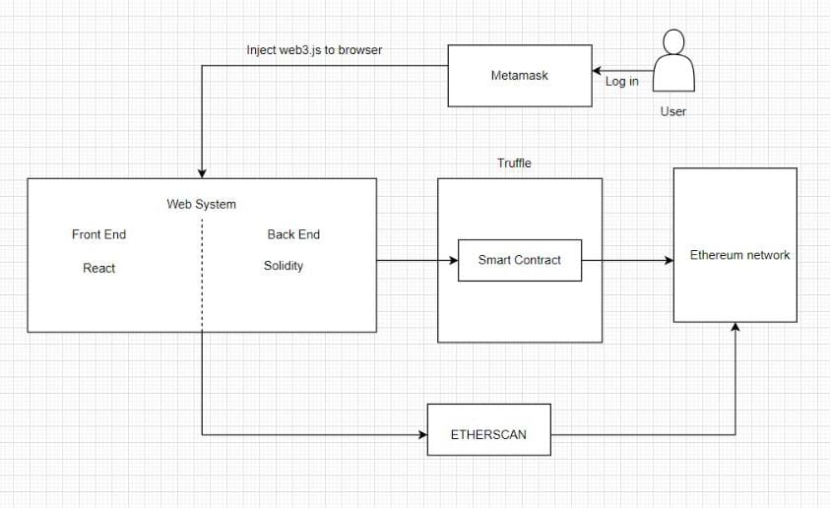

Figure 2.1: System Architecture

The smart contract for the DApp is written in Solidity and is deployed to the Personal Ethereum blockchain using Truffle. The Frontend of the App is made using React.js and web3.js is used to interact with Ethereum and smart contracts.

The system facilitates the creation of campaigns, contributing to campaigns and withdrawal within a blockchain-based crowdfunding platform. Here is an elaboration of the functionalities:
2.1 Campaign Creation: The system allows users to create crowdfunding campaigns. Users can provide detailed information about their project, including the funding goal, timeline, and description. This information is securely stored on the blockchain, ensuring transparency and immutability.

2.2 Contribution to Campaigns: Participants can contribute funds to the campaigns of their choice. The system enables secure transactions by utilizing blockchain technology, which ensures the integrity and traceability of contributions.

2.3 Smart Contract Automation: Smart contracts, implemented using Solidity or other suitable programming languages, automate various aspects of the contribution process. These contracts define the rules and conditions for contributions, ensuring that funds are allocated correctly, financial transactions are transparently recorded on the blockchain.

2.4 Withdrawal Process: Once a campaign is successfully funded, project administrators can initiate the withdrawal process to access the funds. The system verifies the authenticity of the withdrawal request and, based on predefined rules, transfers the funds to the designated account or wallet securely and transparently. Withdrawal transactions are recorded on the blockchain for auditability and accountability.

2.5 Transparency and Auditability: All transactions, including campaign creation, contributions and withdrawals, are recorded on the blockchain, providing transparency and immutability. This allows participants, backers, and project administrators to track the flow of funds, verify the authenticity of transactions, and ensure accountability throughout the process.

METHODOLOGY

System Design and Implementation

The working of blockchain-based crowdfunding that incorporates HTML, CSS, React.js, Web3.js,

smart contracts (using Solidity), Truffle, Ganache, and MetaMask can be outlined as follows:

3.1 Requirement Analysis:

The project starts with a thorough analysis of the requirements for the crowdfunding system. This includes understanding the desired functionalities, user roles, security requirements, and integration with blockchain technology. The requirements are documented to serve as a foundation for the system design.

3.2 System Design:

Based on the requirements, a system design is created. This includes designing the user interface using HTML and CSS to ensure a user-friendly and visually appealing crowdfunding platform. React.js is utilized for building interactive and dynamic components of the application.

3.3 Integration with Blockchain

The system is integrated with the blockchain using Web3.js, which allows interaction with the Ethereum network. The integration involves connecting to the blockchain using MetaMask, which provides a secure wallet and access to the Ethereum network. This allows users to contribute funds, interact with smart contracts, and track transactions on the blockchain.

3.4 Smart Contract Development:

Smart contracts are developed using Solidity, a programming language specifically designed for Ethereum. The contracts define the behavior of campaigns, handle contribution logic, and automate the reward distribution and withdrawal processes. Truffle, a development framework, is used to compile and deploy the smart contracts to the blockchain. Ganache, a local blockchain emulator, is utilized for testing and debugging smart contracts during the development phase.

3.5 Deployment

Once testing is complete, the blockchain-based crowdfunding system is ready for deployment. The smart contracts are deployed to the Ethereum network, and the user interface is hosted on a web server or decentralized storage platform. Users can then access the system through a web browser, connect their MetaMask wallet, and start creating campaigns or contributing funds.

RESULTS AND ANALYSIS

Based on the implemented system, the following are the results and observations:

4.1 Efficient Campaign Creation:

The crowdfunding system efficiently facilitates the creation of campaigns by allowing users to easily set up their fundraising projects. Users can input relevant details such as the funding goal, project description, and timeline. The system ensures that campaign creation is a smooth and streamlined process.

4.2 Secure Contribution Management:

The implemented system provides secure management of contributions made by participants. Contributions are recorded on the blockchain, ensuring transparency and immutability. Smart contracts handle the contribution process, automatically verifying the authenticity of transactions and accurately allocating funds to the respective campaigns.

4.3 Transparent Fund Tracking

The system offers transparency in tracking the flow of funds within the crowdfunding campaigns. Participants can view detailed information about the funds raised, including the total amount contributed, individual contributions, and the current funding status of each campaign. This transparency builds trust among contributors and allows for easy verification of financial transactions.

4.4 Enhanced Security and Privacy:

By leveraging blockchain technology, the crowdfunding system enhances security and privacy. Participant information and financial transactions are encrypted and stored on the blockchain, protecting them from unauthorized access. The decentralized nature of the blockchain reduces the risk of data breaches and enhances the overall security of the system.

4.5 Auditable and Immutable Records

The use of blockchain technology provides an auditable and immutable record of all crowdfunding activities. Every transaction, campaign creation, contribution, and reward distribution is permanently recorded on the blockchain, allowing for easy auditing and dispute resolution if necessary.

4.6 Potential for Scalability

The implemented system lays the foundation for scalability and future enhancements. The use of smart contracts and blockchain technology enables the system to handle a growing number of campaigns and contributions. It also provides flexibility for incorporating additional features, such as social sharing, campaign analytics, or integration with other blockchain networks.

The results and observations of the implemented blockchain-based crowdfunding system demonstrate its efficiency in campaign creation, secure contribution management, transparent fund tracking, reliable reward distribution, enhanced security and privacy, and the potential for scalability. The system harnesses the benefits of blockchain technology to create a secure, transparent, and efficient crowdfunding platform, empowering both project creators and contributors in their fundraising endeavors.

CHALLENGES

The blockchain system implemented presents several challenges that need to be considered:

5.1 Regulatory Compliance: The crowdfunding platform must comply with diverse legal and regulatory frameworks governing financial transactions, investor protection, and data privacy. Navigating these regulations and ensuring compliance can be complex and time-consuming.

5.2 Scalability: Blockchain networks, such as Ethereum, may face scalability limitations, resulting in slower transaction processing and higher fees during peak periods. Overcoming these scalability challenges is crucial to accommodate a large number of crowdfunding campaigns and participants simultaneously.

5.3 User Onboarding and Education: Since Blockchain technology and its associated concepts can be unfamiliar to many users. Ensuring a smooth onboarding experience and providing user-friendly interfaces that simplify the crowdfunding process and educate users about blockchain technology are essential to encourage adoption.

5.4 Availability of Comprehensive Resources: Since BlockChain/Solidiy is a new are less. Compared to more established programming languages, the range of learning materials, tutorials, and documentation for blockchain development are limited

Addressing these challenges requires a comprehensive approach, including rigorous smart contract security audits, optimizing gas usage, staying informed about regulatory requirements, prioritizing user experience, planning for system upgrades, and carefully selecting trusted and reliable data oracles.

CONCLUSION

The blockchain-powered crowdfunding platform aims to revolutionize the crowdfunding landscape by addressing the limitations of conventional methods. It focuses on enhancing transparency and reducing the risk of fraudulent activities. Traditional crowdfunding has often lacked transparency and has been susceptible to fraudulent schemes. In contrast, this platform leverages blockchain technology to provide an immutable and transparent ledger of transactions. By recording every donation and fund allocation on the blockchain, all participants can easily verify and validate the transactions, ensuring a higher level of trust and confidence. Donors benefit from a clear understanding of how their contributions are utilized, as the transparent nature of the platform allows them to track the movement of funds and verify the impact of their donations. As blockchain technology continues to evolve and gain wider adoption, the future of crowdfunding platforms using blockchain holds great promise. It enables secure and transparent funding processes, fostering innovation and empowering creators in a trustworthy environment.

REFERENCES

[1]Ashari, Firmansyah. ‘Smart Contract and Blockchain for Crowdfunding Platform’.
International Journal of Advanced Trends in Computer Science and Engineering, vol. 9,
no. 3, June 2020, pp. 3036–41. DOI.org(Crossref),

https://doi.org/10.30534/ijatcse/2020/83932020
[2] Bhavya Sri, K., et al. ‘Crowdfunding Using Blockchain’. International Journal of
Scientific Research in Computer Science, Engineering and;’[Information Technology, Mar.
2020, pp. 128–34. DOI.org (Crossref), https://doi.org/ 10.32628/CSEIT1206233
[3] Dhokley, Er. Waheeda, et al. ‘Crowdsourcing and Crowdfunding Platform Using
Blockchain and Collective Intelligence’. International Journal of Computer Sciences and
Engineering, vol. 7, no.2, Feb. 2019, pp. 668–73. DOI.org (Crossref),
https://doi.org/10.26438/ijcse/v7i2.668673.
[4] Saadat, Md Nazmus, et al. ‘Blockchain Based Crowdfunding Systems’. Indonesian
Journal of Electrical Engineering and Computer Science, vol. 15, no. 1,

July2019,p.409.DOI.org(Crossref), https://doi.org/10.11591/ijeecs.v15.i1.pp409-413.
[5] Gururaj, H. L., et al. ‘Decentralized Application for Crowdfunding Using Blockchain
Technology’. International Journal of Blockchains and Cryptocurrencies, vol. 2, no.1,
2021, p. 68. DOI.org (Crossref), https://doi.org/10.1504/IJBC. 2021.117809.

