**Resource Usage Cost Optimization in Cloud Computing**

**Mrs.S.Chandrakala, Ms.E.Gokulapriya**

Assistant Professor, Department of MCA, Vivekanandha Institute Of Information and Management Studies, Tiruchengode, Tamilnadu, India

Student, Department of MCA, Vivekanandha Institute Of Information and Management Studies, Tiruchengode, Tamilnadu, India

**ABSTRACT**

To optimize cloud computing resources according to actual demand and to reduce the cost of cloud services. Such approaches mostly focus on a single factor (i.e., compute power) optimization, but this can yield unsatisfactory results in real-world cloud workloads which are multi-factor, dynamic and irregular. It presents a novel approach which uses anomaly detection, machine learning and particle swarm optimization to achieve a cost-optimal cloud resource configuration.

**Keywords:** cost efficiency, optimization, etc.

1. **INTRODUCTION**

Cloud cost optimization is finding ways to run applications in the cloud, performing work or providing value to the business, at the lowest possible cost, and using cloud providers as cost-efficiently as possible. Optimization as a practice ranges from simple business management to complex scientific and engineering areas like operations research, decision science and analytics, and modeling and forecasting**.**

1. **CONCEPT**

Public cloud resources approach and apply the PAYG model differently. For example, a user provisioning a dedicated cloud server is generally billed according to server power and usage and on a recurring basis. Software as a Service (SaaS) works similarly, where a user leases software and customized features. Storage as a Service (SaaS) billing rotates on a frequent basis because storage requirements increase are usually subject to gradually increased pricing. Pay as you go is a cost model for cloud services that encompasses both subscription-based and consumption-based models and memory usage and expiry date, in contrast to traditional IT cost model that requires cost based cloud usage in server.Certain advantages were,Such as higher availability, cost reduction, efficient billing, reduced traffic congestion, fast system response, helpful services and effective management. The network load is reduced to the minimum, lowering the required number of gateways that must be placed across a certain area.

**2.1 Software Description**

Operating System : Windows 10

Platform :VISUAL STUDIO 2015

Front End : ASP.Net 4.0

Back End :MS SQL SERVER 2014

1. **MODULES**

**Infrastructure as service:**

Customers pay on a per-use basis, typically by the hour, week or month. Some cloud providers also charge based on the amount of virtual machine (VM) space used. This model does not require users to deploy in-house hardware and software.

**Platform as service(PAAS):**

Can be priced per application/user or gigabyte of memory consumed per hour. Microsoft has come out with a per-minute pricing model for its PaaS that stops the meter when you stop a VM, while preserving the VM state and configuration.

**Software as service:**

Pricing can be based on features, storage capacity or on a per-user basis.

1. **MODELS**

**Architectural diagram:**

An architecture diagram is a graphical representation of a set of concepts, that are part of an architecture, including their principles, elements and components. An architectural diagram is a visual representation that maps out the physical implementation for components of a software system. It shows the general structure of the software system and the associations, limitations, and boundaries between each element.Architecture diagrams provide a clear view of system components and structure. So, stakeholders can identify problems accurately and resolve them quickly.

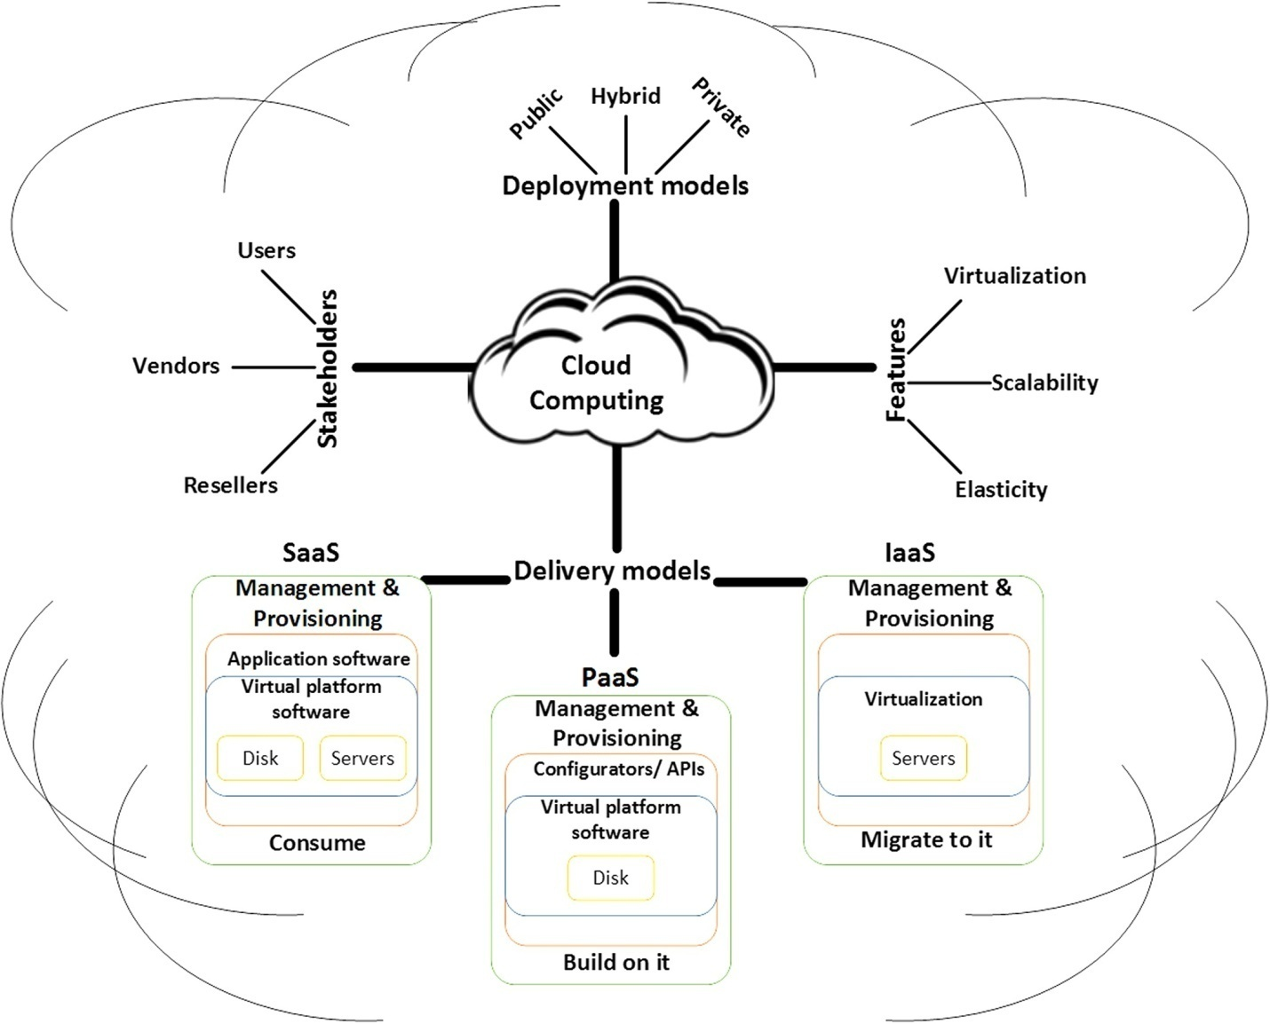

* 1. **ER Diagram**

ER model stands for an Entity-Relationship model. It is a high-level data model. This model is used to define the data elements and relationship for a specified system.It develops a conceptual design for the database. It also develops a very simple and easy to design view of data.In ER modeling, the database structure is portrayed as a diagram called an entity-relationship diagram.

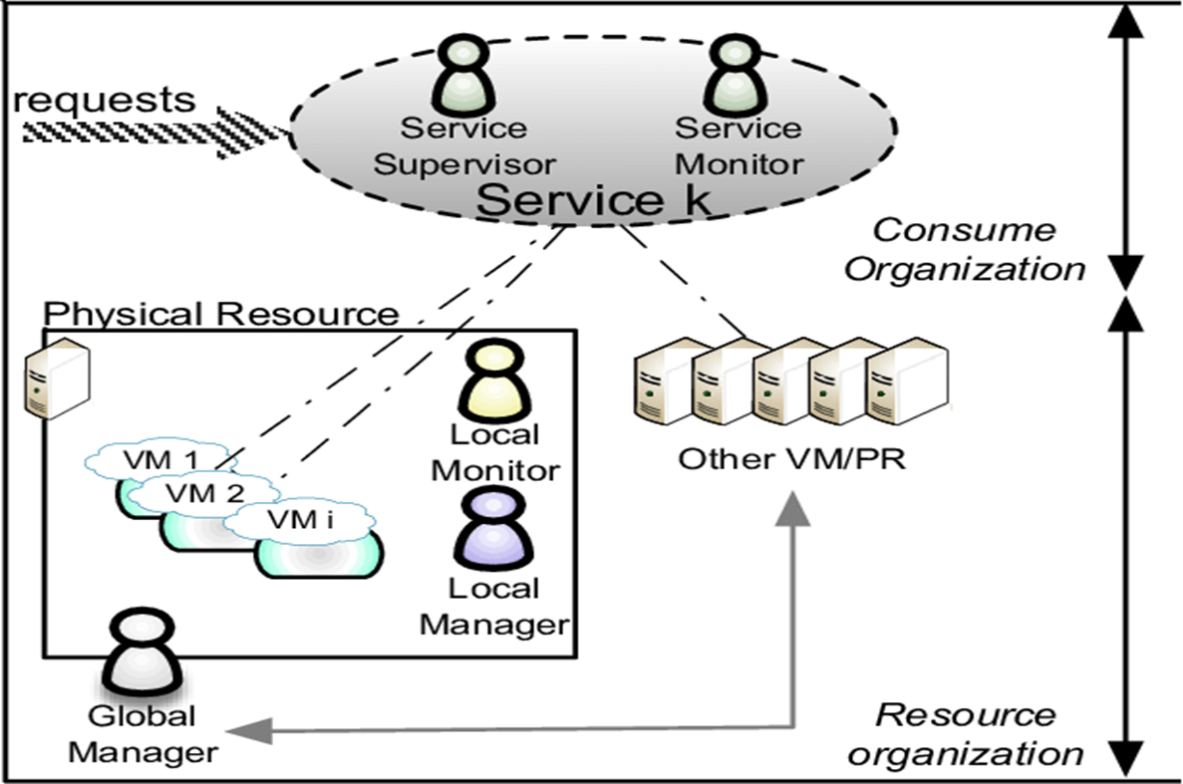

1. **SYSTEM TESTING**

**Whitebox Testing:**

The term 'white box' is used because of the internal perspective of the system. The **clear box or white box, or transparent box** name denotes the ability to see through the software's outer shell into its inner workings. It is performed by Developers, and then the software will be sent to the testing team, where they perform black-box testing. The main objective of white-box testing is to test the application's infrastructure. It is done at lower levels, as it includes unit testing and integration testing. It requires programming knowledge, as it majorly focuses on code structure, paths, conditions, and branches of a program or software. The primary goal of white-box testing is to focus on the flow of inputs and outputs through the software and strengthening the security of the software.It is also known as structural testing, clear box testing, code-based testing, and transparent testing. It is well suitable and recommended for algorithm testing.

**BlackBox Testing:**

The primary source of black-box testing is a specification of requirements that are stated by the customer. It is another type of manual testing. It is a software testing technique that examines the functionality of the software without knowing its internal structure or coding. It does not require programming knowledge of the software. All test cases are designed by considering the input and output of a particular function. In this testing, the test engineer analyzes the software against requirements, identifies the defects or bugs, and sends it back to the development team.In this method, the tester selects a function and gives input value to examine its functionality, and checks whether the function is giving the expected output or not. If the function produces the correct output, then it is passed in testing, otherwise failed.Black box testing is less exhaustive than White Box and Grey Box testing methods. It is the least time-consuming process among all the testing processes. The main objective of implementing black box testing is to specify the business needs or the customer's requirements.In other words, we can say that black box testing is a process of checking the functionality of an application as per the customer's requirement. Mainly, there are three types of black-box testing**: functional testing, Non-Functional testing,**and **Regression testing**. Its main objective is to specify the business needs or the customer's requirements.

**Unit Testing:**

Unit Testing is a type of software testing where individual units or components of a software are tested. The purpose is to validate that each unit of the software code performs as expected. Unit Testing is done during the development (coding phase) of an application by the developers. Unit Tests isolate a section of code and verify its correctness. A unit may be an individual function, method, procedure, module, or object.Unit testing breaks the program down into the smallest bit of code, usually function-level, and ensures that the function returns the value one expects. By using a unit testing framework, the unit tests become a separate entity which can then run automated tests on the program as it is being built.

1. **SYSTEM IMPLEMENTATION**

The optimizing resource usage costs in cloud computing. It involves collecting data and conducting tests in a mock environment. Four different prediction types were implemented and compared, showing effectiveness in optimizing resource usage and reducing costs. The approach also detects anomalies and generates accurate predictions. Overall, it presents a promising approach for cost optimization in cloud computing using machine learning techniques Machine learning can enhance the optimization of resource usage cost in cloud computing in several ways. It can enable predictive resource allocation, detect anomalies in workload patterns, develop automated optimization algorithms, offer customer-specific optimization, and integrate with billing systems to provide recommendations for cost optimization. These enhancements can help cloud providers allocate resources accurately and proactively, reduce resource wastage, and offer personalized services to customers.

1. **CONCLUSION**

Thus, authors propose an anonymous but secure authentication scheme for the data stored in cloud. User revocation is done and once a user is relocated cannot view the messages stored on the cloud. Also, authors propose text filtering to prevent improper and meaningless messages. This system can be useful for government and non government organizations. Our aim is to promote paperless work. One can complain, give feedback and send notice son cloud storage.In future, authors would like to provide document filtering and searchable encryption.Document filtering will improve the functionality of our system greatly. Searchable encryption will ease the searching of messages and other data.

1. **REFERENCES**
2. Teranishi, J. Furukawa, and K. Sako, “k-times anonymous authentication (extended abstract),” in Advances in Cryptology ASIACRYPT 2004. Springer, 2004, pp. 308–322.
3. D. Chaum, “Blind signature system,” in Advances in cryptology.Springer, 1984, pp. 153–153.
4. O. Bic¸er and A. K¨upc¸ ¨ u, “Versatile abs: Usage limited, revocable threshold traceable, authority hiding, decentralized attribute based signatures.” IACR Cryptology ePrint Archive, vol. 2019, p. 203, 2019.