**INTERNET OF THINGS-ENABLED INTELLIGENT FARMING SYSTEMS**

Dr. Ravindra M. Deshmukh

deshmukhrm577@gmail.com

Dr.Rajendra Gode Institute Of Technology & Research, Amravati

**Abstract**

India was placed second out of 238 nations in the Central Intelligence Agency's (CIA) fact books. India accounts for 17% of the global population yet only has 4% of the world's water reserves. 80 percent of the water is used for agriculture. Something such as India possesses excellent assets, but they are not utilized effectively. This resulted in a sufficient supply of water. Therefore, it is now necessary for us to utilize the limited water in an effective manner and to change the country's food output in order to keep pace with global expansion. The management of the drinking water network involving the liquid that is accessible is of utmost importance.

Some agricultural fields overwater their crops without first monitoring the level of soil moisture.

As a result, water resources that may be used in other places where water is needed are wasted. Problems with the water infrastructure are continuously impeding the development of the country.Thus, certain creative techniques were devised to enhance the administration of water purification. The global article's goal is to explain a smart irrigation system that employs the IoT to continually track soil moisture levels and adjust plant irrigation.The main driving force behind the initiatives is to maintain soil moisture levels to ensure the crops are not harmed.

In general, gauge volumes of water are estimated using soil damp detectors. The data gathered from the water's network sensor is collected by the controller, which then transmits it via the GPRS modules to the internet. The clever water infrastructure, spectacular management, and proper options based on the ongoing field data are the most exciting characteristics of these activities. The regulating process of these tasks ought to be feasible through distant sensors or an Internet-connected structure, and each activity should be achievable by merging all of the detectors, such as WI-FI or the Things Speak module.This main goal is to teach ordinary laypeople how to apply these strategies to increase production with enough resources because a large portion of the ordinary populace is not familiar with them.

**Keywords**

Intelligent agriculture, the Internet of Things (IOT), moisture in the soil sensors, level of water sensors, temperatures, and humidity.

**Introduction**

The Indian economic system's main industry is farming. A country that continually increases its crop production could be able to compete in the world market. A country like India provides an ideal climate for raising a range of farming commodities.

India, both the earth and the water are among the most significant assets. Between these two, inadequate water supplies have the most significant and widespread effects on crop productivity. Water shortages therefore have a tremendous influence on the production of food. Lack of water makes it difficult for farmers to cultivate crops, which makes it impossible to feed the world's expanding populations.

Based on the findings of the Global Water Managing Organisation, household, commercial, and recreational users account for 70% of total groundwater consumption, which exacerbates the issue of water shortage. The people are forced to consider the best method of managing water if such a large volume of water is utilized for other purposes and the primary use of water for agriculture is shirked.

Agricultural systems are among these water-related strategies. Irrigation is a technique for delivering liquid to food or cash crops to increase crop productivity.

The effective utilization of water has not been reduced by the use of irrigation devices in an optimized manner. Due to this, either more water is consumed than is necessary or insufficient water is available to ensure healthy crops. According to the Global Bank, the irrigated administration of management works to support and maintain existing groundwater levels and systems for irrigation and enhances irrigated areas to maximize the amount of products that may be produced.

Since it has been demonstrated that irrigated systems' effective use of water has boosted agricultural development, the exact moment of water sprinkling depends on choices like when to apply irrigation and at what volume. In the present day, automatic equipment has taken the place of conventional techniques for plant watering. Automated drip irrigation systems provide the benefit of lowering water and energy costs, reducing inconsistent watering, and guaranteeing that plants receive the required amount of water by eliminating water waste. Watering cultivated land that possesses enough moisture and takes water limitations into account is not an adequate agriculture practice.

Therefore, someone must determine whether the agricultural area in that place needs liquid and just how much water it needs to be watered in the crop prior to automating irrigation. We require the state of the soil and plant' fluids, their development and morphological phases, the accessibility and quality of fluids, the climate, and the watering system's performance in order to create an automated system.

Numerous studies were conducted, and the majority of automated devices are already being used economically. However, we have integrated an intelligent irrigation structure, which has the potential to completely control the irrigation process at the appropriate moment, in place of automation.

Utilizing the ESP8266 Nodes multiple-point controller modules and a digital humidity and temperature sensor (DTH11) detector, we are developing an IOT building system for irrigation in this study. Additionally, a thing-talk server is employed to monitor the state of the land and determine the soil's hydration content.

Sprinkler systems are also irrigation-based systems in which water passes through tubes to provide plants with the water they require. The smart technology can determine how much water is required depending on the land's conditions, including temperature, rainfall, and moisture, and the electricity is going to be turned on to supply sufficient water to the crops.

The automatic methods that are now in use have constraints, such as the inability to retain data indefinitely for future use while still sending alarm messages or SMS to mobile phones and tablets. The purpose of the study is to offer automated components for a smart irrigation system as well as store the information in an IOT cloud. The intelligent irrigation system is also constructed using a circuit for a rain alert and soil moisture sensors.

The following is how the paper was organized: While Section 2 discusses the literature study, Section 1 discusses the need for irrigation systems and improvements to IOT stored in the cloud for intelligent irrigation equipment. Following Section 3, which presents the materials and suggested study methods, comes Section 4, which presents the field experiment evaluation.

LITERATURE SURVEY

A distant monitoring and management device for conservatories that utilizes the International Network of Communication for Cellular GSM is suggested by Jinling et al. The greenhouse's moisture and saturation are updated by SMS, and remote equipment employs computerized devices with sensors to operate the irrigation systems [1]. Gautam and Reddy [2] suggested a revolutionary GSM-based Bluetooth-based remote-controlled comprehensive irrigation system. Suresh et al. [3] have proposed a system based on the characteristics of current- and future-generation controls and their application needs.

The system's electrical operator maintains a bold assertion that by cutting back on energy consumption, it would lengthen the system's overall lifespan. Kansara and colleagues have proposed an IOT-based adaptive watering system for irrigation [4].

It suggested methods for irrigation that would require fewer people to participate. When there's an alteration in the humidity or moisture of the enclosures, sensors detect it and send a signal to the microcontroller, interrupting it to turn the device on or off. A microcontroller-based system that monitors the level of the water and the region that needs to be watered was suggested by Archana and Priya [5]. There are devices here to detect the existence of fluids in the area. Devices detect the need until they are disengaged after the field has dried out. Anitha has developed an IOT-based waste tracking device that uses a device mounted on the bin's lid to determine the amount of trash according to the bin's elevation [6].

An illustration of an adjustable-rate automated microcontroller-based system for irrigation was put out by Uddin et al. [7]. Solar energy is solely used as an alternative form of electricity to operate the system as a whole. On the field of paddy, devices are positioned; these devices continuously monitor the water levels and provide this information to the operator. Producers can find out the water levels without having to go to the rice paddies. A landowner may operate the engine based on the water's level by sending a signal from his mobile, even from a distance. However, if the water's levels exceed the danger level, the motor will start on its own without the owner's approval to determine the ideal water level in the area.

Chavan and Karande have suggested creating a wise wireless sensor network, or WSN, for a farming setting. It might be crucial to keep an eye on the agricultural setting for several aspects, including soil moisture, temperature, or sultriness, among others [8]. A conventional method of measuring these parameters in an agricultural setting involved people manually collecting measurements and periodically verifying them. This study examines a Zigbee-based remote monitoring system. These nodes wirelessly transmit data to a centralized server, which collects, stores, and authorizes its analysis and eventual display. The data may also be delivered to the customer's handheld device.

Anitha has suggested an IOT-based security system for her house [9]. By sending a notice to the user, the security system will alert the owner of any unauthorized entrance or anytime the door is opened. The user may execute the appropriate steps after he receives the message. The security system will employ a WiFi module, the ESP8266, to connect to and interact with via the Internet, a magnet Reed sensor that tracks the status, a buzzer that activates an alarm, and a microcontroller known as Uno to interface among the various parts.

The simplicity of installation, reduced expenses, and minimal upkeep are among the system's key benefits. An irrigated method based on soil moisture has been explored by Parameswaran et al. [10].

MATERIALS AND METHODOLOGY

The following list of many critical elements makes up an effective irrigation system: • Uno • Connecter cable, a breadboard, a portable computer, and a DHT humidity and temperature sensor • Devices for measuring soil water and moisture level The Thing Speak application, Uno utilization, and C Programmer for Uno represent a few of the program's needs.

Arduino Uno

The open-source Uno Arduino PC tool organizes the parts according to the coding of programming and combines the business with the clientele to create controller packages. Such micro-controlled packets are used as a smart agent that was designed to recognise and manage systems operations in the real world. In Fig. 1, an example Arduino Uno is displayed.

Overall, boards made with Arduino cost little money and are used with many different operating systems. It is simple and adaptable for beginners. It works with many other languages, including C++ and Java.

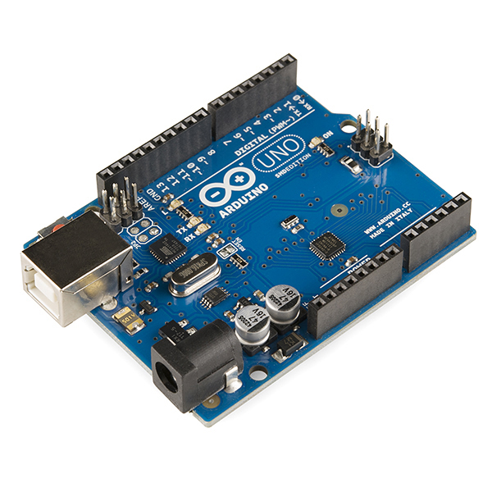

Fig.1 Uno Board

DTH Sensor:

The DTH sensor is a well-liked sensor that measures temperatures and moisture with a precision of +0.5 degrees.On the outside of the detector, the DTH sensor has an IC, an ambient temperature detector, and a moisture-detecting device.It has both 4 and 3 pins. Figure 2 shows an explanation of how to connect the device using the DTH sensor.

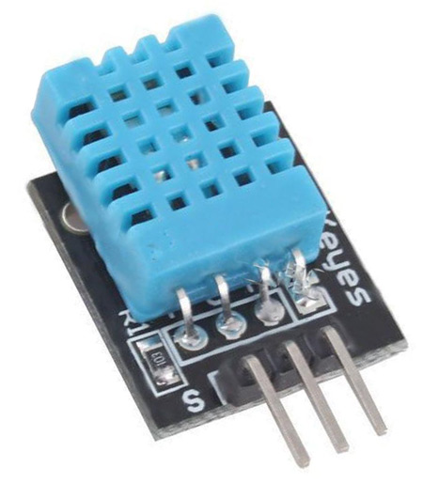

Fig.2 : DTH Sensor

Soil moisture sensor

A kind of soil moisture detector is seen in Figure 3. It includes two procedures that involve injecting current into the soil. After that, it examines the soil's blockage to determine the soil's amount of moisture. We know that when water is close by, dirt is more likely to conduct power easily, meaning that such soil has less resistance (R). However, dry soil has poor conductivity of intensity, so dry earth upholds more insurance than wet soil. This intensity feature is the foundation of the sensor. There must be a point where the resistance is converted to voltage; this is done using a circuit visible inside the sensor, which converts the resistance to energy.

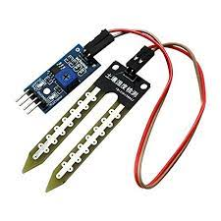

Fig.3 Soil Moisture Sensor

4. Wifi Module

A low-cost wireless module is the ESP-8266. It is capable of driving the whole system and controlling additional microcontroller units, giving it a dual purpose. 3.0 to 3.6 volts is the range of its operating voltage. It has a TCP/IP stack built in.

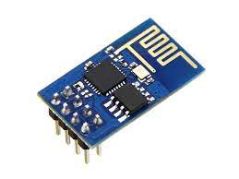

Fig 4. Wifi Module

Water Level Sensor

A water level detector is a simple-to-use, inexpensive, unreasonable level or drop-fade sensor that is obtained by having a series of parallel wires exposed after anticipated beads or water quantity so it can determine the water levels. The Arduino development board may be rapidly employed to pick up the level alert effect from smooth to complete water to simple sign changes and generate simple esteems.

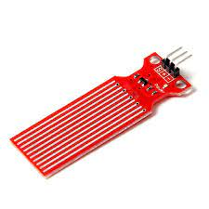

Fig 6. Water Level Sensor

The following are the water level sensor's requirements:

DC3 5V voltage, below 21 mA in current

Format: Analogue

Detection Area: 4 mm by 16 mm

11% to 90% non-condensing humidity

Dimensions of the product: 62mmx2ommx8mm

The breadboard is a more reliable method for use as a temporary template for testing designs for circuits. The bounce cable, also known as a jumpers cable, jumpers interface, a DuPont's cable, or a DuPont's connect (after one of their inventors), is a wire of electricity or group of them that is connected with an adapter or remains that both ends (or occasionally with no them-basically "tinned") and is frequently used for connecting each component of a breadboard or another kind of or evaluate device within or in additional hardware or components without the use of solder. Individual bob wires are connected by inserting their "end connector" into the opening provided in a breadboard, the header connection of a circuit board, or a small portion of the testing apparatus.

PROPOSED METHODOLOGY

Its main research goal is to create an environment for remotely monitoring moisture in the soil from an international location and managing soil water so it does not impact the goods. The IOT-based organized structure provided throughout this test is helpful to complete such a project. The study's sample structure assessment permits tracking of any agricultural arrival and maintains soil moisture levels. Any nation will undoubtedly be inspired by this idea to transition to smart agriculture. The structure is expected to calculate and produce records throughout time.

While the method and control stay constant, the actual execution of the framework would necessitate modifications in the detecting component, innovations, and supply code. The Thingspeak cloud was used to showcase the suggested technology. ThingSpeak is an IOT analytics platform that enables real-time data streams to be gathered, visualized, and analyzed in the cloud. ThingSpeak provides a quick visual representation of data supplied by devices capable of running MATLAB code. In addition, it is frequently used for IOT system development and demonstration of concepts that demand analysis.

Proposed system

In this section, the various sensors' data is initially gathered. Sensors, including moisture levels in the soil, local temperatures, air moisture levels, and water levels, are employed. They're fastened to a breadboard that's internal to the Uno boards. An Arduino IDE receives the board's operational data. The language of programming executes commands that collect and display information. Figs. 9 and 10 make it obvious that the procedure finishes if the data is invalid.

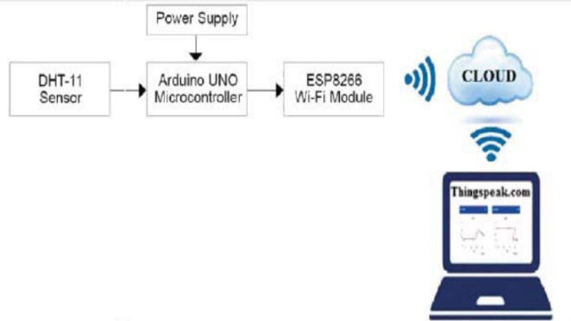

Fig.7 Proposed system

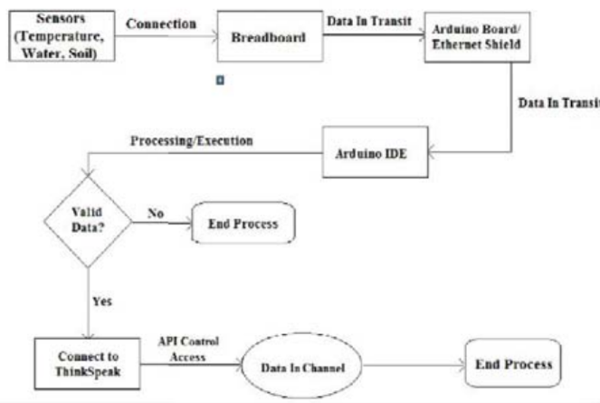

Fig.8 Data flow diagram of the proposed system

IMPLEMENTATION OF THE PROPOSED SYSTEM

In the system we propose, we successfully design a structure that can aid in a programmable water supply device by concentrating on the environment's relative humidity. Given that it automates and controls irrigation without the need for human intervention, the clever irrigation device proves to be a useful tool. Farmers or plant experts who lack the opportunity to water plants are the target audience for the project's crucial bundle.

The unmistakable vegetation's temperature and moisture content are measured by moisture meters and thermometers. If the humidity level is found to be below the desired level, the humidity sensor sends a flag to the Uno board, which causes the water pump to turn on and give water to a specific plant. Additionally, the equipment could be pulled out for use outside of doors. Figures 9 and 10 show an operational version of the suggested technology.

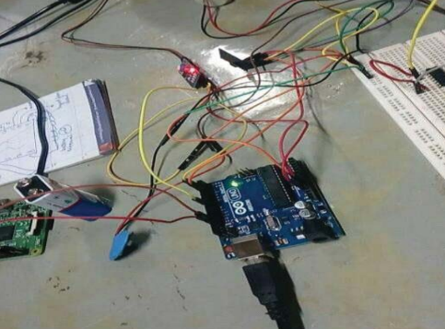

Fig 9. Working model of the proposed system

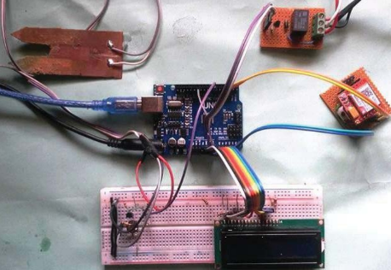

Fig 10. Complete connection of the proposed model

EXPERIMENTAL ANALYSIS

The DHT11 sensor's input was used to conduct the test. The ESP8266 NodeMCU analogue pin A0 may read the analogue output that the moisture sensors produce. We use a relay module to operate the 5V motor pump since the NodeMCU's GPIO can't provide an output voltage higher than 3.3V. The sensor that makes up the DHT11 and the sensor for moisture are both driven by a separate 5V power source.

The data table below lists the information gathered through different sensors. The information from the temperature detector, moisture sensor, soil humidity sensor, and the water level monitor is presented in Table.1 and is denoted by the characteristics A1, A2, A3, and A4 correspondingly.

Table 1. SAMPLE DATASET

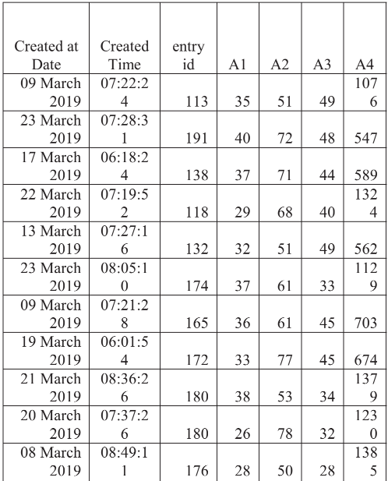

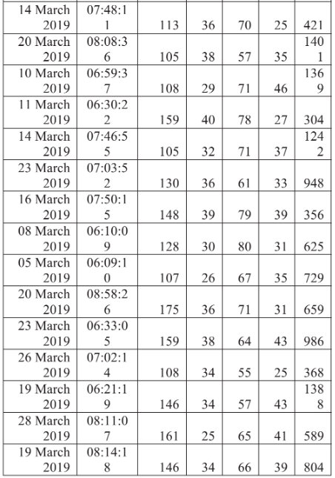

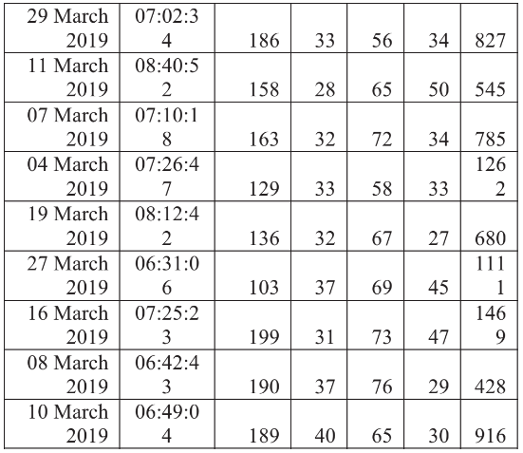

The temperatures measured by the DTH11 sensor over different periods of time at different points in Vellore are depicted in Fig. 11 above.

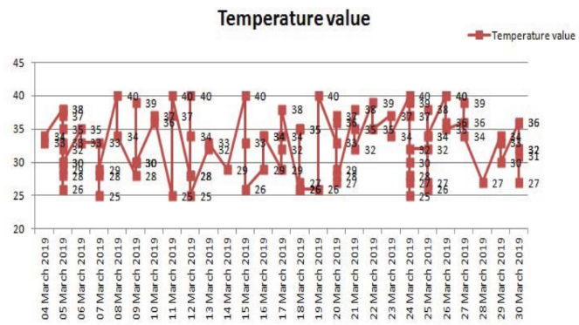

Fig 12. Temperature recorded by DTH-11 Sensor

Similar to this, Fig. 13 of the chart above shows humidity levels measured by the DTH11 sensors at various locations.

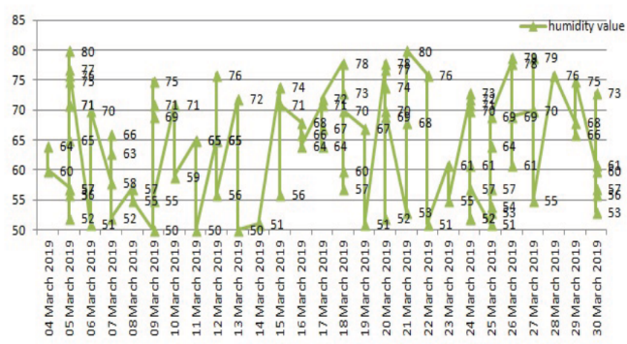

Fig 13. Humidity recorded by DTH-11 Sensor

The sensor that detects water levels is used to track the water's level in different fields around the Vellore district.

Following Fig. 14 illustrates this well.

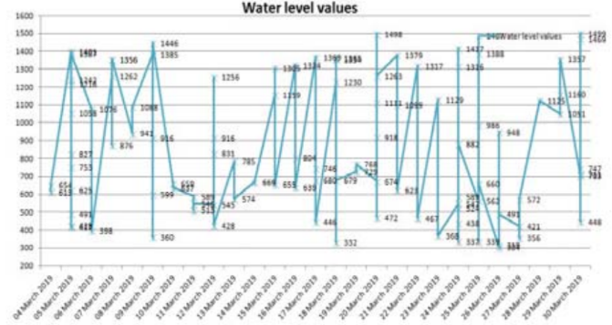

Fig 14. Water level recorded by water level sensor

For visualization purposes, these data are uploaded into the Thingspeak cloud, where the connection between moisture and temperature is determined. When caring for plants, the relationship between humidity and temperature is crucial. Therefore, we may turn on or off the irrigation system depending on the connection. The association is displayed in what follows in Fig. 15 using Thingspeaks' MatLab visualization programmes.

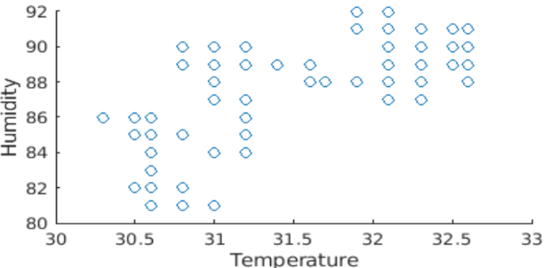

Fig 15. Correlation map between temperature and humidity

The planned study is new since, up until now, the majority of research on irrigation systems has typically recorded data and sent SMSes or alarms to the owners to let them know when to water or turn off the water supply. However, the suggested approach uses data gathered from numerous sensors to autonomously turn on and off. Additionally, the captured data is kept in the cloud for later use.

CONCLUSION AND FUTURE WORK

The stream of water and the amount of sand in it are crucial factors in the creation of an intelligent watering system. irrigation. In general, a wide range of factors, including air temperature, soil temperature, humidity in the air, ultraviolet rays, and a lot more, have an impact on soil moisture levels. This study suggested an Internet of Things (IoT)-based intelligent system for irrigation that would use sensors to collect data and store it in the cloud. Using the data that has been collected, future studies might involve predicting soil moisture, which could be efficient and affordable. It is a sophisticated system that can be additionally customized for specific category circumstances thanks to the auto mode. The objective of the suggested method with many nodes is to analyze water savings while reducing system costs.

References

[1] G S. Jin, S. Jingling, H. Qiuyan, W. Shengde, and Y.Yan, “A remote measurement and control system for greenhouse based on gsm-sms,”. In 2007 8th International Conference on Electronic Measurement and Instruments IEEE. pp. 2-82, August 2007.

[2] I. Gautam, and S.R.N Reddy, “Innovative GSM bluetooth based remote controlled embedded system for irrigation”. International Journal of Computer Applications, vol 47, pp.1-7,2012.

[3] R. Suresh, S.Gopinath, K. Govindaraju, T. Devika and N.S. Vanitha, “GSM based automated irrigation control using raingun irrigation system”, International Journal of Advanced Research in Computer and Communication Engineering”, vol 3, pp.5654-5657, 2014.

[4] K. Kansara, V. Zaveri, S. Shah, S. Diwadkar, and K.Jani, “Sensor based automated irrigation system with IOT: a technical review”, International Journal of Computer Science and Information Technologies, vol 6, pp.5331-5333, 2015.

[5] P. Archana, R. Priya, “Design and implementation of automatic plant watering system”, International Journal of Advanced Engineering and Global Technology, vol 4, pp. 1567-1570, 2016.

[6] A. Anitha, “Garbage Monitoring System Using IoT”. IOP Conference Series. Materials Science and Engineering, pp.420-427, 2017

[7] M. Uddin, “Measurements of evaporation during sprinkler irrigation”, (Doctoral dissertation, University of Southern Queensland). 2012

[8] C.H. Chavan, and P.V. Karande, “Wireless monitoring of soil moisture, temperature & humidity using zigbee in agriculture”. Int. J. Eng. Trends Technol, vol 11, pp. 493-497, 2014.

[9] A. Anitha,“Home security system using internet of things”. In Materials Science and Engineering Conference Series, vol. 263, pp. 1-11, 2017.

[10] G. Parameswaran, and K. Sivaprasath, “Arduino based smart drip irrigation system using Internet of Things”. Int. J. Eng. Sci, 5518, 2016.