A REVIEW ON ANALYSIS ON RC TEE BEAMS WITH WEB OPENINGS SHEAR STRENGTHENING APPLYING FRP MIXTURES
Vinod Kumar¹, Sunil Kumar²
¹M.Tech. Scholar, Ganga Institute of Technology and Management
²Assistant Professor, Ganga Institute of Technology and Management
ABSTRACT
Retrofitting has emerged as a cost-effective solution to enhance the safety of existing structures, particularly in response to earthquakes and other natural disasters. This process involves making modifications to safeguard buildings against various hazards. The need for retrofitting arises due to outdated design standards, structural deterioration, and design deficiencies in older buildings. By improving the load carrying capacity and prolonging the lifespan of structures, retrofitting eliminates the need for costly and time-consuming replacements. The civil engineering sector has witnessed the emergence of novel materials and technologies, including fiber-reinforced polymers (FRP), which have proven to be effective in strengthening structures. FRP composites offer high tensile strength and can withstand regular and seismic forces. They have become increasingly important in reinforcing both new and existing reinforced concrete structures. These abstract highlights the significance of retrofitting in meeting modern safety requirements, the reasons for its necessity, and the role of FRP in improving the durability and safety of structures.
Keywords: retrofitting, structures, safety, seismic engineering, fiber-reinforced polymers (FRP)
- INTRODUCTION
The degradation of existing civil engineering concrete structures is a major concern for structural engineers worldwide. To address this issue, rehabilitation and total replacement are two common approaches for rejuvenating older structures. However, due to the significant cost and effort involved, rehabilitation often becomes the preferred choice. Fiber-reinforced polymers (FRP) have emerged as the material of choice for reinforcing new civil engineering structures and restoring damaged ones. This chapter provides a brief review of the existing literature on RC (reinforced concrete) beams reinforced with epoxy-attached FRP. The focus is on highlighting the key successes and findings from the literature. The literature review is divided into three groups, which include firming up RC-rectangular and Tee beams with web maiden, firming of RC-Tee beams, and firming up RC-rectangular shape beams. Several studies have explored the use of FRP in enhancing the strength and performance of RC beams. Ghazi et al. (1994) investigated the performance of RC beams strengthened with fiber glass plate bonding (FGPB) for shear reinforcement. Chaallal et al. (1998) developed a comprehensive design strategy for one-directional slabs and reinforced concrete flexural beams using externally attached FRP plates. Khalifa et al. (2000) conducted an analytical examination of the shear capacity and failure mechanisms of RC girders enhanced with externally bonded FRP laminates. Alex et al. (2001) experimentally investigated the impact of shear strengthening on stress distribution, early cracking, and ultimate strength of RC beams. Sheikh (2002) examined the use of FRP for retrofitting and repairing damaged buildings, highlighting its potential to improve mechanical performance. Chen and Teng (2003) focused on the shearing capacity of FRP-strengthened girders and proposed a model to predict failure due to FRP debonding.
Furthermore, research has also been conducted on improving the strength of RC Tee beams. Hamid et al. (1992) studied the flexural strength of RC beams reinforced with glass-fiber-reinforced-plastic (GFRP) sheets attached to the tension flange. Sayed et al. (1999) investigated the performance of RC beams enhanced with various types of FRP wraps, evaluating the ductility and load-bearing capacity. Khalifa et al. (2000) examined the shear strength of RC T-section joists strengthened with externally bonded CFRP, exploring different wrapping strategies and CFRP quantities.
In summary, the reviewed literature demonstrates the potential of FRP in enhancing the strength and performance of RC beams. The findings from these studies provide valuable insights for engineers and researchers working on retrofitting and rehabilitation projects in civil engineering.
- METHODOLOGY
  - Beam Preparation
- Eleven prestressed concrete Tee beams were prepared with dimensions of 1400 mm in length, 40 cm width across the webbing, 450 mm width across the flanges, and 150 mm thickness.
- Two sets of 10 mm rods and one set of 12 mm HYSD rods were used for tensile reinforcement.
- Group B beams had double the amount of 20 mm and 1-10 mm HYSD rods for tensile reinforcement, 4-8 mm bars for hooking, and eight 8 mm bars for shearing reinforcement, spaced 220 mm apart.
2.2 Concrete Mix Design:
- The concrete mixture proportions were determined according to IS 456-2000 standards.
- The water-cement ratio used was 0.56.
- Four sets of cementitious concrete cubes and four 150x300 mm cylindrical samples were prepared for each beam to assess the strength of concrete at 28 days.
- Compression tests were conducted on control and reinforced cube samples at 7 days and 28 days.
2.3 Material Properties:
- Cements:
- Portland Slag Cement (PSC) Konark Brand with a specific gravity of 2.96 was used.
- Fine Aggregate:
- Fine aggregate or sand with a specific gravity of 2.64 and passing through a 4.75 mm screen was used.
- Coarse Aggregate:
- Two grades of coarse aggregates were used: one with aggregates retained on a 10 mm sieve and the other on a 16 mm sieve.
- The coarse aggregate had a size of 25 mm and a specific gravity of 2.88.
- Water:
- Plain, clean tap water was used for mixing the concrete.
- Steel Reinforcement:
- HYSD steel reinforcement rods with sizes of 20 mm and 10 mm, conforming to IS 1786:1985, were used.
- The tensile strength of the steel reinforcement was determined through testing three coupons of steel bars.
2.4 Testing and Evaluation:
- Compression tests were conducted on control and reinforced cube samples at 7 days and 28 days to assess the concrete strength.
- The tensile strength of the steel reinforcement was evaluated through testing steel bar coupons.
2.5 Data Analysis:
- The test results of concrete and steel reinforcement were analyzed to evaluate the performance and properties of the reinforced concrete beams.
The methodology outlines the process followed in preparing the beams, determining the concrete mix proportions, and evaluating the material properties through testing. The results obtained from the tests will be used for further analysis and assessment of the reinforced concrete beams.
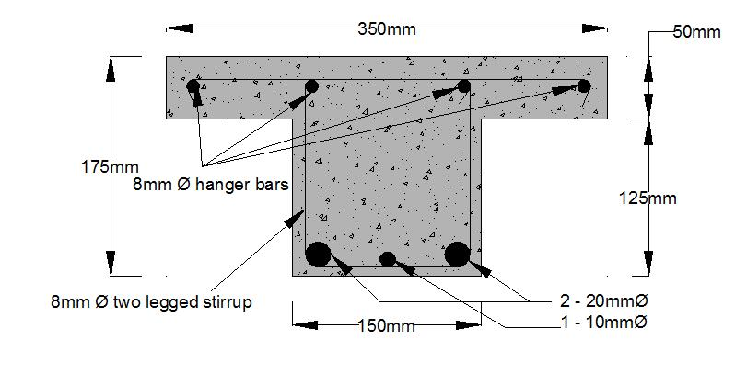

Figure 1: Specifying Supports

Table 1: Minimal Mixture Amounts of Concrete

Explanation | Cements | Fine | Coarse | Water
 |  | Aggregate | Aggregate
Mixture Ratio | 3 | 2.88 | 2.65 | 0.6
Amounts of ingredients for one | 42.2 | 34.66 | 165.25 | 22.22
sample beam in kg

- CRITICAL OBSERVATIONS
  - The majority of study has focused on strength and deformation performance of hybrid concrete block rectangular (RC) spans (FRP).
  - There aren't many publications scheduled the shearing performance of reinforced concrete Tee beam made of outwardly attached FRP complexes, notwithstanding the expanding amount of pitch bids.
  - Inadequate research on strengthening RC Tee beams with web apertures has been documented.
  - When reinforced with FRP composites, RC beams' shear capacity increases. However, incorrect anchoring has been known to cause FRP sheets to peel away from the primary concrete.
  - Around a little study done on how shear performance of RC beams is affected by the anchoring mechanism employed to avoid debonding of FRP and concrete.

- RESULTS AND DISCUSSION
- To investigate how shearing-lacking RC Tee beams having crosswise apertures behave.
- To research how GFRP composites affect reinforced concrete beams' eventual force bearing capability and fiasco outline.
- To examine how the anchoring mechanism utilised to keep concrete and FRP from debonding affects the shear strength of RC Tee beams.
- To understand how GFRP-retrofitted reinforced concrete Tee beams behave.
- To understand FRP's practical viability in the construction sector.

- CONCLUSION
- The test findings show that the FRP system's strengthening method may be applied to boost the shearing capability of Tee beam girder.
- The usefulness of the flanges anchoring technique in boosting the shearing capability of RC beam has been experimentally verified.
- REFERENCES
- ACI 440.2R-02, “Guide for the Design and Construction of Externally Bonded FRP
- Systems for Strengthening Concrete Structures”, Reported by ACI Committee 440.
- Al-Amery R., and Al-Mahaidi R. (2006), “Coupled flexural-shear retrofitting of RC
- Beams using CFRP straps”, Construction and Building Materials, 21, 1997-2006.
- Alex L., Assih J., and Delmas Y. (2001), “Shear Strengthening of RC Beams with externally bonded CFRP sheets”, Journal of Structural Engineering, Vol. 127, No. 4, Paper No. 20516.
- Balamuralikrishnan R., and Jeyasehar C. A. (2009), “Flexural behaviour of RC beams strengthened with Carbon Fiber Reinforced Polymer (CFRP) fabrics”, The Open Civil Engineering Journal, 3, 102-109.
- Bousselham A., and Chaallal O. (2006), “Behavior of Reinforced Concrete Tee beams strengthened in shear with carbon fiber-reinforced polymer –An Experimental Study”, ACI Structural Journal, Vol. 103, No. 3, pp. 339-347.
- Ceroni F. (2010), “Experimental performances of RC beams strengthened with FRP materials”, Construction and Building materials, 24, 1547-1559.
- Chaallal O., Nollet M. J., and Perraton D. (1998), “Strengthening of reinforced concrete beams with externally bonded fibre-reinforced-plastic plates: design guidelines for shear and flexure”, Canadian Journal of Civil Engineering, Vol. 25, No. 4, pp. 692-704.
- Chen J. F., and Teng J. G. (2003), “Shear capacity of FRP-strengthened RC beams: FRP debonding”, Construction and Building Materials, 17, 27-41.
- Chen J. F., and Teng J. G. (2003), “Shear capacity of Fiber-Reinforced Polymer-strengthened Reinforced Concrete Beams: Fiber Reinforced Polymer Rupture”, Journal of Structural Engineering, Vol. 129, No. 5, ASCE, ISSN 0733-9445, pp. 615-625.

