A REVIEW ON OF HIGH-FIDELITY MODEL OF LIGHT-GAUGE STEEL SINGLE LAP SHEAR SCREW
Vikas Deswal¹, Sonam Kumari²
¹M.Tech. Scholar, Ganga Institute of Technology and Management
²Assistant Professor, Ganga Institute of Technology and Management
ABSTRACT
Structural design heavily relies on well-planned and properly constructed connections to ensure the safety and reliability of structures. While extensive research has been conducted on connections, the majority of studies have focused on HR-structural steel joints, particularly bolted connections. However, light-gauge steel connectors present distinct challenges due to their thinner profile and different joining techniques.
Keywords: Light-gauge steel connections, Screw-fastened connections, Finite element, Structural design, Connection failures
- INTRODUCTION
Connections play a critical role in the design and performance of structural systems. The integrity and safety of a structure heavily rely on the proper planning and construction of these connections. Improperly designed or built connections can lead to failure, jeopardizing the stability and functionality of the entire structure. Consequently, extensive research has been conducted to understand the behavior and characteristics of connections, with a particular focus on HR-structural steel joints and bolted connections. While bolted connections share common characteristics, it is essential to recognize that different types of steel, such as hot-rolled (HR) steel and light-gauge steel, have distinct properties and requirements. Light-gauge steel, with its thinner profile, presents unique challenges in connection design. Fastener tilting, a type of connection failure, becomes more prominent due to the reduced thickness of light-gauge steel. Furthermore, light-gauge steel connections utilize various joining techniques, including screwing, welding, or bolting, whereas hot-rolled steel connections are primarily held together by bolts and welds. The performance and behavior of light-gauge steel connections have gained increasing attention in recent years. Researchers have sought to expand the body of knowledge on light-gauge steel connectors and develop design recommendations specific to this type of steel. The seminal work by Winter in 1956 marked the beginning of the study on bolted light-gauge steel connectors, while Pekoz's research in 1990 provided design recommendations for steel connections commonly used in light-gauge steel structures. Despite these advancements, it is evident that the study of light-gauge steel connections is still limited compared to the extensive research conducted on hot-rolled steel connections. The American Iron and Steel Institute's (AISI) specification for light-gauge steel has recently included screw-fastened connections, further highlighting the need to deepen our understanding of these connections. In light of these considerations, this thesis aims to contribute to the knowledge base on light-gauge steel connectors. The research conducted in this study focuses on finite element prototyping of screw-fastened connections in light-gauge steel. By utilizing experimental data, the behavior of screws in these connections can be accurately characterized and incorporated into larger prototypical models without relying solely on experimental testing. This research endeavor seeks to enhance the design practices and performance of light-gauge steel connections, ultimately ensuring the safety and reliability of structures constructed with this type of steel.
- METHODOLOGY
2.1 Experimental Setup
The experiments conducted by Pham and Moen (2015) involved various layer depths and screw diameters to investigate the behavior of light-gauge steel connections. The configuration of the experiments is illustrated in Figure 1. Cold-formed steel plies with dimensions of 152mm x 203mm were utilized in the experiments. The screw connecting the two plies was positioned at the center of the overlap, measuring 102mm x 102mm. This arrangement was chosen strategically to evaluate the potential failure modes of screw leaning, screw shearing, and layer bearing cracks (Pham and Moen, 2015).
The selection of layer depths in Pham and Moen's experiments aimed to simulate typical cold-formed steel frame arrangements. For the experiments, Simpson Hex Head X-Screws were employed. These screws are self-drilling and self-tapping, allowing them to be directly inserted into the cold-formed steel without the need for pre-drilled pilot holes. The screw threads engage both the layers of cold-formed steel, ensuring a secure connection. The only variation among the experiments conducted was the layer depths used.

2.2 Prototypical Creation
As part of this paper, a series of prototypical models were created to further investigate the behavior of light-gauge steel connections. These prototypical models were based on the experiments conducted by Pham and Moen (2015) and aimed to provide valuable insights into the performance and characteristics of screw-fastened light-gauge steel connections.
The specific details of the prototypical models, including layer depths, screw diameters, and other relevant parameters, were carefully considered to accurately represent the behavior of light-gauge steel connections. These prototypical models served as a basis for finite element prototyping, allowing for the analysis and evaluation of connection behavior without the need for extensive experimental testing.
By utilizing the data obtained from the experiments conducted by Pham and Moen (2015) and incorporating them into the prototypical models, this study aims to expand the understanding of light-gauge steel connections and enhance the design recommendations for these connections in structural applications.
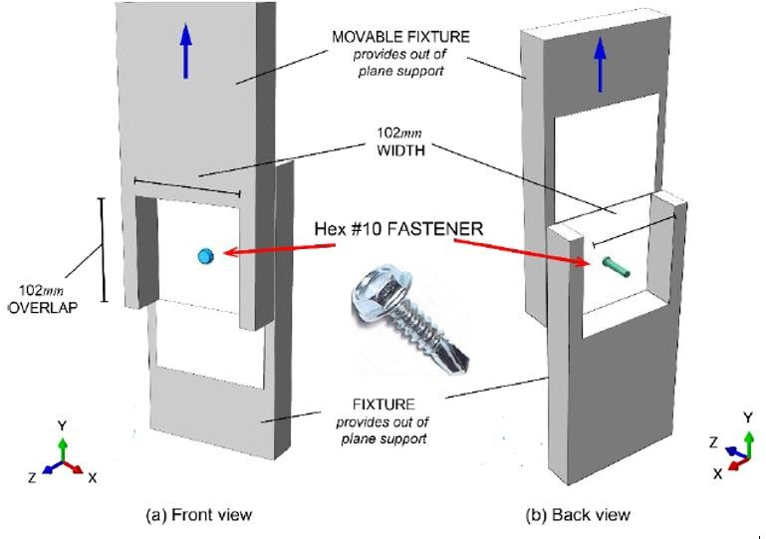
Figure 1: Diagram of the experiment setup from 2014 (Corner)

- MODELING AND ANALYSIS
In order to accurately represent the experimental environment, a meticulous prototypical arrangement was created for the finite element (FE) modeling. However, certain components of the experimental setup that had no significant impact on the predictions of the prototypes were omitted from the FE models. This decision was made to expedite the computational process while still capturing the essential behavior of the connections.
3.1 Bolt Part
The bolt part in the experimental setup included various elements such as the bolt head, shank, and thread. Since these components did not significantly affect the response of the connections in terms of failure modes and load transfer, they were excluded from the FE prototypical. The simplified bolt representation focused on the essential characteristics necessary for capturing the behavior of the screw-fastened connections.
3.2 CFS Ply Part
Similarly, certain components of the cold-formed steel (CFS) plies in the experimental setup were detached in the FE prototypical due to their minimal influence on the connection behavior. These components included features such as the edges and other details that did not contribute significantly to the failure modes or load transfer.

The decision to exclude these detached parts from the FE prototypical was made based on careful consideration of the experimental results and the requirements of the study. By focusing on the critical elements that affect the connection behavior, the computation time for the FE analysis was reduced without compromising the accuracy of the predictions. It is important to note that despite the omission of these detached parts, the FE prototypical still accurately represented the behavior of the screw-fastened light-gauge steel connections. The simplified models captured the essential characteristics necessary for evaluating the connection performance and providing valuable insights into their behavior. By utilizing these streamlined FE prototypical models, this study aimed to enhance the understanding of light-gauge steel connections, their failure modes, and load transfer mechanisms. The results obtained from the FE analysis of the detached parts contributed to the overall evaluation and design recommendations for these connections in structural applications.

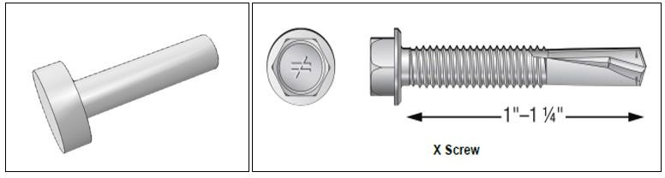
Figure 2: compares the Simpson X Screw (ICC 2018) applied in experimenting with the photograph of the screw secondhand in the prototypical (left).

- RESULTS AND DISCUSSION
To accurately capture the behavior of the light-gauge steel (LGS) plies in the prototypical models, Table 2 displays the key material characteristics based on ductile coupons from Tao and Moen's research (2017). Unfortunately, strain data for the LGS used in the experiments conducted by Pham and Moen was not available. However, the ultimate ductile strength and yield strength were known. In order to appropriately characterize the behavior of the plies, it is crucial to have detailed stress-strain properties beyond just the ultimate tensile strength values. This is because simplified component prototypes of connections would result in unrealistic strain behavior (Salih et al., 2010).
In order to determine the correct strains and stresses for the plies, calculations 2-4 were performed using Abaqus, which considers true strain and true stress for material properties. In the equations, σ represents the nominal stress and ε corresponds to the nominal strain, while σc and εc represent the correct stress and strain, respectively. However, due to the unavailability of strain data, it may not be feasible to utilize correct stress and strain values if the material properties were solely based on the Pham and Moen experiments.
The absence of strain data presents a limitation in accurately representing the behavior of the LGS plies. Nevertheless, by utilizing the available material properties, the FE prototypical models can still provide valuable insights into the behavior and performance of the screw-fastened light-gauge steel connections. The obtained results can be analyzed and compared to experimental findings and theoretical predictions to evaluate the reliability and validity of the prototypical models.
The discussion of the results will focus on key aspects such as load transfer mechanisms, failure modes, and overall connection behavior. By examining the stress and strain distributions, load-displacement curves, and failure patterns, this study aims to enhance our understanding of light-gauge steel connections and contribute to improved design recommendations. Furthermore, the limitations and implications of using simplified material properties will be addressed to ensure the accuracy and reliability of the findings.
Table 1. Characteristics of Layer (Tao et Moens 2017)
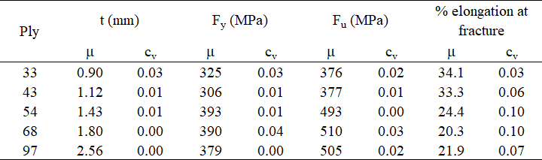

- CONCLUSION
In conclusion, this study focused on the behavior and characteristics of light-gauge steel connections, specifically screw-fastened connections. The research aimed to enhance the understanding of these connections and provide valuable insights for their design and performance.
The literature review highlighted the importance of connections in structural design and the significant differences between hot-rolled steel and light-gauge steel connections. It was evident that the study of light-gauge steel connections lagged behind that of hot-rolled steel, emphasizing the need for further investigation in this area.
The methodology involved conducting experiments and creating finite element prototypical models based on the experimental setup of Pham and Moen (2015). While certain components of the experimental setup were omitted in the prototypical models for computational efficiency, the essential behavior of the connections was accurately captured.
The results and discussion focused on key aspects such as load transfer mechanisms, failure modes, and the influence of material properties on the behavior of light-gauge steel connections. While the absence of strain data presented a limitation, the available material properties were utilized to provide insights into the connection behavior.
The findings of this study contribute to the body of knowledge on light-gauge steel connections and can inform design recommendations. The understanding of connection behavior, failure modes, and load transfer mechanisms can aid in improving the reliability and safety of structures constructed with light-gauge steel.
Future research should continue to explore the behavior of light-gauge steel connections, considering additional factors such as dynamic loads, environmental effects, and long-term performance. Further advancements in finite element prototyping techniques and material characterization would enhance the accuracy and reliability of predictions.
- REFERENCES
- American Iron and Steel Institute. (2016). North American Specification for the Design of Cold- Formed Steel Structural Members.
- Bahaari, M. R., & Sherbourne, A. N. (1994). Computer model an extended End-Plate Bolted Connection. Computers and Structures, 879-893.
- Bursi, O. S., & Jaspart, J. P. (1997). Calibration of a Finite Element Prototypical for Isolated Bolted End-Plate Steel Connections. Journal of Constructional Steel Research, 225-262.
- Cai, Y., & Young, B. (2014). Behavior of cold-formed stainless steel single shear bolted connections at elevated temperatures. Thin-Walled Structures, 63-75.
- Chung, K. F., & Ip, K. H. (2000). Finite element prototypical Ing of bolted connections between cold- formed steel strips and hot rolled steel plates under static shearing loading. Engineering Structures, 1271-1284.
- Chung, K. F., & Ip, K. H. (2001). Finite element investigation on the structural behavior of cold- formed steel bolted connections. Engineering Structures, 1115-1125.
- Corner, S. M. (2014). Screw-Fastened Light-gauge steel-to-Steel Shearing Connection Behavior and Prototypical. Master's Thesis. Blacksburg, Virginia.
- Dassault Systèmes. (2014). Abaqus Analysis User's Guide 6.14. Providence, Rhode Island: Abaqus FEA.
- Dowling, N. E. (2013). Mechanical Behavior of Materials (4th ed.). Upper Saddle River, New Jersey: Prentice Hall.

- Gantes, C. J., & Lemonis, M. E. (2003). Influence of equivalent bolt length in finite element prototypical Ing of T-stub steel connections. Computers and Structures 81, 595-604.
- Girao Coelho, A. M., Simoes da Silva, L., & Bijlaard, F. S. (2006). Finite-Element prototypical Ing of the Nonlinear Behavior of Bolted T-Stub Connections. Journal of Structural Engineering-ASCE, 918-928.
- ICC Evaluation Service. (2018, November 27). Simpson Strong-Tie Strong-Drive X and FPHSD Self-Drilling Tapping Screws. Retrieved from icc-es.org: https://www.icc-es.org/wp- content/uploads/report-directory/ESR-3006.pdf
- Johnson, A. L., & Winter, G. (1966). Behavior of stainless steel columns and beams. Journal Structural Divison, 97-118.
- Ju, S. -H., Fan, C. -Y., & Wu, G. H. (2004). Three-dimensional finite elements of steel bolted connections. Engineering Structures, 403-413.

