**Virtual Reality In Screenless Display**

Mr. Rehan Bojgar

(MCA Student)

Dr.Prakash Kene

(Proffesor)

P.E.S Modern College of Engineering, Pune

Dept. of Master of Computer Application

**Abstract:**

The rapid advancement of technology has revolutionized the way we interact with information, with screens playing a central role in our daily lives. However, traditional screens come with limitations such as size, portability, and dependency on external devices. In recent years, screenless displays have emerged as a groundbreaking alternative, offering a new paradigm in visual information presentation. This research paper explores the concept of screenless displays, their underlying technologies, applications, and potential implications for various fields. By delving into the advantages, challenges, and future prospects of screenless displays, this paper aims to shed light on this innovative approach to visual communication.

1. **Introduction**

The technology of screenless displays is currently developing and advancing in the field of computer-enhanced technologies. It is predicted to be one of the most significant technological advancements in the upcoming years. Numerous patents are still in progress to further develop this emerging technology, which has the potential to revolutionize the traditional concept of displays. The primary objective of screenless displays is to transmit information without the use of screens or projectors. This new trend of screenless displays is gaining popularity and becoming a prominent area of focus for the next generation. Screenless videos depict systems for visual information transmission from a video source, eliminating the need for a screen. By presenting a comprehensive overview of screenless displays, this research paper aims to provide researchers, technologists, and industry professionals with valuable insights

into this cutting-edge technology. The exploration of their underlying principles, applications, advantages, and challenges contributes to a deeper understanding of screenless displays, fostering further research and innovation in this field.



Fig.1 Screenless Display

Screen less computing systems can be divided mainly into 3 groups:

• Visual image

• Retinal direct

• Synaptic interface

1. **Types of Screenless Display**

**2.1 Visual Image**

Visual Image screen less display refers to any type of image that can be seen without a physical screen. A common example of this type of display is a hologram.

**Hologram**

Holograms were mainly used in telecommunications as a substitute for screens. Holograms can either be transmitted directly or saved in storage devices such as holodiscs. To access the stored image, the storage device can be connected to a holoprojector. Virtual reality goggles, although consisting of two small screens, are also considered screenless as they are different from traditional computer screens. Heads-up displays in jet fighters also fall into the category of Visual Image displays as they project images onto the clear cockpit window. In all of these cases, light is reflected off an intermediate object such as a hologram, LCD panel, or cockpit window before reaching the retina. With new software and hardware, users can customize and adjust the system to fit their individual needs, preferences, and capabilities. These advancements can allow the system to adjust to the user's behavior when interacting with movable type.

**Working of hologram**

Creating a hologram requires several components. First, there must be an object or person that needs to be recorded. A laser beam is then directed onto both the object and the recording medium that contains the necessary materials to clarify the image.

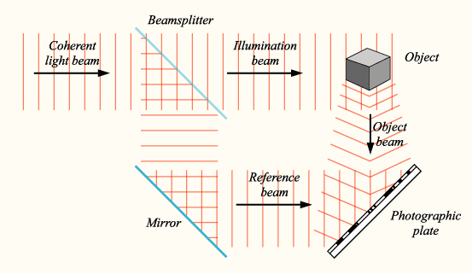

Fig.2 Recording a Hologram

To prevent any interference, the laser beam is split into two identical beams using mirrors. One of the beams, known as the illumination beam or object beam, is directed at the object. Some of the light is reflected off the object onto the recording medium. The second beam, called the reference beam, is directed onto the recording medium to create a more precise image. The two beams intersect and interfere with each other, creating an interference pattern that is imprinted onto the recording medium. This interference pattern recreates a virtual image that can be seen by our eyes. It is important to have a clear environment to enable the light beams to intersect accurately.

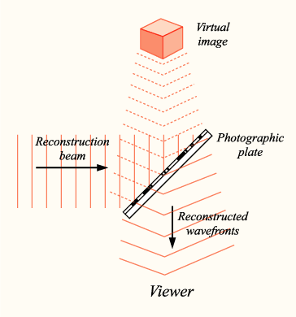

Fig.3 Reconstructing a Hologram

When you create a hologram, the diffraction grating and reflective surfaces inside the hologram help to recreate the original object beam. This beam is exactly the same as the original object beam before it was combined with the reference wave. This is similar to how a radio works by removing the sine wave that carried the amplitude or frequency-modulated information. The wave of information then returns to its original state before it was transmitted. The hologram beam also travels in the same direction as the original object beam, spreading out as it goes. Since the object was on the other side of the holographic plate, the beam travels towards you. When this light reaches your eyes, your eyes focus on it and your brain interprets it as a three-dimensional image located behind the transparent hologram. This may seem strange, but it's similar to what happens when you look in a mirror and see yourself and your surroundings behind you. The light rays that create this image bounce off the mirror's surface and reach your eyes. Holograms also act like color filters, so you see the object as the same color as the laser used to create it rather than its natural color.

In a hologram, the virtual image that you see is made of the light that bounces off the interference fringes and spreads out as it travels to your eyes. However, the light that hits the reverse side of each fringe behaves differently. Instead of diverging and moving upward, it converges and moves downward. This creates a focused reproduction of the object - a real image that you can see if you place a screen in its path. The real image is flipped back to front and is the opposite of the virtual image that you can see without a screen. With the correct lighting, holograms can display both images at the same time.

Your brain plays an important role in how you perceive both of these images. When your eyes detect the light from the virtual image, your brain interprets it as a beam of light reflected from a real object. It uses multiple cues, such as shadows, relative positions of objects, distances, and differences in angles, to correctly interpret this scene. Your brain uses the same cues to interpret the pseudoscopic real image.

**2.2 Retinal Display**

A virtual retinal display system is a type of screen-less display that directly projects images onto the retina of the eye, as shown in figure 2.2. Unlike visual image systems, which reflect light off of an intermediate object onto the retina, virtual retinal display systems project light directly onto the retina. These systems could provide a high level of privacy when working on a computer in public places since most onlookers rely on seeing the same light that the legitimate user sees. However, with retinal direct systems, the projected light only enters the pupils of the intended viewer.

Fig.4 Block diagram of Retinal Display

In order to make an image using a VRD, a photon source is used to create a beam of light that is coherent. This means that the light waves are all in sync, which allows the system to draw a spot on the retina that is very precise. To make the image appear, the beam of light is changed in intensity to match the brightness of the image being displayed. This can be done after the beam is created. If the source of the light has a high enough bandwidth to change its intensity quickly, like a laser diode, then the source can be changed directly to make the image appear.

Once the image is modulated, it is then projected onto the retina by a scanner that moves the beam to the correct position for each pixel in the image. There are different ways that the scanner can work, such as a calligraphic mode that directly draws the lines of the image, or a raster mode that is similar to computer monitors and TVs. The focus of our project is on the raster mode, which allows the VRD to be used with standard video sources. The raster is created by a horizontal scanner that moves the beam to draw a row of pixels, followed by a vertical scanner that moves the beam to the next row where it draws another set of pixels.

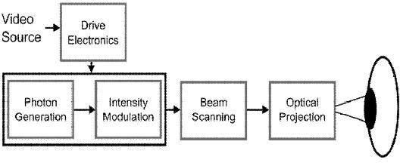In order for the image to be seen clearly, the optical beam from the VRD must be projected correctly into the eye. The VRD's exit pupil and the eye's entrance pupil should be at the same level. When the eye focuses on the spot of light on the retina, it determines the location of the image. The brightness of the spot is determined by the intensity modulation of the light beam. The spot of light moves in a raster pattern, which helps to create a stable and continuous image on the retina. Finally, the electronics that control the VRD synchronize the scanners and intensity modulator with the video signal to ensure that the image is stable and clear.

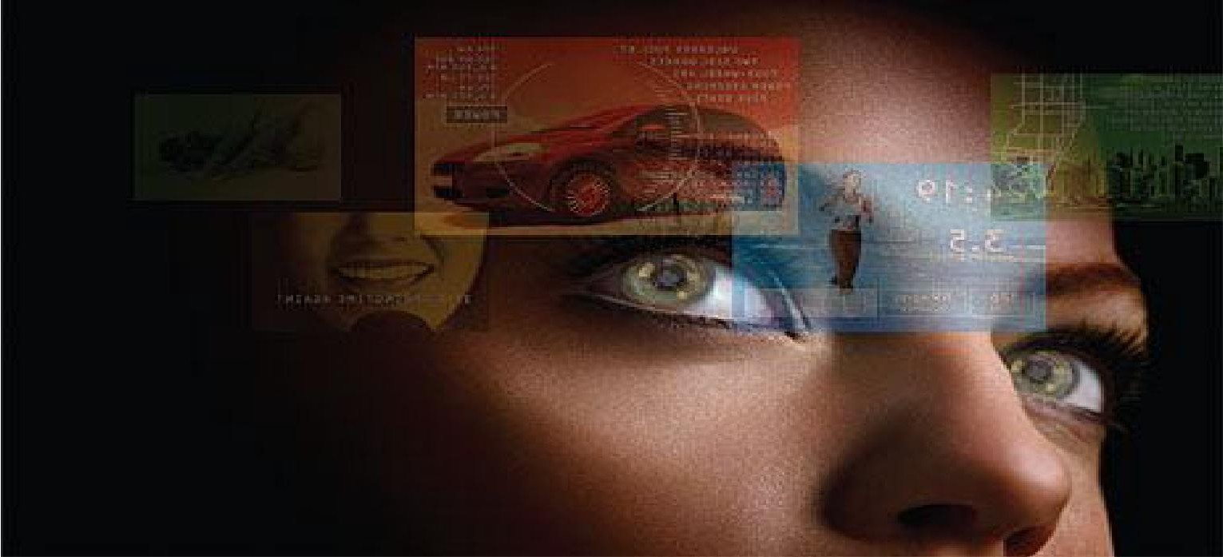Fig.5 Retinal Display

**VRD STRUCTURE**

A virtual retinal display (VRD) or retinal scan display (RSD) is a new type of display technology that projects a raster display directly onto the retina of the eye. This means that users see a display that appears to be floating in front of them, much like a regular screen. Older versions of this technology projected a defocused image onto a small "screen" in front of the user's eyes, which had limitations such as a small screen area and high weight.

Recent developments have made it possible to create a true VRD system that is bright enough to be used during the day and can dynamically correct for irregularities in the eye. This creates a high-resolution screenless display with excellent color range and brightness, which is far better than the best television technologies.

The VRD was invented in 1991 at the University of Washington, and it has mostly been used in combination with virtual reality systems. It can also be used as part of a wearable computer system or as a display system for portable devices such as cell phones and media players. In this role, the device is placed in front of the user and detects the eye using facial scanning techniques.

In the future, mobile devices will be touchless and screenless, using laser-based displays that project images directly onto our retinas and brain wave sensing implants. This will allow technology to integrate with our vision seamlessly, creating a more natural and intuitive user interface. We are on the verge of a hardware revolution that will make this all possible, as well as the cloud-based information streaming that will enable this new type of user interface.

Fig. 6 Virtual Retinal Display –Example

**2.3 Synaptic Interface**

The Synaptic Interface screen less video technology doesn't use light to transmit visual information. Instead, it bypasses the eye and sends the information directly to the brain. Although this technology hasn't been used in humans yet, scientists have been able to sample usable video signals from the eyes of living horseshoe crabs and send video signals from electronic cameras into their brains using the same method.

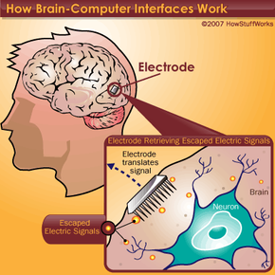

Fig. 7 Synaptic Interface

1. **The Working Principle**

There are several new ways that screen less displays are being developed with technology. The GEN-X wonder view is a combination of various software programs. Any computer system that can run Modoc software can display interactive movable text. Most of the Modoc software that will be used in the next few years will be used with personal computers, e-book readers, and other types of display and projection devices that are currently in use. Soon, a new type of input/output system will be created to allow communication and interaction between computers and users. This new human/computer interface is called the telereader terminal. Visual Image is a software product that can manipulate and compose bitmap images. Bitmaps can be manipulated individually in Image Mode or combined in Object Mode to create a "collage." Visual Image can create and manipulate images of any size, but the amount of memory resources your system has will limit it.

**3.1 Creating Visual CatLog Files**

Visual Image is a program that lets you make files in a special format called EYE. These files are useful for creating image catalogs with logical groupings of pictures. For example, you could create a catalog file that shows all pictures of different building materials such as brick, concrete, or stone.

To make an EYE file, you can use the "File, Export Project" command in Visual Image. This will create a new file that refers to all the images that are currently open in Visual Image. You will be asked to give a name to the file you create. If there are any images that you have created in Visual Image that have not been saved, you will be asked if you want to include them in the EYE file, and if you say yes, they will be saved as bitmaps.

Additionally, Visual Image has an "Export Editor" command that lets you choose which image files on your computer you want to include in a catalog EYE file. When you choose "File, Exports Editor" in Visual Image, a file browser will appear, and you can select the image files you want to add to your project file for use in Visual Catalog.

## **3.2 Additional Software and Hardware Requirements.**

* To enable or enhance the level of interaction.
* To improve the user's ability to perceive and understand information.
* To offer the user a visually healthy environment.
* Reacting to diverse user commands, which can be conveyed through voice, hand gestures, foot movements, or other signaling methods.
* Supplying indications or reactions through blinking.
* Adjusting the output to accommodate alterations in the user's physiology or response time, among other factors. The updated software and hardware will empower the user and the system to more effectively utilize each other's strengths and collaborate as a fully integrated team.

**Conclusion**

Screenless display technology is an exciting and rapidly developing field that has the potential to revolutionize the way we interact with digital content. The development of new techniques, such as Synaptic Interface and GEN-X wonder view, are paving the way for new input/output systems that will make communication and interaction with computers more intuitive and seamless. Additionally, software programs like Visual Image are allowing us to create and manipulate images in new and innovative ways, such as creating EYE files for cataloging and logical sub-groupings. As this technology continues to develop, we can look forward to a future where screenless displays are the norm and digital content is more accessible and integrated into our everyday lives.

**REFERENCES**

[1] K. Ranganath, M.Sravanthy, P.Krupali “SCREENLESS DISPLAYS – THE EMERGING COMPUTER TECHNOLOGY*”* in journal of “ International Journal of Engineering Research and Application.” published in Vol. 1, Issue 3, pp.942- 947 .

[2] Parimal S. Bhosale, Kulkarni Niraj Rajeev, Kurkute Shubham Sanjay, “ Screen less Display”, in journal of **“International Journal of Scientific Research in Computer Science, Engineering and Information Technology”** published in January-February-2022.

[3] LAVANYA.K, Dr.N.SHANMUGAPRIYA2 “SCREENLESS DISPLAY”, in journal of “International Journal of Engineering Technology, Management and Applied Sciences” published in Vol 10,Issue 9, Sept /2019 ISSN NO:0377-9254.

[4] A. Vikas, “Screenless Display Technology”, in journal of “International Journal Of Engineering And Computer Science” published in Volume 7 Issue 6 June 2018, Page No. 23997-24002 ISSN:2319-7242.