**EXPERIMENTAL EXAMINATION OF COMPRESSIVE STRENGTH**

**OF COARSE AND FINE RECYCLED AGGREGATES**

**Aman Dalal1, Harish2, Sheela Malik3**

1M.Tech Scholar, Structure Design Department of Civil Engineering,, Ganga Institute Of Technology and Management, Kablana, Jhajjar, Haryana, India

2Assistant Professor, Department of Civil Engineering, Ganga Institute Of Technology and Management, Kablana, Jhajjar, Haryana, India

3Assistant Professor, Department of Civil Engineering, Ganga Institute Of Technology and Management, Kablana, Jhajjar, Haryana, India

**ABSTRACT**

Trash from the construction industry, namely construction and demolition (C&D) debris, is dumped rather than disposed of, which adds to the depletion of the natural resources necessary to produce concrete. Recycling and reuse of these C&D wastes can help protect the environment and consume fewer natural resources. However, the quality of RA is significantly impacted negatively by cement mortar that is put to the surface of the aggregate, which results in greater porosity and higher rates of water absorption. This study will look at the properties of concrete that contains demolition waste that has been processed in different ways. Abrasion therapy (AT), cement slurry treatment (CST), and chemical treatment (CT) are examples of therapeutic techniques under investigation.

Laying the foundation for the use of reactive aggregates (RA) in structural concrete is the aim of this study. It examines the physical and mechanical characteristics of natural materials and RA while testing concrete compositions with various ratios of fine and coarse RA. Results demonstrate that abrasion treatment (AT) provides greater comp. strength compared to alternative RAC and is more effective and efficient. For higher grades of concrete with varying ratios of coarse and fine RAs, the toughened characteristics of RAC were further examined.

The findings demonstrated that a partial replacement with a 30% coarse RA and a 50% fine RA achieved comp. strength equivalent to NAC.

**Keywords**: Compressive Strength, Recycled Aggregate, Treatment, Construction & Demolition Waste

1. **INTRODUCTION**

Resources are in low supply for the concrete industry, and outdated buildings must be torn down to create room for new construction. Rapid urbanisation has made waste management an ecological and social concern that requires the integration of reuse and waste minimization concepts. The majority of C&D waste generated in metropolitan areas is due to the demolition of pre-existing, weakened, and ageing structures, including when roads are dug or repaved, new ones are constructed, existing structures are upgraded, and flyover bridges are erected. Among the often discovered items in C&D wastes include metals, plastics, cardboard and paper, wood, sand and residues, brick and tile pieces, and concrete debris.

India uses cement in the manufacturing of concrete at a rate that ranks second in the world after China, thus it is crucial to take this into account. 80% of concrete is typically made up of aggregate and 12% cement, both of which need energy-intensive mining and transportation processes to generate. To reduce this waste, efficient waste management is needed. Utilising RA to develop RAC is an effective strategy for reusing and maintaining irreplaceable shared assets and resources. A significant amount of the coarse and fine aggregates used in mix are utilised in India, hence it is crucial to take recycling of both coarse and fine aggregate into account while producing concrete in India.

1. **METHODOLOGY**

To accomplish the aforementioned objectives, the procedure below is used.

• An analysis of published works using the most recent design standards.

• Experiment with various RA therapy modalities.

• Analysing both types of aggregates' mechanical and physical properties.

• Investigation of the mechanical properties of the M-20 grade mix using different proportions of treated coarse RA and fine RA.

• Finalising the best management strategies in light of the outcomes.

• Determining the optimal recycled coarse-to-fine aggregate mix ratio.

• Studying the mechanical characteristics of a mixture of M-40 and M50 grades using the correct proportions of treated coarse and fine RA.

• M70's exceptional strength is achieved by using recycled aggregates.

1. **MODELING AND ANALYSIS**

**Characteristics of RA**

Specific tests are used to assess the mechanical characteristics of river sand, coarse RAs, and natural coarse aggregates. Concrete was made using these aggregates.

**Strength of Aggregate**

RAs are less strong than conventional aggregates. This was a typical result and was brought on by the mortar that was stuck to the natural aggregates. This connected material was significantly less resistant as compared to the standard aggregates.

**Absorption of Water**

9.7% of the RAs absorbed water as a consequence. The raw, coarse granite aggregates' water absorption rate is 1.15 percent. All of the absorption capabilities must be taken into consideration, in addition to the aggregates' moisture content, for the purpose of determining the concrete's mix percentage. This demonstrates that while taking RA, water absorption might be problematic

**Coarse RAs characteristics improvement methods**

Numerous methods have been developed and are documented in literature in order to enhance the quality of RA. To get rid of the mortar specks on the aggregate surface is the goal. Three different therapy modalities are used in this experimental investigation to enhance the superiority of RA, these are Abrasion therapy (AT), chemical treatment (CT), slurry treatment (CST).

1. **RESULTS AND DISCUSSION**

**Comp. Strength of RA Concrete**

Six similar instances of each mix were cast test the impact of substituting the RA. As required by IS: 516 - 1959, the test conducted at a loading rate of 7 KN/s. The results show that the abrasion-treated RA20AT has a 7-day comp. strength that is 40% higher than the CST RAC. The comparative strength created with AT RA at 20% substitution is 40% higher than that made with acid-treated RAC. The comp. strength of RAC (AT) is 32% higher than that of RAC (CST), 29.08% higher than that of RAC (CT), and 20% higher than that of NAC under the situation of a 30% coarse RA replacement.

With varying replacement percentages of coarse RA and fine RA, the 28-day comparative strengths of RAC (AT) and RAC (CST) are studied. With a 30% replacement of coarse RA, RAC (AT) has a 28-day comparative strength that is 25% more than RAC (CST) and 15% more than NAC. Due to the effective removal of the adhering mortar, mixes formed with RAC(AT) and fine RA 50% have 28-day comparative strengths that are up to 33% greater than those made with NAC.The shift in comp. strength, which eventually leads to greater strength, is also influenced by higher aggregate densities. The results of concrete (RAC-AT) treated with 10 , 20, and 30 % coarse RA with and without treatment to show the improved efficiency attained by adopting a simple abrasion method.

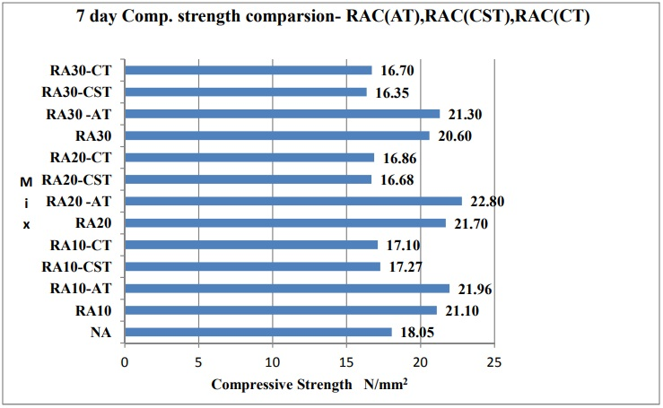

**FIGURE -1** Strength comparison

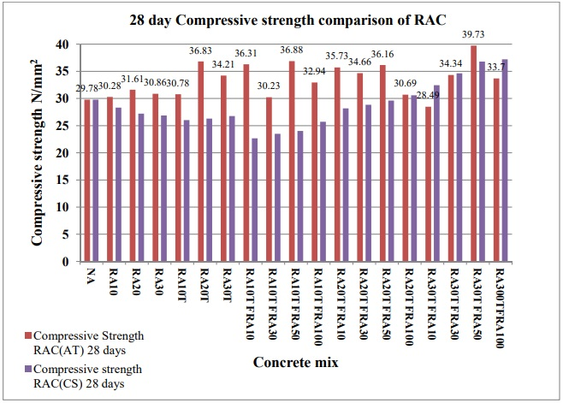

**FIGURE-2** Comparison of RAC’s Compressive Strength

**Tested Comp. Strength parameters for M20**

Concrete cube specimens' comp strength's statistical properties are established. The remaining 18 mix proportions are divided into coarse RA replacement amounts of 10, 20, and 30%.

**Table 3.1 Cylindrical and cube samples compressive strength**

|  |  |  |  |  |  |  |
| --- | --- | --- | --- | --- | --- | --- |
| **No of sample** | | **Mix** | **concrete grade** | | **Cylinderism comp. strength in MPa.** | **Cube Comp. Strength in MPa.** |
|  | NAC | M20 | 25.10 | | 28.32 |
|  | RA30TFRA50 | M20 | 25.30 | | 32.34 |
|  | NAC | M40 | 42.32 | | 52.32 |
|  | RA30TFRA50 | M40 | 38.35 | | 49.63 |
|  | NAC | M50 | 55.35 | | 61.25 |
|  | RA30TFRA50 | M50 | 44.01 | | 59.12 |
|  | NAC | M70 | 74.32 | | 85.23 |
|  | RA30TFRA50 | M70 | 58.36 | | 83.19 |

In comparison to the requirements of the IS Code, experimental values of elasticity modulus are negligible. We thus come to the conclusion that recycled aggregates can be used instead of natural aggregates.

1. **CONCLUSION**

Studies on RAs have shown that both coarse and fine RAs may be used to produce high-quality concrete.

(1) Even after being treated with abrasion, acid, and cement slurry, concrete with RA and 30% coarse aggregate replacement has equivalent comp. strength to natural aggregate.

(2) For eliminating linked mortar and enhancing RA performance, abrasion treatment is more proficient and appropriate than CT and CST.

(3) In concrete grades M20, M40, M50, and M70, 50% fine RA and 30% coarse RA replacement can produce 28-day compressive values that are equivalent to those of conventional concrete.

1. **REFERENCES**
2. Rama, A. Lokeswari M (2010), “Management of Construction and Demolition Waste”.Journal of Environmental Research and Development,5(1),96-104, ISSN:0973-6921.
3. Noguchi, T. and M. Tamura, (2001) “Concrete Design Towards Complete Recycling”. Structural Concrete, 3(2): 155-167.
4. Central Pollution Control Board 2017. “Guidelines on Environmental Management of C&D Wastes.”1-85, http://cpcb.nic.in/
5. Limbachiya M, Meddah M S, Ouchagour Y.(2012), “Use of recycled concrete aggregate in fly-ash concrete” Construction and Building Material, 27(1), 439– 449.
6. Abbas A, Fathifazl G, Isgor OB, Razaqpur AG, Fouriner B, Foo S(2006). “Environmental benefits of green concrete.”, EIC Climate Change Technol IEEE; 10–12 May:1–8.
7. Limbachiya Mukesh & Seddik Meddah, Mohammed & Ouchagour, Youssef. (2012). “Performance of Portland/Silica Fume Cement Concrete Produced with Recycled Concrete Aggregate”. ACI Materials Journal. 109(1). 91-100.
8. Milad Ghanbari, Armin Monir Abbasi, and Mehdi Ravanshadnia(2017), “Economic and Environmental Evaluation and Optimal Ratio of Natural and Recycled Aggregate Production,” Advances in Materials Science and Engineering, 10.1155/2017/7458285
9. Akbarnezhad A, Ong KCG, Tam CT, Zhang MH(2013) " Effects of the Parent Concrete Properties and Crushing Procedure on the Properties of Coarse Recycled Concrete Aggregates". Journal of Materials in Civil Engineering, 25(12),10.1061/(ASCE)MT.1943-5533.0000789.
10. Hansen TC, Boegh E.(1985) “Elasticity and drying shrinkage of recycled aggregate concrete”. J ACI 1985;82(5):648–52.
11. Hurley, j. & Bush, r. 2007. The Use of Recycled Aggregates in Structural Concrete. Concrete Engineering International. Camberley, Surrey: The Concrete Society.
12. Gómez-Soberón JMV.(2002),”Porosity of recycled concrete with substitution of recycled concrete aggregate: an experimental study”. Cement Concrete Research,32(1),1301–11.
13. Poon CS, Shui ZH, Lam L.(2004), “Effect of microstructure of ITZ on compressive strength of concrete prepared with recycled aggregates”. Construction and Building. Material,18(1) 461–8.
14. Hansen TC, Narud H (1983). “Strength of recycled concrete made from crushed concrete coarse aggregate.” Concrete International 1983;5(1):79–83.
15. Limbachiya MC, Leelawat T, Dhir RK(2000), “Use of recycled concrete aggregate in high-strength concrete”. Material and Structure, 33(1) 574–80.
16. Bcsj Committee (1978) Study On Recycled Aggregate and Recycled Aggregate Concrete. Building Con-tractors Society of Japan, Committee on Disposal and Reuse of Concrete Construction Waste. Summary in Journal, Japan, Vol. 16, No. 7:pp. 18-31
17. Sagoe-Crentsil KK, Brown T, Taylor AH.(2001) “Performance of concrete made with commercially produced coarse recycled concrete aggregate” Cement Concrete Research ,31(1)707–12.