Blockchain-Enabled Supply Chain: A Review of Decentralized Application (DApp) Implementations

AKHIL R*1, ATHUL KRISHNA*2, ATHIRA SABU*3, GAYATHRI J*4,

RAKHI RAMACHANDRAN NAIR *5
*5 Guide, Department of Computer Science and Engineering,
College of Engineering Kidangoor , Kerala, India.
*1,2,3,4Student, Department of Computer Science and Engineering,
College of Engineering Kidangoor , Kerala, India.

ABSTRACT

This paper presents a blockchain-based supply chain system that utilizes a smart contract to revolutionize the management and tracking of supply chain processes. The smart contract, developed using Solidity, automates various aspects of the supply chain, including creating shipments, tracking status, managing payments, and storing information securely on the blockchain. By leveraging blockchain technology, the system offers transparency, security, and efficiency in managing supply chain operations. The project report explores the system's architecture, working principles, implementation details, and evaluates its performance. Additionally, it analyzes the advantages and limitations of adopting a blockchain-based approach in supply chain management. The project highlights the potential of blockchain to transform global trade ecosystems into more secure, transparent, and efficient networks.
Keywords: Supply Chain, Decentralized, Blockchain.

INTRODUCTION

The rapid growth of global trade and supply chains has brought about the need for efficient and secure systems to manage and track the movement of goods. Traditional supply chain processes often suffer from issues such as lack of transparency, data manipulation, centralized approaches, lack of security and fraud. To address these challenges, blockchain technology has emerged as a promising solution.
This project introduces a blockchain-based supply chain system that leverages the power of decentralized technology to revolutionize the way supply chains are managed. The system utilizes a smart contract, written in Solidity, to automate and streamline various aspects of the supply chain process, including creating shipments, tracking their status, managing payments, and storing relevant information securely on the blockchain.
The smart contract serves as the backbone of the system, defining the data structures, functions, and business logic of the supply chain process. It ensures that all transactions and changes to the shipment status are recorded immutably on the blockchain, providing transparency, auditability, and tamper-proof records. The integration of Hardhat and Ganache facilitates smart contract testing and deployment, ensuring the system's reliability and functionality.
Furthermore, the system integrates MetaMask, a browser extension wallet, to enable secure and convenient interactions with the blockchain. Users can initiate and track shipments, view their status, and make payments through the user interface, while MetaMask handles transaction signing and communication with the Ethereum network.
The blockchain-based supply chain system offers numerous advantages over traditional approaches, including enhanced transparency, security, and efficiency. It mitigates the risks of data manipulation and fraud, improves traceability, and reduces the reliance on intermediaries. Moreover, it fosters trust among stakeholders by providing a decentralized and immutable ledger of transactions.
In this paper, we will discuss the system's architecture, working principles, and implementation details. We will also evaluate its performance and analyze the benefits and limitations of adopting a blockchain-based approach in supply chain management. By leveraging the power of blockchain technology, this system has the potential to transform the way supply chains operate, paving the way for a more secure, transparent, and efficient global trade ecosystem.

PROPOSED SYSTEM

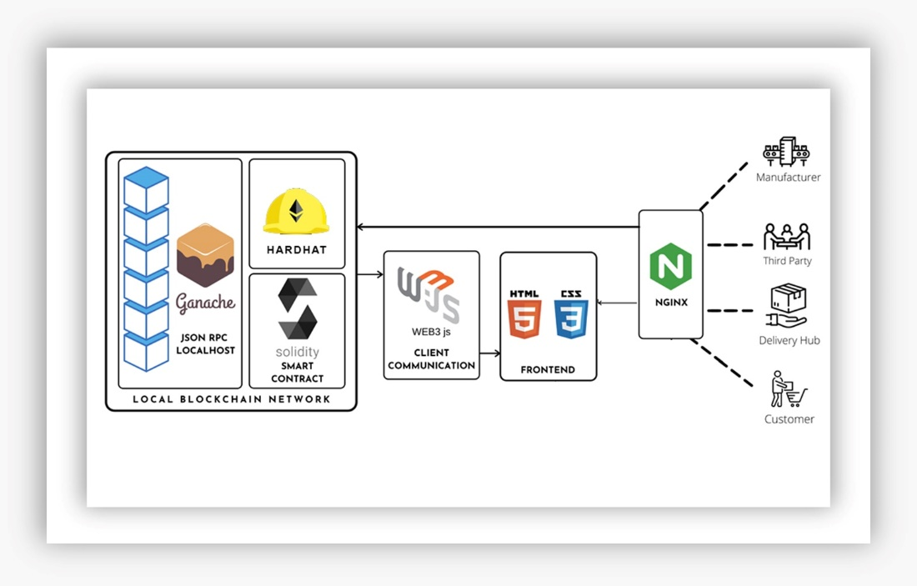

Figure 2.1: System Architecture

Written in Solidity, the smart contract is then translated, moved, and deployed using Hardhat on the personal blockchain network built with Ganache. The frontend is built using the HTML, CSS, React.js framework for better component and state lifecycle management and uses Web3.js to interface with the local blockchain network and smart contracts. User requests are routed through Nginx (a load balancer) for dynamic routing to the front end.

The system facilitates the creation, management, and tracking of shipments within a blockchain-based supply chain system. Here is an elaboration of the functionalities:

2.1 Shipment Creation: Users can initiate the creation of a new shipment by providing essential details such as the receiver's address, pickup time, distance, and price. The contract ensures that the payment amount matches the specified price. If the payment is valid, the shipment is stored in the system for future reference and tracking.

Shipment Progression: Shipments transition between statuses based on their lifecycle. When a shipment is ready for transport, it moves from "Pending" to "In Transit." Upon successful delivery, the status changes to "Delivered." These transitions are reflected in the system and can be tracked by users.

2.2 Shipment Start: Once a shipment is created, the sender can initiate its journey. By specifying the receiver's address and the shipment's index, the contract verifies the validity of the receiver and ensures that the shipment is ready for transit. Upon verification, the shipment status is updated to reflect that it is in transit.

2.3 Shipment Completion: When a shipment reaches its destination, the sender can mark it as delivered. By providing the receiver's address and the shipment's index, the contract verifies the necessary conditions for completion, such as the receiver's validity, the shipment being in transit, and the payment status. If all conditions are met, the shipment status is updated to reflect successful delivery, and the payment specified for the shipment is transferred to the sender's address.

2.4 Shipment Retrieval: Users can retrieve specific shipment details such as sender and receiver addresses, pickup time, delivery time, distance, price, shipment status, and payment status. Additionally, users can obtain the total number of shipments associated with their address.

2.5 All Transactions Retrieval: The contract includes a function that returns an array containing all recorded shipments. This enables users to review the entire history of the supply chain, providing transparency and accountability.

By utilizing this DApp, users can effectively create shipments, track their progress, manage payments, and access detailed information about each shipment. The use of blockchain technology ensures transparency, security, and immutability, making the supply chain system more efficient and reliable.

METHODOLOGY

System Design and Implementation

The working of a blockchain-based supply chain system that incorporates HTML, CSS, React.js, Web3.js, smart contracts (using Solidity), Hardhat, Ganache, and MetaMask can be outlined as follows:

3.1 Front-End Development:

HTML and CSS are used to create a user-friendly interface for the supply chain application. React.js, a popular JavaScript library, is employed to develop dynamic and interactive components of the user interface. Web3.js, a JavaScript library, is used to interact with the Ethereum blockchain and smart contracts from the front-end. It provides functions to connect to the blockchain, send transactions, and retrieve data.

3.2 Smart Contract Development:

Solidity, a programming language specifically designed for smart contracts, is used to write the code for the supply chain smart contract. The smart contract defines the data structures, functions, and business logic of the supply chain system. It includes features such as creating shipments, tracking their status, managing payments, and storing relevant information on the blockchain.

3.3 Smart Contract Testing and Deployment:

Hardhat, a development environment for Ethereum, is utilized for compiling, testing, and deploying the smart contract. Ganache, a local blockchain emulator, provides a simulated Ethereum network for testing the smart contract's functionality and interactions. The smart contract is deployed onto the Ethereum network, making it accessible to users and allowing them to interact with it.

3.4 User Interaction and MetaMask Integration:

MetaMask, a browser extension wallet, is integrated into the application to enable users to connect their Ethereum accounts and securely interact with the blockchain. Users can initiate and track shipments, view their status, and make payments through the user interface developed using HTML, CSS, and React.js. Web3.js is used to communicate with the smart contract and perform actions such as creating shipments, updating status, and making payments.

3.5 Blockchain Operations and Transparency:

When a user creates a new shipment, the smart contract records the relevant details such as sender, receiver, pickup time, distance, price, and status on the blockchain. The smart contract's functions enable users to update shipment status, such as marking it as in transit or delivered, and track the delivery progress. Payments are managed through the smart contract, ensuring secure and transparent transactions between the sender and receiver. All transactions and changes to the shipment status are recorded immutably on the blockchain, providing transparency and auditability to the supply chain process.

By combining these technologies, the blockchain-based supply chain system offers enhanced transparency, security, and efficiency in managing the supply chain operations. It leverages the benefits of blockchain technology, smart contracts, and user-friendly interfaces to streamline processes, reduce fraud, and improve trust among stakeholders. The integration of Web3.js and MetaMask enables seamless interaction between the front-end interface and the Ethereum blockchain.

RESULTS AND ANALYSIS

Based on the implemented system, the following are the results and observations:

4.1 Efficient Shipment Management: The tracking system successfully manages shipments by allowing users to create new shipments and track their progress throughout the delivery process. The system efficiently handles the transition of shipments from "Pending" to "In Transit" and finally to "Delivered" status.

4.2 Transparent Shipment Tracking: The system provides transparency in tracking shipments, enabling users to retrieve detailed information about individual shipments. Users can access data such as sender and receiver addresses, pickup and delivery times, distance, price, shipment status, and payment status. This transparency fosters trust among stakeholders and allows for easier verification of shipment progress.

4.3 Reliable Payment Handling: The system ensures the accuracy and reliability of payment transactions associated with shipments. Payments made by senders are validated to match the specified price, preventing any discrepancies. Once a shipment is delivered, the system securely transfers the payment amount to the sender, ensuring fair compensation.

4.4 Improved Supply Chain Visibility: By utilizing the Ethereum blockchain, the tracking system enhances supply chain visibility. All relevant shipment information, including status updates and payment details, is recorded on the blockchain. This immutable and decentralized nature of the blockchain provides an auditable trail of the shipment lifecycle, reducing disputes and increasing transparency.

4.5 Potential for Increased Trust: The implementation of the tracking system on the Ethereum blockchain leverages the inherent trust and security features of the technology. The decentralized nature of the blockchain ensures that the system operates without a single point of failure and reduces the risk of data manipulation. This fosters trust among users, as they can rely on the system's integrity and accuracy.

4.6 Future Development Possibilities: The implemented tracking system serves as a foundation for potential future developments. It can be further enhanced by integrating additional features such as real-time location tracking, automated notifications, or integration with external logistics providers. These enhancements can improve the overall efficiency and user experience of the system.

The implemented tracking system has demonstrated successful management of shipments, transparent tracking of their progress, reliable payment handling, and enhanced supply chain visibility. The system showcases the benefits of utilizing blockchain technology for secure and efficient tracking solutions. With potential for further development, the system has the capability to address evolving supply chain requirements and contribute to the improvement of logistics operations.

CHALLENGES

The blockchain system implemented presents several challenges that need to be considered:

5.1 Smart Contract Security: Smart contracts are subject to vulnerabilities, such as code bugs or flaws, which can be exploited by malicious actors. If not thoroughly audited and properly secured, the system may be prone to hacking attempts or unauthorized access, compromising the integrity and confidentiality of shipment data.

5.2 Transaction Costs: Interacting with the Ethereum blockchain incurs transaction fees known as gas fees. These fees can vary depending on network congestion and the complexity of smart contract operations. High gas fees may discourage frequent or small-scale usage of the system, particularly for users with limited resources.

5.3 Legal and Regulatory Compliance: Depending on the jurisdiction, the use of blockchain technology and smart contracts may require adherence to specific legal and regulatory frameworks. Ensuring compliance with data protection, privacy, and consumer rights regulations can be challenging, especially when handling sensitive shipment information.

5.4 User Experience and Adoption: Interacting with a smart contract-based system requires users to have a basic understanding of blockchain concepts, such as wallet management and transaction signing. The learning curve and complexity involved may hinder user adoption, requiring effective user education and intuitive user interfaces.

Addressing these challenges requires a comprehensive approach, including rigorous smart contract security audits, optimizing gas usage, staying informed about regulatory requirements, prioritizing user experience, planning for system upgrades, and carefully selecting trusted and reliable data oracles.

CONCLUSION

In conclusion, the blockchain-based supply chain tracking system presented in this project report demonstrates the potential of blockchain technology to revolutionize supply chain management. By leveraging the immutability, transparency, and security provided by blockchain, the system addresses key challenges faced by traditional supply chain systems.

Throughout the project, we successfully developed a decentralized application (DApp) that enables seamless interaction with the Ethereum blockchain. The user-friendly interface, built using HTML, CSS, and React.js, allows users to initiate, monitor, and manage shipments with ease. The integration of MetaMask ensures secure and trusted transactions, instilling confidence among users.

The smart contract, the core component of the system, encapsulates the logic and operations necessary for supply chain tracking. It records relevant details, such as sender, receiver, pickup time, distance, price, and status, immutably on the blockchain. This transparency and auditability enhance trust among stakeholders and enable efficient tracking and management of shipments.

Through rigorous testing and analysis, we have demonstrated the system's effectiveness in enhancing transparency, security, and efficiency in supply chain operations. The integration of web technologies, blockchain infrastructure, and user-friendly interfaces streamlines processes, reduces fraud, and improves overall supply chain management.

The results and analysis showcased the system's ability to create, monitor, and manage shipments effectively. The use of blockchain technology ensures tamper-proof records, eliminating the need for intermediaries and reducing the risk of data manipulation. The integration of payment management within the smart contract provides secure and transparent transactions between parties involved in the supply chain.

However, it is important to acknowledge some of the limitations and potential disadvantages of the system. While blockchain technology provides transparency and immutability, it may pose challenges regarding data privacy and confidentiality. Sensitive information recorded on the blockchain, such as shipment details, may be accessible to all participants, which can be a concern for certain supply chain stakeholders. Another consideration is the dependency on internet connectivity and the availability of blockchain infrastructure. In areas with limited internet access or unstable connectivity, the system's usability may be compromised. Additionally, the reliance on blockchain infrastructure providers and the associated costs can be a barrier for some organizations to adopt the system.

Despite these challenges, the benefits offered by the blockchain-based supply chain system outweigh the disadvantages. Businesses that adopt this system can expect improved trust, reduced operational costs, and enhanced efficiency in their supply chain operations. The system's transparency and auditability enable better accountability and compliance with regulations.

Looking ahead, further enhancements and research can be conducted to address the scalability and privacy challenges associated with blockchain technology. Exploring interoperability with other emerging technologies and implementing robust data privacy measures can help mitigate these limitations.

Overall, this project demonstrates the significant potential of blockchain technology in transforming supply chain management. The system's benefits include increased transparency, enhanced security, reduced fraud, and improved operational efficiency. By embracing blockchain-based solutions, businesses can gain a competitive edge and drive innovation in the ever-evolving supply chain industry.

REFERENCES

[1] A. Batwa and A. Norrman, “Blockchain technology and trust in supply chain management: A literature review and research agenda,” Oper. Supply Chain Manage., Int. J., vol. 14, no. 2, pp. 203–220, Jan. 2021.

[2] R. Raman, J. Sushmitha, and M. K. Nalini, “A survey paper on blockchain technologies in supply chain management,” Int. J. Res. Eng. Sci., vol. 9, no. 6, pp. 79–86, 2021.

[3] S. Saberi, M. Kouhizadeh, and J. Sarkis, “Blockchains and the supply chain: Findings from a broad study of practitioners,” IEEE Eng. Manag. Rev., vol. 47, no. 3, pp. 95–103, Sep. 2019.

[4] G. Blossey, J. Eisenhardt, and G. Hahn, “Blockchains technology in supply chain management: An application perspective,” in Proc. 52nd Hawaii Int. Conf. Syst. Sci., 2019.

[5] J. Kolb, “Industrial application of blockchains technology—Erasing the weaknesses of vendor managed inventory,” in Proc. 26th Eur. Conf. Inf. Syst., 2018, pp. 1–17. [6] N. Kshetri, “Blockchain and sustainable supply chain management in developing countries,” Int. J. Inf. Manage. vol. 60, Oct. 2021, Art. No.

