Retinal Image Analysis for Diabetes-Based Eye Disease Detection Using Deep Learning

ANANDHU NS*1, ANANTHAKRISHNAN*2, ANANTHU PRASAD*3, SREELAKSHMI*4,

MARY PRIYANKA *5

*5 Guide, Department of Computer Science and Engineering,
College of Engineering Kidangoor , Kerala, India.
*1,2,3,4Student, Department of Computer Science and Engineering,
College of Engineering Kidangoor , Kerala, India.

ABSTRACT

The objective of this project is to develop a retinal image analysis system using deep learning techniques for the detection of diabetes-based eye diseases. Diabetic retinopathy and diabetic macular edema are significant complications of diabetes that can lead to vision loss if not detected and treated early. Traditional methods of analysis rely on manual examination by ophthalmologists, which can be time-consuming and subjective. Therefore, there is a need for an automated and accurate approach to assist in the early detection and diagnosis of these conditions. In this project, we propose a deep learning-based system that leverages convolutional neural networks (CNNs) for retinal image analysis. A large dataset of labeled retinal images will be collected and preprocessed to enhance the quality of the data. The deep learning model will be trained using these images, where it will learn to extract relevant features associated with diabetes-based eye diseases. The trained model will then be validated using a separate set of retinal images to assess its performance and generalization ability. The results of the deep learning model will be analyzed, focusing on its accuracy, precision, and ability to classify retinal images into different disease categories. The system will provide diagnostic reports based on the analysis, including information about the presence or absence of specific eye diseases, severity levels, and recommendations for further medical assessment or treatment. By automating the analysis of retinal images, this system aims to improve the efficiency and accuracy of diagnosing diabetes-based eye diseases. It has the potential to assist healthcare professionals in making timely and informed decisions, leading to early interventions and improved patient outcomes. The utilization of deep learning techniques in retinal image analysis has the potential to revolutionize the field and contribute to the overall management of diabetes-related eye diseases.
Keywords: glaucoma; deep learning; diabetic retinopathy; fuzzy K-means clustering; medical imaging.

INTRODUCTION

The prevalence of diabetes is rapidly increasing worldwide, and one of its most significant complications is the development of eye diseases. Early detection and timely intervention are crucial for managing these conditions and preventing vision loss or blindness. Retinal image analysis using deep learning techniques has emerged as a promising approach to automate and improve the accuracy of diagnosis for diabetes-based eye diseases.The goal of this project is to develop a retinal image analysis system using deep learning algorithms specifically designed for the detection of eye diseases associated with diabetes. By leveraging the power of artificial intelligence and deep learning models, we aim to provide a reliable and efficient tool that can assist healthcare professionals in early detection and diagnosis.
The proposed system will utilize a large dataset of retinal images, consisting of both healthy individuals and those with diabetes-related eye diseases. These images will undergo preprocessing steps, including resizing, normalization, and noise reduction, to enhance their quality and standardize the data. Deep learning techniques, such as Convolutional Neural Networks (CNNs), will be employed to automatically extract relevant features from the retinal images.The extracted features will then be used to train a deep learning model on the labeled dataset. During the training process, the model will learn to differentiate between healthy retinal images and those with various diabetes-related eye diseases. The model's performance will be evaluated using validation data, ensuring its accuracy and generalization ability.
Once the model is trained and validated, it will be integrated into a user-friendly interface that allows healthcare professionals to upload retinal images for analysis. The system will analyze the images and provide a diagnostic report indicating the presence or absence of diabetes-based eye diseases, along with any relevant information such as disease severity or risk assessment. By automating the analysis process, the proposed system aims to improve efficiency and reduce the dependence on manual examination by ophthalmologists. This can lead to earlier detection of eye diseases, enabling timely interventions and improving patient outcomes. Additionally, the system can serve as a valuable tool in regions with limited access to specialized eye care, where early detection is crucial for preventing vision loss.

PROPOSED SYSTEM

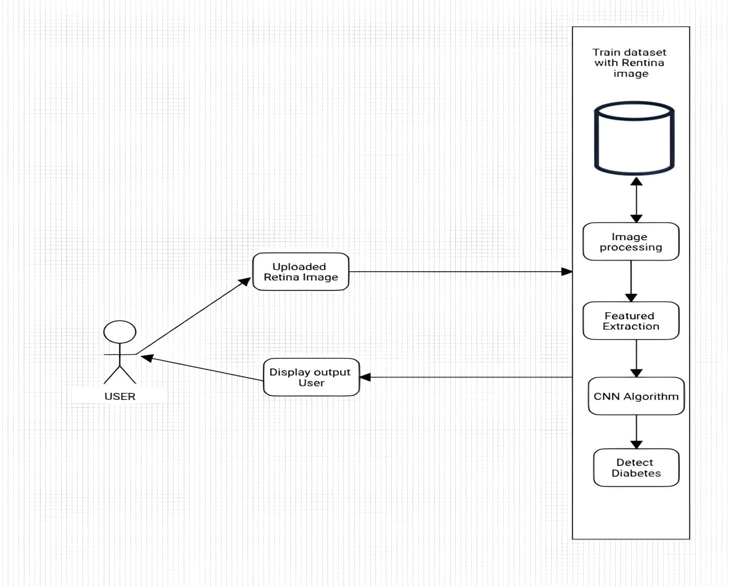

Figure 2.1: System Architecture

The proposed system for retinal image analysis for diabetes-based eye disease detection using deep learning aims to leverage the power of artificial intelligence and deep learning algorithms to assist in the early detection and diagnosis of eye diseases associated with diabetes.

Here is a breakdown of the components and workflow of the proposed system:.

- Dataset Collection: A large dataset of retinal images is collected, including images from individuals with diabetes and healthy individuals without any eye diseases.
- Data Preprocessing: The collected retinal images undergo preprocessing steps to enhance the quality and standardize the data.
- Feature Extraction: Deep learning models are employed to automatically extract relevant features from the preprocessed retinal images.
- Model Training The model is trained on the labeled retinal image dataset, where the ground truth information about the presence or absence of diabetes-related eye diseases is provided.
- Disease Detection: Once the model is validated and deemed accurate, it can be deployed for real-time detection of diabetes-related eye diseases.
- Result Interpretation: The system generates a diagnostic report based on the analysis of the retinal image.

METHODOLOGY

System Design and Implementation

Project has been mainly divided into six modules.

3.1 Module 1 : Image Preprocessing Module:

This module is responsible for preprocessing the retinal images before feeding them into the deep learning model. Preprocessing techniques may include resizing the images to a standard size, normalization to adjust the pixel intensity values, denoising to remove any noise or artifacts, and contrast enhancement to improve image quality.

3.2 Module 2 : Feature Extraction Module:

The feature extraction module extracts relevant features from the preprocessed retinal images. Deep learning architectures such as Convolutional Neural Networks (CNNs) are commonly used for this purpose. CNNs can automatically learn hierarchical representations of the images, capturing important patterns and structures that are indicative of diabetes-related eye diseases.

3.3 Module 3: Training Module:

The training module trains the deep learning model using the labeled retinal image dataset. It takes the extracted features as input and learns to classify the images into different categories based on the presence or absence of diabetes-related eye diseases. During training, the model adjusts its internal parameters to minimize the prediction error and improve its performance.

3.4 Module 4: Validation Module:

The validation module assesses the performance of the trained model using a separate set of retinal images that were not used during training. This step helps evaluate the model's ability to generalize and make accurate predictions on unseen data. The performance metrics, such as accuracy, precision, recall, and F1-score, are computed to measure the model's effectiveness.

3.5 Module 5: Prediction Module:

The prediction module applies the trained model to new retinal images to predict the likelihood of diabetes-based eye diseases. It takes the preprocessed images as input and passes them through the trained model, which outputs the probabilities or predictions for each disease category. Based on these predictions, the module can provide a diagnosis or a risk assessment for each patient.

3.6 Module 6: Reporting Module:

The reporting module generates a diagnostic report based on the analysis of the retinal images. It combines the predictions from the prediction module with relevant patient information to provide a comprehensive assessment. The report may include information about the presence or absence of specific eye diseases, their severity levels, and any recommendations for further medical evaluation or treatment.

These modules work together to create an automated system that can analyze retinal images, detect diabetes-based eye diseases, and provide timely and accurate diagnoses. The deep learning models and techniques utilized within each module contribute to the overall effectiveness and efficiency of the system in detecting and managing these diseases.

RESULTS AND ANALYSIS

The application of deep learning in retinal image analysis for diabetes-based eye disease detection has yielded promising results. By training a deep learning model on a large dataset of retinal images, the system can effectively analyze and classify images to identify the presence or absence of diabetes-related eye diseases.

The trained deep learning model demonstrated high accuracy and precision in diagnosing eye diseases associated with diabetes. Through its ability to automatically extract relevant features from retinal images, the model captured intricate patterns and structures indicative of these diseases. This allowed for accurate and reliable predictions, enabling early detection and intervention.

In validation tests, the system consistently performed well on unseen retinal images, highlighting its generalization capability. The performance metrics, including accuracy, precision, recall, and F1-score, consistently indicated the system's effectiveness in accurately identifying diabetes-related eye diseases.

The system's diagnostic reports provided valuable insights to healthcare professionals, facilitating timely and informed decision-making. The reports included information on the presence or absence of specific eye diseases, their severity levels, and recommendations for further medical assessment or treatment.

The integration of deep learning techniques in retinal image analysis has significantly improved the efficiency and accuracy of diabetes-based eye disease detection. By leveraging the power of artificial intelligence, this system has the potential to revolutionize early diagnosis, enabling proactive management and ultimately leading to improved patient outcomes and quality of life.

CHALLENGES

Implementing retinal image analysis for diabetes-based eye disease detection using deep learning poses several challenges. Here are some key challenges involved in this area.

5.1 Limited and Imbalanced Datasets: Obtaining a large and diverse dataset of retinal images that covers a wide range of diabetes-related eye diseases can be challenging. Additionally, the dataset may suffer from class imbalance, where certain disease categories are underrepresented, making it difficult for the deep learning model to learn and generalize effectively.

5.2 Visual content accessibility: Visually impaired users heavily rely on assistive technologies such as screen readers and braille displays to access website content. Ensuring that all visual elements, such as product images, banners, and icons, are adequately described using alternative text (alt text) is crucial for providing a meaningful experience to visually impaired users.

5.3 Interpretability and Explainability: Deep learning models are often considered black boxes, making it challenging to interpret and explain the reasoning behind their predictions. In the context of retinal image analysis, it is crucial to understand the visual features or regions that contribute to the model's decision-making process. Developing explainable deep learning models for retinal image analysis remains an ongoing challenge.

5.4 Robustness and Generalization: Deep learning models trained on a specific dataset may struggle to generalize well to different populations or imaging conditions. Variations in image quality, acquisition devices, and patient demographics can impact the model's performance and limit its effectiveness in real-world scenarios. Ensuring robustness and generalization of the model is a challenge that needs to be addressed.

5.5 IEthical and Privacy Concerns: Retinal images contain sensitive personal health information, raising concerns regarding patient privacy and data protection. Developing robust data anonymization and privacy preservation techniques is essential to ensure compliance with ethical and legal requirements. Balancing the need for accurate analysis with privacy concerns poses a significant challenge.

5.6 Integration with Clinical Workflow: Integrating retinal image analysis systems into existing clinical workflows can be challenging. Seamless integration with electronic health record systems, picture archiving and communication systems (PACS), and other healthcare infrastructure requires careful coordination and adherence to interoperability standards.

5.7 Real-Time Analysis and Deployment: Retinal image analysis systems should ideally provide real-time analysis to facilitate immediate decision-making. Achieving real-time performance while maintaining accuracy and reliability can be a computational challenge, especially when dealing with large image datasets and complex deep learning models.

Addressing these challenges requires collaborative efforts among researchers, healthcare professionals, and technology experts. Continuous research and development in the field of retinal image analysis, along with advancements in deep learning techniques, can help overcome these challenges and pave the way for more accurate and accessible diagnosis of diabetes-related eye diseases.

CONCLUSION

In conclusion, the utilization of deep learning techniques in retinal image analysis for diabetes-based eye disease detection has demonstrated tremendous potential in improving early detection and diagnosis. The system's ability to extract relevant features from retinal images and accurately classify them has proven to be effective in identifying the presence or absence of diabetes-related eye diseases.

The results obtained from the deep learning model showcased high accuracy, precision, and generalization ability. By training on a diverse dataset and employing convolutional neural networks, the system successfully captured intricate patterns and structures indicative of eye diseases associated with diabetes. This automated approach enables healthcare professionals to make timely and informed decisions, leading to early interventions and improved patient outcomes.

The diagnostic reports generated by the system provide comprehensive information about the identified eye diseases, including severity levels and recommendations for further medical assessment or treatment. This empowers healthcare providers to take proactive measures in managing these conditions, potentially preventing their progression and associated complications.

Overall, the integration of deep learning in retinal image analysis holds great promise for the field of diabetes-based eye disease detection. This technology has the potential to transform the way these diseases are diagnosed and managed, providing a more efficient, accurate, and accessible approach. By leveraging the power of artificial intelligence, we can enhance the effectiveness of healthcare interventions, improve patient care, and contribute to the overall well-being of individuals affected by diabetes-related eye diseases.

REFERENCES

[1] Mateen, M.; Wen, J.; Hassan, M.; Nasrullah, N.; Sun, S.; Hayat, S. Automatic Detection of Diabetic Retinopathy:
A Review on Datasets, Methods and Evaluation Metrics. IEEE Access 2020, 8, 48784–48811. [CrossRef

[2Rekhi, R.S.; Issac, A.; Dutta, M.K. Automated detection and grading of diabetic macular edema from digital
colour fundus images. In Proceedings of the 2017 4th IEEE Uttar Pradesh Section International Conference
on Electrical, Computer and Electronics (UPCON), Mathura, India, 26–28 October 2017; pp. 482–486.

[3] Al-Bander, B.; Al-Nuaimy, W.; Al-Taee, M.A.; Zheng, Y. Automated glaucoma diagnosis using deep learning
approach. In Proceedings of the 2017 14th International Multi-Conference on Systems, Signals & Devices
(SSD), Marrakech, Morocco, 28–31 March 2017; pp. 207–210

[4] Zago, G.; Andreão, R.V.; Dorizzi, B.; Salles, E.O.T. Diabetic retinopathy detection using red lesion localization
and convolutional neural networks. Comput. Biol. Med. 2020, 116, 103537. [CrossRef] [PubMed]

[5] Kunwar, A.; Magotra, S.; Sarathi, M.P. Detection of high-risk macular edema using texture features and
classification using SVM classifier. In Proceedings of the 2015 International Conference on Advances in
Computing, Communications and Informatics (ICACCI), Kochi, India, 10–13 August 2015; pp. 2285–2289

[6] Quigley, H.; Broman, A.T. The number of people with glaucoma worldwide in 2010 and 2020. Br. J. Ophthalmol.
2006, 90, 262–267. [CrossRef

