The Airborne Internet Technology using HALO
¹Sunkara Santhi Priya, ²Roja D
¹Assoc. Professor, Dept. of CSE, Chalapathi Institute of Technology, Guntur, AP, India
²Asst. Professor, Dept. of CSE, Chalapathi Institute of Technology, Guntur, AP, India

Abstract
The word on just about every Internet user's lips these days is "broadband." We have so much more data to send and download today, including audio files, video files and photos, that it's clogging our wimpy modems. Many Internet users are switching to cable modems and digital subscriber lines (DSLs) to increase their bandwidth. There's also a new type of service being developed that will take broadband into the air. In this paper, we'll learn about the future of the Airborne Internet. We'll take a look at the networks in development, the aircraft and how consumers may use this technology.

Land-based lines are limited physically in how much data they can deliver because of the diameter of the cable or phone line. In an airborne Internet, there is no such physical limitation, enabling a broader capacity. The airborne Internet will function much like satellite-based Internet access, but without the time delay. The airborne Internet will actually be used to compliment the satellite and ground-based networks, not replace them. These airborne networks will overcome the last-mile barriers facing conventional Internet access options.

This paper addresses some of the trends and issues involved in developing an Airborne Internet capable of achieving this goal. Understanding relationships between these trends and issues and the objectives and functional requirements of the program will allow various participants in this complex program to keep activities in proper perspective. The all-round development and improvement are the key areas of research work performed in this paper.

Key Words – Airborne, Broadband, HALO.

INTRODUCTION
Airborne Internet is a private, secure and reliable peer-to-peer aircraft communications network that uses the same technology as the commercial Internet. It is an implementation which connects aircraft to a ground-based Internet access node, including the information which is passed across this communication link. It provides airborne access to wealth of Internet information and resources. It is convenient and has several uses like flight planning, en route reservations, travel arrangements. It is useful in providing the information about weather, surrounding airspace environment and for aircraft-to-aircraft communications. The security applications include flight tracking/deviation monitoring, in-flight video monitoring, cockpit voice/video recording.

This Airborne Internet (A.I.) is an approach to provide a general purpose, multi-application data channel to aviation. In doing so, A.I. has the potential to provide significant cost savings for aircraft operators as it allows the consolidation of many functions into a common data channel. A primary application for A.I. is to track aircraft for the air traffic control system. Many other applications can utilize the same A.I. data channel. The applications available are only limited by the bandwidth available.
A.I. began as a supporting technology for NASA’s Small Aircraft Transportation System (SATS). But there is no reason that A.I. should be limited to SATS-class aircraft. All of aviation, and even transportation, has the potential to benefit from A.I. The principle behind the A.I. is to establish a robust, reliable, and available digital data channel to aircraft.

How does satellite Internet operate?
How do you access the Internet other than dial-up if you live too far from a phone company office for DSL and there is no cable TV on your street? Satellite Internet access may be worth considering. It's ideal for rural Internet users who want broadband access. Satellite Internet does not use telephone lines or cable systems, but instead uses a satellite dish for two-way (upload and download) data communications. Upload speed is about one-tenth of the 500 kbps download speed. Cable and DSL have higher download speeds, but satellite systems are about 10 times faster than a normal modem.
Firms that offer or plan to offer two-way satellite Internet include StarBand, Pegasus Express, Teledesic and Tachyon. Tachyon service is available today in the United States, Western Europe and Mexico. Pegasus Express is the two-way version of DirecPC.
Two-way satellite Internet consists of
- Approximately a two-foot by three-foot dish
- Two modems (uplink and downlink)
- Coaxial cables between dish and modem
The key installation planning requirement is a clear view to the south, since the orbiting satellites are over the equator area. And, like satellite TV, trees and heavy rains can affect reception of the Internet signals.

How the Airborne Internet Will Work
The word on just about every Internet user's lips these days is "broadband." We have so much more data to send and download today, including audio files, video files and photos, that it's clogging our wimpy modems. Many Internet users are switching to cable modems and digital subscriber lines (DSL’s) to increase their bandwidth. There's also a new type of service being developed that will take broadband into the air.
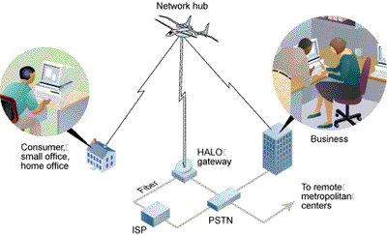
Photo courtesy Angel Technologies
This diagram shows how the HALO Network will enable a high-speed wireless Internet connection
At least three companies are planning to provide high-speed wireless Internet connection by placing aircraft in fixed patterns over hundreds of cities. Angel Technologies is planning an airborne Internet network, called High Altitude Long Operation (HALO), which would use lightweight planes to circle overhead and provide data delivery faster than a T1 line for businesses. Consumers would get a connection comparable to DSL. Also, Aero Vironment has teamed up with NASA on a solar-powered, unmanned plane that would work like the HALO network, and Sky Station International is planning a similar venture using blimps instead of planes. Now we’ll look at the networks in development, the aircraft and how consumers may use this technology at their homes.
The Net Takes Flight
The computer most people use comes with a standard 56K modem, which means that in an ideal situation your computer would downstream at a rate of 56 kilobits per second. That speed is far too slow to handle the huge streaming-video and music files that more consumers are demanding today. That's where the need for bigger bandwidth Broadband comes in, allowing a greater amount of data to flow to and from your computer. Land-based lines are limited physically in how much data they can deliver because of the diameter of the cable or phone line. In an airborne Internet, there is no such physical limitation, enabling a broader capacity.
Several companies have already shown that satellite Internet access can work. The airborne Internet will function much like satellite-based Internet access, but without the time delay. Bandwidth of satellite and airborne Internet access are typically the same, but it will take less time for the airborne Internet to relay data because it is not as high up. Satellites orbit at several hundreds of miles above Earth. The airborne-Internet aircraft will circle overhead at an altitude of 52,000 to 69,000 feet (15,849 to 21,031 meters). At this altitude, the aircraft will be undisturbed by inclement weather and flying well above commercial air traffic.
Networks using high-altitude aircraft will also have a cost advantage over satellites because the aircraft can be deployed easily -- they don't have to be launched into space. However, the airborne Internet will actually be used to compliment the satellite and ground-based networks, not replace them. These airborne networks will overcome the last-mile barriers facing conventional Internet access options. The "last mile" refers to the fact that access to high-speed cables still depends on physical proximity, and that for this reason, not everyone who wants access can have it. It would take a lot of time to provide universal access using cable or phone lines, just because of the time it takes to install the wires. An airborne network will immediately overcome the last mile as soon as the aircraft takes off.
The airborne Internet won't be completely wireless. There will be ground-based components to any type of airborne Internet network. The consumers will have to install an antenna on their home or business in order to receive signals from the network hub overhead. The networks will also work with established Internet Service Providers (ISPs), who will provide their high-capacity terminals for use by the network. These ISPs have a fiber point of presence -- their fiber optics are already set up. What the airborne Internet will do is provide an infrastructure that can reach areas that don't have broadband cables and wires.
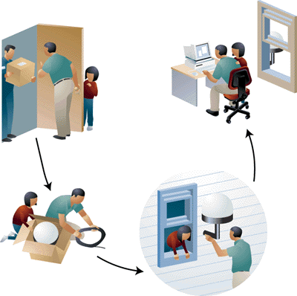
Photo courtesy Angel Technologies
Airborne-Internet systems will require that an antenna be attached to the side of your house or work place.
In the next three sections, we will take a look at the three aircraft that could be bringing you broadband Internet access from the sky.

Compare/Contrast to ground based internet
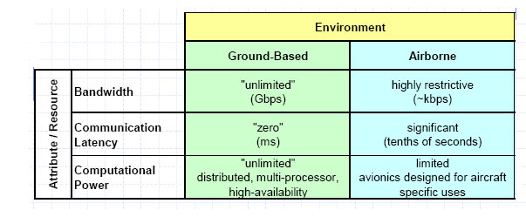
IMPLEMENTATION SYSTEMS
A HALO Overhead
The Angel Technologies is developing an air borne internet network through its HALO Network. The centerpiece of this network is the Proteus plane, which will carry wireless networking equipment into the air.
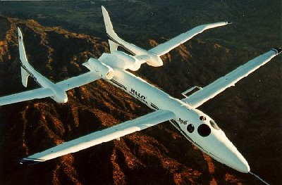
Photo courtesy Angel Technologies
The Proteus plane will carry the network hub for the HALO Network.
The Proteus plane,developed by Scaled Composites is designed with long wings and the low wing loading needed for extended high-altitude flight. Wing loading is equal to the entire mass of the plane divided by its wing area. Proteus will fly at heights of 9.5 and 11.4 miles (15.3 and 18.3 km) and cover an area up to 75 miles (120.7 km) in diameter.

Proteus Aircraft
Weight | 9,000 pounds at takeoff  5,900 pounds empty
Wingspan | 77 ft 7 inches (23.7 m)  Expandable to 92 feet (28 m)
Length | 56.3 ft (17.2 m)
Height | 17.6 ft (5.4 m)
Engines | 2 turbofan engines  2,300 pounds of thrust
Range | 18 hours
Speed | 65 knots (75 mph/120.7 kph)  to 250 knots (288 mph/463.5 kph)
At the heart of Angel's Proteus plane is the one-ton airborne-network hub, which allows the plane to relay data signals from ground stations to workplaces and homes. The AI network hub consists of an antenna array and electronics for wireless communication. The antenna array creates hundreds of virtual cells, like mobile-phone cells, on the ground to serve thousands of users. An 18-foot dish underneath the plane is responsible for reflecting high-speed data signals from a ground station to your computer. Each city in the HALO Network will be allotted three piloted Proteus planes. Each plane will fly for eight hours before the next plane takes off and after takeoff it will climb to a safe altitude, above any bad weather or commercial traffic, and begin an 8-mile loop around the city.
Floating On Air
Sky Station International is counting on its blimps,in the race to deliver high-speed Internet access from high altitudes and calls them as lighter-than-air platforms, and plans to station these airships,one over each city. Each station would fly at an altitude of 13 miles (21 km) and provide wireless service to an area of approximately 7,500 square miles (19,000 square km).
Sky Station Blimp
Diameter | 203 ft (62 m)
Length | 515 ft (157 m)
Width | approx. 300 ft (91 m)
Power | Solar and fuel cells
Each blimp will be equipped with a telecommunications payload to provide wireless broadband connections. The blimps will be able to carrying payloads of up to about 2,200 pounds (1,000 kg). Each blimp will have a life span of about five to 10 years. Sky Station says that its user terminals will enable broadband connections of between 2 and 10 megabits per second (Mbps).
NASA's Sub-space Plans:
NASA is also playing a role in a potential airborne Internet system being developed by AeroVironment.
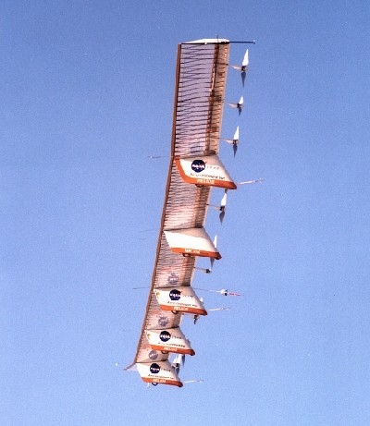
Photo courtesy NASA
The Helios aircraft will be equipped with telecommunications equipment and stay airborne for six months straight.

Helios Aircraft
Weight | 2,048 pounds (929 kg)
Wingspan | 247 ft (75.3 m)
Length | 12 ft (3.7 m)
Wing Area | 1,976 square ft (183.6 m²)
Propulsion | 14 brushless, 2-horsepower,  direct-current electric motors
Range | 1 to 3 hours in prototype tests  6 months when fully operational
Speed | 19 to 25 mph (30.6 to 40.2 kph)

The Helios prototype is constructed out of materials such as carbon fiber, graphite epoxy, Kevlar and Styrofoam, covered with a thin, transparent skin. The main pole supporting the wing is made out of carbon fiber, and is thicker on the top than on the bottom in order to absorb the constant bending during flight. The wing's ribs are made of epoxy and carbon fiber. Styrofoam comprises the wing's front edge, and a clear, plastic film is wrapped around the entire wing body. The all-wing plane is divided into six sections, each 41 ft (12.5 m) long. A pod carrying the landing gear is attached under the wing portion of each section. These pods also house the batteries, flight-control computers and data instrumentation. Network hubs for AeroVironment's telecommunications system would likely be placed here as well.
It seems that airborne Internet could take off in the very near future. If and when those planes and blimps start circling to supplement our current modes of connection, downloading the massive files we've come to crave for entertainment or depend on for business purposes will be a snap -- even if we live somewhere in that "last mile."
Why all this detail?
The rather lengthy and detailed explanation just provided is to illustrate how the use of IP can very dependably be relied on to deliver network communications. Aircraft use of communication and navigation information must be nearly real time, highly dependable and it must have backup redundancy. IP has inherent redundancy in its digital delivery system, making it an excellent candidate for aircraft use. The reason IP has never been used in an aircraft context before is because until now there has not been a method proposed to keep the aircraft connected to the network, so that the IP connection is never lost. Now it is appropriate to examine how aircraft currently operate so we can draw both analogy and cite the differences between present day aircraft “networks” and an IP based aviation network (Airborne Internet).
Roadmap of future activities
We intend to continue applying the methodology defined above to develop Airborne Internet alternatives, analyze the advantages and disadvantages of each alternative and arrive at a recommendation. Then, working with other SATS organizations we will refine the architecture and document it for use by system developers. Key elements of the architecture will be prototyped and evaluated to better understand their applicability to SATS. Estimates of performance and cost will be made. A separate security assessment will be produced.

Conclusion
Thus this airborne internet technology has a wide range of utilities in the field of aviation services like aircraft monitoring and air traffic management, weather information etc., and also provides an opportunity for the passengers to access the internet at very high altitudes that is, in the aeroplanes and other conventional services. Thus it is a further new trend in this mobile world which is establishing the connectivity by building network in the air.

References:

- Vellela, S.S., Balamanigandan, R. Optimized clustering routing framework to maintain the optimal energy status in the wsn mobile cloud environment. Multimed Tools Appl (2023). https://doi.org/10.1007/s11042-023-15926-5
- "MOBILE RFID APPLICATIONS IN LOCATION BASED SERVICES ZONE", International Journal of Emerging Technologies and Innovative Research (www.jetir.org | UGC and issn Approved), ISSN:2349-5162, Vol.10, Issue 6, page no. ppd851-d859, June-2023, Available at : http://www.jetir.org/papers/JETIR2306410.pdf
- Vellela, S. S., Reddy, B. V., Chaitanya, K. K., & Rao, M. V. (2023, January). An Integrated Approach to Improve E-Healthcare System using Dynamic Cloud Computing Platform. In 2023 5th International Conference on Smart Systems and Inventive Technology (ICSSIT) (pp. 776-782). IEEE.
- VenkateswaraRao, M., Vellela, S., Reddy, V., Vullam, N., Sk, K. B., & Roja, D. (2023, March). Credit Investigation and Comprehensive Risk Management System based Big Data Analytics in Commercial Banking. In 2023 9th International Conference on Advanced Computing and Communication Systems (ICACCS) (Vol. 1, pp. 2387-2391). IEEE.
- Vellela, S. S., & Balamanigandan, R. (2022, December). Design of Hybrid Authentication Protocol for High Secure Applications in Cloud Environments. In 2022 International Conference on Automation, Computing and Renewable Systems (ICACRS) (pp. 408-414). IEEE.
- Vellela, S. S., Basha Sk, K., & Yakubreddy, K. (2023). Cloud-hosted concept-hierarchy flex-based infringement checking system. International Advanced Research Journal in Science, Engineering and Technology, 10(3).
- Rao, M. V., Vellela, S. S., Sk, K. B., Venkateswara, R. B., & Roja, D. (2023). SYSTEMATIC REVIEW ON SOFTWARE APPLICATION UNDERDISTRIBUTED DENIAL OF SERVICE ATTACKS FOR GROUP WEBSITES. Dogo Rangsang Research Journal UGC Care Group I Journal, 13(3), 2347-7180.
- Vullam, N., Vellela, S. S., Reddy, V., Rao, M. V., SK, K. B., & Roja, D. (2023, May). Multi-Agent Personalized Recommendation System in E-Commerce based on User. In 2023 2nd International Conference on Applied Artificial Intelligence and Computing (ICAAIC) (pp. 1194-1199). IEEE.
- Sk, K. B., & Vellela, S. S. (2019). Diamond Search by Using Block Matching Algorithm. DIAMOND SEARCH BY USING BLOCK MATCHING ALGORITHM", International Journal of Emerging Technologies and Innovative Research (www. jetir. org), ISSN, 2349-5162.
- Vellela, S. S., Balamanigandan, R., & Praveen, S. P. (2022). Strategic Survey on Security and Privacy Methods of Cloud Computing Environment. Journal of Next Generation Technology (ISSN: 2583-021X), 2(1).
- Vellela, S. S., & Krishna, A. M. (2020). On Board Artificial Intelligence With Service Aggregation for Edge Computing in Industrial Applications. Journal of Critical Reviews, 7(07), 2020.
- Madhuri, A., Jyothi, V. E., Praveen, S. P., Sindhura, S., Srinivas, V. S., & Kumar, D. L. S. (2022). A New Multi-Level Semi-Supervised Learning Approach for Network Intrusion Detection System Based on the ‘GOA’. Journal of Interconnection Networks, 2143047.
- Madhuri, A., Praveen, S. P., Kumar, D. L. S., Sindhura, S., &Vellela, S. S. (2021). Challenges and issues of data analytics in emerging scenarios for big data, cloud and image mining. Annals of the Romanian Society for Cell Biology, 412-423.
- Praveen, S. P., Sarala, P., Kumar, T. K. M., Manuri, S. G., Srinivas, V. S., &Swapna, D. (2022, November). An Adaptive Load Balancing Technique for Multi SDN Controllers.In 2022 International Conference on Augmented Intelligence and Sustainable Systems (ICAISS) (pp. 1403-1409).IEEE.
- Sk, K. B., Roja, D., Priya, S. S., Dalavi, L., Vellela, S. S., & Reddy, V. (2023, March). Coronary Heart Disease Prediction and Classification using Hybrid Machine Learning Algorithms. In 2023 International Conference on Innovative Data Communication Technologies and Application (ICIDCA) (pp. 1-7). IEEE.
- SRINIVAS, V. S., PUSHPALATHA, D., SARATHKUMAR, G., KAVITHA, C., & HARSHITHKUMAR, D. ADVANCED INTELLIGENCE HEALTH INSURANCE COST PREDICTION USING RANDOM FOREST.
- D, Roja and Dalavai, Lavanya and Javvadi, Sravanthi and Sk, Khader Basha and Vellela, Sai Srinivas and B, Venkateswara Reddy and Vullam, Nagagopiraju, Computerised Image Processing and Pattern Recognition by Using Machine Algorithms (April 10, 2023). TIJER International Research Journal, Volume 10 Issue 4, April 2023, Available at SSRN: https://ssrn.com/abstract=4428667
- Sk, K. B., Vellela, S. S., Yakubreddy, K., & Rao, M. V. (2023). Novel and Secure Protocol for Trusted Wireless Ad-hoc Network Creation. Khader Basha Sk, Venkateswara Reddy B, Sai Srinivas Vellela, Kancharakunt Yakub Reddy, M Venkateswara Rao, Novel and Secure Protocol for Trusted Wireless Ad-hoc Network Creation, 10(3).
- Venkateswara Reddy, B., Vellela, S. S., Sk, K. B., Roja, D., Yakubreddy, K., & Rao, M. V. Conceptual Hierarchies for Efficient Query Results Navigation. International Journal of All Research Education and Scientific Methods (IJARESM), ISSN, 2455-6211.
- Yakubreddy, K., Vellela, S. S., Sk, K. B., Reddy, V., & Roja, D. (2023). Grape CS-ML Database-Informed Methods for Contemporary Vineyard Management. International Research Journal of Modernization in Engineering Technology and Science, 5(03).
- Pratap, V. K. (2020). An Effective Automatic Automobile Safety Method Using AI and Convolutional Neural Network. International Journal for Innovative Engineering and Management Research, 9(09).
- Gajjala Buchi Babu, Mutyala Venu Gopal, Vellala Sai Srinivas, V. Krishna Pratap, Efficient Key Generation for Multicast Groups Based on Secret Sharing, (IJERA) ISSN: 2248-9622 www.ijera.com Vol. 1, Issue 4, pp.1702-1707.
- Karthik, J. V., & Reddy, B. V. (2014). Authentication of secret information in image stenography. International Journal of Computer Science and Network Security (IJCSNS), 14(6), 58.

