**COMPASSIONATE AUTO-INTEGRATION OF DESIGN ENTERPRISE**

**Mrs.S.Chandrakala, Ms.M.Gokila**

Assistant Professor, Department of MCA, Vivekanandha Institute Of Information and Management Studies, Tiruchengode, Tamilnadu, India

Student, Department of MCA, Vivekanandha Institute Of Information and Management Studies, Tiruchengode, Tamilnadu, India

**ABSTRACT**

The industrial sector is facing new challenges and increased competition nowadays, customer satisfaction depends on products, it can be achieved through efficient error control, as well as possible customization. To reach these objectives, one of the main components is efficient productivity, meaning machine availability needs to be maxed and not impacted by unplanned breakdowns, which mitigates wastage of money and time, and possibly quality issues on parts produced during the deteriorating phase of the machine. The industry will play an essential role, as it comes with new digital tools to improve productivity through real-time interactions from the digital world to the physical world. It is especially true with the maintenance policies, which are changing from corrective to planned ones from predictions of machine failures. We use the Condition-Based Maintenance (CBM) algorithm in these cases; they are based on data analysis to propose a health assessment of critical components, to predict future issues. In recent years, many types of research focused on these topics; however, few of them deal with the full scope of implementing practically this strategy in the industry, particularly in the automotive sector. Thus, this paper aims at predicting the fault that occurs in an industrial motor by using a condition monitoring algorithm and how it can be overcome efficiently.

**Keywords:** Error Handling, Increases Productivity, Time Consumption.

1. **INTRODUCTION**

The Condition-Based Maintenance (CBM) algorithm are based on data analysis to propose a health assessment of critical components, to predict future issues. In recent years, many types of research focused on these topics. However, few of them deal with the full scope of implementing practically this strategy in the industry, particularly in the automotive sector. Thus, this paper aims at predicting the fault that occurs in an industrial motor by using a condition monitoring algorithm and how it can be overcome efficiently.

1. **CONCEPT**

In general manufacturing industry facing a huge problem when it comes to predicting the problem at the initial stage, the problem is monitored manually, productivity decreases exponentially where a huge amount of time and money is wasted, by using condition monitoring we can find the problem prior in the machine and update the machine, by this productivity can be increased and reduce the maintenance is optimizing the secure monitoring of the machine. In general lower reliability means an increased cost of production or an inability to meet the required demand, except it may get very expensive.

By condition monitoring we can solve, if an organization has been operating with breakdown maintenance or regular planned maintenance, a changeover to condition-based maintenance can result in major improvements in plant availability and reduced costs.

**2.1 Objective**

* Condition monitoring eliminates the need to strip down equipment during annual overhaul.
* The equipment’s can also be used to assist in troubleshooting and to help identify failed components when breakdown does occur.
* Safety is improved by avoiding the development of dangerous situations that may be hazardous to personnel and other plant and equipment.
* Distribution of production schedules can be reduced by preventing unexpected breakdowns.
* By detecting faults before serious failure occurs, damage to the plant and equipment is reduced.
  1. **Purpose of System**
* It will reduce the difficulty on the fault occur in motor while using in industry.
* It will reduce the time consumption and increase the production growth.
* By this application we can easily find out the problem facing on the frequently running industries for 24 hours.

**3. SOFTWARE DESCRIPTION**

* **Front End :** Core Java, CSS, JS, Servlet
* **Web Application :** J2ee Frameworks, Hibernate
* **Back End :** MySQL 5.1

1. **MODULE DESCRIPTION**
   * + - * Customer
         * Operator
         * Controller
         * Manager
         * Admin

**3.1. Customer**

This Module is used to register first and logged in, to the module. The, need to register the user details and motor details to check the failure or prediction of the motor’s faults using the resource. When the customer registered, and then got approval from the admin side for the next process. Then the customer can check the status of the registered details about the process. Finally, the customer can check the motor details which are submitted for the prediction.

**3.2. Operator**

The operator module has to log in first and monitor the motor which is present. Then the operator makes the reading of the motor with the current live data of the motor in mechanical and electrical data. Then the data are loaded into the database for prediction maintenance. And the stored details are sent to the controller for the failure prediction. Then the operator confirmed that the customer's motor details are the same as the readings.

**3.3. Controller**

The controller module is logged in to the application. Then the controller checks the details which are sent by the operator about the motor reading details. After that, the controller finds which type of error or failure going to occur by applying the methods for finding the failure to motors. Then the identified failure of each motor detail is gets stored in the database and error details is sent, to the manager for further process.

**3.4. Manager**

The Manager module is logged in to the process. Then the manager checks the details, which are sent by the controller about the motor details. Then the manager finds and calculates the cost, pending process and time to repair the motor. Then they found details are sent to admin for the approval for the changing the motor. Later the manager is getting approval and the motor is changed or repaired.

**3.5. Admin**

The Admin module, the admin is going to log in to the process. And the admin is training data for finding the failure in the motor. Then the admin is getting the details about the motor conditions with every motor which is present in the company before the admin approves the customer or user who is registered for the process. Then the Manager sent details are checked with the details of time, cost and pending process. Admin is approved if need some change and message is sent to the Manager for the further process.

1. **SYSTEM ANALYSIS AND DESING**

**4.1. Use Case Diagram**

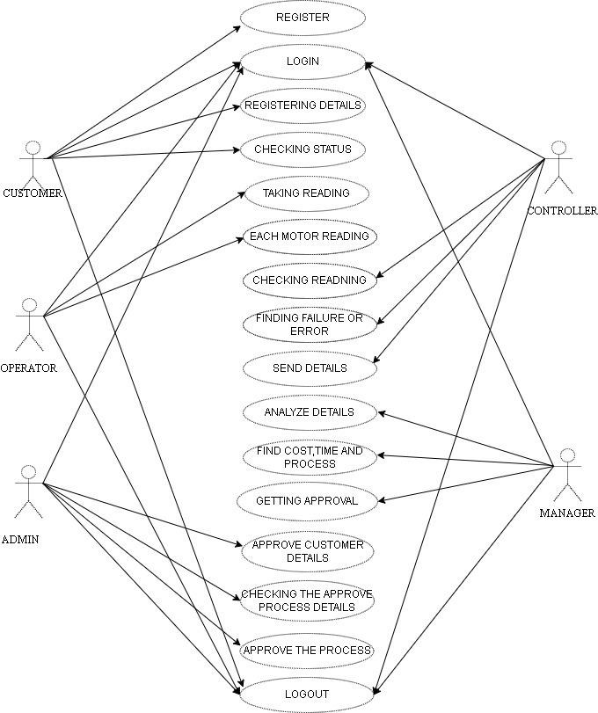

1. **SYSTEM TESTING**

**5.1. Unit Testing**

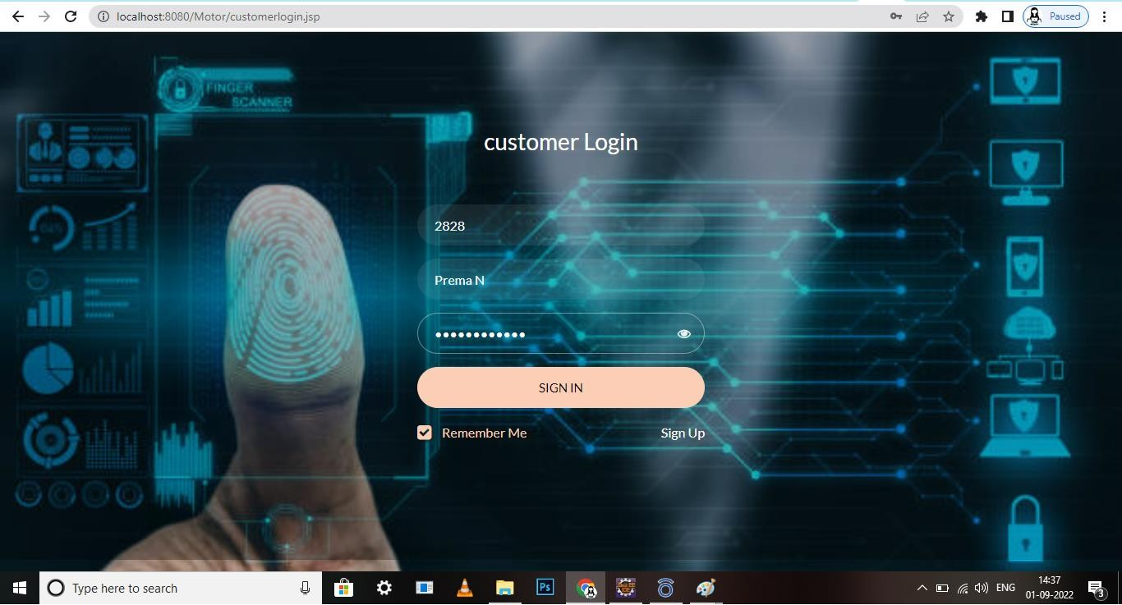Customer Login Form In this form, If we give wrong password it throws Exception handling error,we can’t login.

**5.2. Integration Testing**

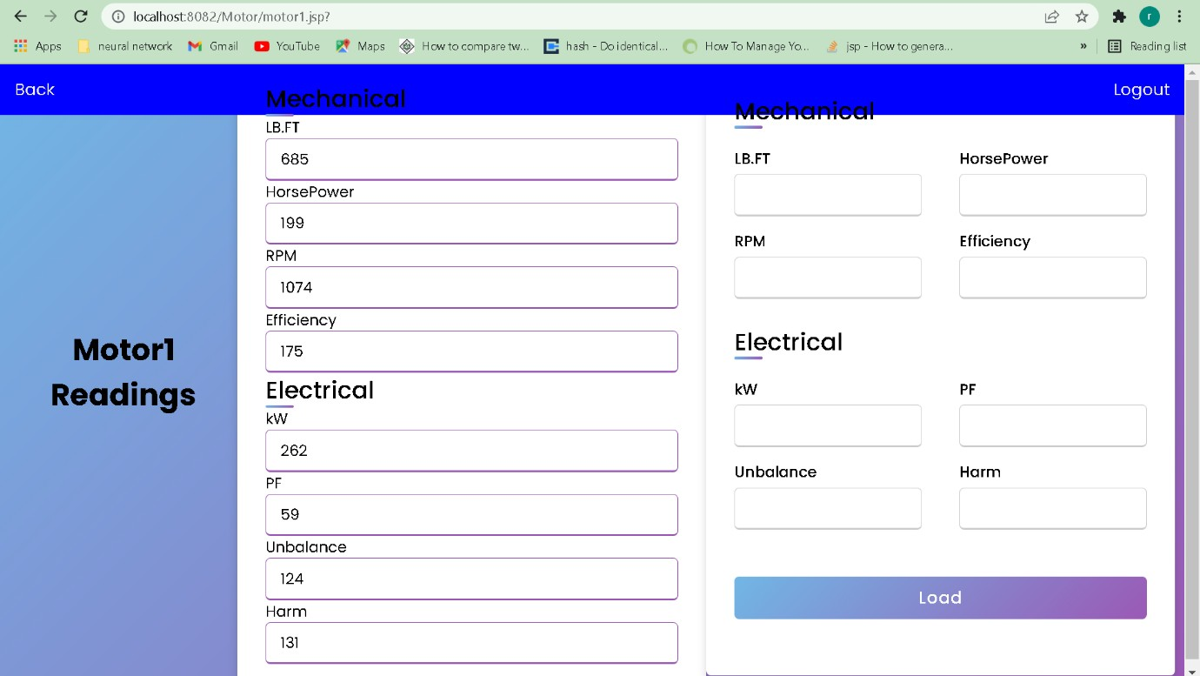Motor Readings to Check the Mechanical error and Electrical Error.

1. Report Mechanical error Status No Problem.
2. 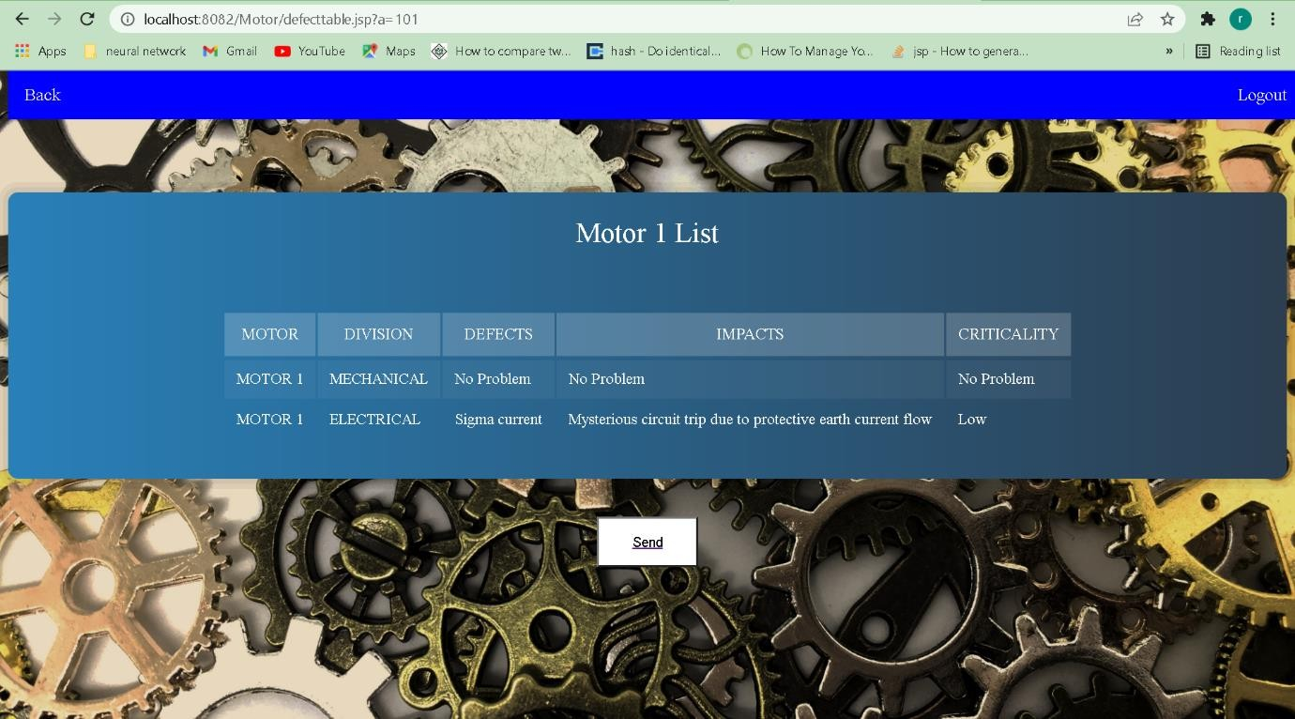Report Electrical error Status Low.

**3.3. Validation Testing**

In Register Form if we give User id as a string it Shows error.

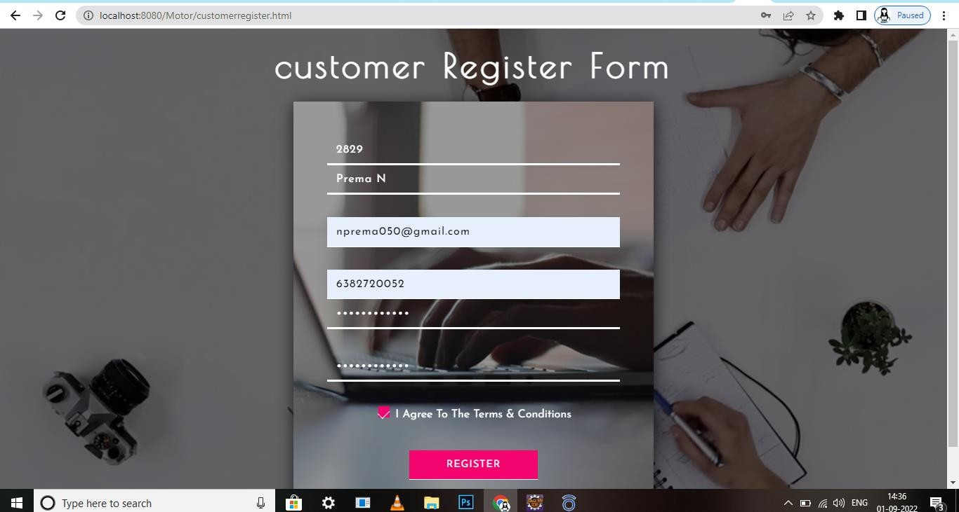

1. **CONCLUSION**

In the present work, we proposed a new methodology to determine the overall service efficiency. To achieve the value of the overall service efficiency there are three main areas under observation: the organization of the conduction monitoring services, the human resource affected to condition monitoring service, and the interface between condition monitoring service and other services within the organization. It was presented a real case study where the referred methodology was applied with the result. Continuously monitoring the condition of equipment and taking note of any irregularities that would normally shorten an asset's lifespan allows maintenance or other preventive actions to be scheduled to address the issue before they develop into more serious failures.

**REFERENCES**

1. G.Adomavicius and Y.Kwon, “New recommendation techniques for multicriteria rating systems,” IEEE Intelligent Systems, vol. 22, no. 3, 2007.
2. T. Arendt, E. Biermann, S. Jurack, C. Krause, and G. Taentzer, “Henshin: Advanced concepts and tools for in-place emf model transformations,” in Proc.13th Int. Conf.- Model Driven Engineering Languages and Systems, 2010, pp. 121–135.
3. J. Arlow and I. Neustadt, UML and the uniﬁed process: practical object-oriented analysis and design, 2nd ed. Addison-Wesley, 2005.
4. G.Bergmann, I.David, A.Hegedus, A.Horvath, I.Rath, Z.Ujhelyi, and D.Varro, “Viatra 3:a reactive model transformation platform,” in International Conference on Theory and Practice of Model Transformations. Springer, 2015, pp. 101–110.