**MENTAL HEALTH STATE DETECTION THROUGH INTEGRATION OF PULSE-BASED DEPRESSION, FACIAL EMOTION DETECTION AND SENTIMENTAL ANALYSIS**

**ALBIN JOHNSON *1, DEVIKA SATHEESH*2, PANCHAMI S*3, RIONS REJI*4 , JISHA C THANKAPPAN*5**

*5 Guide, Department of Computer Science and Engineering, College of Engineering Kidangoor , Kerala, India.

*1,2,3,4Student, Department of Computer Science and Engineering, College of Engineering Kidangoor , Kerala, India.

# ABSTRACT

Emotion recognition systems based on facial gesture enable real-time analysis, tagging, and inference of cognitive affective states from a video recording of the face.It is assumed that facial expressions are triggered for a time period when an emotion is experienced, and so emotion detection can be achieved by detecting the facial expression related to it. Out of all the major 6 emotions present,depression plays a vital role. Depression is classified as a mood disorder. It may be described as feelings of sadness,anger or loss that interfere with a person’s everyday activities. People experience depression in different ways. In certain cases, depression may lead to fatal cases. In order to avoid all of these, depression must be detected at the earliest and victim must be treated with appropriate remedies. The objective of the project is to analyse the emotion of a user using realtime video. This is achieved using Convolutional Neural Networks [CNN]. If the emotion is analysed as depression, then it has to be treated at the early stages. As the symptoms worsen, the mental ability of an individual goes out of control which leads to a disorder.

# INTRODUCTION

Health is a state of complete physical, mental, and social well-being and not merely the absence of disease or infirmity. Humans will simply focus on their physical health. Unfortunately, in many parts of the planet, mental state and mental disorders are not given similar importance as physical health. Rather they have been for the most part unnoticed or neglected. Psychological disorder, if not taken care of, will cause disability, permanent loss of memory, manipulation, or perhaps self-harm.

Modern society has made human life so busy, making it vulnerable to mental disorders like depression, anxiety etc. Psychological health proves a vital role on their overall personal and social life. Neglecting psychological problems results in rise of issues such as stress, anxiety, depression etc. Detection and controlling of these problems at the initial stages itself is necessary to achieve better mental health. So, an automated system is required that will pick out the people who are dealing with depression. A system proposed, captures frontal face videos, extracts the facial features from each frame and analyses these facial features to detect signs of depression in them. Sentiment analysis is a hot topic that’s been on research for decades. Sentiment analysis (SA) represents a computational study of opinions, sentiments, emotions, and attitudes expressed in texts or other media about a specific topic. An innovative solution to monitor and to detect potential users with emotional disturbances, based on the classification of sentences with depressive or stressed content can be done.

Depression is a disorder of impaired emotion regulation. It is an abnormal emotional state that affects our thinking, perceptions, and behaviour in pervasive and chronic ways. Depression does not necessarily branch out from a difficult or challenging situation, a loss, or a change of circumstance as a trigger. In fact, it often occurs in the absence of any such triggers. Depression is a common illness worldwide with 264 million people affected by it. When its long-lasting and with moderate or severe intensity, depression may lead to serious health condition. People tend to suffer a lot, and this creates an impact in their lives. They function poorly at work, school and at home. At its worst, depression can lead to suicide. Depending upon the severity of symptoms and its number, a depressive episode can be categorized as mild, moderate, or severe. The system aims at helping the basic investigation to detect the individual’s state of mind. This will save the doctor’s time being invested in preliminary tests. It has a wide range of applications like testing the mental health of students in school and colleges, assisting doctors in preliminary tests, testing mental stability in the organization, and also in the common public. It can also be used to aid the medical check-up for other related diseases. For e.g. stress and depression can also lead to a rise in blood pressure. Once tested that the mental health of an individual is not good, he shall be advised to visit a psychologist in person or through our website in virtual mode thereby reducing the risk of mental disorder at early stages.

# LITERATURE SURVEY

Carlos Busso, have done an analysis of Emotion Recognition using Facial Expressions. Two methods are used, decision level and feature level integration. A database of four emotions were used: sadness, anger, happiness, and the neutral state. facial movements were captured with motion capture, in conjunction with simultaneous recordings of speech. Result: The system based on facial expressions gave better performance than the system based on the audio information of the studied emotions. Also when the two methods are combined, the performance and robustness of the emotion recognition system improves significantly. The limitations are technological complexity, Security risks etc.

Jyoti Kumari discusses the Detection of mental disorders, and synthetic human expressions.The author provides a quick scan for facial expression recognition.A comparative study was also performed using various feature extraction techniques in the JAFFE dataset.Limitations: Analyzing facial expressions has a major drawback - humans can control the simulation to some extent, so recognition results may be falsified, intentionally or unintentionally.

Filippo La Paglia have done a Study in Obsessive-Compulsive Disorder (OCD) and Schizophrenic Patients using Psychometric Assessment Using Classic Neuropsychological and Virtual Reality Based Test. The author discovered that the assessment of neurocognitive functioning could be a crucial task in clinical settings.The author has done this study to judge the manager functions by scrutiny the evaluations obtained employing a psychology battery with the one obtained victimization the computer game version of the Multiple Errands check (V-MET).The study population enclosed 3 groups: ten patients stricken by neurotic Compulsive Disorder (OCD); ten Schizophrenic patients; ten healthy Controls.

Shaul Hammed have surveyed various Facial expression techniques. The steps of Facial expression recognition systems are:signal acquisition, Pre-processing, Extraction of features, selection of features and classification.

The various pre-processing are Noise reduction using filters; face detection by localising and extracting facial region; Normalisation of color & size of images; enhancement of image by Histogram Equalisation. The limitations is that CNN does not encode the position and orientation of the object into their prediction

# PROPOSED METHOD

The proposed system is derived using open CV and sentimental analysis. Two modules in open CV :

Heart Pulse rate

Facial Emotion Detection.

Heart rate extracted from facial skin color variation caused by blood circulation. Information is collected from the users face to detect pulse rate.

In facial emotion detection, it uses deep convolutional neural networks to classify emotion

detected on the face. Model is trained with the help of TensorFlow Image classifier.

In sentimental analysis which is done using questionnaire and a chatbot.

# METHODOLOGY

The system consists of 4 modules namely –

1) Pulse-based Depression detection

2) Facial Emotion Detection

3)Questionnaire

4)Chat Box(External Feature)

The output of all the models is combined and by further analysis ,the final outcome is given in the form of prediction of the user’s state of mind .

**1)Pulse-based Depression detection**

The heart pushes the blood to every part of the body and to the head particularly (towards the brain), so it changes the color and opacity of the skin. These changes can be detected by analyzing the average red or green component of the frames, taken from the camera. We learned the above concepts to be able to understand the different filters required to develop the said application. The analysis is done using the following approach:

1. Spatial filtering

Pyramid multiresolution decomposition of the video sequence; This is done to extract features/structures of interest, and to attenuate noise.

1. Time domain filtering.

Performing time domain bandpass filtering on the images of each scale to obtain several frequency bands of interest; This is done using Fourier transform.

3.Amplify the filtering result

The signal of each frequency band is differentially approximated by Taylor series, and the result of linear amplification is approximated; Using Euler amplification.

4.Composite image

The amplified image is synthesized.

It uses Open CV to search out the situation of the user’s face, then isolates the forehead region. Information is collected from this location over time to estimate the user’s rate, this is often done by measurement average optical intensity within the forehead location, within the sub image’s inexperienced channel alone (a higher color mixture quantitative relation could exist; however, the blue channel tends to be noisy). Physiological information is calculable in this manner due to the optical absorption characteristics of (oxy-) Hb.

With better lighting and lowest noise, a stable heartbeat ought to be isolated in about fifteen seconds, an alternative physiological waveform (such as Mayer waves) ought to be visible within the information stream. Once the user’s rate has been calculable, the period of time section variation related to this frequency is additionally computed. This permits for the heartbeat to be exaggerated within the post-process frame rendering, inflicting the highlighted forehead location to pulse incorrect with the user’s heartbeat. There is support for the detection of multiple simultaneous people in a very single camera’s image stream, however, at any instant, only the data from one face is extracted for analysis.

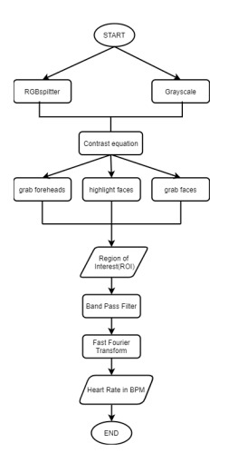

Implementing the above principle using a simple method shown in Figure :

1) RGBsplitter and Grayscale with contrast equations helps in detecting the face , aligning and highlighting it.

2) Region of Interest (ROI) is obtained using the technique of facial landmarks.

3)Then applying band pass filter as a threshold with fl = 0.8 Hz and fh = 3 Hz, which are 48 and 180 bpm respectively.

4) After calculating the mean color value of ROI in each frame, provide it to a data buffer which is 150 in length.

5)Fast Fourier Transform (FFT) the data buffer, the greatest peak is nothing but Heart Rate. The heart rate of an individual is scaled to an integer value from 0-3 using this Table.

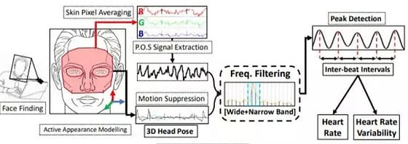

**SCALED VALUE FOR HEART RATE**

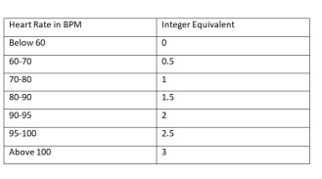

**2) Facial Emotion Detection**

The steps of Mental Health Monitoring system using Facial recognition are:

1. Face Detection

2. Feature extraction -Eye Extraction, Eyebrow Extraction and Mouth Extraction

3. Facial Emotion Recognition

4. Mental State Detection

1.FACE DETECTION

The input to the system is the Human Face, which can be captured using a web cam. This image undergoes image enhancement, where tone mapping is applied to images with low contrast to restore the original contrast of the image.

2.FEATURE EXTRACTION

The facial image obtained from the face detection stage forms an input to the feature extraction stage. To obtain real time performance and to reduce time complexity, for the intent of expression recognition, only eyes and mouth are considered.

• Eye Extraction 5 The eyes display strong vertical edges (horizontal transitions) due to its iris and eye white. Thus, the Sobel mask is applied to an image and the horizontal projection of vertical edges can be obtained to determine the Y coordinate of the eyes.

• Eyebrow Extraction Two rectangular regions in the edge image which lies directly above each of the eye regions are selected as the eyebrow regions. The edge images of these two areas are obtained for further refinement. Now Sobel method was used in obtaining the edge image since it can detect more edges than roberts method. These obtained edge images are then dilated and the holes are filled. The result edge images are used in refining the eyebrow regions.

• Mouth Extraction The top, bottom, right most and left most points of the mouth are extracted and the centroid of the mouth is calculated.

3.FACIAL EMOTION RECOGNITION

An emotion matrix is constructed with a discrete set of values. The rows and columns represent the extent of each motion in the person. These values set a range that determines the permutations of different emotions.

4.MENTAL STATE DETECTION

The emotions recognized are stored in a data frame and monitored over a period of time. Depending on the persistence and repetition of the emotions, the mental state of the person is detected. Further a psychology test is taken up to evaluate the severity of the clinical condition.

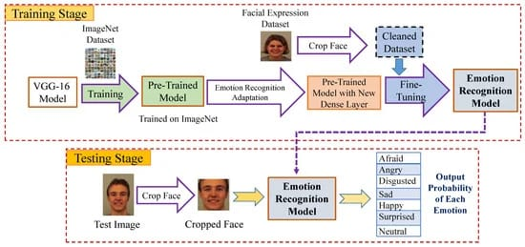

The first thing is to collect the dataset. The model is trained and build on the FER-2013[10] data set available on Kaggle. This dataset contains face images with seven emotions- Angry, Disgusted, Sad, Neutral, Happy, Very Happy and Joyful. It is a three-step process to implement it. The first step is the implementation of OpenCV HAAR CASCADES. The “Frontal Face Alt” Classifier is used for detecting the presence of Face in the Webcam. The Second step is Training the Network with the help of the TensorFlow Image Classifier. The Third step is Running the trained model. The algorithm is described in the proposed solution in depth. Using OpenCV, the face is detected, then by using dlib, the face landmarks are then extracted. Also the HOG features are extracted and inputs the raw image data with the face landmarks hog into a convolutional neural network as shown in Figure.

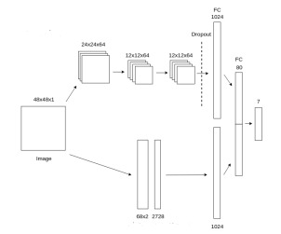

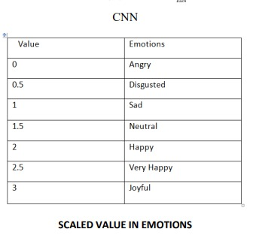

The output in the form of label is obtained and then converted into an equivalent integer for

using the information from above Table.

# 3) QUESTIONNARE

# EVALUATION OF PSYCHOMETRIC

# The term psychometrics refers to the design and interpretation of tests that measure psychological values such as aptitude, ability, personality, memory, happiness and intelligence. These tests are designed for, and given in, mental health, education and employment settings. In this project, we measure the IQ value and the personality traits of the person. Hans Eysenck’s personality test is used to measure personality based on three dimensions Psychoticism, Extraversion and Neuroticism (PEN). Personality disorders like depression, anxiety, dissociation, positive and negative, Agreeableness and Openness, Neuroticism, Psychoticism etc. can be detected and preventive measures can be addressed at the early stage itself.

# The questionnaire forms the part of rule-based learning technique where 10 questions were selected after research which is mostly used by psychological doctors to check the state of mind of an individual. The questions are in an MCQ format and have three answers. The answers have been given a predefined range from (0- 3). Based on the answers to the question by an individual, the value is given. The sum of values from 10 questions is then averaged to get the final result. The final value will be in the range of 0-3 and the values are rounded off to the nearest half value. E.g., if the value is 1.37 it will be round off to the nearest half value that is 1.5. Now this final value from Questionnaire module will be used in further Analysis as shown in Table for deducing the mental state of an individual

# 4) CHATBOT (EXTERNAL FEATURE)

# The bot forms the part of Context based learning. Now, the bot was developed using dialog flow, which again checks the individual’s state of mind but the process is different from the questionnaire. The bot’s responses are programmed in such a way as to reflect properly on the user’s chat and understand clearly what the user’s intention is and proceed with that intention in its responses. In this, the answers given by the user is split into word by word. The responses are then converted into words. All the unnecessary words like (the, it) are removed and the responses are trimmed and cut short. Now using sentimental analysis on data from twitter, reviews, and web crawling, a bag of words is created which consists of both positive and negative words. This bag of words acts as a trained dataset that is useful for deducing sentiment from the user’s chat. The modified response from the user is checked with the bag of words. Since we are concerned with finding the mental state of an individual, we focus on the negative words rather than positive. A word count for negative words is created as seen in Table. The total no of word count for negative words from each sentence is obtained and the final value is obtained in the form of integer from range of 0-3.

# 

# This value will then be used as shown in table for predicting final result.

# RESULT

# FINAL RESULT IS

|  |  |  |  |  |
| --- | --- | --- | --- | --- |
| Pulse based detection | Facial emotion detection | Questionare | Average | Emotion |
| 2.5 | 2 | 2 | 2 | HAPPY |
| 2 | 2.5 | 2.5 | 2.5 | VERY HAPPY |
| 1.5 | 1 | 1 | 1 | SAD |
| .5 | 1 | .5 | 0.5 | DISGUST |

# CONCLUSION

# The main contribution of the proposed system is developing an experimental model for successfully identifying stress at multiple levels. This proposed system uses python packages to give accurate results for our research on pulse rate, facial emotion-based system along with psychometric tests such as IQ and PEN to evaluate the problem solving capability and the nature of users character in this world and if the user is facing some mental disturbance, they are provided with relevant suggestions so that they can change their view in the things they face and try be happy in all the situations. The proposed system can be enhanced to detect more disorders. Also, the system can be enhanced to help doctors, counsellors, therapists to identify and detect stress in patients using the framework. The proposed system can also be made into a complete software for the companies to identify their employees mental health on a daily basis

# REFERENCES

[1] G. D. Costa, ”Optical remote sensing of heartbeats,” Optics Communications, vol. 117, pp. 395-398, 6/15/ 1995.

[2] [5]K. Humphreys, T. Ward, and C. Markham,” Noncontact simultaneous dual wavelength photoplethysmography:noncontact pulse oximetry,” Rev Sci Instrum, vol. 78, p. 044304, Apr 2007.

[3] W. Verkruysse, L. O. Svaasand, and J. S. Nelson, ”Remote plethysmographic imaging using ambient light,” Optics express, vol. 16, pp. 21434-21445, 2008

[4] PawełTarnowski, Marcin Kołodziej, Andrzej Majkowski, Remigiusz J. Rak,Emotion recognition using facial expressions,Procedia Computer Science,Volume 108,2017,Pages1175-1184,ISSN 1877- 0509,https://doi.org/10.1016/j.procs.2017.05.025.

[5] Kaj Sparle Christensen, Per Fink, Tomas Toft, Lisbeth Frostholm, Eva Ørnbøl, Frede Olesen, A brief case-finding questionnaire for common mental disorders: the CMDQ, Family Practice, Volume 22, Issue 4, August 2005, Pages 448–457, <https://doi.org/10.1093/fampra/cmi025>

[6] Ogunsemi, O. O., Oluwole, F. A., Abasiubong, F., Erinfolami, A. R., Amoran, O. E., Ariba, A. J., Alebiosu, C. O., & Olatawura, M. O. (2010). Detection of mental disorders with the Patient Health Questionnaire in primary care settings in Nigeria. Mental illness, 2(1), e10.https://doi.org/10.4081/mi.2010.e10.

[7] Preamble to the Constitution of WHO as adopted by the International Health Conference, New York, 19 June - 22 July 1946.