# Rendering Reality: A Study on Physically Based Render Engines

**AKASH AJI*1, AKSHAYA K.S*2, HARIKRISHNAN H*3, WILLIAM REJI*4,**

**ALPHA MATHEW*5**

*5 Guide, Department of Computer Science and Engineering, College of Engineering Kidangoor , Kerala, India.

*1,2,3,4Student, Department of Computer Science and Engineering, College of Engineering Kidangoor , Kerala, India.

# ABSTRACT

Photorealism and physics simulation is an actively researched topic in computer science. This project aim to further advance the optimizations obtained by the eazy engine that is a research based engine, that implemented PBR and include realism and physic simulations that are considered to cutting edge. The basic premise of the project is to implement physics based real time simulation that are generated through real time data that is provided by the user, This would produce more real looking and physics accurate models that can be used for medical purposes and fluid simulations further creating accurate physics model. PBR is a computer graphic approach looks to render images in a way that models the flow of light in real world. It highlights the limitations of traditional rendering techniques and emphasizes the need for more physically accurate approach. PBR is applied in different domains such as gaming, virtual reality and architectural visualization.

# INTRODUCTION

Physical Based Rendering(PBR) is a rendering technique widely used in computer graphics to create realistic and visually accurate images.It aims to simulate the behaviour of light in realworld,taking into account the physical properties of materialsand the interaction between light and surfaces.PBR provides a more accurate representation of how light interacts with different materials,resulting in more believable and visually appearing renderings.Traditional rebdering techniques rely on approximations,which can lead to unrealistic and inconsistent results.On the other hand,PBR is the grounded in the principles of physics that helps in creating more accurate,realistic and predictable rendering outcomes.PBR ensures that materials in virtual scene respond realistically to lighting condition.Another key aspect of PBR is integration of environment lighting and image based lighting techniques.These captures the environment and accurately represents its contribution in the illumination of the scene.This allows more convincing lighting and shading effects.Overall,PBR offers a powerful and flexible approach to rendering that enables the creation of visually stunning and realistic computer generated imagery.

# LITERATURE SURVEY

The [1] 3D Math Primer For Graphics And Game Development, Authors Fletcher Dunn, Ian Parbey. Approaches from introductions of vectors and matrix to the advanced quaternion operations and their demonstrations for their use in graphics.Description of book,that is written to familarize the modern mathmatics behind rendering and image processing for graphical applications,Familarizes the reader form the basics to advance mathmatic behind the renderer and systems that are in place at the moment,

sample programs and library to show how potential implementations can be done.Doesn't use fpu or

accelerated arithemetic processors for faster mathematical operations.

The [2] Introductions To Algorithms, Authors Cormen, Leiserson, Rivest, Stein. Approaches familiarizing the thought process behind every algorithmic thinking and the relavant generic data structures that are used in the library's api.Description about the book, that currently acts the fundamental basics for every modern algorithms and data structures and their thinking introductions to the core algorithmic thinking,introduction to generic data structures.Quite old and fails to account for newer and faster methods

The [3] Game Engine Architecture,Author Jason Gregory. Approaches to the study of popular engines that are out in the market and their corresponding architecture , as an unbiased outside viewer with accesss to source.Information and review of popular game engines and their feature with potential improvements and their implementations quirks.Covering the basics of software architecture and their implementations.Fails to educate on the process or the architecture that the decision was made for or influenced by.

Various 3D libraries currently offer rendering of high fidelity visuals. Here we compare against the most widely used ones.

## Meshlab

Meshlab is an open-source, advanced 3D mesh processing software .It offers tools for mesh cleaning and repair .Is a versatile and powerful tool for working with 3D meshes. Its functionality can be accessed either through the graphical user interface (GUI) or the provided scripting interface. This makes Meshlab difficult to integrate into current Python or C++ projects. In contrast, EasyPBR offers both a Python package that can be easily imported and a shared library that can be linked into an existing C++ project. EasyPBR also integrates with libigl (Jacobson et al.,2018), allowing the user to access powerful tools for geometry processing. Additionally, EasyPBR offers more realistic renderings of meshes together with functionality for creating high-resolution screenshots or videos.

## Blender

Blender (Blender Online Community, 2018) is an open-source 3D creation suite. It includes all aspects of 3D creation, from modeling to rendering and video editing; and it offers a Python API, which can be used for scripting. However, the main usage of Blender is to create high-quality visuals through ray-traced rendering, which is far from real-time capable. The Python API is also not the main intended use case of Blender, and while rendering commands can be issued through scripts, there is no visual feedback during the process. In contrast, we offer real-time rendering and control over the scene from small Python or C++ scripts.

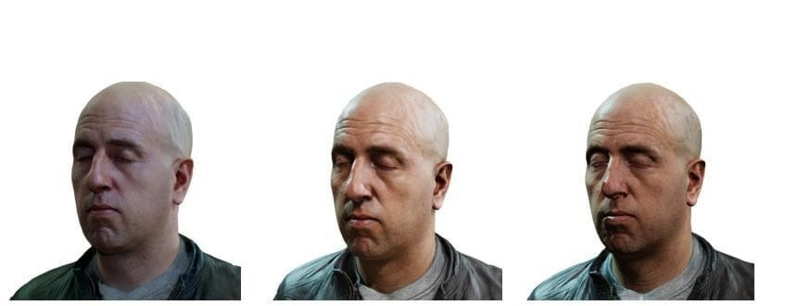

a)Marmoset b)PBR c)VTK

Figure[1]Comparison of various PBR rendering tools(Ref. Paper Easy PBR-Radu Alexandra Rosu and Sven Behenke)

## VTK

VTK (Schroeder et al., 2000) is an open-source scientific analysis and visualization tool.Is an open-source software library widely used for scientific and data visualization, image processing, and 3D graphics. It provides a comprehensive set of tools and algorithms for visualizing and analyzing data in various domains. Extensions of the main rendering model with new techniques is cumbersome as it requires extensive knowledge of the VTK framework. In contrast, our rendering methods are easy to use .

## Marmoset

Marmoset toolbag (Marmoset, 2020) is a visual tool designed to showcase 3D art.Real-time rendering and texture baking software used in the game development and computer graphics industry. It is primarily known for its high-quality rendering capabilities and its ability to create visually stunning and realistic real-time graphics.It features a realtime PBR renderer, which allows easy setup of a scene to create high-quality 3D presentations. However, it is not available on Linux and is also distributed under a paid license.

## Unreal Engine

Unreal Engine (Epic Games, 2007) is a state-of the-art engine created with the goal to provide real time high-fidelity visuals. It has been used in professional game-making, architecture, visualisation and VR experiences. While it provides a plethora of tools for content creation, the entry barriers can also be quite high. Additionally, the Python API provided can only be used as an internal tool for scripting and results in cumbersome setup code for even easy importing of assets and rendering. In contrast, EasyPBR acts as a Python library that can be readily imported in any existing project and used to draw to screen in only a couple of lines of code.

Overall, PBR stands out for its physically accurate simulation of light and material properties, resulting in more realistic and visually appealing renderings compared to traditional shading models or specialized rendering techniques. While other rendering techniques have their specific applications and advantages, PBR has become widely adopted in various industries due to its ability to achieve high-quality results in a broad range of rendering scenarios.

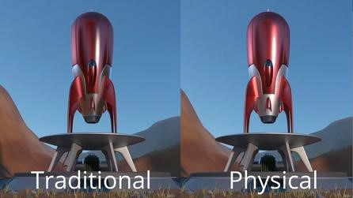

Figure [2]Comparison of Old style rendering vs PBR.(Reference from the Modo 901 spotlight series)

# METHODOLOGY

Our project aims to further advance the optimizations obtained by the eazy engine that is a research based engine, that implemented PBR and include realism and physic simulations. The basic premise of the project is to implement physics based real time simulation that are generated through real time data that is provided by the user.

Proposed system shows all the modules in API specifies ways at the backend keeping track of its lifetime and use case. The frontend sees the properties and models as a graph which it traverses and renders based on priority. This would produce more real looking and accurate physics models that can be used for medical purposes.

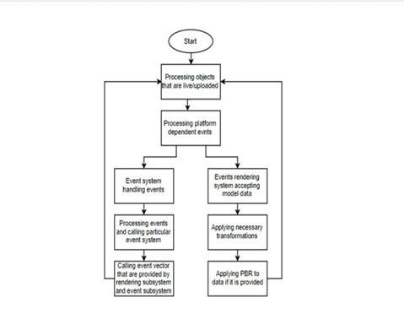

# ADVANTAGES

We have created an application that would produce more real looking and physics accurate models.

The application was setup with following feature advantages:

* a lightweight framework for real-time physically based rendering.

* More accurate physics model

•Easy to use.

# CONCLUSION

We presented PBR, a physically-based renderer with a focus on usability without compromising visual quality.PBR simplifies the rendering process by automatically choosing parameters to render a specific scene, alleviating the burden on user side. PBR is a rendering technique that aims to achieve realistic and visually accurate results by simulating the physical properties of light and materials. PBR has become increasingly popular in various industries, including game development, film production, architectural visualization, and product design. Its ability to produce high-quality and realistic renderings has made it a standard in modern rendering pipelines. PBR has revolutionized the way realistic graphics are created, providing a robust and efficient approach to rendering that delivers stunning visual results.

The future scope of this project are :

* More accurate physics model.

* More accurate scientific models.

* Better models that accurately simulates real life.

* Higher quality model generations and physic simulation.

# REFERENCES

[1] 3D Scan Store (2020). 3D scan store. https://www.3dscanstore.com/blog/Free-3DHead-Model. [2] Bavoil, L. and Sainz, M. (2008). Screen space ambient occlusion. http://developers.nvidia.com

1. Behley, J., Garbade, M., Milioto, A., Quenzel, J., Behnke,S., Stachniss, C., and Gall, J. (2019). SemanticKITTI:A dataset for semantic scene understanding of lidar sequences. In IEEE International Conference on Computer Vision (ICCV), pages 9297– 9307.
2. Droeschel, D., Schwarz, M., and Behnke, S. (2017). Continuous mapping and localization for autonomous navigation in rough terrain using a 3D laser scanner. Robotics and Autonomous Systems, 88:104–115.
3. Cignoni, P., Callieri, M., Corsini, M.,
4. Dellepiane, M., Ganovelli, F., and Ranzuglia, G.(2008). Meshlab: an open-source mesh processing tool. In Eurographics Italian Chapter Conference, volume 2008, pages 129–136.
5. Salerno.
6. Karis, B. (2013). Real shading in Unreal Engine 4. Proc. Physically Based Shading Theory Practice.
7. Reeves, W. T., Salesin, D. H., and Cook, R. L. (1987). Rendering antialiased shadows with depth maps. In 14th Annual Conference on Computer Graphics and Interactive Techniques, pages 283–291.
8. Epic Games (2007). Unreal Engine. https://www.unrealengine.com.