**Evaluation of Harmonic Improvement Using Fuzzy Logic based SAPF For a Grid Integrated Solar-PV System**

#1Praful Dange, *2 Vivek Kumar Koshta

#*Electrical & Electronics Engineering Department, , CIST, Bhopal

1prafuldange5@gmail.com

2vivekkoshta@yahoo.com

## ABSTRACT

*The renewable energy is seen as a solution against global warming & other environmental issues. A solar cell will provide maximum power at maximum power point (MPP). Moreover, the locus of MPP changes over a various range that depends on the PV array temperature & insolation intensity. The P&O based MPPT method is used to track MPP. This DC output voltage is inverted through into 3-phase AC and synchronised with AC grid. However these power electronic converters causes injection of harmonics in the system. Moreover, presence of non linear load in system will further inject harmonic current and as a consequence, there is a violation of IEEE-519-1992 limit. As a solution, fuzzy logic based Shunt Active Power Filter (FLC-SAPF) is proposed. The FLC-SAPF will keep THD below 5%. The effect of sudden change in non linear load and variation in solar insolation should also taken into consideration.*

*KEYWORDS*

***Solar-PV, Perturb and Observe, MPPT, Fuzzy Logic, Active Filter***

## INTRODUCTION

The highly increased demand of energy whose cost is less and concern for environmental issues, which leads to various problems like health hazards, acid rains etc. has shown interest in utilization of renewable sources of energy like solar energy. The non- ending, freely available as well as abundantly presence of solar energy can be easily converted into electrical energy. A PV structure with various benefits such as cost of maintenance is less, no moving or rotating parts, and a pollution-free energy conversion process. However, the demerits found in the PV source about its ineffectiveness at nights or when isolation is low and also during partial shading condition.

The initial high capital cost is another hurdle at the time of installation, of PV systems. The above demerits are not withstanding. The emergence of PV systems is very popular alternatives to conventional energy, thanks to the advancement in technology and favorable government policies in several countries. The challenging condition in application of PV as shown by P-V non linear Current–voltage [I–V] characteristics. Furthermore since its characteristics totally depends on various changing weather condition because of which a change in Insolation, temperature and partial shading. As the above parameters vary continuously thus variation occurs faster, so the MPP does the same, maintaining power at its maximum value Including cost of installation is high in case of PV source and low value of energy conversion and thus the efficiency is also reduced, it is suitable to operate, the PV system at its MPP value so that highest power is achieved.

A number of solutions exist to reduce the undesirable effects of harmonics. The most common and the conventional method is installing passive filters to remove the harmonic currents, which present a low cost solution, with certain limitations. Although enhancements in semiconductor device technology have led to an increase in the usage of modern harmonic polluter loads, they have also provided reliable solutions. In order to overcome the problems associated with traditional passive filters, active power filters (APF) have been developed in recent years. In this chapter, traditional method of harmonic filtering is briefly discussed; the basic operating principle of active power filters and their classification is highlighted. Indirect current control scheme for controlling of shunt active power filter is modeled.

## MAXIMUM POWER POINT TRACKER

Solar radiation when directly changed into electrical energy, obtained from cells of PV has a number of merits. A photo-voltaic [PV] module has non linear characteristics and its [P–V] quality study, makes clear that there is only one point, [P max] at which it delivers the maximum power. Depending on load variation, highest value of power is obtained and accordingly efficiency is optimized for transferring energy.



## Fig 1: Maximum power point tracker system

Tracking of highest power point [MPP] of a Solar PV array is usually an important for the PV system. There are various classic algorithms so that maximum power can be tracked they are constant voltage method, Hill climbing, Constant current ,Incremental conductance ,Perturb and observation etc specifically used is Inc and Perturb-and-observation [P&O] .The algorithms are dependent on technology, which regulates PV array’s voltage by maintaining optimal set point. Various methods have been developed & implemented. The above methods varies in its complexity, the kind of sensors, its working speed, its cost, to the range at which it efficiently, implementation of hardware, its popularity, and various other respect. Various other tracking schemes is brought. Among which the better option can be Perturb and observation [P&O] and Incremental conductance. This paper Solar PV system is modeled; and Perturb & observe based MPPT techniques are used so as to output obtained from solar system remains constant, so that it can be harnessed for various application. The performance of proposed system is judged under varying solar insolation and with impacts of loads. This analysis is so designed so that MPPT can achieve an optimal algorithm. This analysis is so designed to find out the most suitable method for MPPT in order achieve an optimal algorithm.

## FUNCTION OF MPPT

The nature of MPPT is mostly influenced by three factors of environmental changes. The quality of each cells of solar are chiefly influenced by –a)Insolation b)Temperature c) Partial criteria of shading. Their impacts like that of an environmental affects various factor which are shown under.



## Fig 2: Solar I–V and P–V curve (a) with different temperature insolation and (b) MPP for different Insolation



## Fig 3. (a) Operation of solar P-V under partial shading (b) P–V graph under same partial shading criteria

From fig 3(a) : Connected solar cell with its terminal V: V1 andV2, overall power P and total V Thus it is seen that all these time variant and environmental dependent factors shows a major contribution in the adjustments of the operation point or highest or maximum power point tracker [MPP] throughout the whole day. Its behavior i.e. high power point tracker is there to make a shift in the continuously varying operating point [P max] here PV module delivers highest power. Photons energy is defined on the wavelength and the frequency; also calculate it from the Einstein’s law, which is:

E = h*υ* (1)

E - energy of photon

h -Plank’s constant = 6.626×10 – 34 *Js*

*υ* -Photon frequency

Photon frequency Released electrons obtained by such process of a photo electric effect is known as photo electron. The amount of energy required for the releasing the valence electron, from the atom on which photon are collided is known a work out Wi and it defines on the kind of material on which all such process of “photo electric effect”, is being done. The process is as follow:

hv = Wi + Ekin Where, (2)

hv - Photon energy

Wi, - work out

Ekin - kinetic energy of emitted

## CHARACTERISTIC OF PHOTO-VOLTAIC CELL

The basic circuit diagram represents overall working of the MPPT method. It contains a current source which represents the photocurrent (I-ph) i.e. the current when solar radiation falls on the panel and current in diode,(I-d) which represents the saturation current in diode. It is that value of a current when solar radiation is absent on the solar panel. The load current value is kept at zero and output current flowing through the panel (I) and output voltage across the panel (Voc)is given as feedback signal to the MPPT.



## Fig 4: Equivalent circuit of photo-voltaic cell

Applying Kirchhoff’s law to the node where Iph, diode, RP and Rs meet, we get

|  |  |
| --- | --- |
| $$I=I_{ph}-I_{s}\left(\exp^{\frac{q\left(V+IRs\right)}{NKT}-1}\right)-(V+IR_{s})/R_{sh}$$ | **(3)** |
| $$I=n_{p}I_{ph}-n_{p}I_{s}\left(\exp^{\frac{q\left(V+IRs\right)}{(NKT)n_{s}}-1}\right)$$ | **(4)** |
| $${I_{d}=I}_{s}\left(\exp^{\frac{q\left(V+IRs\right)}{NKT}-1}\right)$$ | **(5)** |

Where RS = intrinsic sequence resistance, value is highly small, Rp = shunt/parallel resistance having high value, Iph = Isolation I, I = Cell I, Io = Reverse saturation I,V = Cell’s voltage, Vt is the Thermal voltage [KT/q], K =Boltzmann constant, T = Temperature (Kelvin), q = electron charge.

## PERTURB & OBSERVE [P&O] ALGORITHM

Solar cell power module changes continuously, in case of power increment, the perturbation will be continued in (same) as previous direction. The power will then at next step will decrease as soon as maximum power is attained, and after this perturbation will reverse. The algorithm starts oscillating around its highest point as soon as the steady value is reached. Size of perturbation is kept very small, thus power variation small. Even then this algorithm is important in mega service as it is simple. The algorithm can be understood from study of flow chart, which is shown below:



## Fig 5 : Flow chart of Perturbation and observation

## TABLE 1: FOR PERTURB & OBSERVATION METHOD

|  |  |  |
| --- | --- | --- |
| **Sign of dv** | **Sign of dp** | **Direction of next step.** |
| Positive | Positive | +C |
| Negative | Negative | +C |
| Negative | Positive | -C |
| Positive | Negative | -C |

## ACTIVE POWER FILTER

The modern APF technology uses IGBT based voltage source converter. With the progress in digital signal processors (DSPs), field programmable gate arrays (FPGAs) and availability of Hall Effect sensors and isolation amplifiers at low cost have forced researchers and designers to develop efficient control strategies for the APFs to solve harmonic related problems in the utility and industrial power systems. The operation principle of APFs is basically canceling the distorting harmonic currents by measuring them and generating a harmonic current spectrum in opposite phase to the measured current. Figure 6, shows the ideal source current when the shunt APF performs harmonic filtering of a diode rectifier. The injected shunt APF current completely cancels the current harmonics from the nonlinear load, resulting in a harmonic free source current.



Fig 6 Main Principle of Active Filtering

The compensation currents are generated via a pulse width modulated (PWM) converter including a dc link energy storage element ( Capacitor or Inductor) depending on the employed converter type. No additional supply is required for the dc link side; because a small amount of current at fundamental frequency is drawn from the supply to meet the APF losses so that the dc link voltage or current is kept constant. In addition to their basic principle of harmonic current compensation, active power filters are also used for elimination of voltage harmonics, reactive power compensation and load balancing depending on the type of the APF.

Fuzzy Logic Controller (FLC) is a technique to embody human-like thinking into a control system. FLC can be designed to emulate human deductive thinking, that is, the process people use to infer conclusions from what they know. FLC has been primarily applied to the control of processes through fuzzy linguistic descriptions. The idea behind Fuzzy Logic controller is to assimilate the experience and knowledge of human in the designing of a controller whose input-output relationships are described in a collection of Fuzzy control rules i.e. IF-THEN rules that involve linguistic variables. Fuzzy rules make the core of the speed regulator design, fuzzy logic control system is expressed by a series of linguistic description of expert knowledge that is often composed by conditional statements like "if ... then". To simplify the calculation triangular membership functions are used and all the membership functions are distributed symmetrically in the entire universe. The membership functions are so designed that they are more dense near the origin of the membership function, so that will help to improve the steady-state accuracy error, change in error and alpha membership function graph is shown in Fig 7.

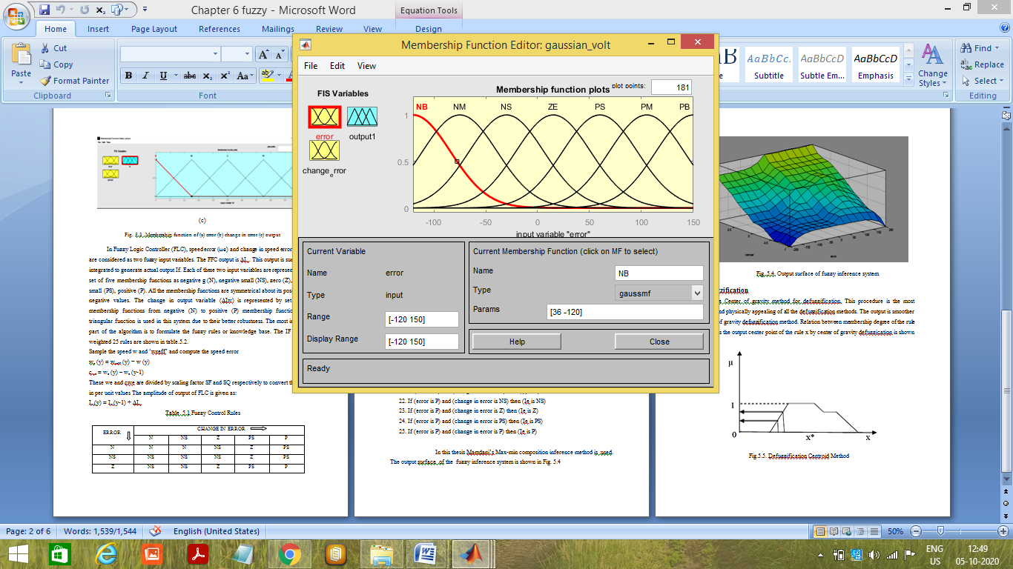

(a)

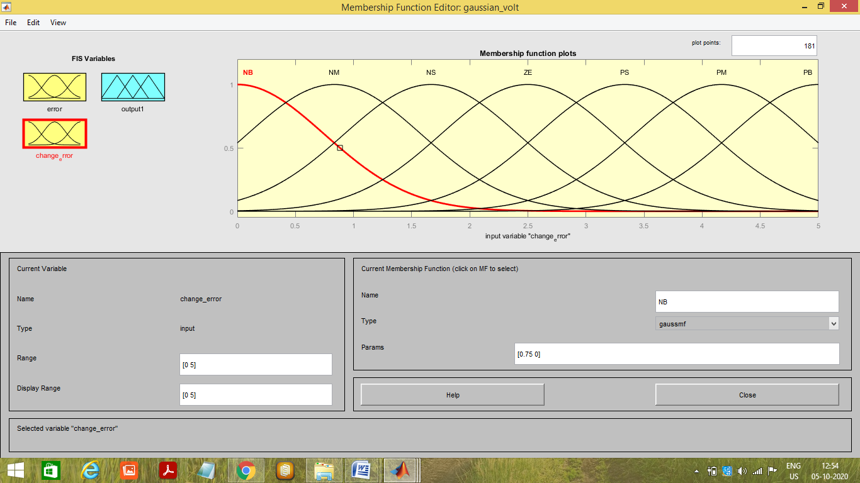

(b)

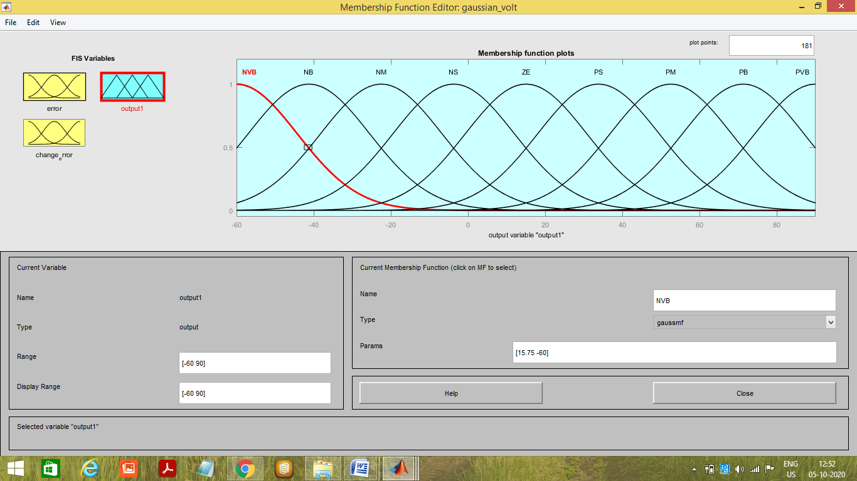

(c)

Fig. 7 Membership function of (a) error (b) change in error (c) output

In Fuzzy Logic Controller (FLC), speed error ($ωe$) and change in speed error (dwe/dt) are considered as two fuzzy input variables. The FFC output is ΔIw. This output is summed or integrated to generate actual output If. Each of these two input variables are represented by a set of five membership functions as negative g (N), negative small (NS), zero (Z), positive small (PS), positive (P). All the membership functions are symmetrical about its positive and negative values. The change in output variable (ΔIw) is represented by set of five membership functions from negative (N) to positive (P) membership functions. The triangular function is used in this system due to their better robustness. The most important part of the algorithm is to formulate the fuzzy rules or knowledge base. The IF –THEN weighted 25 rules are shown in table-1.

Sample the speed w and ‘wreff’ and compute the speed error

we (y) = wreff (y) − w (y)

cwe = we (y) – we (y-1)

These we and cwe are divided by scaling factor SF and SQ respectively to convert the signal in per unit values The amplitude of output of FLC is given as:

Iw(y) = Iw(y-1) + ΔIw

Table-1 Fuzzy Control Rules

|  |  |  |  |  |  |  |  |
| --- | --- | --- | --- | --- | --- | --- | --- |
| ERROR | CHANGE IN ERROR | | | | | | |
| NB | NM | NS | ZE | PS | PM | PB |
| NB | NVB | NVB | NVB | NB | NB | NB | NM |
| NM | NB | NB | NB | NM | NM | NM | NS |
| NS | NM | NM | NM | NS | NS | NS | ZE |
| ZE | NS | NS | NS | ZE | PS | PS | PS |
| PS | ZE | PS | PS | PS | PM | PM | PM |
| PM | PS | PM | PM | PM | PB | PB | PB |
| PB | PM | PB | PB | PB | PVB | PVB | PVB |

## SIMULATIONS AND RESULTS

The PV array simulation model shown below in fig 8 Since the Irradiance effect is not constant all the time but do changes, therefore different Irradiance value is taken at 1000 w/m2,800 w/m2,600 w/m2 and again at 1000 w/m2.and the temperature constant is 25.

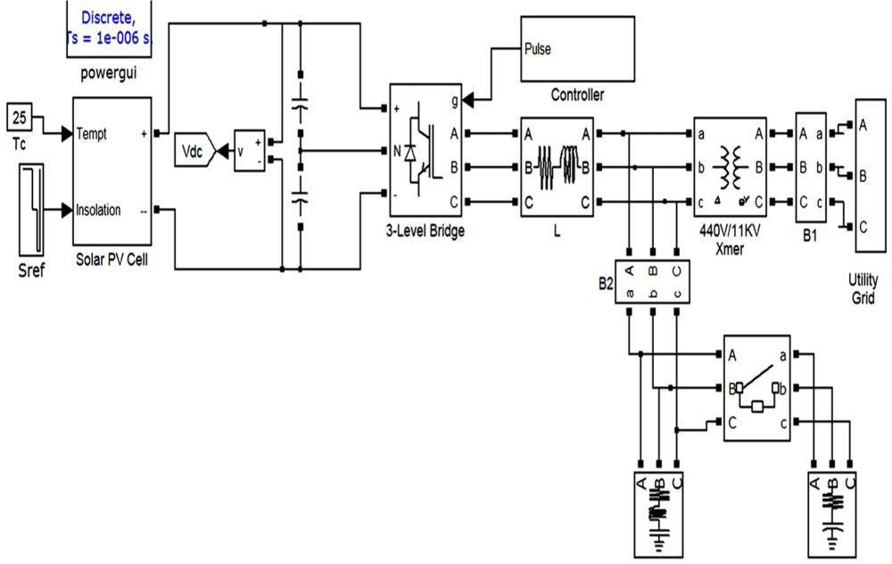

## Fig 8: Simulink model of Grid connected Solar PV system

The output obtained from Solar PV cell is fed into Inverter which then changes the Solar PV cell outut voltage into suitable AC voltage and frequency.A 33/11kv grid which is connected in parallel to the solar PV model, then 11kv voltage is stepped down to suitable voltage i.e 440 V .A load of 2kv connected intially and an additional load of 5kv is also connected by three phase circuit breaker.

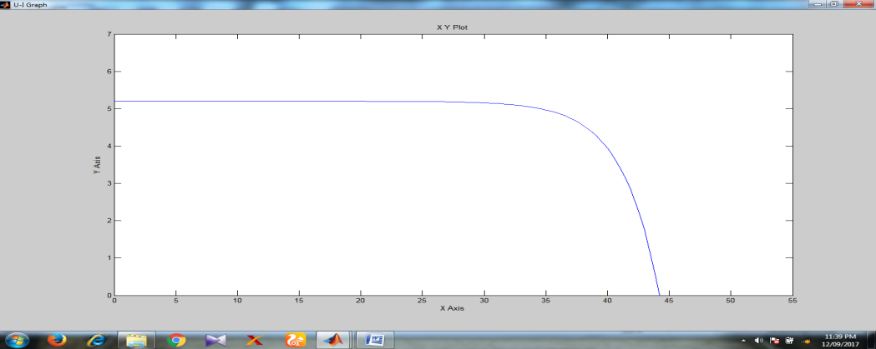

## Fig:9 P-V curve

Above shown PV curve shows that, MPPT always tracks maximum current though the voltage varies. The maximum voltage i.e VOC=44V. However the current is maintained at its maximum value i.e ISC =5.2A.

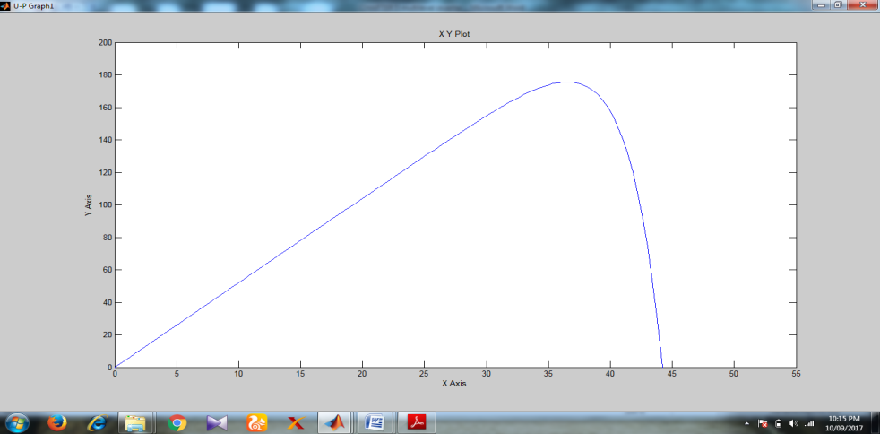

## Fig 10: I-V curve

Above figures shows that MPPT maintains maximum Power i.e (short circuit current) ISC= 170A, and VOC=44V. and power obtained is 5.2 KW

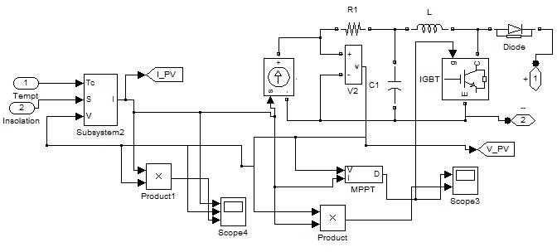

## Fig 11: Simulink model for Solar PV cell

Simulation model for Solar PV cell shown in fig 11, An input with Irradinace 1000 w/m2,800 w/m2,600 w/m2 and again at 1000 w/m2.and the temperature constant is 25. When Irradinace = 1000 w/m2,from 0 to 1 second PV voltage before MPPT is 40 V, and after MPPT it variates about 550 V. As irradince drops to 800 w/m2, (t)=1 to 1.5sec. Voltage also goes down by 38 V and after MPPT 600V. Further when Irradince reduced to 600 w/m2 from t=1.5 to 1.8 sec, Voltage before MPPT goes more down to 22V. But clearly Voltage after MPPT is still 600V. And as Irradince increased to 1000 w/m2 from 1.8 to 3 sec, Voltage before MPPT is increased with it and becomes 40V again, but after MPPT it is still maintained to 600V.



## Fig:12 Effect of solar Irradinace on the PV cell voltage before and after MPPT

Since Irradiance is 1000 watt/meter square, so the power 175 watt from 0 to 1 second, as Irr value lowers at 800 watt/meter square, and so the power drops to 148 watt, from 1 to 1.5 second, Similarly between 1.5 to 1.8 second power drops to75 watt, since irradinace goes down to 600 watt per meter square. Now again as Irr increases & reaches 1000 w/m^2 with time & so the power output also increases to 175 watt.



## Fig 13: Power obtained from PV cell

Fig. 14 shows the source voltage and source current waveform after compensation with Shunt active power filter. The dc link voltage Vdc and compensation current (Icomp) as drawn by SAPF is also shown in Fig. 14. The dc link voltage is settled to reference value of 750V.

Fig. 15 shows the harmonic spectrum analysis of supply current after compensation with SAPF being switched on at 0.3 sec. and insolation value of 1000W/m2. The total harmonic distortion of supply current is 2.96%, which is below the prescribed limit of 5% (IEEE 519-1992 standard).

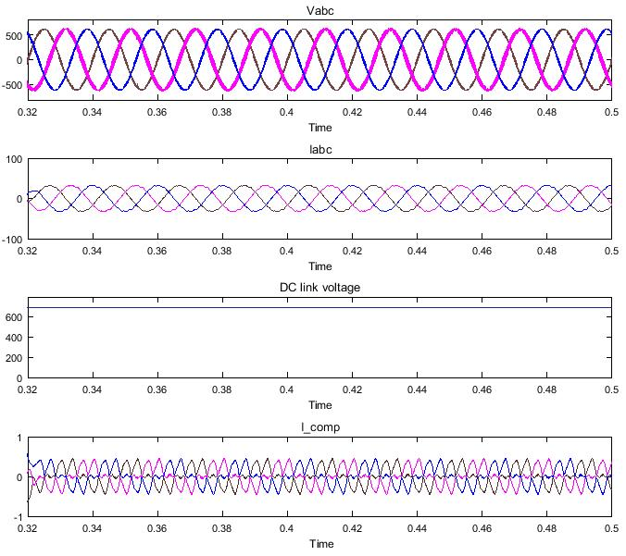

Fig 14 Source voltage (vabc), compensated source current (Iabc), dc link voltage (Vdc) and compensation current (Icomp) in steady state with SAPF and insolation 1000W/m2



Fig.15 Frequency spectrum of compensated source current insolation 1000W/m2

Fig. 16 shows the source voltage and source current for 800watt per meter square insolation waveform after compensation with Shunt active power filter, dc link voltage Vdc and compensation current (Icomp) as drawn by SAPF. The dc link voltage is settled to reference value of 750V.

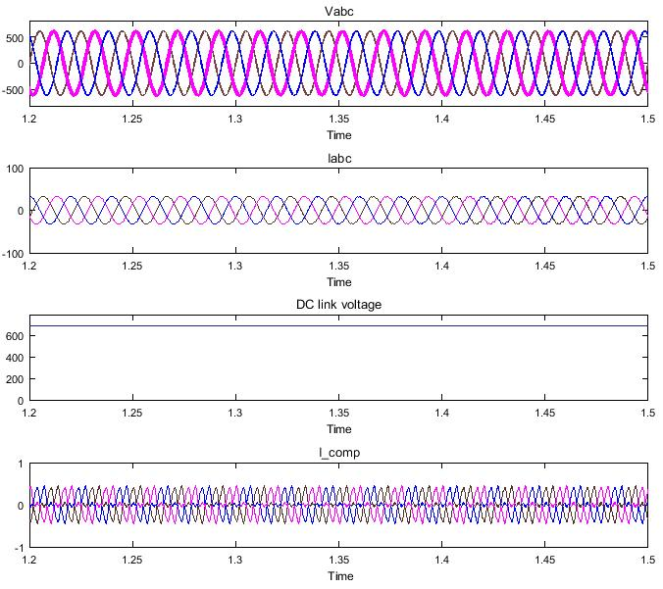

Fig 16 Source voltage (vabc), compensated source current (Iabc), dc link voltage (Vdc) and compensation current (Icomp) in steady state with SAPF and insolation 800W/m2



Fig.17 Frequency spectrum of compensated source current insolation 800W/m2

## CONCLUSION:

The perturb and observe based maximum power point algorithm is simulated under different loading condition with variation in solar radiations. When environmental conditions are constant or change slowly, the P&O based MPPT oscillates close to MPP accurately and give maximum output power in every condition. The Fuzzy based shunt active power filter is effective in mitigation of harmonics in grid connected PV system under variation in insolation.

## REFERENCES

1. Deepak Verma ,Savita Nema ,Shandhiya, Soubhaghya dash,’Maximum power point tracking(MPPT) techniques :Recaptulation of solar photovoltaic system. Jacob- James Nedumgat, Jayakrishna & K. B., Kothari D. P.,”Perturb &Observe MPPT Algorithm of a Solar PV Systems-Modeling &Simulation’’, IEEE conf. on Power electronics application in renewable energy,2013, pp. 1-6
2. R.K. Nema1, Savita Nema1, &Gayatri Agnihotri1,” Computer Simulation Based Study of Photovoltaic Cells /Modules &their Experimental Verification” International Journal of Recent Trends in Engineering, Vol 1, No. 3, May 2009.
3. Rajesh Kumar Nema*, Savita Nema &Gayatri Agnihotri,” Design, development &simulation of PC-based scheme

for characterization of solar photovoltaic modules”.

1. Vikas Khare, Savita Nema, Prashant Baredar,” Solar–wind hybrid renewable energy system: A review Renewable &Sustainable Energy Reviews 58(2016)23–33.
2. Pratik U. Mankar1 and2R.M. Moharil,” comparative analysis of thePerturb-and-observe &incremental Conductance mppt methods”,International Journal of Research in Engineering &Applied Sciences
3. William Christopher &Dr.R.Ramesh,” Comparative Study of P&O &InC MPPT Algorithms”, American Journal of Engineering Research (AJER) e-ISSN : 2320-0847 p-ISSN : 2320-0936 Volume-02, pp-402-408.
4. Ms. Sangita S. Kondawar1, U. B. Vaidya,” A Comparison of Two MPPT Techniques for PV System in Matlab Simulink”, International Journal of Engineering Research andDevelopment e-ISSN : 2278-067X, p-ISSN : 2278- 800X, www.ijerd.com Volume 2, Issue 7 (August 2012), PP. 73-79
5. Savita Nema, R.K.Nema, Gayatri Agnihotri, “ Matlab / simulink based study of photovoltaic cells / modules / array &their experimental verification”, IJEE journal, Volume 1, Issue 3, 2010 pp.487-500.
6. R. Belaidia, A. Haddouchea, H. Guendouza, “Fuzzy Logic Controller Based Three-Phase Shunt Active Power Filter for Compensating Harmonics and Reactive Power under Unbalanced Mains Voltages”, Energy Procedia 18 ( 2012 ) 560 – 570.

[10] Ayoub Benzahia, Rabhi Boualaga, Ammar Moussi, Laeid Zellouma, Memich Meriem, Bouziane Chaima, “ A PV powered shunt active power filter for power quality improvement”, Global Energy Interconnection, Volume 2 Number 2 April 2019 (143-149). DOI: 10.1016/j.gloei.2019.07.001

[11] Muhammad Kashifa, M.J. Hossaina, Fang Zhuob, Samir Gautam, “Design and implementation of a three-level active power filter for harmonic and reactive power compensation”, Electric Power Systems Research 165 (2018) 144–156.

[12] R. Mahanty, “Indirect current controlled shunt active power filter for power quality improvement”, Electrical Power and Energy Systems 62 (2014) 441–449.

[13] Sushree Diptimayee Swain, Pravat Kumar Ray, and Kanungo Barada Mohanty, “Improvement of power quality using a robust hybrid series active power filter” IEEE Transactions on Power Electronics, vol. 32, no. 5, pp. 3490-3498, May 2017.