**“Monitoring, Tracking the working and financial activities of SHG’s(Self Help Group)**

**Mrs. V.N.Waghchoure**

**Department of Computer Technology**

**K. K. Wagh Polytechnic, Nashik, India**

---------------------------------------------------------------------***----------------------------------------------------------------------------

**Abstract –** This project helps the organization which provided funds to the Self Help Groups (SHGs). In this project, we are monitoring and tracking the financial and working activities of SHGs from the state level to the ground level town. Here, we are helping the SHGs and our core concept is to help the SHGs with all their problems. We are developing a web-based application (portal) for the Self Help Groups. We are making this portal for the government authorities, organizations and NGOs which are providing Corporate Social Responsibility (CSR) funds for the SHGs. In India, there are many SHGs, however, the tracking and working status of these groups is not known. Therefore, the government and CSR groups can get an idea about the SHGs and plan different activities for the uplifting of SHG women. The person appointed by the organization (coordinator) can add the members by registering them in the group and can add all the information about bank linkages, monthly profit, monthly savings, producing and non-producing, etc. of the Self Help Group. There are more than 300,000 members in India in Self Help Groups.

***keywords****:*

Agency, Community development, Rural development, Self-help approach, social organisation

# Introduction

A Self-Help Group (SHG) is a group of approximately 20 individuals from a homogenous class who come together to address their shared problems. They promote voluntary thrift on a regular basis, pooling their resources to make

small, interest-bearing loans to members. This process helps them to understand the fundamentals of intermediation, prioritization of needs, setting and adhering to conditions, and accounting. This builds discipline and credit history for themselves, as the money involved in the lending operations is their own hard-earned funds, which they have acquired with great difficulty. They also learn to manage resources of a size that is much beyond their individual capacities. Once the groups demonstrate this mature financial behavior, banks are encouraged to make loans to the SHGs in certain multiples of the accumulated savings of the SHG. These bank loans are offered without any collateral and at market interest rates, as the members have developed a credit history. SHGs are small groups composed of female members (generally 20 members) living in a specific area, with the core skill set to produce a product either individually or in groups, and have begun their own business venture with the support of government agencies. The Government of India, through the state governments, is developing SHGs comprised of female members who are interested in taking up entrepreneurship to establish their own business ventures jointly as a group.

Over the years Indian banking system has made considerable outreach in rural areas. Almost half of the scheduled commercial bank branches are rural. Though rural banking has been able to make such progress, for a country whose 71% population lives in rural areas, it is still not sufficient. Access to financial services (especially credit) by the poor and vulnerable sections of the society is a prerequisite for poverty reduction and social empowerment. ‘Financial Inclusion’ as mandated by Reserve Bank of India (RBI) is defined as timely delivery of financial services to low-income groups and weaker sections at an affordable cost. Large sections of the rural population still lack access to even the most basic banking services. According to a Government of India report, 51.4% of farmer households in India out of a total of 89.3 million households do not have access to any credit (formal or informal). Also, only 27% of the farm households borrow from formal sources (of these one-third also borrow from informal sources). Due to lack of easy accessibility to formal financial sources there is a very high dependence on informal sources where interest rates could even be more than 100% per annum Providing financial services to rural poor is quite challenging since it is difficult to set up banking infrastructure in close proximity to villages due to difficulty of access, and also because of the high costs associated with lowvalue transactions. Moreover, the banking processes need to be simple with minimum documentation. Since conventional banks were not poised to meet such demands, the Self Help Group (SHG) – Bank Linkage Program was developed in India to link the un-banked rural population to the formal financial system. In principle, an SHG is a small group of rural poor belonging to the same locality and having similar social and economic background, who voluntarily come together to regularly save small amounts of money in a common fund to meet their emergency needs and improve their socio-economic status. MFIs use Business Correspondents (BCs) to extend banking services to SHG members in the hinterland, without setting up a brick-andmortar branch in rural areas. The SHG model has gained immense popularity in India, with nearly 100 million households accessing banking services via SHGs, worth more than a billion dollars in aggregate savings and loans

# Literature Survey

During the development of this project, we

read through papers. Shreeraj S S, Vishnu K. (2020)

Title: Empowerment of Women Self Help Groups: Human Centered Design of a Participatory IoT Solution. Description: Empowering women, is one of the major challenges experienced in several developing countries. This is majorly due to lack of education, minimal community engagement and less exposure to mobile phones and mobile applications, age difference, and varying skills. To address this issue, several women self-help groups have been formed worldwide to provide the opportunity for them to engage in several livelihood activities. This paper discusses one of the proposed design for the Internet

of Things based solution for empowering women in India. This solution is intended to be used by the rural cluster based organizations intended to work for the social and economic well-being of the rural community. This research details the requirements for empowering such rural community based organizations. Dr. R. Amudha (2014)

Title: Micro-insurance: A mechanism for women empowerment through Self Help Group linked LIC

Description: Micro finance is the process of formation of groups to support the poverty incapacitated people by extending money without any collateral security. Micro finance includes savings accounts, insurance products and credit provided to low income unbanked people to increase their economic status in the society. A micro-insurance policy may be a general or a life insurance and done through Non-Government organizations, Self-help groups and Micro-finance institutions. The main objective of this study is to find out the need for micro insurance among unbanked people and to find out whether micro insurance helps the unbanked people to enhance their livelihood.

Vikas Agarwal, Vikram Desai (2011) Title: Enhancing the Rural Self Help Group – Bank Linkage Program**.** Description: In this paper, we observe that mobile penetration, the ease with which rural population uses the voice interface, and acceptability of mobile related technologies, all bring us to the confluence of mobility and innovative interaction technologies that can help in designing a system for the next billion population. This system enables low cost financial services to be comprehended and adopted by the SHGs while empowering them to raise concerns and undertake active participation. This kind of empowerment of SHGs is unseen till date and can lead to, especially in case of women, better representation in elections of local panchayats, dowry upliftment and other social advancements**.** Mr V. Sivakumar . Title: Review on Financial Prospects and Problems of Women’s Self Help Groups (SHGs) with Special Reference. The studies have addressed the challenges faced by SHG members in different contexts. However, these studies have covered limited dimensions of challenges and are from researchers’ own perspectives only. A comprehensive study on inhibiting factors is still absent in the literature. Therefore, this study aims at systematically exploring a comprehensive set of challenges faced by SHGs in Odisha and recommending a roadmap to address these challenges. The literature on financial problems and prospects of women’s self help groups can be Classified under many categories. Tom Tom, Emmanuel Munemo (2019) Title: Social Organization, Agency and Self-help: Opportunities, Challenges and Prospects for Community Development. The paper interrogates community organization, agency and self-help in the context of community development. The paper is informed by the interpretive paradigm and qualitative research design. Basing on self-help development projects in selected 10 wards of Madwiza rural area in Shamva district, Mashonaland Central Province of Zimbabwe, the central argument is that the self-help to community development is increasing due to failure of the government to provide for the citizens, economic meltdown leading to unprecedented levels of unemployment and poverty deepening. Core findings are that the initiatives are important as coping strategies and are supported by several factors within the area (collective existence, norms of reciprocity, agency, social capital, labour availability, road and transport network for transportation of produce and natural conditions among other key variables). Several critical challenges are affecting the effectiveness of community self-help groups and their agency to address development challenges experienced by their members. These include low financial base, savings and (re)investment, limited lucrative markets, shortage of technical expertise, non-ownership of trucks, and conflicts, attrition and disintegration. Capacity building, technical and financial support from multi-stakeholders are essential in improving the functioning and outcomes of the self-help initiatives.

# 3. Problem Definition

Self-help groups (SHGs) have widely been accepted by developing nations for their contribution to inclusive development. Despite its importance and the recognition of the same, SHGs and their members face several challenges. The purpose of this paper is to comprehensively investigate the inhibiting factors affecting the effectiveness of women SHGs. The paper also proposes a roadmap for all the self-help promoting institutions, such as banks, state and central government, and non-government organizations to address the challenges.

# Proposed Working

Now this Digital Era we are faster growing country all are growing in their field but if we can check in our rural area still woman are not sustainable and they are form SHG Group for their growth and development, but the major issues they are getting proper guideline and links for connect with digital Era and which product is faster selling and market requirement for their product and from where they can get the raw material and how they package their product and they make and create market for their Product.

Here we are helping to the SHG and Our Core concept Help to SHG for all problems listed above in this project we are monitoring Tracking of SHG from State level to Ground level Town so we, Government and CSR(Corporate Social Responsibility) groups get an idea about the SHG they can planning for different activities for uplifting SHG women.

Second we are tracking their bank linkages and running activity, product quality and producing capacity so we can categorized all SHG in 3 state like Producing , Seasonal , Dominant (closed ) so we can take action for how we convert their stage and how we help to each state.

# 5. Features

* Information about Training Skills, Exhibition and Government Schemes for SHG Knowledge.
* Live Tracking of SHG’s from taluka, district states and country.
* Evaluation of SHG performance. (Can classification for best product SHG).
* Connect Local SHG Market to all over online market and get authentic, original HOME product to every working woman also.

# 6. Design Concept:

# 

**7. Hierarchical Diagram:**

In the following diagram it is shown that the main admin is present and under the admin there are many organizations. Under Organization there are many Coordinators who manages store all the information of groups under them. The Organization has provided Coordinators to the groups. Under the coordinator, there are many SHG groups. And each group consists of 10 to 15 women in a particular group. In this way, the whole hierarchy of the project is given.

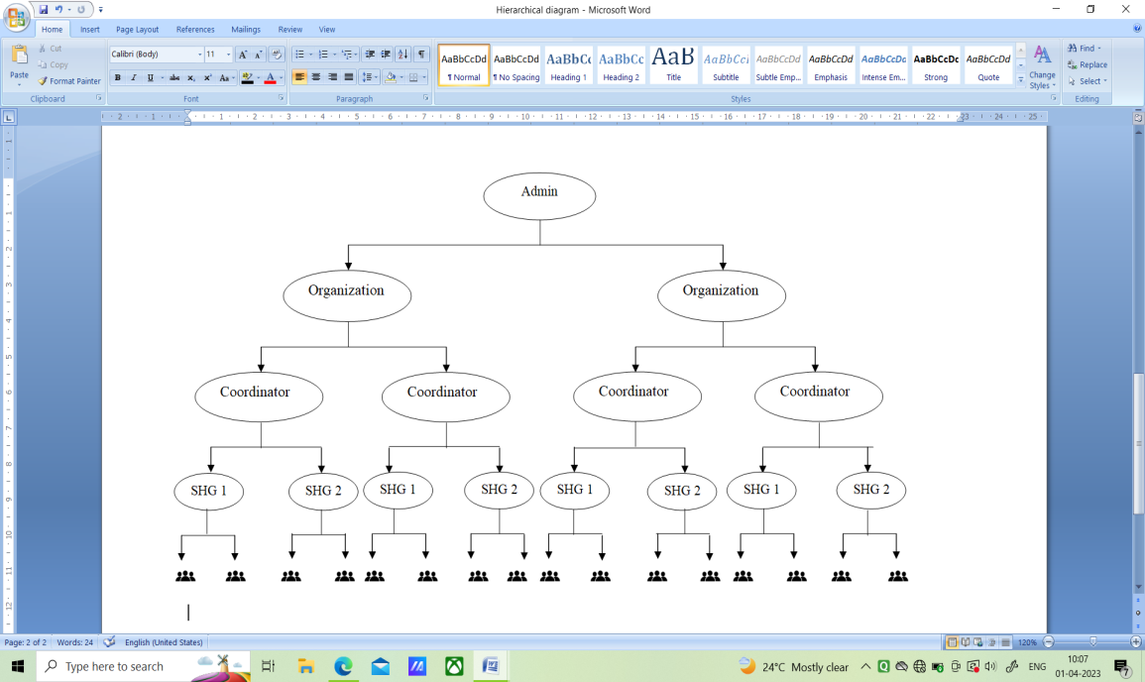

**Block Diagram:**

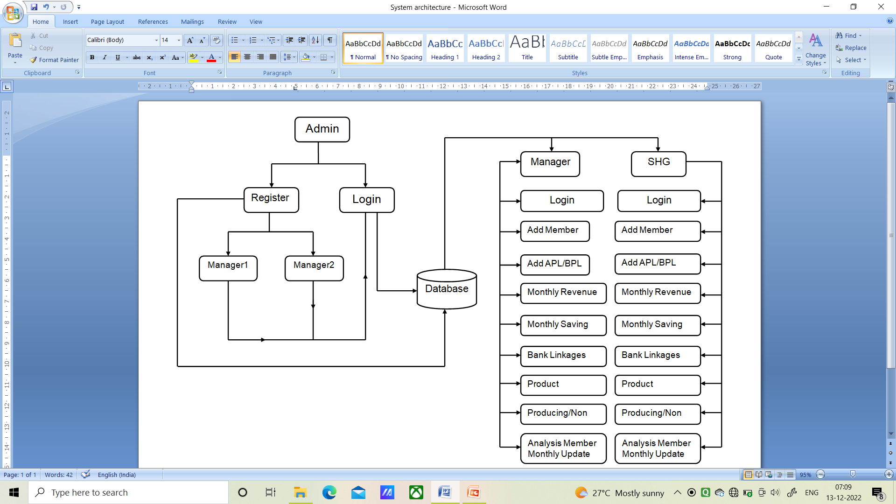

**Applications:**

**Government Authority**:

Government authorities like Collector, Zila Parishad, State Government and Central Government department which work on woman employment and Growth and work with SHG formation , Monitoring and tracking Activities for Government Projects and CSR activities and for that they need proper data for Funds Raising and Distributions .

**Organization:**

Organizations who gives CSR(Corporate Social Responsibility) like Mahindra & Mahindra Ltd., Ultra Tech Cement, Godrej consumer products Ltd, Tech Mahindra, Ambuja Cement. which work on woman employment and Growth and work with SHG formation , Monitoring and tracking Activities for record to Show how their CSR activities works and outcome from that Activities

**(NGO) Non-Profitable Organizations:**

NGO’s working for Women’s Empowerment and provide them opportunities of Self-Employment to improve their social and economic status.

**8. Result**

This system is supported by the online database managed by the SHG website administrator. There are five modules on our website. The first is the administration module. When an organization registers on our website, it is directed to an administrative module and the administrator receives a request to approve the organization. The second is the organization where we can add coordinators and see how many coordinators there are in that organization, and then we can see the total number of groups under that coordinator, the total number of members, the total income, the loan, the repayment of the loan, and the balance sheet. The third one is the coordinator, which can add groups and show the groups. We can see the total number of members in these groups, the total number of members, the total income, the loan, the return of the loan and the balance. The fourth one is the groupwhere the coordinator can add members, he can see the members, total income, loan, returned loan, balance and so on. The coordinator can add all this information. And the fifth module is trainer coordinator can register any kind of training program. And see how many trainings are conducted. Administrator can see all this information. How many organizations are under him and so on.

**9. Conclusion**

This project helps the crew who conduct events in villages. It has been a great pleasure for us to work on this exciting and challenging project. This project proved good for me as it provided practical knowledge of not only programming in PHP as well as CSR Activity and what exactly upliftment of SHG Groups. Also, lots of research gives us number of ideas about market links and challenges how all things are work in markets how commercials carried out from market how products developed which Help SHG group wants, lots of government Schemes and all other activity

# References

1. J. Wang and M. Cohen, “Optimized Color Sampling for Robust Matting,” Proc. IEEE Conf. Computer Vision and Pattern Recognition, pp. 1-8, 2007.
2. F.Rosenblatt, “Remarks on Some Nonparametric Estimates of a Density Function,” Annals of Math & Statistics, vol. 27, pp. 832-837, 2004.
3. Mr. Shreeraj S S, Vishnu K., “Empowerment of Women Self Help Groups: Human Centered Design of a Participatory IoT Solution”, 2020.
4. Mr. V. Sivakumar, “Review on Financial Prospects and Problems of Women’s Self Help Groups (SHGs) with Special Reference”, September 2012
5. EDA rural systems and APMAS (2006), “Self Help Groups in India: A study of Light and Shades”, A Joint initiative of CARE, CRS, USAID and GTZ, New Delhi.
6. Emmanuel Munemo, “American Journal of Humanities and Social Sciences Research (AJHSSR)”, 2019.
7. Dr. R.Amudha, “Micro-insurance: A mechanism for women empowerment through Self Help Group linked LIC”, 2014.
8. Mr. Vikas Agarwal, Vikram Desai, “Enhancing the rural Self Help Group- Bank linkage Program”, 2011.