**EXPERIMENTAL EXAMINATION OF SPLITTING TENSILE STRENGTH AND FLEXURAL STRENGTH OF COARSE AND FINE RECYCLED AGGREGATES**

**Aman Dalal1, Harish2, Sheela Malik3**

1M.Tech Scholar, Structural Design Department of civil engineering, Ganga Institute of technology & management, Jhajjar, Haryana, India

2Assistant Professor, Department of civil engineering Ganga Institute of technology & management, Jhajjar, Haryana, India

3Assistant Professor, Department of civil engineering, Ganga Institute of technology & management, Jhajjar, Haryana, India

**ABSTRACT**

In order to achieve mechanical qualities of treated coarse recycled aggregate and treated fine recycled aggregate that are equivalent to concrete made with natural coarse and fine aggregates, this research intends to offer a foundation for the use of recycled aggregate (RA) in structural concrete. Natural materials' physical and mechanical characteristics are investigated and contrasted with RA. To create 19 series of concrete mixes for all three types of treated coarse aggregates, a mix proportion for M20 grade was then computed. The characteristics of RAC were investigated, and the impact of RAC on the slump value of freshly laid concrete was examined. The outcomes showed that abrasion therapy (AT) is the most productive and successful of the three therapies. A stronger splitting and flexural strength is provided by RAC (AT) compared to other types of RAC. For higher grade concrete such as M40, M50, and M70 with varying percentages of coarse and fine recycled aggregates, the hardened characteristics of RAC were also examined.

1. **INTRODUCTION**

In India, unauthorized and improper disposal of C&D waste is the norm, leading to myriad problems and the resource potential of C&D waste is lost without recycling. However, proper management and processing of C&D waste can lead to profitable recycling. Concrete is often delivered using alluvial river rock and sands, but there is a shortage of sand and abundance of sand mining, leading to consumption of ground water and ecological issues. Mining is denied by certain state governments due to the danger of digging the sand from stream bed in abundance amount, the effects of deep pits in the stream bed, and the erosion of close-by lands. It is a basic sight that the well foundation of bridges is uncovered extensively due to intemperate lifting of sand around the substructure imperils the life and security of bridges.

1. **METHODOLOGY**

Method To accomplish the aforementioned objectives, the procedure below is used.

• An analysis of published works using the most recent design standards.

• Experiment with various RA therapy modalities.

• Analysing both types of aggregates' mechanical and physical properties.

• Investigation of mechanical properties of the M-20 grade mix using different proportions of treated coarse RA and fine RA.

• Finalising the best management strategies in light of the outcomes.

• Determining the optimal recycled coarse-to-fine aggregate mix ratio.

• Studying the mechanical characteristics of a mixture of M-40 and M50 grades using the correct proportions of treated coarse and fine RA.

• M70's exceptional strength is achieved by using recycled aggregates.

1. **MODELING AND ANALYSIS**

Crushing concrete to create coarse aggregate for the creation of fresh concrete is a green method to lessen the use of landfills and natural resources. Recycled aggregates are made from demolition waste, including waste concrete, precast concrete members that were rejected, broken brick, concrete roadbeds, leftover ready-mix concrete, waste produced by various research laboratories, flooring tiles and marbles, and ceramic waste products. Deliveries of construction and demolition trash are weighed when they arrive at the plant. The recyclable hard C&D trash is sorted out, heaped up, and then fed onto a conveyor that feeds a crusher. After crushing, the waste is graded and cleaned to improve the quality of the final products before being sent past screens.

**Slurry Treatment (Cement) of RA (CST)**

This approach involved making a paste out of cement and water. To ensure good mixing and dispersion, cement was dissolved in water using 10% water by weight, then the mixture was agitated for 10 to 15 minutes. After that, a sample of coarse RA is left to soak for 24 hours in this cement water paste. To guarantee that cement particles properly penetrated on aggregate surface, then saturated aggregate are dried in the oven. This recovered dry aggregate was utilised in the creation of concrete.

**RA’s Chemical Treatment**

Quantity of cement mortar bonded on the surface determines whether it is recycled or natural. The cement mortar attaches on particles of RA when old concrete is broken or crushed, creating a rather fragile layer. Coarse RAs were first soaked in acid for one day, after that it is washed with water so that we can remove the chemical, with the goal of removing the loose connected mortar stick to the original RA. In this work, hydrochloric acid (HCl), which has a concentration of 0.1 mole, is used as an acidic solvent.

**Splitting Tensile Strength**

According to IS: 516-1959, this strength of concrete was determined. Throughout the experiment, this strength was measured using cylinders measuring 150 x 300 mm. The compression testing machine has been used to conduct the test. The specimens were made and tested in accordance with IS: 5816–1970.

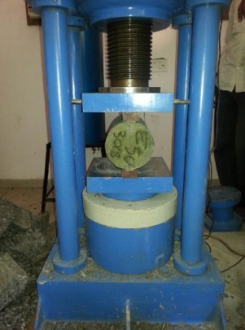 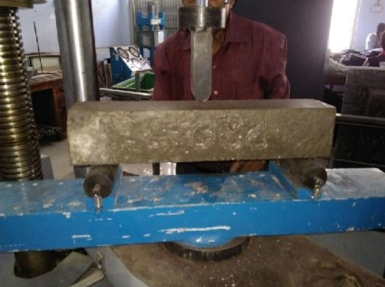

**FIGURE 3.1** Test for Splitting Tensile strength  **FIGURE. 3.2** Flexural strength test

**Flexural Strength**

A measurement of this strength shows how resistant a material is to deforming under bending loads. For various concrete grades, the flexural strength of RA concrete beams was examined. According to IS strength was determined.

1. **RESULTS AND DISCUSSION**

**Observations on Workability: Fresh State of Recycled aggregate concrete**

• As fine RAs were used, especially when they replaced fine particles by 50% and 100%, it causes decrease in fresh concrete workability.

• When the quantity of fine RAs is higher (100% replacement), the compaction factor likewise decreases, indicating an extremely stiff mix.

• When replacing fine aggregates by 10%, 30%, or 50% or 100%, the workability is improved.

• Treated coarse RA had somewhat greater slump values than untreated coarse RA.

**Splitting Tensile and Flexural Strength of Recycled aggregate concrete**

To evaluate the flexural strength and splitting tensile strength of concrete M20 Grade concrete with varying replacement percentages of coarse RA and fine aggregate, the IS: 516-1959 flexural strength test was developed and used to 18 concrete mixes. The connection between the predicted bending moment and the section modulus of the beam specimen was used to compute the flexural tensile strength. The results of the splitting tensile strength and flexural strength tests conducted on concrete of grades M40 and M50 are shown in the figures.

The flexural and splitting strengths of the concretes prepared with RA were comparable to or slightly lower than those of the control concrete when fine aggregate replacement reached 50%. Only concrete produced utilising 30% of the fine RA obtained or having a flexural strength comparable to control concrete was allowed.

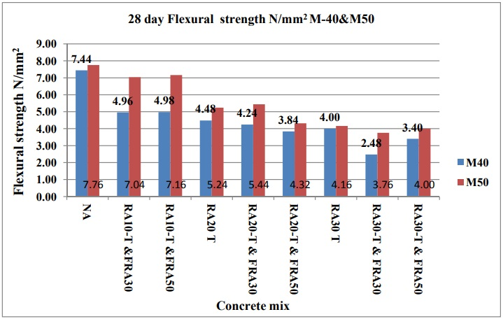

**FIGURE 4.1** M40&M50 Flexural strength

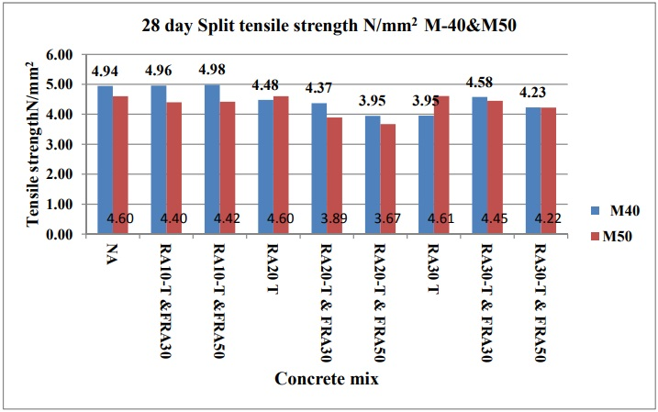

**FIGURE 4.2** M40 & M50 Tensile Strength

**CONCLUSION**

* RA concrete mix is less workable than natural aggregate because only 30% of the coarse recycled material is processed. However, with the addition of super plasticizer, traditional concrete built with natural aggregates is comparable to concrete with a ratio of 50% fine RA and 30% coarse RA.
* The experimental splitting tensile strength and flexural strength for concrete with 30% coarse RAs and 50% fine RAs is close to the code value, however it is somewhat lower for M20, M40, and M50 classes. The British code and ACI created a theoretical splitting tensile strength and flexural strength that is still higher than this. The elastic modulus in RA and natural aggregate concrete has a higher experimental value.
* RAs can replace natural ones and save money with a 10% cost benefit in this sector.

1. **REFERENCES**
2. Sagoe-Crentsil KK, Brown T, Taylor AH.(2001) “Performance of concrete made with commercially produced coarse recycled concrete aggregate” Cement Concrete Research ,31(1)707–12.
3. McNeil K, Kang TH-K.(2013) “Recycled concrete aggregates: a review International Journal of Concrete Structures and Materials”;7(1):61–9.
4. Tavakoli M, Soroushian P (1996). “Drying shrinkage behavior of recycled aggregate concrete”. Concrete International, 18(11),58–61, ISSN0162-4075
5. Padmini AK, Ramamurthy K, Mathews MS.(2009),. “Influence of parent concrete on the properties of recycled aggregate concrete.” Construction and Building Material, 23(2), 829–36.
6. Tabsh SW, Abdelfatah AS. (2009) “Influence of recycled concrete aggregates on strength properties of concrete.” Construction and Building Material;23(1) 1163– 67.
7. Etxeberria M, Vazquez E, Mari A, BarraM. (2007) “Influence of amount of recycled coarse aggregates and production process on properties of recycled aggregate concrete”. Cement and Concrete Research, 37(5), 735–42.
8. Rakshvir M, Barai S(2006), “Studies on recycled aggregates based concrete” Waste Management and Research ,24(1) 225–33.
9. Y. Liang, Z. Ye, F. Vernerey, and Y. Xi, (2015)“Development of Processing Methods to Improve Strength of Concrete with 100 % Recycled Coarse Aggregate,” Journal of Materials in Civil Engineering ,27(5). 1–9,
10. D. Matias, J. De Brito, A. Rosa, and D. Pedro,( 2013.) “Mechanical properties of concrete produced with recycled coarse aggregates – Influence of the use of superplasticizers,” Construction and Building Material., 44(1), 101–109,
11. K. Kim, M. Shin, and S. Cha9(2013), “Combined effects of recycled aggregate and fly ash towards concrete sustainability”, Construction and Building Material ,48(1), 499–507,
12. Saravana Kumar P, Dhinakaran G.( 2012) “ Effect of admixed recycled aggregate concrete on properties of fresh and hardened concrete”. Journal of Materials in Civil Engineering ,24(4),494–8.
13. C. Thomas, J. Setién, J. A. Polanco, P. Alaejos, and M. S. De Juan (2013), “Durability of recycled aggregate concrete,” Construction and Building Material., 40(1), 1054–1065,.
14. Ö. Çakır, ( 2014)”, “Experimental analysis of properties of recycled coarse aggregate ( RCA ) concrete with mineral additives”, Construction and Building Material 68(1),17–25
15. K. H. Younis and K. Pilakoutas,( 2013) “Strength prediction model and methods for improving recycled aggregate concrete,” Construction and Building Material,49(1), 688–701,
16. D. Matias, J. De Brito, A. Rosa, and D. Pedro (2014.) “Durability of Concrete with Recycled Coarse Aggregates : Influence of Super plasticizers,” vol. 06014011, no. 5, pp. 1–5,