**FIRE FIGHTING ROBOT USING ARDUINO WITH CALL AND SMS ALERT SYSTEM**

# Mr. M. Raja Shekar *1, B. Rakesh*2, S. Aravind*3, K. Yogesh*4

### *1Associate Professor, Department of Electrical & Electronics Engineering, ACE Engineering College, Hyderabad, Telangana, India

*2Student, Department of Electrical & Electronics Engineering, ACE Engineering College, Hyderabad, Telangana, India

### *3Student, Department of Electrical & Electrical Engineering, ACE Engineering College, Hyderabad, Telangana, India

*4Student, Department of Electrical & Electronics Engineering, ACE Engineering College, Hyderabad, Telangana, India

# ABSTRACT

A fire extinguishing robot has been proposed and constructed in this study work, which identifies the fire location and extinguishes the fire using sprinklers after initiating the water pump. For effective fire detection, this robot has three) flame sensors. This suggested form of Arduino based Autonomous Fire Extinguishing Robot detects the presence of fire and extinguishes it without the need for human intervention. It has gear motors and a motor driver that regulate the robot's motions when it senses a fire and starts the water pump to extinguish it. This miniature robot is equipped with a water ejector that can squirt water over the flames. A servo motor can be used to move the water ejector pipe in the direction necessary. An Arduino Uno microcontroller is in charge of the entire setup. This robot will move to the fire source when the flame sensor detected the fire and it will send message to any phone of the GSM network through the modem connected to the programmable device. This robot also programmed to stop before the robot hit the flame. This robot also can extinguish fire at 45 Degree for upper side and 45 Degree for lower side. This robot implicated the function of finger to clip the fire extinguisher clipper.

**Keywords:** Arduino Uno, DC Submersible pump, Flame sensors, L293D motor driver, Servo motor.

# INTRODUCTION

# In recent years, the development of advanced technologies has significantly contributed to enhancing the efficiency and effectiveness of various industries. One such industry that has greatly benefited from technological advancements is fire safety and emergency response. The introduction of Fire Fighting robots equipped with SMS and call alert systems has revolutionized the way we combat fires and protect lives and property. Fire Fighting robots are autonomous or remotely operated machines designed specifically to navigate through hazardous environments and extinguish fires. These robots are equipped with a range of Flame sensors, IR Temperature Sensor (MLX09614), and firefighting equipment, making them highly capable in responding to fire emergencies. One of the key features of these robots is the integration of SMS and call alert systems. This technology allows the robot to immediately notify designated emergency personnel, firefighters, or building managers about the presence of a fire and the need for immediate action.

# When a fire is detected by the robot's sensors, it automatically moves towards the fire direction and extinguish the fire with the help of attached Mini submersible pump and triggers the call alert system to respective mobile number, which instantly notifies the relevant authorities.

The integration of SMS and call alert systems in firefighting robots has several advantages.

Firstly, it significantly reduces response time, as emergency personnel can be alerted immediately, even before they receive reports from traditional sources. This timely notification enables early intervention, minimizing the spread of fire and reducing potential damage.

Secondly, the SMS and call alert system ensures that multiple stakeholders are informed simultaneously. This promotes collaboration and coordination among different entities involved in fire safety, such as building managers, fire departments, and emergency services.

Lastly, the system enhances the overall safety of firefighters and emergency responders. By providing real-time updates and video feeds, it allows them to assess the situation remotely and devise appropriate strategies without exposing themselves to unnecessary risks.

# METHODOLOGY

# A. VECHILE DESCRIPTION

# For Fire Fighting Robot we need a Robot Chassis for Effective working. The Robo Chassis contains four BO motors with attached wheels these BO motors are interfaced with L293D motor driver. The motor driver will be supplied by 5V using Batteries. In the front side three flame sensors are attached for effective fire detection and to move the vehicle towards the fire direction. One MQ2 Sensor is used for Gas Detection if any abnormal gas is detected then it sends an SMS to the respective mobile Number. Mini submersible pump is attached to one relay module this will extinguish the fire using mini submersible pump. For GSM we interfaced one buck converter with an output voltage 4.3V. This all components are Interfaced with Arduino UNO R3. Arduino UNO is the heart of the robot it will gives direction to all the components.

# 

# Fig:1 Fire Fighting Robot

# B. CONNECTION DETAILS

# Flame Sensors

* Left Sensor – Arduino Pin 9
* Right Sensor – Arduino Pin 8
* Forward Sensor – Arduino Pin 10

**Submersible Pump:** Arduino Pin 10

**Servo Motor Sg90:** Arduino 13

**GSM SIM800L:**

* Rx-A3
* Tx-A4

**L293D Motor Driver:**

* LM1 2 - left motor
* LM2 3 - left motor
* RM1 4 - right motor
* RM2 5 - right motor

**C. SOFTWARE REQUIRED:**

**Arduino IDE:** The Arduino IDE is an open-source software, which is used to write and upload code to the Arduino boards. The IDE application is suitable for different operating systems such as **Windows, Mac OS X, and Linux**. It supports the programming languages C and C++. Here, IDE stands for **Integrated Development Environment**.

The program or code written in the Arduino IDE is often called as sketching. We need to connect the Genuine and Arduino board with the IDE to upload the sketch written in the Arduino IDE software. The sketch is saved with the extension ‘. ino.'

The Arduino IDE will appear as:

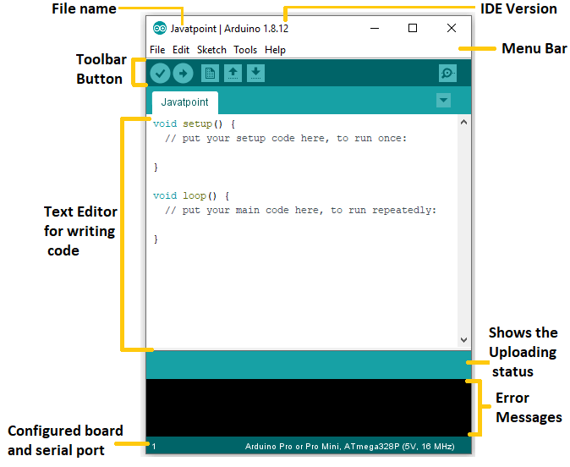

**Fig:2 Arduino IDE Software**

# III. MODELING AND ANALYSIS

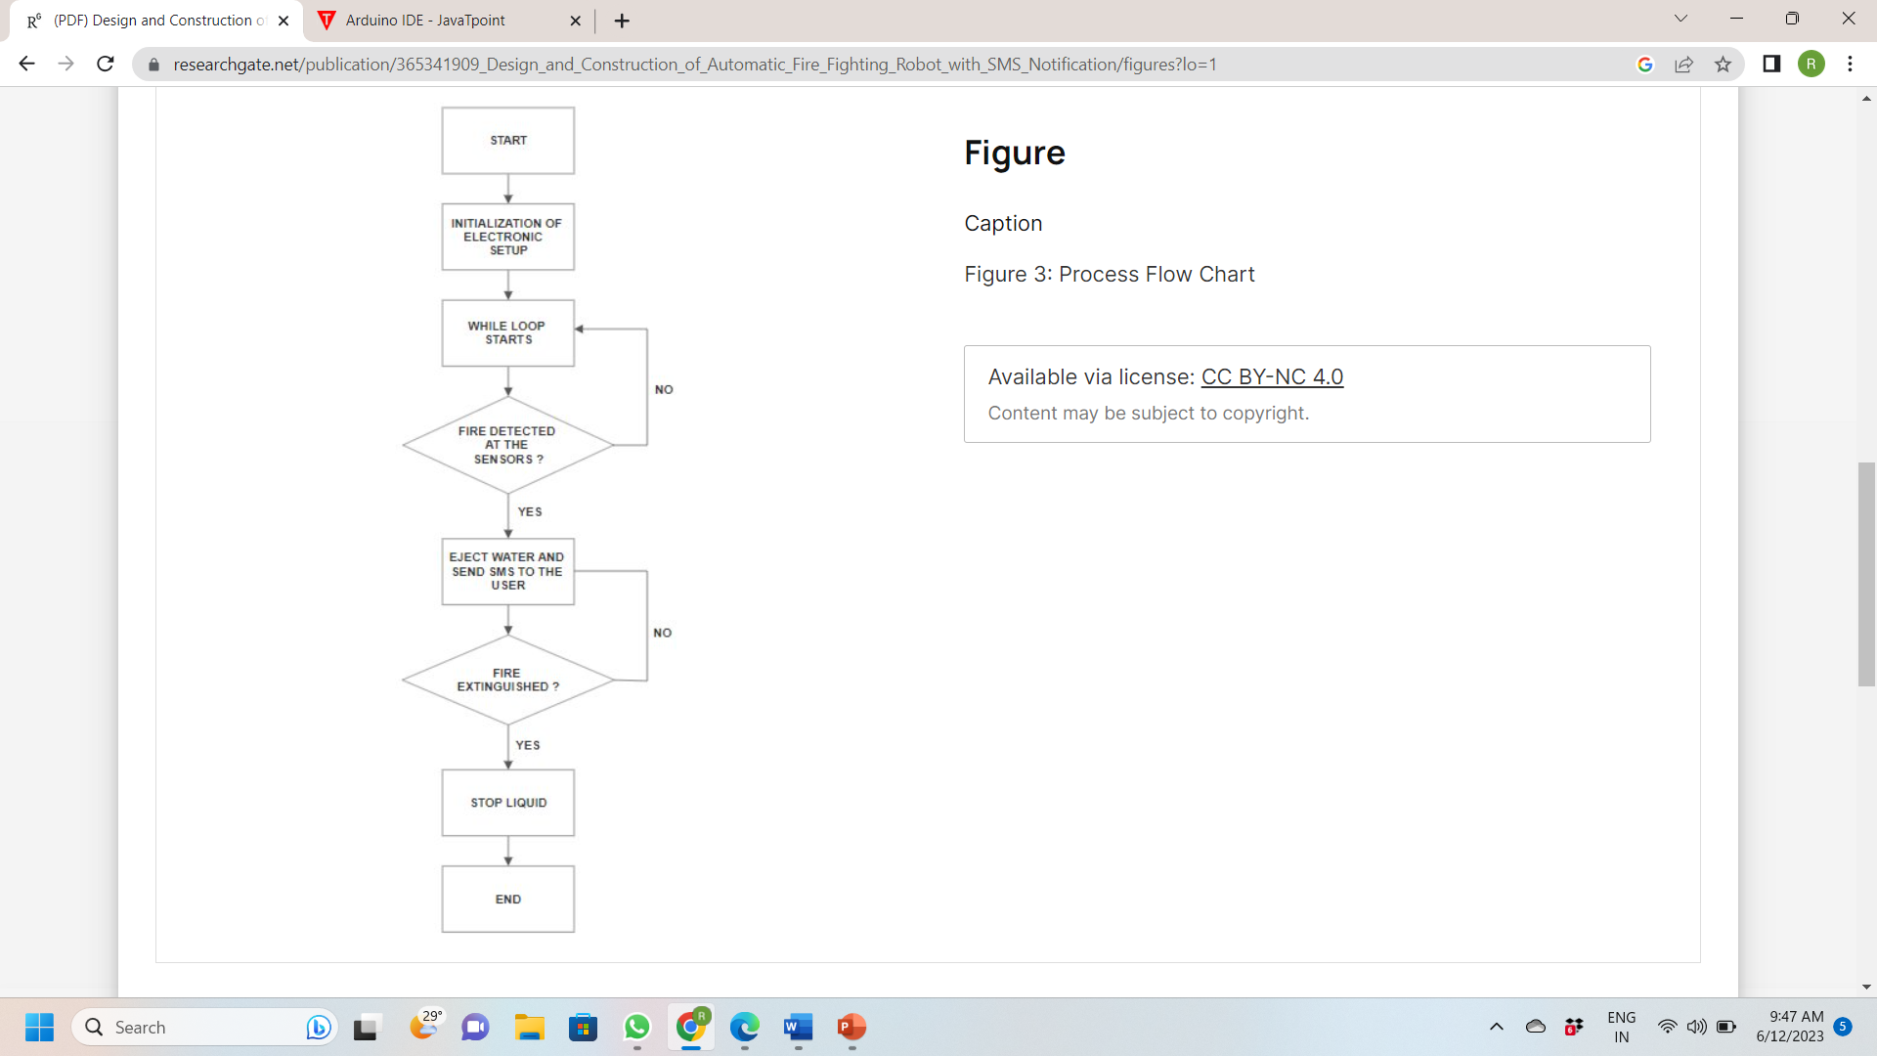

**Fig:3 Flow Diagram**

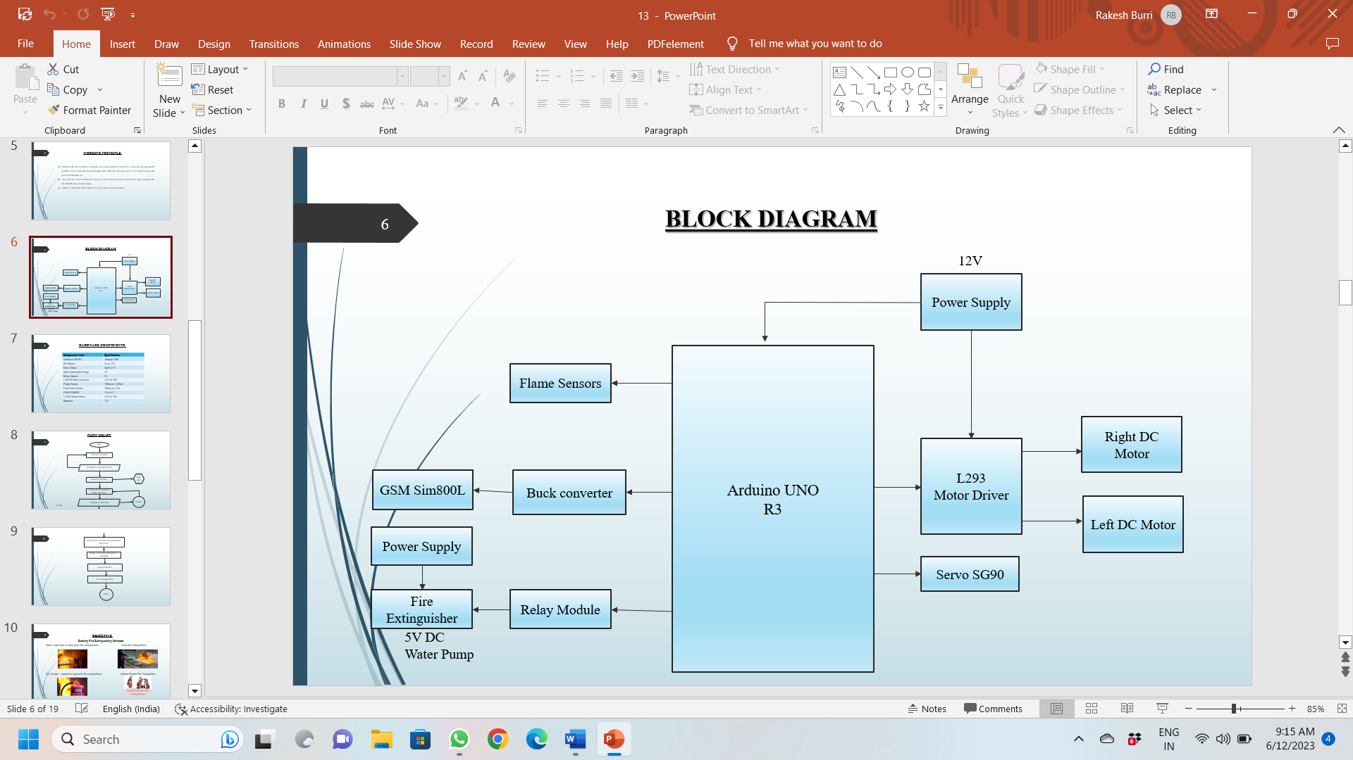

**Fig: 4 Block Diagram**

# RESULT

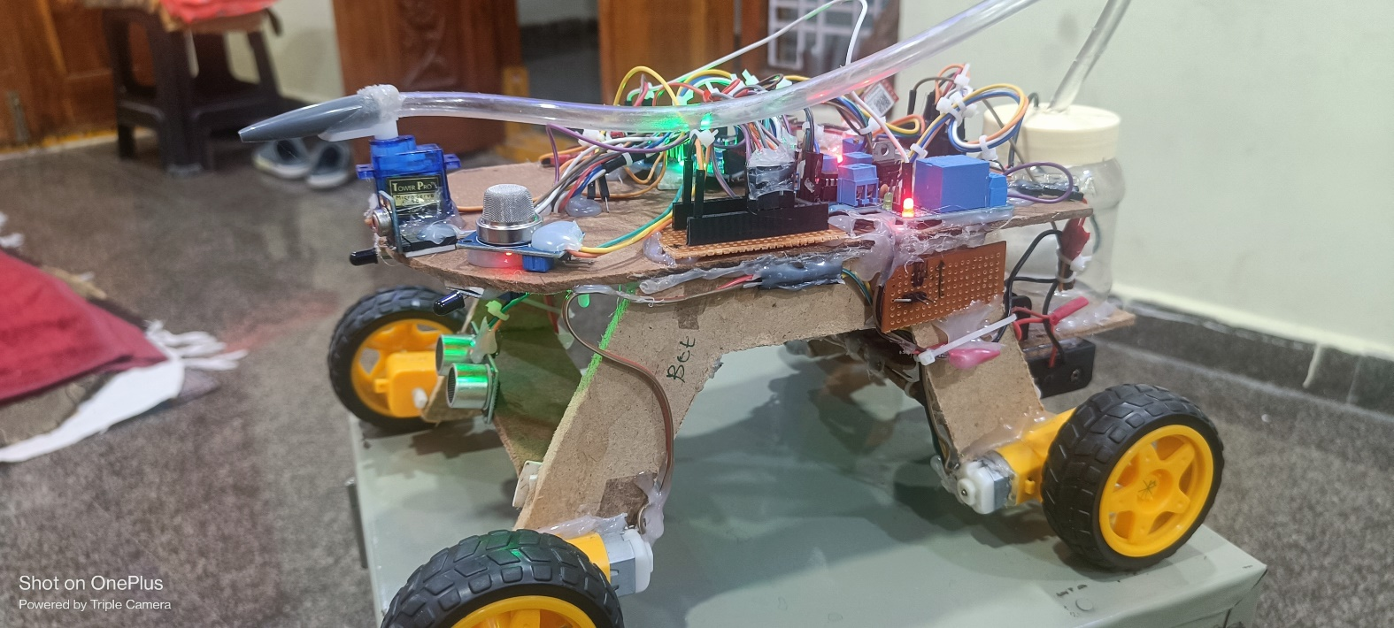

**Fig:5 Prototype**

# CONCLUSION

Here we successfully developed the Fire Fighting Robot using GSM. Robot detects temperature and flame at site where the robot exists. The movement of this robot vehicle is controlled by MCU as per the program. This robot is help full in those areas where natural calamity and bomb explosions where occurred. If fire is detected with the help of sensors, MCU operates the water pump mechanism through relay circuit. Through this we can conclude that a robot can be used in place of humans reducing the risk of life of the fire fighters. We can use them in our homes, labs, offices etc. They provide us greater efficiency to detect the flame and it can be extinguished before it become uncontrollable and threat to life. Hence, this robot can play a crucial role.

# REFERENCES

[1]. International Journal for Research in Applied Science & Engineering Technology (IJRASET) ISSN: 2321-9653; IC Value: 45.98; SJ Impact Factor: 7.538 Volume 10 Issue V May 2022- Available at [www.ijraset.com](http://www.ijraset.com/).

[2]. Takfir Rakib, M. A. Rashid Sarkar, “Design and fabrication of an autonomous firefighting robot with multi sensor fire detection using PID controller”, ICIEV Volume 23 issue-1 JUNE 2016.

[3]. Saravanan P., Soni Aishwarya, “Android controlled integrated semi-autonomous firefighting robot”, International journal of innovative science Eng. and Technology 2015.

[4]. Nagesh MS, Deepika T V, Stafford Michahial, Dr M Shiva Kumar, “Fire Extinguishing Robot”, International Journal of Advanced Research in Computer and Communication Engineering, Vol. 5, Issue 12, December 2016

[5]. Sushrut Khajuria, Rakesh Johar, Varenyam Sharma, Abhideep Bhatti, “Arduino Based Fire Fighter Robot”, International Journal of Scientific Engineering and Research (IJSER), Volume 5 Issue 5, May 2017