IoT BASED DISTRIBUTION TRANSFORMER MONITORING SYSTEM
Mr.M. RAJASHEKAR*1, P. NAGA KUMAR*2, K. VIJAY KUMAR*3, G. ANUDEEP*4
*1Associate Professor, EEE Department, ACE Engineering College, Hyderabad, Telangana, India.
*2,3,4Student, EEE Department, ACE Engineering College, Hyderabad, Telangana, India
ABSTRACT
Distribution Transformers are vital for the electric power system. It is very important to collect data and monitor the transformer condition to prevent failures. The operator must go to the transformer site to monitor it. The project aims to monitor the transformer parameters such as temperature, current, voltage, and oil level using IoT. Sensors are used to measure the transformer parameters. The Arduino UNO microcontroller receives the sensor data. The data is sent through GSM MODULE AND ESP 8266 Wi-Fi module and can be accessed from anywhere in the world using IOT technology with HTTP protocol. This enables remote identification and resolution of problems before a failure without human intervention.
Keywords: - Distribution Transformer; Microcontroller; GSM Module; Sensors; LCD display.

- INTRODUCTION

Electricity is essential for our life. We depend on electricity for every moment of our life. Electricity has various components and equipment that help humans to transfer and regulate the power distribution according to their needs. The transformer is the most important equipment for transmitting and distributing electric power. The transformer should operate under rated conditions (as specified in their name plate) to ensure their long service life. However, this is not always possible during their operation. Overloading and insufficient cooling of transformers can lead to unexpected failures that can disrupt the power supply to many consumers. The manual inspection of voltage, temperature, current and other parameters is difficult and unreliable as some factors cannot be measured easily. In IoT, sensors and actuators enable the interaction between the physical and digital worlds. IoT technology aims to monitor and control devices remotely. Therefore, IoT based monitoring is preferable than manual monitoring. The system is a real time monitoring of transformer parameters such as voltage, current and temperature. This can help to detect the faults before they cause serious damage.

- METHODOLOGY

This project proposes the design and implementation of an IOT embedded system that can measure load currents, over voltage, transformer oil level and temperature using online sensors. The system uses an Arduino microcontroller to process and store the sensor data, and to detect any abnormal conditions. The system also updates the data on the internet via serial communication. This Internet of Things (IOT) system can help the utilities to use the transformers optimally and to identify problems before they cause catastrophic failures. Therefore, Transformer Health Measuring can improve the reliability and reduce the costs of power systems. Transformers are vital electrical equipment in power systems. By monitoring the transformers for potential problems, faults that are expensive to fix and result in power outages can be prevented. The overall goal of the Transformer Monitoring System is to read and record valuable information about either pole mounted transformers or those which lie on the ground effectively and accurately. Once recorded, the information is sent through wireless connections to a central hub computer which would be located at the electric company’s transfer stations or substations. Installed on the computer is the program that transfers the data to database located on the electric company’s server. The web application then presents all the information in a nice, neat, organized fashion, so that the electric companies can easily detect a failure in their power lines. Several key goals of this entire device are that it needed to be extremely affordable, due to the large quantity of transformers in each radius, and small enough to fit on the same pole as the transformer.

- MODELING AND ANALYSIS

We propose a real-time framework that uses four sensors to monitor the voltage, current, temperature and oil level of a transformer.
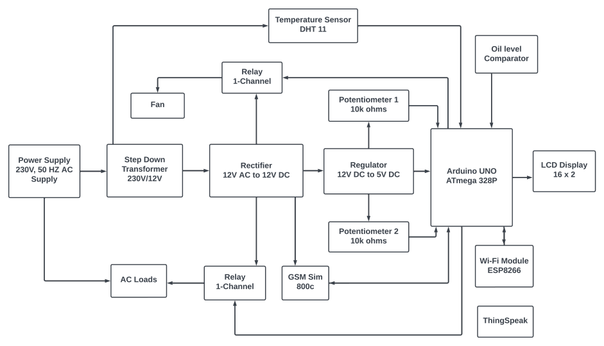
Figure 1: block diagram

The sensors are a voltage sensor, a current sensor, an LM35 temperature sensor and an oil level sensor. They are connected to an Arduino microcontroller that multiplexes the analog values and sends them to a dedicated IP address via a Wi-Fi module using TCP IP protocol and GSM Module sim 800c. The data can be viewed in real time on any web-connected device as a chart. The data also sends message alert to censored operator. The power supply for the system is provided by a step-down transformer that converts 230V AC to 12V AC, which is then rectified to DC and regulated to +5V for the Arduino, the Wi-Fi module, and other components. If any of the parameters exceed the threshold values, the microcontroller will send an alert message to the phone and server.
The overall goal of the Transformer Monitoring System is to read and record valuable information about either pole mounted transformers or those which lie on the ground effectively and accurately. Once recorded, the information is sent through wireless connections to a central hub computer which would be located at the electric company’s transfer stations or substations. Installed on the computer is the program that transfers the data to database located on the electric company’s server. The web application then presents all the information in a nice, neat, organized fashion, so that the electric companies can easily detect a failure in their power lines. Several key goals of this entire device are that it needed to be extremely affordable, due to the large quantity of transformers in each radius, and small enough to fit on the same pole as the transformer.
This system introduces a new and improved method of transformer health parameter monitoring using IoT. The sensors incorporated in the system collect the data of transformer health parameters such as voltage, temperature and current. These data can be sent and accessed using HTTP protocol. Thus, the real time data collection, storage and monitoring of the transformer health parameters are possible with the system.
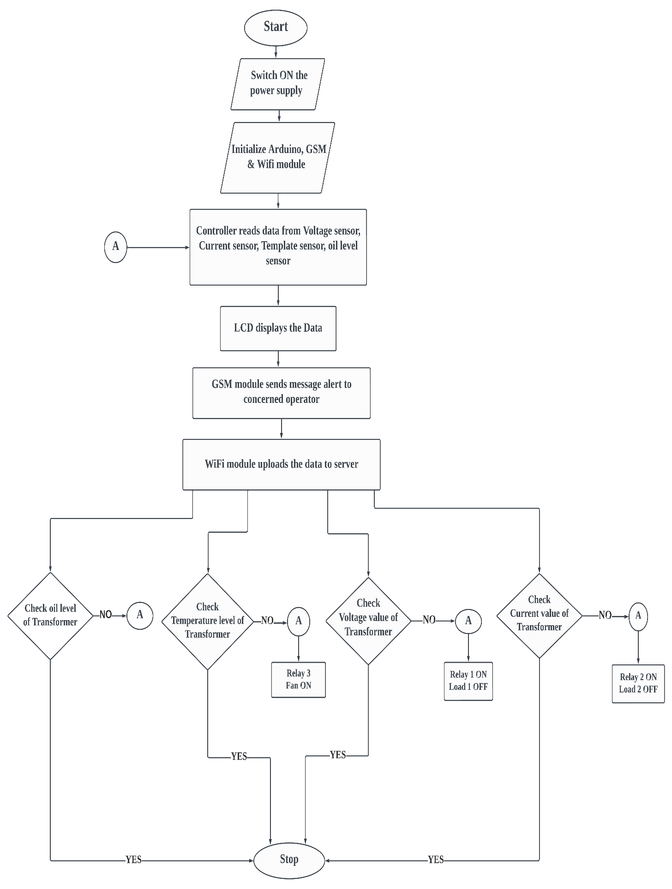
Figure 2: flow chart

- RESULTS AND DISCUSSION
The results of the proposed technique demonstrate that the protection scheme is accurate and sensitive to abnormal and faulty conditions. Transformer Health Monitoring can detect unexpected situations before they cause serious damage, which improves reliability and saves costs. We can monitor the transformer from anywhere if it is in an abnormal condition. No human power is required to monitor the transformer. The webpage automatically updates the details about the transformer. Voltage to DC.
Table 1. Thing speak Monitored Data
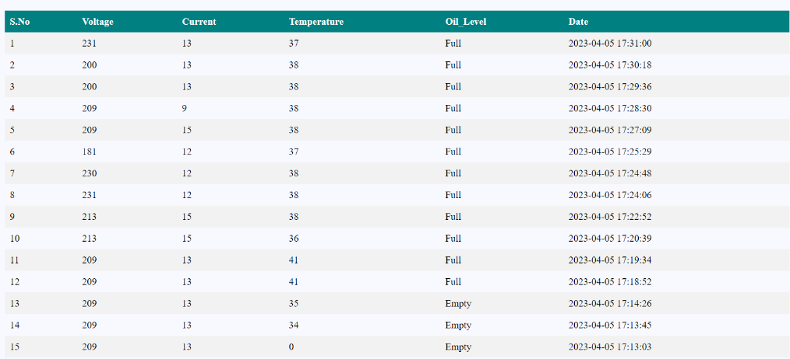
The cloud used in this is named Thing speak, which is again an open-source platform from the makers of MATLAB and Simulink. The data is stored, and the graphical representation is also done. The stored data is available for download in three different formats. JSON,.XML,.CSV. The representation of cloud data interface is shown in the picture below.

Below is the pictorial representation of the hardware prototype we have developed.

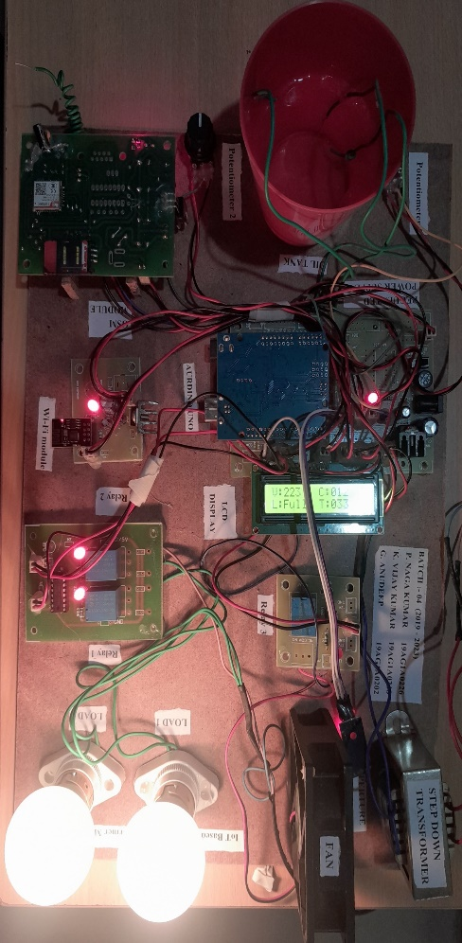
Figure 3: prototype
Below is the data which is uploaded to the server in graphical representation.
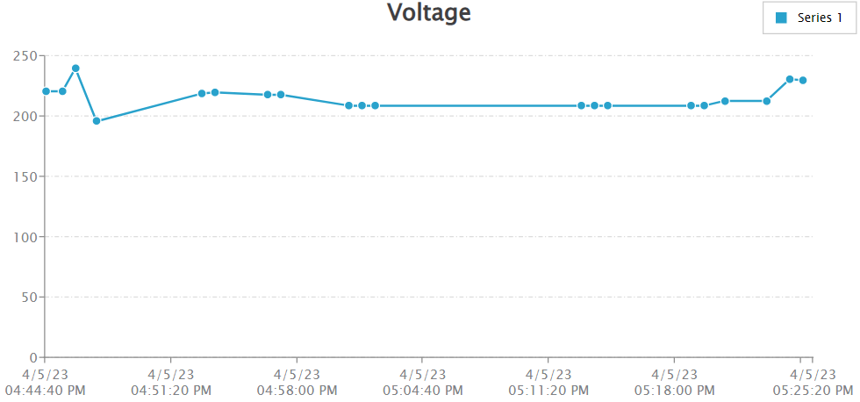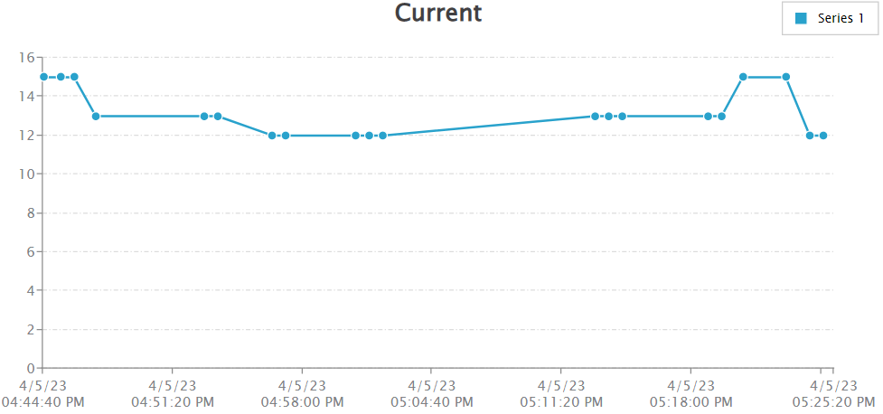
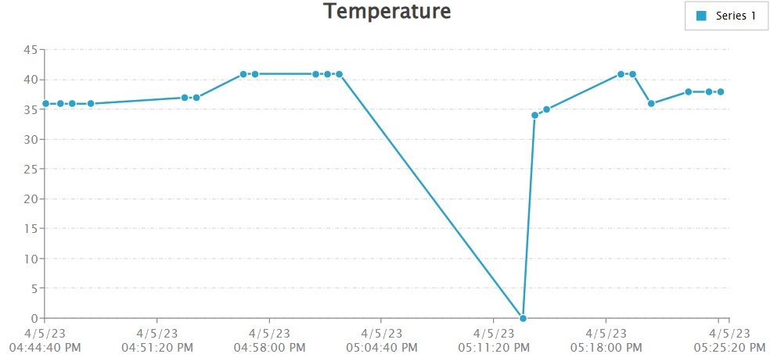

Figure 4: Thing speak showing data upload data in charts.

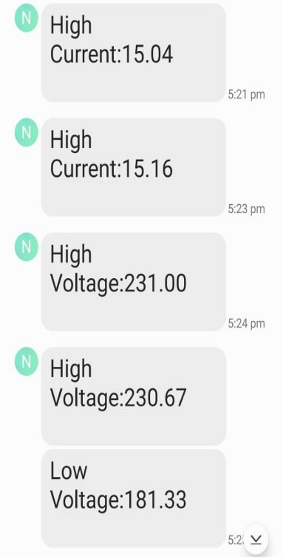

Figure 5: GSM sends message alert to registered mobile number.

- CONCLUSION
We have shown that online health monitoring using the internet is more effective and accurate than traditional methods. Therefore, transformer safety and monitoring are important. This system uses the Internet of Things to offer a new and improved way of monitoring transformer health indicators. The system has sensors that measure voltage, temperature and current of the transformer. The data is sent to Thing Speak, an IoT platform, using the HTTP protocol. This way, the system provides real-time data on transformer health and allows for monitoring and adjustments. We have designed and built an Internet of Things Transformer Monitoring System that can display the status of the transformer in real time. The device was tested successfully after it was built. For example, the device can track the state of the transformer and send data from the sensors via Wi-Fi to be shown on the IoT platform. Any critical and required parameters that exceed their threshold can be notified by SMS for quick action. However, there were some challenges in building the system. The use of pre-made microcontrollers in projects that need specific features increases the complexity and number of hardware components needed to do a simple task.

- REFERENCES
[1] Saidpur Rahman, Shimanta Kumar Dey, Bikash Kumar Bhawmick and Nipu Kumar Da, “Design and Implementation of Real Time Transformer Health Monitoring System Using GSM Technology” International Conference on Electrical, Computer and Communication Engineering (ECCE) 2017
[2] Siddhant Gaikwad, Raj Mehta, Prathamesh Shetye, Jay Khut, Kavita Bani, “GSM based Distribution Transformer Monitoring System” International Journal of Engineering Research & Technology (IJERT) 2017.
[3] “Determination of the breakdown voltage at power frequency-Test Method,” in International Standard (IEC 60156), Second. IEC, 1995.
[4] Distribution Transformer Monitoring for Smart Grid in India, 1st IEEE International Conference on Power Electronics, Intelligent Control and Energy Systems (ICPEICES-2016).

