**SOLAR POWERED FLOAT FOR PLASTIC WASTE COLLECTION FROM WATER BODIES**

**Dr.V.K. KRISHNAN, M.E., Ph.D1, N.DURAIRAJ., M.E2 , A.K.KARTHIKEYAN., M.E.,(ph.d)3**

Associate Professor Department Of Mechanical Engineering Vinayaka Mission’s Kirupananda VariyerEngineering College –Vinayaka Missions Research Foundation(Demmed To Be University),

Salem-636 308, Tamilnadu

Assistant professor Department Of Mechanical Engineering,Asian College Of EngineeringAndTechnology,Coimbatore-641110,Tamilnaduassistant professor department of mechanical engineering,asian college of engineering andtechnology,coimbatore-641110,Tamilnadu.

**ABSTRACT**

As we know the population of India increasingday by day and due to this the pollution also gets increase. The garbage with are produced by the peoples are the main cause of pollution. The most of the garbage are dumped or just thrown in the lake, river of other water resources. The garbage which are thrown in the water such as lakes, rivers and other water resources due to which the water get polluted because of which we cannot use that water for our daily use and the water will also get wasted. In many of cities of India this is the major problem. To overcome this water pollution our project “SOLAR POWERED FLOAT” is very helpful by collecting the garbage which are floating on the surface of water. The United Nations have published Sustainable Development Goals (SDG) in the year 2016, where the points 6 and 14 can be achieved through maintaining a clean water bodies. Smaller plastic particles are consumed by fish and passed through good chain and also causes cancer cells when consumed in large quantity.

Keywords: solar, solar powered float, sustainable development goals (sdg), lake, river.

1. **INTRODUCTIONFishes And Other Aquatic Species Getting Stuck Into Plastic Items Like Wires, Covers, Etc., Reduced Bio Diversity And Results In More Algae Formation In Fresh Water Bodies. Wastes Which Aren’t Cleared From River And Dam’s Finally End Up In Ocean Which Further Worsen The Ocean Environment. This Project Is Works Automatically By Using Internet Of Things (Iot) Technology And Saves The Manpower. This Project Is Also Very Efficient And Work On The Solar Energy No External Power Supply Is Required. 18650 Batteries Of 3.7v Are Used In Packs To Store The Energy Which Collected By The Solar Plate, Then This Battery Will Use This Stored Energy To Operate Complete Float.**
2. **Objectives:**

To clear the lakes or pond from surface and sub-surface floating plastic waste and maintain the water body free from pollution.

1. **MODELING AND ANALYSIS**

**SOLAR FLOAT CONSTRUCTION**

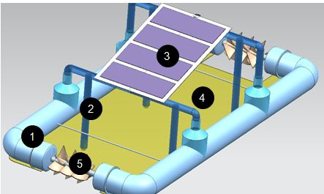

**Figure1: solar float construction**

1. **Pvc float frame**
2. **Side propeller**
3. **Solar panel**
4. **Filter mesh**
5. **Waste collecting impeller**

* Floating frame is made up of 4” ø pvc pipes and standard fittings. (low density pipes proffered for weight saving) 140 x 75 cm
* Secondary structural is made of 1” ø pvc pipes which are connected as shown in the 3d model and used as frame for solar panel and rigid structure to hold the floating frame in place and also houses propellers to steer this float.
* 30w flexible thin solar panel is selected for this application which has surface area of 56 x35 cm.
* Waste collection impellers are driven via 12v dc gear motor rated for 500 rpm which drives the whole float in forward and reverse direction while collecting the floating plastic wastes while travelling through that direction.
* The impeller for waste collection is made of 1” ø pvc pipe and impeller is made through connecting series of cable ties in sample face and later a 3d printed plastic impeller would be slide fitted with the pipe

**3.1. MECHANICAL MODEL CONSTRUCTION**

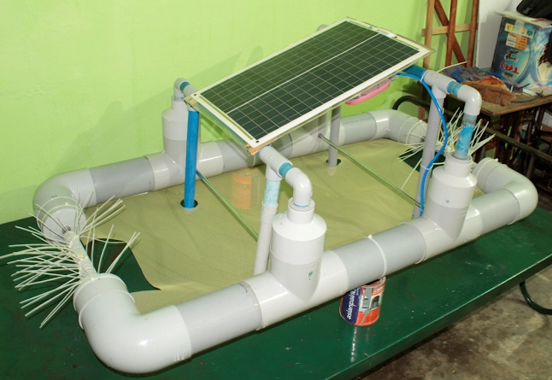

PVC Frame, Propeller Stem,Solar Panel,Electronics Storage,Solenoid valve,Axial Impeller

**3.2. ELECTRONICS COMPONENTS**

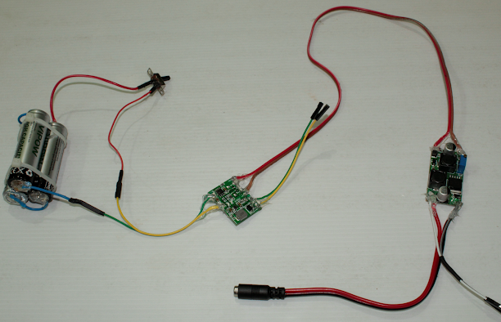

1. 3 x 18650 Batteries connected in series 11.1V
2. Battery management device for charge and discharge
3. Auto UP DOWN module
4. L293D motor drive module
5. RC controller Module

**3.3. SMART SYSTEM**

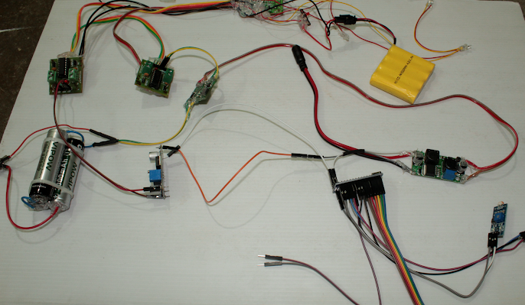

1. Adruino NANO
2. GSM Module for Adruino
3. GPS Module for Adruino

**4.WORKING PRINCIPLE**

1. **Collection Method**

Density of the plastic is lesser and mostly spread over the surface of water bodies makes a ideal to collect using a fishing net or similar means.

1. **System Design**

* 4” PVC pipe frame with two sides open to collect the wastes using a Impeller.
* There are 4 propellers to control the direction of the float.
* 30W solar panel placed on top for energy collection and storage.

1. **Smart Operation**

Iot based solution developed to collect the floating plastic and other waste particles from water bodies like lake, river and dam's. Guidance can be controlled through various means either through remote or via smartphone applications.

1. **Reliable system**

As float uses a Adruino module and various sensors to detect environment, its easy to get weather information in advance to bring this device to shore in case of bad weather or storm.

All fittings are sealed to standard IP69 (water ingress protection) to stay floating for longer period.

**4.1WORKING PROCEDURE**

1. Engineering model is prepared and a prototype of required float frame is prepared with the help of PVC pipes and fittings. Drive components like gear motor are fitted into the frame.
2. To collect the waste mosquito net is used as filter mesh at bottom of frame and any waste are pushed inside the frame with the help of impeller thus collecting the plastic wastes.
3. Find a polluted water body like pond and test this system efficiency and collection.
4. Solar panel is used as a power sources with 18650 batteries as energy storage to power efficiently and our float works with very less operating voltage as the only functional unit is the two impeller motors and the propeller kicks in when there is need for direction changes.

**4.2ADVANTAGES**

Solar Powered Float for plastic waste collection

1. Finding a missing person or item

Get a modern PowerPoint Presentation that is beautifully designed. I hope and I believe that this Template will your Time, Money and Reputation.

1. Floating Waste

It can greatly reduce the problems caused by floating waste of various sizes. The frame can be modified to accommodate bigger impeller thus collecting more bigger to small floating wastes

1. Environment

We can prove to be a helping hand in controlling the increasing problem of water pollution.Which brings to more sustainable environment and eco-system

1. Autonomous

We can prove to be a helping hand in controlling the increasing problem of water pollution.Which brings to more sustainable environment and eco-system

1. Surveillance

Also it can be effectively used for the surveillance purpose and can be used as a good security equipment when equipped with cameras and smart imaging system

**4.3 APPLICATIONS**

1.Landscapes where can be applied

Various water bodies like Lake, Pond, Pools & Dams* (Closed), river with low water currents.

2.Floating plastic wastes

Collection of floating wastes from water bodies of various sizes between 1 cm up to 25cm in cross section and length can be anywhere between 1 and 60cm. Even sub-surface or just below water surface floating waste also can be collected

3.Clothes left at Pilgrimage

As we all know that people tend to leave their clothes after drenching at holy rivers as well as sea shore. Where the used clothes can be collected using robotic arm fitted to our float

4.Surveillance

As this device operates with solar power. It can be used to monitor the water bodies and even warn the people by fitting a megaphone on the frame and triggered automatically with the help of AI video processing techniques

5.Finding lost things or people

Any dropped objects or person accidently drowning in water body makes huge challenge in recovering. So our float can be used to remotely survey a large area and narrow down search area quickly.

6.Weather monitor

As float is always in open environment it can be retrofitted with temperature and humidity sensors to get accurate weather info on particular location. Helps in calculating evaporation rate from water body.

**4.4PHOTOS OF ACTION PLANS AND RESULT**

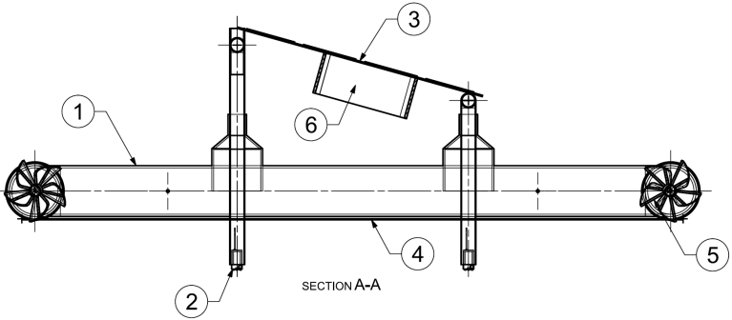

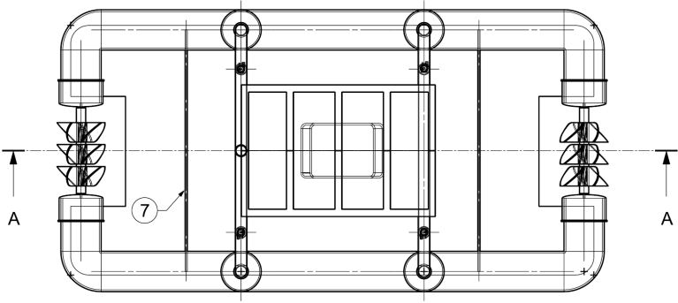

|  |  |
| --- | --- |
| **POSITION** | **DESCRIPTION** |
| 1 | FLOAT FRAME |
| 2 | PROPPELLER (12V DC PUMP) |
| 3 | 30W SOLAR PANEL |
| 4 | FILTER MESH |
| 5 | COLLECTION IMPELLER |
| 6 | ELECTRONICS STORAGE |
| 7 | THREADED ROD |

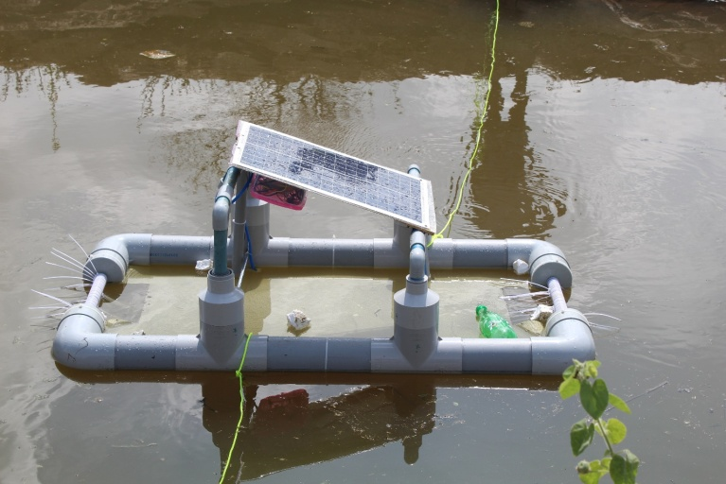

**5. PLANS AND RESULTS**

**1**.This solar powered float is taken to nearby water body to do a real time test of collecting waste material from the water body, we had chosen a local water body with very less area and depth for initial tests and once the solar float is dropped off the float started to map it’s environment and identify the wastes and starts to move towards the floating wastes and later the impeller is turned on once the float is near the floating waste and the waste material is collected by the rotation of the impeller.

2.This test is conducted with tying rope to either side to recover the float and we were able to collect water bottles and thermocol wastes. To simplify the movement we have a manual override using remote, where the movement with the help of individual pump and impeller movement for maximum waste collection can be controlled and calibrated

3.Initial tests show that the impeller design have to be improvised and a 3D printed impeller or a proper solid piece of impeller have to be used for collection, as we have designed the impeller with the help of cable ties tied in series and formed a profile that would suit the collection of plastic wastes.

4.The profile is improved alternatively we can also try a flexible end conveyor that can beattached to improve the collection of the plastic particles

**6.REFERENCES**

1. National Mission for Clean Ganga (NMCG), G., 2021. [online] National Mission for Clean Ganga (NMCG), Ministry of JalShakti, Department of Water Resources, River Development & Ganga Rejuvenation, Government of India.
2. Available at:https://nmcg.nic.in/NamamiGanga.aspx
3. A. Sinha, P. Bhardwaj, B. Vaibhav, and N. Mohammad, “Research and development ofRo-boat: an autonomous river  
   cleaningrobot,”NASA/ADS.[Online].Available:https://ui.adsabs.harvard.edu/abs/2013SPIE.9025 E..0QS/abstract
4. Bhatkhande, Ankita. “Mumbai Students Build Robot to Help Clean Surface Water.” DNA India, 23 Mar. 2017,  
   [https://www.dnaindia.com/india/report-mumbai-students-build-robot-to-help-clean-surface-water-2 364246](https://www.dnaindia.com/india/report-mumbai-students-build-robot-to-help-clean-surface-water-2%20364246)
5. Trash skimming — Cleantech Infra,” Cleantecinfra.com.
6. Available:https://www.cleantecinfra.com/trash-skimming.
7. WaterSurfaceCleaningRobot”,R.Raghavi1,K.Varshini2,L.KembaDeviAvailable:http://www.ijareeie.com/upload/2019/march/42_ NCIREST106.pdf