COMPARATIVE STUDY BETWEEN LGSF BUILDING AND CONVENTIONAL BUILDING

**SUMIT RUHIL1, VIRENDER RANA2**

**1 M.Tech Scholar, Ganga Institute Of Tech. & Management, Jhajjar, India**

sumitkumarruhil@gmail.com

**2 Assistant Professor, Ganga Institute Of Tech. & Management, Jhajjar, India**

Virender.rana70@gmail.com

**ABSTRACT**

As load-bearing and non-load-bearing parts in commercial and residential structures, light gauge steel frames are becoming more prevalent. The study and design of light gauge steel structures using STRAP software is the goal of this work. After some time, the house structure sector has developed better materials and development tactics, leading to fabricating systems that are as excellent as ever. Homes are now more livable, sturdy, safe, economical, and environmentally friendly because to advancements in construction materials and building methods. In both load-bearing and non-load-bearing components, Light Gauge Steel Frame (LSF) divider frameworks are often used in residential, commercial, and land current constructions. We use the codes IS: 801-1975 for cold formed light gauge and IS: 801-1987 for member requirements for cold formed light gauge. Software called Strap is used to model and examine the building. The findings and conclusions of the study are presented, and it is suggested that we design structures using light gauge steel.

**Keywords:** Light Gauge Framing System, Cold Formed Steel, STRAP Software.

# INTRODUCTION

Light gauge steel framed buildings (LGSF), which are mostly based on items fabricated of galvanised light gauge metal in manufacturing facilities, are now gaining popularity. The basic building components of light gauge metallic body are bloodless formed pieces that may be manufactured on the website using special connection procedures. Website shape penal excellent wall and ground shaped metallic frame construction. Unique types of screws and bolts are used for mounting. Bloodless formed materials are widely employed in construction, including residential apartments, commercial buildings, office buildings, and hotels, and are becoming increasingly appealing. within the housing industry. In North America, Australia, and Japan, LGSF is already well-established in residential construction, and it is expanding in India. The LGSF is constructed according to a codal machine with load requirements that are commensurate with Indian regulations and is based on a long-standing system of mild gauge metallic systems. LGSF is often appropriate for one to three storey high rise buildings, including residences, apartments, and office buildings. This technology offers a lot of potential for countries like India because of its adaptability, speed of development, and durability. A composite deck made of metal and concrete may be used with the LGSF light steel frames for walls. Along with the possibility of public housing, LGSF may be utilised for short- or long-term permanent structures, such as college and lecture halls, military and civilian housing needs, submit disaster relief structures, and commercial dwellings. The proper span for LGSF houses is 7.5 metres. Light gauge framing is often utilised in high-rise commercial and multi-family residential construction to support internal walls, outside walls, and cladding. However, the whole structural machine may be built with a light gauge in numerous mid upward push coffee rise packages. The creation of a light gauge body. A metallic part. Due to the shape's non-flammability, wood has a lot of promise and a sustainable option. Comparing the development speed to the traditional RCC approach, it is much quicker.

# OBJECTIVES

A comparison between light gauge steel framing (LGSF) and traditional building techniques aims to assess the advantages, disadvantages, and overall effectiveness of each type of construction. Insights on a number of factors, such as structural integrity, cost efficiency, construction time, sustainability, design flexibility, and durability are sought for by the research. The research may assist stakeholders, including architects, engineers, contractors, and developers, in making knowledgeable judgements when selecting the most appropriate construction style for a particular project by comparing these two building techniques.

# METHODOLOGY

1) Thinking about a single G+1 residential building plan

2) Create a Strap software model of the building

3) The structural model analysis below has an effect on the subsequently chosen loads. According to IS 875 Part 1, dead loads

Set loads in accordance with IS 875 Part 2

4) Analyse the wind loads in accordance with IS 875 Part 3 and design the structure utilising strap software.

### Description of the model

The research takes into account residential construction. Each floor is 3 metres high, and the beams and columns are made of channels with lips on both the back-to-back and front-to-front sides. Design uses steel grade fy 500. Floors and Roofing utilised Galvanised sheet. Live loads for the roof are 0.65 kn/m2, all rooms on the floor are 2 kn/m2, and the balcony is 3 kn/m2, correspondingly. In STRAP, a 3D model of the building is created. For the research, a G+1 story building is taken into account. Figure 1 depicts a building plan.

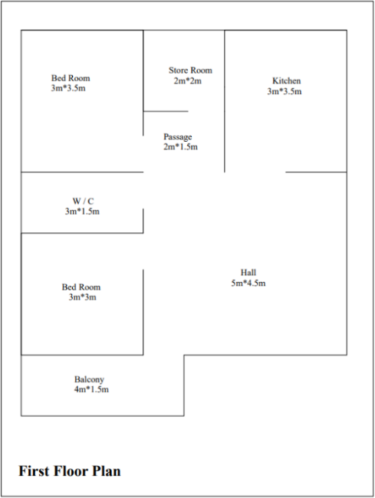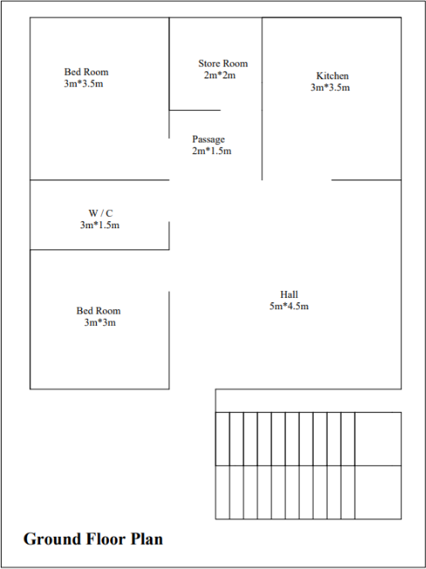

**Figure 1:** Ground floor and first floor plan of conventional Building

# MODELING AND ANALYSIS

STRAP software is used to simulate the light gauge steel construction. Light gauge steel was utilised throughout the construction for analysis and design.

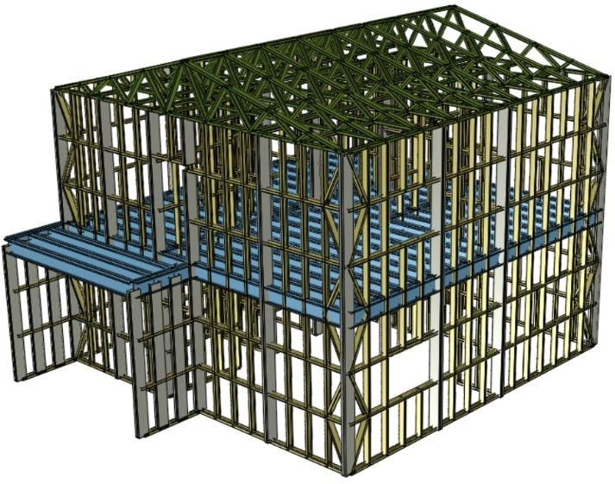

**Figure 2:** 3D Render view of building.

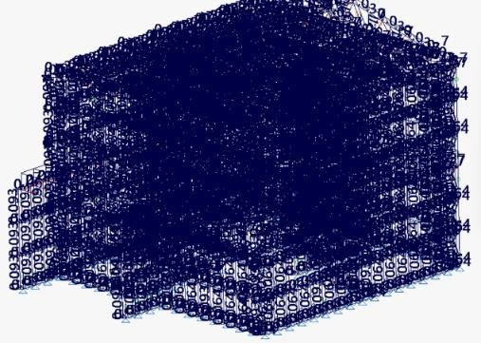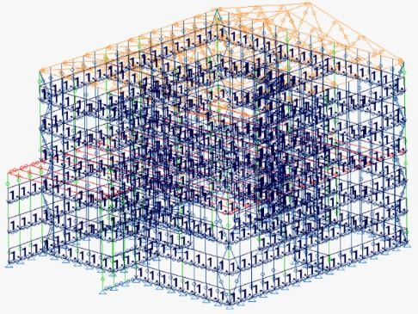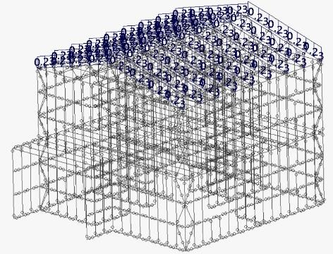

**Figure 3:** Self weight and Dead load

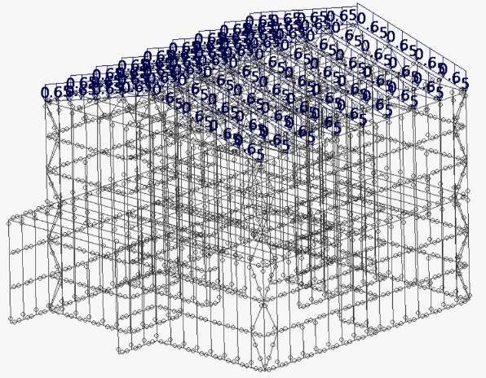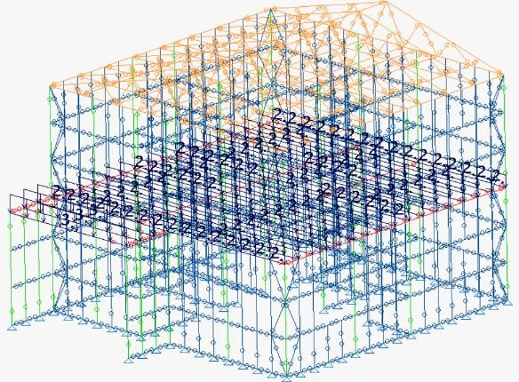

**Figure 4:** Live load on roof and floor

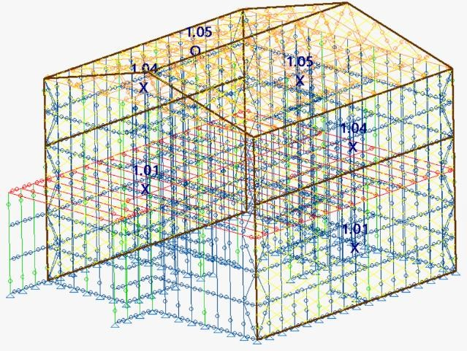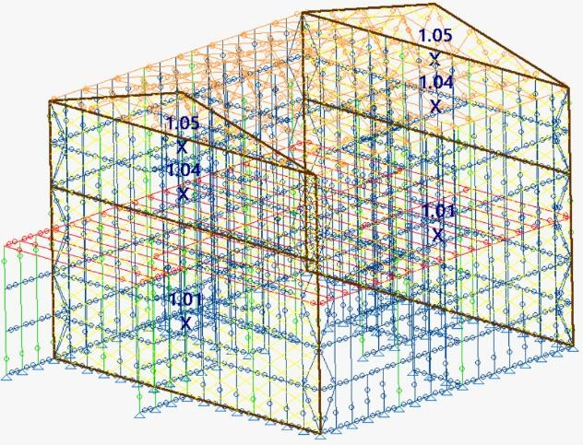

**Figure 5:** Wind load on structural model

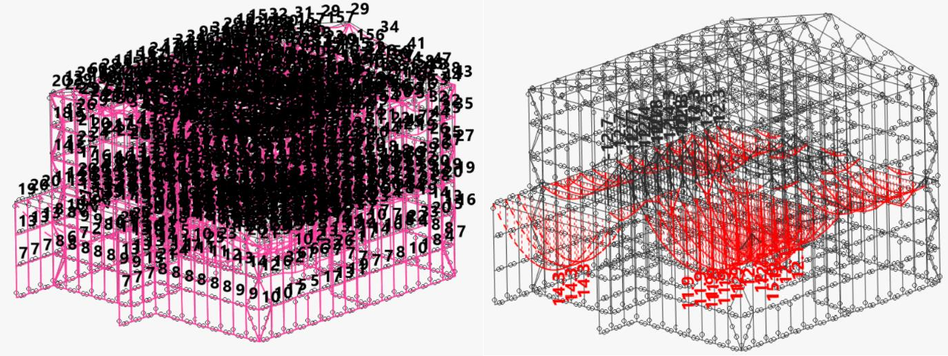

**Figure 6:** Displacement and Bending moment

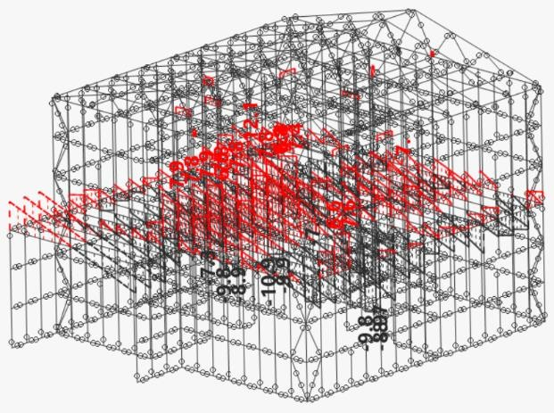

**Figure 7:** Shear Force

# RESULTS AND DISCUSSION

### Analysis results of displacement

The maximum displacement of the nodes getting after analysis of the structure. All the defection are with in the allowable limit.

**Table 1**. Maximum deflection

|  |  |  |
| --- | --- | --- |
| Node | Direction | Maximum deflection in ‘m’ |
| 1022 | X1 | 0.00073 |
| 1108 | X2 | 0.00062 |
| 1019 | X3 | -0.00479 |
| 830 | X4 | -0.004576 |
| 1025 | X5 | 0.0052519 |
| 1007 | X6 | 0.0012767 |

### Analysis results of support reaction

The support are getting after the analysis of the structure using STRAP software

Table 2. Support reaction

|  |  |  |  |  |  |  |
| --- | --- | --- | --- | --- | --- | --- |
|  | Node | X1 | Node | X2 | Node | X3 |
| Max | 69 | 1.453 kN | 17 | 2.123 kN | 364 | 47.236 Kn |
| Min | 85 | -1.313 kN | 85 | -1.938 kN | 82 | 1.693 kN |

### Analysis results of max shear force and max bending moment

**Table 3**. Maximum Shear Force and Bending Moment

|  |  |  |  |
| --- | --- | --- | --- |
|  | Beam number | Maximum | Unit |
| v2 | 2007 | 21.582 | kN |
| v3 | 1946 | 89.539 | kN |
| m2 | 1945 | 43.567 | kN-m |
| m3 | 2271 | 10.789 | kN-m |

**Table 4**. minimum shear force and bending moment

|  |  |  |  |
| --- | --- | --- | --- |
|  | Beam number | Minimum | Unit |
| v2 | 2007 | -21.538 | kN |
| v3 | 1488 | -89.586 | kN |
| m2 | 1488 | -44.273 | kN -m |
| m3 | 2271 | -10.79 | kN -m |

### Section Summery

The table below displays a summary of the sections that the manual assigns to the programme. Using manually defined sections, software analysis is used to develop the structure. Following completion of all sections, the summary section is provided below.

**Table 5**. Summery manually given section

|  |  |  |  |
| --- | --- | --- | --- |
| Sections Summary Table | | | |
| Section | Total length (m) | Weight ( kN ) | Sub-total ( kN ) |
| CLB2B 304.8x177.8x25x3.4 | 357 | 48.92 | 100.428 |
| CLF2F 127x50.8x15x3.4 | 799.57 | 51.508 |
| CLIPS C120x50x2.0 | 328.35 | 12.21 | 23.318 |
| CLIPS C250x50x1.6 | 239.8 | 11.108 |
| Total weight: | 123.746 | | |

The below table shows the section summery after optimisation of the structure. Software analysis and design taking automatically best section for the member and design the structure. Section summery given below.

**Table 6**. Summery of software chosen section

|  |  |  |  |
| --- | --- | --- | --- |
| Sections Summary Table | | | |
| Section | Total length (m) | Weight ( kN ) | Sub total ( kN ) |
| C+LIPS 12x3.5x0.135 | 357 | 48.92 | 89.597 |
| C+LIPS 5x2x0.105 | 799.47 | 40.677 |
| CLIPS C100x50x1.9 | 328.35 | 10.644 | 21.761 |
| CLIPS C250x50x1.6 | 240 | 11.117 |
| Total weight: | 111.357 | | |

# CONCLUSION

1) The structure is basic and adaptable at any point in its service life.

2) The characteristics and benefits of light gauge steel sections are examined in general. Cold-formed steel sections have excellent performance all throughout the globe. in order to protect our structure, our lives, our environment, our society, and the next generation.

3) Light gauge steel has excellent flexural behaviour. Both the building's vertical and horizontal displacements are insufficient to give the impression that it is stable. Stiff frames make up the floor plane and the roof plane. The residential building has adequate capacity under restraint, according to the findings. Due to its apparent lower cost, light gauge steel has a bright future as a structural material.

# REFERENCES

1. S.Vigneshkannan, J.Abdul Bari and P.Easwaran “A GENERAL STUDY OF LIGHT GAUGE STEEL STRUCTURES”, International Journal of Advanced Research Methodology in Engineering & Technology, ISSN 2456-6446 Volume 1, Issue 4, December 2017.
2. Abhijeet Shinde, Lalit Chaudhari and Dr. S. M. Ghumare “Analysis and Design of Light Gauge Steel Structures for Commercial Building”, International Research Journal of Engineering and Technology (IRJET), Volume: 08 Issue: 10 | Oct 2021.
3. Navyashree P M, Sowjanya G V and Dr. T. V. Mallesh “Analysis of Cold Formed Steel Sections: Review Paper”, International Journal of Engineering Research & Technology (IJERT) ISSN: 2278-0181, Special Issue – 2020.
4. Busanaboyina Jagadish Chakravarti and Bhamidipati Sai Krishna “BEHAVIOUR OF COLD FORMED LIGHT GAUGE STEEL ANGLE COLUMNS SUBJECTED TO ECCENTRIC LOADING”, International Journal of

Engineering and Advanced Technology (IJEAT) ISSN: 2249 – 8958, Volume-8 Issue-6, August 2019.

1. Mayankeshwar Singh and Hemant Singh Parihar “STRUCTURAL ANALYSIS OF SKYWALK WITH LIGHT GAUGE STEEL MATERIAL”, International Journal of Advanced Science and Technology, Vol. 29, No. 7, (2020), pp. 3771-3777.
2. Swapnil R. Kalbhor, Nagesh Shelke and Vishwajeet Kadlag “OPTIMIZATION OF INDUSTRIAL STRUCTURE USING LIGHT GAUGE STEEL SECTION”, International Research Journal of Engineering and Technology (IRJET), e-ISSN: 2395-0056, Volume: 07 Issue: 08 | Aug 2020.
3. R. B Kulkarani and Shweta B. khidrapure “Parametric study and comparison of Indian standard code for the Design of Light Gauge cold formed flexural member”, International Journal of Engineering and Technical Research (IJETR), ISSN: 2321-0869, Volume-2, Issue-11, November 2014.
4. . A. Jayaraman, S. Athibaranan , A.Mohanraj-Flexural Behaviour Of Light Gauge Cold Formed Steel Members : Comparison of IS Code And Euro Code-IJRET: International Journal of Research in Engineering and Technology-Volume: 04 Issue: 06 | June2015
5. R.B. Kulkarni, Shweta B.Khidrapure- Parametric study and comparison of Indian standard code with British standard code for the Design of Light gauge cold formed flexural members- nternational Journal of Engineering and Technical Research (IJETR) ISSN: 2321-0869, Volume-2, Issue-11, November 2014
6. Salokhe S. A , Patil P. S -Comparative Study Of Behaviour Of Cold-formed Steeland Hot Rolled Steel Section Under Compressive Loading-IJRET: International Journal of Research in Engineering and Technology,Volume: 04 Issue: 04 | Apr-2015