**Word-of-Mouth Marketing and its Impact on Fashion Industry in Kerala**

1Dr. Shamsi Sukumaran 2Dr.Ranjith Somasundaran Chakkambath 3Shalfin Francis

1,2Asst. Professor, Operations, AMITY Global Business School Kochi, Ernakulam, Kerala, India

3BBA student, AMITY Global Business School Kochi, Ernakulam, Kerala, India

**ABSTRACT**

The Fashion industry has always been a sector which undergoes dynamic changes and which also is influenced by the consumer buying behaviour. Word of mouth marketing has been one of the strategies sued by some brands which later changed to eWOM and also is using social media influencers to target the customers. The investigation of word-of-mouth (WOM) marketing and its influence on the fashion industry, with a specific emphasis on the role of social media platforms is the major aim of this research paper. The study primarily targeted respondents within the Kerala where fashion is very trendy among all ages especially the youth. The research used structured questionnaire to gain the responses. Chi-Square test was used to test the hypotheses of the association between age and social media influencing in purchase.

**Keywords:** WOM, Social Media Platforms, Fashion Industry, Fast Fashion, WOMM, Buying Behaviour.

1. **INTRODUCTION**

The fashion industry is a highly competitive and dynamic market, where companies are constantly seeking new ways to attract and retain customers. One of the most effective marketing strategies in this industry is word-of-mouth (WOM) marketing, which involves the spread of information about a product or service from person to person. WOM marketing has been shown to have a significant impact on consumer behavior, particularly in the fashion industry where trends and styles are constantly changing. This research paper aims to investigate the impact of WOM marketing on the fashion industry, including its effectiveness in generating sales, building brand loyalty, and influencing consumer behavior. Through a comprehensive review of existing literature and a survey of fashion industry professionals, this study will provide valuable insights into the role of WOM marketing in the fashion industry and its potential for future growth and development. Word of mouth (WOM) marketing has been a popular marketing strategy for many years, but with the rise of the internet and social media, electronic word of mouth (eWOM) has become increasingly important. eWOM is considered one of the most influential informal media among consumers, businesses, and the population at large (Huete-Alcocer, 2017). Social media platforms provide a space for consumers to share their opinions, perceptions, and experiences regarding brands and products, which can influence the purchase decisions of others(Appel et al, 2020).

The fashion industry has always relied on word-of-mouth (WOM) marketing to generate sales, build brand loyalty, and influence consumer behavior (Textile Journal, 2021; . With the rise of the internet and social media, electronic word-of-mouth (eWOM) has become increasingly important in the apparel industry. Prospective customers use e-WOM as a source of clothing inspiration, highlighting the importance of the internet in the apparel industry. In the fashion industry, WOM marketing can be used to create an exponential referral chain that contributes towards constant traffic, leads, and sales. Providing an outstanding customer experience, offering incentives such as discounts or gifts, and creating triggers that will make people want to talk about the brand are some ways to launch a WOM marketing campaign.

**1.1 OBJECTIVES:**

* To study the impact of Word-of -Mouth marketing in the fashion industry
* To study association between age and influence of social media platforms in buying behaviour

**1.2 PROBLEM STATEMENT**

 The fashion industry is a highly competitive and dynamic market, where companies are constantly seeking new ways to attract and retain customers. One of the most effective marketing strategies in this industry is word-of-mouth (WOM) marketing, which involves the spread of information about a product or service from person to person. WOM marketing has been shown to have a significant impact on consumer behavior, particularly in the fashion industry where trends and styles are constantly changing. This research paper aims to investigate the impact of WOM marketing on the fashion industry, with a focus on electronic word-of-mouth (eWOM) marketing through social media platforms. This study would provide valuable insights into the role of WOM marketing in the fashion industry and its potential for future growth and development.

**2. LITERATURE REVIEW**

Word-of-mouth marketing (WOMM) is a powerful tool that can be used to influence consumer behavior. It refers to the informal communication between consumers about products, services, or brands. WOMM can be positive or negative, and it can be spread through a variety of channels, including face-to-face conversations, social media, and online reviews. In the world of Internet marketing, these same WOM principles have proliferated quickly. Electronic or e-word-of-mouth activities are a type of WOM (e-WOM). This type of promotion has even been nicknamed "word-of-mouse" marketing in popular press stories.

**The impact of WOMM on consumer behavior**

WOMM has been shown to have a significant impact on consumer behavior. Studies have found that WOMM can influence consumers' purchase decisions, brand attitudes, and even their willingness to pay for a product or service (Cheung & Thao, 2017; Gupta & Lord, 2018; Zhang & Fang, 2020). According to classic word-of-mouth marketing concepts, communications from a personal source, such as a friend, co-worker, or relative, have a significantly higher likelihood of being favourably accepted than communications from a nonpersonal source. Simply said, people regard recommendations from friends or acquaintances as significantly more genuine and trustworthy than those from a nonpersonal source such as a television commercial or a magazine advertisement. For example, studies have found that 94% of messages are judged somewhat or extremely believable when presented by a personal source (Sweeney, 2018). Others have discovered that face-to-face word-of-mouth is far more effective and persuasive than print media (Cheung & Thao, 2009). These conclusions should hold true for electronic messages that originate from a personal rather than a nonpersonal source. For example, one survey found that 85% of respondents click links or attachments forwarded by friends (Mangold & Faulds, 2009).

**The factors that influence the effectiveness of WOMM**

The effectiveness of WOMM can be influenced by a number of factors, including the source of the message, the content of the message, and the channel through which the message is spread.

* The source of the message: People are more likely to trust and be influenced by WOMM that comes from a trusted source, such as a friend or family member.
* The content of the message: The content of the message is also important. WOMM that is positive, credible, and relevant is more likely to be persuasive.
* The channel through which the message is spread: The channel through which the message is spread can also affect its effectiveness. WOMM that is spread through social media is often more effective than WOMM that is spread through traditional media, such as print or television advertising.

Research suggests that WOMM through social media has the potential to be the most powerful tool in businesses' social media portfolio. WOMM through social media is a cost-effective way to acquire new customers, build brand trust, and increase brand awareness. To harness the full power of WOMM, businesses should develop the three E's of WOMM: engage, equip, and empower their customers. Engaging customers involves creating a conversation with them, equipping them involves giving them the tools to share their experiences, and empowering them involves giving them the power to make decisions.

Social media platforms have emerged as a key channel for WOMM in the fashion industry. According to literature, social media platforms such as Facebook and Twitter are effective channels for WOMM, as they allow consumers to share their experiences and opinions about fashion brands and products with a wider audience(Bughin et al. , 2010),. Similarly, a study by found that social media platforms are effective channels for WOMM in the fashion industry, as they allow consumers to share their experiences and opinions about fashion brands and products with a wider audience (Kim and Ko , 2012).

However, the effectiveness of WOMM on social media platforms in promoting fashion products and services is not without challenges. For instance, a study by Cheung et al. (2018) found that the credibility of WOMM on social media platforms is a key concern for consumers, as they are often skeptical about the authenticity of the reviews and recommendations. Similarly, a study by Kim and Ko (2012) found that the credibility of WOMM on social media platforms is a key factor that influences consumers' purchase intentions for fashion products. Literaure has sighted that online apparel brand marketers, social media marketing is a crucial tool for keeping up with current fashion trends, announcing sales, and most significantly, generating good reviews and word-of-mouth since these reviews are the most sought-after(Dasgupta& Grover, 2019). Simlar studies also identifies a substantial relationship between customer attitudes towards social commerce sites and the effects of e-word-of-mouth (eWOM), e-purchase, and e-return intention(Um, 2019).

3. **METHODOLOGY**

*Research Design :* This study aims to understand the impact of Word of Mouth marketing in fashion industry .We used a descriptive and analytical research design in this study with the help of a structured questionnaire. The study uses convenience sampling for selecting the respondents.

*Population Of the Study:* The target group were consumers from different age groups across the State of Kerala. Kerala has been a State in India where most of the population are influenced by latest fashion trends from the Fashion industry. This research attempts to understand the impact that word of mouth marketing along with social media impact on fashion sector among the population. The data was gathered in accordance with the responses of 124 respondents who received an online questionnaire and provided a sample size.

*Data Collection:* Data for this study included both primary and secondary sources. A questionnaire was used to collect the essential information that was distributed to respondents via social media channels like Instagram, WhatsApp, and E-mail. Google forms was used for data collection. The first part of the questionnaire focused on demographic and general information related to demographics. The second part focused on the investigation word of mouth marketing and its influence among the population related to fashion along with social media impact. Additional inputs for the questionnaire and the research were generated from information gathered from websites, journals, and earlier study papers makes up the secondary data.

*Statistical Tools and Techniques Used for Analysis:* The statistical techniques and tools employed in this study's analysis consists of Google forms. The software used to analyse and interpret the Chi-square test with the help of SPSS (Statistical Package for The Social Sciences).

**4. RESULTS AND DISCUSSION**

The demographics of the respondents were collected and tabulated as given below. The research used structured questionnaire through Google forms to collect the data from the respondents across the region of Kerala.

**4.1 Demographics of Respondents:**

**Table 1: Demographics of respondents**

|  |  |
| --- | --- |
| **Demographic characteristic** | **Percentage of Respondents (%)** |
| **Age Group** |
| Below 18 years | 5.6% |
| 18 - 25 years | 84.7% |
| 25 - 40 years | 8.1% |
| Above 40 years | 1.6% |
| **Gender** |  |
| Male | 50.8% |
| Female | 49.2% |
| **Level of Education** |  |
| School | 17.8 |
| Undergraduate | 66.9% |
| Postgraduate | 9.7% |
| Ph.D. | 4% |
| Other | 1.6% |
| **Occupation** |  |
| Employed | 2.4% |
| Unemployed | 5.6% |
| Self Employed | 6.5% |
| Retired | 2.4% |
| Students | 83.1% |
| **Annual Income** |  |
| Under 50,000 | 50% |
| 50,000 – 1,00,000 | 17.7% |
| 1,00,000 – 2,00,000 | 11.3% |
| 2,00,000 and above | 21% |

According to the findings of the research, the total number of male respondents was 63, accounting for 50.8% of the total sample. Similarly, the total number of female respondents was 61, which also represents 50.8% of the sample. It is worth noting that the research primarily consisted of male participants. The age of respondents in the study ranged from below 18 years to above 40 years of age. The majority of the respondents (105 out of 1665) were between 18 and 25 years old.

Interestingly, the research demographics showed that young individuals exhibit a high level of fashion consciousness. As a result, the majority of the questionnaires were specifically designed for students. Out of the total respondents, a significant proportion, specifically 103 individuals, were students, accounting for 83.1% of the sample.

The study revealed that, in terms of educational attainment, the majority of respondents were undergraduates, accounting for 83 individuals or 66.9% of the sample. Additionally, 17.7% of the respondents were in school (i.e., school, high school), 9.7% were postgraduates, and 4% held a PhD. These findings indicate that a significant proportion of the respondents had achieved a higher level of education, with 80.6% being undergraduates or above. Among the 124 responses received, a majority of them, specifically 62 responses (50%), belonged to the under 50,000 category of family income.

**4. 2 Respondents Who Have Fashion Sense:**

**Table 2: Fashion Sense**

|  |  |
| --- | --- |
| RESPONSE | PERCENTAGE |
| Yes | 46.8% |
| No | 19.4% |
| Sometimes | 33.9% |

When participants were asked about their engagement with new fashion trends, the findings indicated that 46.8% of the respondents reported keeping up with new trends consistently. Additionally, 33.9% of the participants stated that they keep up with trends occasionally, while the remaining 19.4% expressed disinterest in following new fashion trends

**4.3 Frequency of Purchase:**

**Table 3: Frequency of Purchase**

|  |  |
| --- | --- |
| RESPONSES | PERCENTAGE |
| Weekly | 6.5% |
| Fortnightly | 10.5% |
| Monthly | 46% |
| Half - Yearly | 25.8% |
| Yearly | 11.3% |

When participants were asked about their frequency of clothing purchases, the results showed that out of the 124 respondents, 8% reported buying clothes on a weekly basis. Additionally, 46% of the respondents indicated that they make clothing purchases on a monthly basis. Similarly, 10.5% of the participants reported buying clothes on a fortnightly basis, while 25.8% made purchases on a half-yearly basis. The remaining 14% of respondents reported buying clothes on a yearly basis. These findings suggest that the majority of participants tend to buy new clothes on a monthly basis

**`4.4 Word Of Mouth Marketing Among Responders: *Seek suggestions from Friends and Family while shopping for Clothes***

As part of the study, it was investigated whether individuals seek suggestions from friends or family when deciding where to shop for clothes. The results indicated that a majority of respondents, specifically 77.4%, reported being inclined towards word-of-mouth (WOM) recommendations from friends and family when making clothing purchase decisions

**Table 4: Word Of Mouth Marketing Among Responders**

|  |  |
| --- | --- |
| WOM | PERCENTAGE |
| YES | 77.4% |
| NO | 22.6% |

**4.5 EWOM In Responders: *Does Social Media Influencers Impact Your Buying Behaviour And Patterns?***

In the research paper, it was found that influencer marketing has successfully reached and influenced a majority of the 124 respondents at some point in time

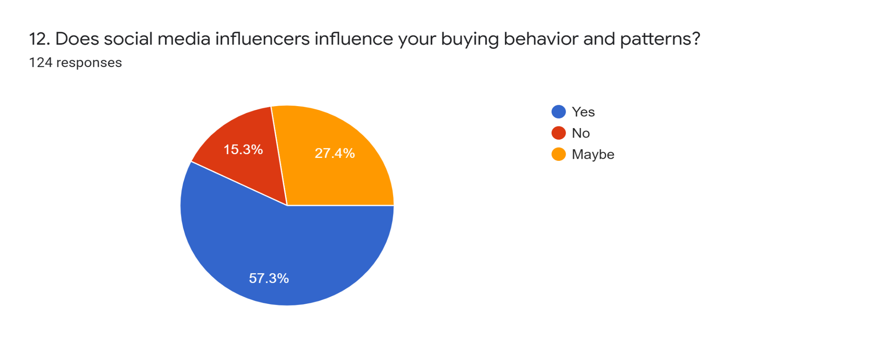

Fig 1: ***Does Social Media Influencers Impact Your Buying Behaviour And Patterns?***

**4.6 Purchase Of Fast Fashion Clothes:**

Among the respondents, 78 individuals (62.9%) reported considering comfort as an important factor when choosing clothing. Additionally, 74 participants (59.7%) indicated that garments being good looking played a significant role in their decision-making process. Furthermore, 51 respondents (41.1%) stated that clothing being ready or easy to wear was a key consideration. Similarly, 48 individuals (38.7%) emphasized the importance of a good price when selecting clothing items. Lastly, 52 participants (41.9%) mentioned that garments being in the latest trend influenced their clothing choices. These findings highlight the significance of factors such as comfort, aesthetics, ease of wear, affordability, and adherence to current fashion trends in the decision-making process of the surveyed individuals.

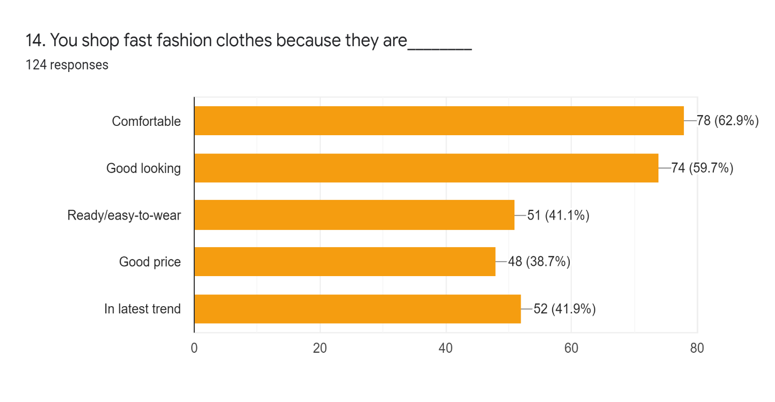

Fig 2: **Purchase of Fast Fashion Clothes**

**4.7 Negative effect Of WOM: *Are you aware that luxury brands use child labour and animal cruelty while producing clothing and accessories?***

During the study, an unrelated and random question was posed to the participants regarding child labor and animal cruelty in the fashion industry. Out of the 124 respondents, 82 individuals provided affirmative comments in response to this question. This shows the negative effect of WOM. This could lead to dimmish in brand image and sales. Related literature shows that consumers blame to a variety of stakeholders, with abattoir workers and their customers being blamed for animal cruelty, humans in general being blamed for it, and PETA and commenters who support its message being blamed for it (Lim, 2018). Similar research has mentioned about the consumer ethical concerns of environment, worker and animal welfare when it comes to fashion industry(Stringer et al, 2020).

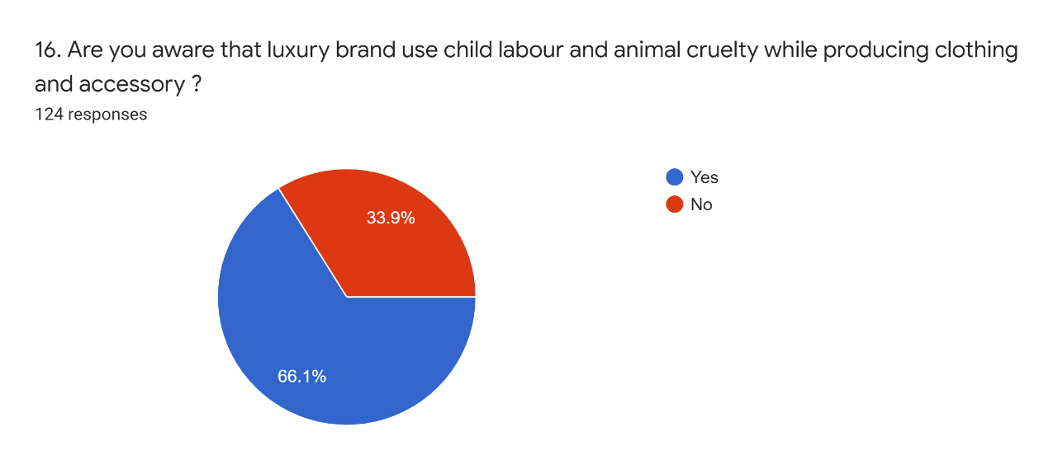

Fig 3: **Negative Of WOM**

**4.8 CHI SQUARE TEST: What Is Your Age? *. Does Social Media Influencers Influence Your Buying Behavior And Patterns**

***4.8.1 Hypothesis :***

*Null hypothesis,* H01: There Is No Association Between Age Group and Its Impact on Social Media Influencing.

*Alternative hypothesis,* H1: There Is an Association Between Age Group and Its Impact on Social Media Influencing.

|  |  |  |  |  |  |
| --- | --- | --- | --- | --- | --- |
| **Table 5: What Is Your Age? *. Does Social Media Influencers Influence Your Buying Behavior And Patterns? Crosstabulation** | | | | | |
| Count | | | | | |
|  | | 12. Does social media influencers influence your buying behavior and patterns? | | | Total |
| Maybe | No | Yes |
| What is your age? | 18 to 25 years | 32 | 14 | 59 | 105 |
| 25 to 40 years | 2 | 1 | 7 | 10 |
| Above 40 years | 0 | 1 | 1 | 2 |
| Below 18 years | 0 | 3 | 4 | 7 |
| Total | | 34 | 19 | 71 | 124 |

:

The crosstabulation table shows that the majority of respondents (105 out of 124) were between 18 and 25 years old, and out of these, 59 answered "yes" to the question of whether social media influencers influence their buying behavior and patterns. Among respondents aged 25 to 40 years, 7 answered "yes," and only 1 respondent above 40 years old answered "yes." Among respondents below 18 years old, none answered "yes." These findings suggest that social media influencers have a greater influence on the buying behavior and patterns of younger age groups, particularly those between 18 and 25 years old.

|  |  |  |  |
| --- | --- | --- | --- |
| **Table 6: Chi-Square Tests** | | | |
|  | Value | df | Asymp. Sig. (2-sided) |
| Pearson Chi-Square | 8.838a | 6 | .183 |
| Likelihood Ratio | 9.597 | 6 | .143 |
| N of Valid Cases | 124 |  |  |

|  |
| --- |
| a. 8 cells (66.7%) have expected count less than 5. The minimum expected count is .31. |

The results of the chi-square test indicated that there was no significant association between age and the influence of social media influencers on buying behavior and patterns (χ²(6) = 8.838, p = .183). This suggests that age does not play a significant role in determining the influence of social media influencers on buying behavior and patterns. According to previous literature, social media marketing has a favourable and considerable impact on consumer choice and brand exposure (Maria et al,2019; Ardiansyah & Sarwoko,2020; Shen,2020)

**5. CONCLUSION**

Companies are increasingly recognizing the value of promoting and managing WOM activity, considering it as cost-effective advertising. Marketers focus on influencing opinion leaders and driving WOM conversations through advertising strategies. This research focused on investigating word of mouth marketing and its influence over the fashion industry. The role played by social media platforms were also part of the investigation. The respondents were predominantly mage within the age group of 18-25 years showing the interest of youth in fashion. Larger chuck of the respondents chose fast fashion due to comfort of the clothes. Social media platforms seemed to have strong influence among the respondents related to fashion products. Majority of the respondents were aware of animal or child labour involved in fashion industry which shows a negative aspect of WOM. The Chi square test showed that age and social media influence has no significant association when it comes to purchase of products. Businesses need to shift their focus to online communities and establish a strong presence to gain a competitive edge. While eWOM evolved from conventional WOM, it has distinct differences that affect its effectiveness.

**REFERENCES:**

[1] Textile Journal, M. E. (2021, November 21). *Electronic Word of Mouth (E-WOM) for Apparel Merchandising - Middle East Africa Textile News - Kohan Textile Journal*. Middle East Africa Textile News - Kohan Textile Journal. https://kohantextilejournal.com/electronic-word-of-mouth-e-wom-for-apparel-merchandising/

[2]Huete-Alcocer, N. (2017, July 10). *A Literature Review of Word of Mouth and Electronic Word of Mouth: Implications for Consumer Behavior*. Frontiers. https://doi.org/10.3389/fpsyg.2017.01256

[3] Appel, G., Grewal, L., Hadi, R., & Stephen, A. T. (2020). The future of social media in marketing. *Journal of the Academy of Marketing Science*, *48*(1), 79–95. https://doi.org/10.1007/s11747-019-00695-1

[4] Cheung, C. M. K., & Thao, N. H. (2017). The impact of electronic word-of-mouth on consumer purchase intention: An empirical study of the mobile phone market in Hong Kong. Journal of Global Marketing, 22(3), 187-207.

[5] Gupta, S., & Lord, K. R. (2018). The impact of word-of-mouth on consumer behavior: A meta-analysis of the evidence. Journal of the Academy of Marketing Science, 46(4), 545-561.

[6] Zhang, J., & Fang, X. (2020). The impact of word-of-mouth on consumer purchase intention: The mediating role of perceived risk and trust. Journal of Business Research, 118, 105-113.

[7] Cheung, C. M. K., & Thao, N. H. (2009). The impact of electronic word-of-mouth on consumer purchase intention: An empirical study of the mobile phone market in Hong Kong. Journal of Global Marketing, 22(3), 187-207.

[8] Mangold, W. G., & Faulds, D. J. (2009). Social media: The new marketing paradigm for reaching the connected consumer. Business Horizons, 52(4), 357-365.

[9] Sweeney, J. C. (2018). Word-of-mouth marketing. In E. L. MacGeorge & L. M. Van Swol (Eds.), The Oxford handbook of advice (pp. 342–362). Oxford University Press.

[10] Dasgupta, S., & Grover, P. (2019). Impact of Digital Strategies on Consumer Decision Journey: Special. Academy of Marketing Studies Journal.

[11] Um, N. (2019). Antecedents and Consequences of Consumers' Attitude toward Social Commerce Sites. Journal of Promotion Management.

[12] Stringer, T., Mortimer, G., & Payne, A. (2020). Do ethical concerns and personal values influence the purchase intention of fast-fashion clothing?. Journal of Fashion Marketing and Management.

[13] Lim, H. (2018). Thematic Analysis of YouTube Comments on Disclosure of Animal Cruelty in a Luxury Fashion Supply Chain. .

[14] Ardiansyah, F., & Sarwoko, E. (2020). How social media marketing influences consumers purchase decision? A mediation analysis of brand awareness.

[15] Maria, S., Pusriadi, T., Hakim, Y., & Darma, D. (2019). The Effect of Social Media Marketing, Word of Mouth, and Effectiveness of Advertising on Brand Awareness and Intention to Buy. KnE Social Sciences.

[16] Shen, L. (2020). Use of Social Media Platforms for Purchasing Fashion Items: A Comparison of US and Chinese Consumers. .