**A NUMERICAL ANALYSIS OF STEEL BUILDINGS WITH DIAGONAL-BRACING STRUCTURAL SYSTEMS**

**Ashish1, Sunil Kumar2**

1M.Tech. Scholar, Ganga Institute of Technology and Management

2Assistant Professor, Ganga Institute of Technology and Management

**ABSTRACT**

The construction industry has witnessed a shift in focus among civil engineers towards designing elevated buildings that can withstand lateral earthquake loads. The Diagonal-grid structural system has emerged as an innovative and flexible solution to address this need. This system utilizes inclined columns arranged in a bordered tube pattern on the building's outer surface, enabling axial action to resist lateral loads. Its advantages include improved organizational efficiency and architectural flexibility. However, further research is necessary to explore the structural characteristics of this system in depth. This study aims to investigate the Diagonal-grid system by conducting linear dynamic analysis using the response spectrum technique in the ETABS software. A comparison is made between the Diagonal-grid system and traditional systems, considering parameters such as top storey displacement, inter-storey drift, base shear, and time period. The impact of module variation on these parameters is examined through the analysis of alternative high-elevation constructions with different module sizes vertically and horizontally.

**Keywords:** elevated buildings, Diagonal-grid system, lateral earthquake loads, structural characteristics, research

1. **INTRODUCTION**

In recent years, the increasing population growth and limited availability of land have driven the need for larger structures, leading to a shift towards vertical expansion. As buildings reach greater heights, ensuring their structural stability and resistance to lateral loads, particularly from wind and earthquakes, becomes crucial. This has prompted civil engineers to explore innovative structural systems that can efficiently withstand these forces.

Among the various structural systems used in tall buildings, steel and reinforced concrete systems have gained prominence due to their strength, durability, and ease of construction. However, as the demand for taller structures continues to rise, traditional gravity load-resisting systems alone are no longer sufficient. The focus has shifted towards developing systems that effectively address lateral loads.

One such innovative system that has gained attention is the Diagonal-grid structural system. This system employs inclined columns arranged in a bordered tube pattern on the building's outer surface, enabling efficient load distribution and lateral load resistance through axial action. The Diagonal-grid structure offers advantages in terms of organizational productivity and architectural flexibility, making it an appealing choice for tall buildings.

To further explore the potential and characteristics of the Diagonal-grid system, extensive research and analysis are needed. This study aims to analyze and compare the structural behavior of the Diagonal-grid system with traditional systems commonly used in tall buildings. The analysis will be conducted using the response spectrum technique, a widely accepted method for evaluating the dynamic response of structures subjected to seismic loads.

Key parameters such as top storey displacement, inter-storey drift, base shear, and time period will be examined to assess the performance of the Diagonal-grid system under different scenarios. Additionally, the impact of module variation, shear wall core, and external corner columns on the behavior of the Diagonal-grid system will be investigated.

The findings of this research will contribute to a better understanding of the Diagonal-grid system's structural characteristics and its suitability for tall buildings subjected to tangential earthquake loads. By identifying the benefits and limitations of the system and studying its behavior under various conditions, this study aims to advance the field of structural engineering in the context of vertical expansion and innovative construction systems for tall buildings.

|  |
| --- |
|  |

Figure 1: Gravity Loading Effect

|  |
| --- |
|  |

**Figure 2:** Shear loading Effect

1. **METHODOLOGY**

To analyze the structural behavior of Diagonal-grid Structures and compare them with traditional systems, a comprehensive methodology is employed. The methodology includes the following steps:

**2.1. Literature Review:** A thorough review of relevant literature and research articles is conducted to gain a comprehensive understanding of the Diagonal-grid system, its design principles, and its performance under seismic and wind loads. This step provides a foundation for the subsequent analysis.

**2.2 Data Collection:** Necessary data for the analysis, such as structural drawings, material properties, and loading conditions, are collected. This includes obtaining information on the Diagonal-grid system's configuration, module variations, and the presence of shear wall cores and external corner columns.

**2.3 Software Selection:** The ETABS software is chosen for its proficiency in modeling and analyzing building structures. ETABS (Extended Three Dimensional Analysis of Building Systems) is a widely used finite element-based structural analysis application that offers specialized capabilities for designing and analyzing building systems.

**3.4 Model Creation:** Using the collected data, a detailed structural model of both the Diagonal-grid system and traditional systems is created in the ETABS software. The model accurately represents the geometry, material properties, and connection details of the structures under investigation.

**3.5 Load Definitions:** Seismic and wind loads are defined based on the design codes and regulations specific to the study area. These loads are applied to the structural model to simulate real-world conditions and evaluate the response of the systems.

**3.6 Analysis Methods:** Various analysis methods are employed to study the structural behavior of the Diagonal-grid system and traditional systems. These methods include static analysis, dynamic study, response spectrum study, period antiquity examination, and pushover analysis. Each method provides valuable insights into the systems' response to lateral loads and their overall stability.

**3.7 Evaluation Parameters:** Key parameters such as top storey displacement, inter-storey drift, base shear, and time period are evaluated for both the Diagonal-grid system and traditional systems. These parameters serve as indicators of the structural performance and resilience under seismic and wind loads.

**3.8 Comparative Analysis:** The analysis results are compared between the Diagonal-grid system and traditional systems to assess the advantages and disadvantages of each. The influence of module variation, shear wall cores, and external corner columns on the behavior of the Diagonal-grid system is also examined.

1. **RESULTS AND DISCUSSION**

The analysis of Diagonal-grid systems with varying module sizes and different numbers of storeys provides valuable insights into their structural properties and behavior. The following results and discussions summarize the findings of the study:

1. Influence of Module Size Variation:

- Shear Rigidity: According to Moon (2007), a module angle of 35 degrees offers optimal shear rigidity for Diagonal-grid systems. As the module size increases, the system's cross-stiffening improves, leading to enhanced shear resistance.

- Bending Inflexibility: Moon (2007) notes that a module inclination of 90 degrees (upright pillar) provides extreme bending inflexibility. Therefore, the bottom portion of the Diagonal-grid system should be designed for bending resistance.

- Shear and Bending Balance: The study reveals that a balance between shear and bending rigidity must be achieved in the Diagonal-grid system. As the module size varies, the structural design should be adjusted to ensure an appropriate balance between shear and bending resistance.

2. Influence of Building Height:

- Cross-Stiffening Effect: According to Moon (2011), as the Diagonal-grid system grows in height, the cross-stiffening effect improves. This enhancement in cross-stiffening contributes to increased structural stability and reduced lateral displacements.

- Horizontal Variation: The study suggests that as the Diagonal-grid system increases in height, horizontal variation becomes feasible. This implies that different ideal angles can be adopted for different portions of the building, considering the varying shear and bending requirements.

3. Structural Performance:

- Shear Forces: The analysis indicates that the top section of the Diagonal-grid system should be designed to resist shear forces, which increase linearly with height.

- Bending Moments: Bending moments increase non-linearly with height. Consequently, the bottom portion of the Diagonal-grid system should be designed to effectively withstand bending moments.

- Structural Stability: The results demonstrate that Diagonal-grid systems with appropriate module size variation exhibit improved structural stability, reduced lateral displacements, and enhanced resistance against lateral loads.

The findings of this study emphasize the significance of module size variation in achieving an optimal balance between shear and bending rigidity in Diagonal-grid systems. By adjusting the module sizes both horizontally and vertically, it is possible to tailor the structural design to effectively resist shear and bending forces. This flexibility in design enables the creation of tall buildings with enhanced stability and reduced lateral displacements.

It is important to note that the design and implementation of Diagonal-grid systems with varying module sizes require careful consideration of construction techniques, fabrication processes, and connection details. The complexity of the system and potential challenges in construction should be carefully managed to ensure successful implementation.

Further research and analysis are warranted to explore the optimal module size variations for different building heights and to assess the long-term performance and resilience of Diagonal-grid systems under various loading conditions. This research contributes to the understanding of the structural behavior of Diagonal-grid systems and provides valuable insights for the design and construction of tall buildings using this innovative structural system.

**Table 1:** Frame Sections Properties of Structures for Study of Module Variation

|  |  |  |  |  |
| --- | --- | --- | --- | --- |
| **Structure-** | **Beam-** | **Diagonal-grid** | **Slab** | **Shear Wall** |
| 24- Storey | ISMB 550 &  ISWB 500 | ISNB 300 steel pipes (as per IS1161-1982) | 220 mm | 240 mm |
| 30 -Storey | ISMB 550 &  ISWB 500 | ISNB 350 steel pipes ( as per IS1161-1982) | 220 mm | 300 mm |
| 36- Storey | ISMB 500 &  ISWB 550 | ISNB 350 steel pipes (as per IS1161-1982) | 220 mm | 300 mm |

**Table 2:** Different structures and module sizes have been employed

|  |  |
| --- | --- |
| ***Building Configurations*** |  |
| Plan Dimension |  |
| 24 & 30 Storey | 21.5*21.5 m |
| 36 & 42 Storey | 36.5*36.5 m |
| Storey Height | 3.2 m |
| Shear Wall Core |  |
| 24 & 30 Storey | 7.2*7.2 m |
| 36 & 42 Storey | 9.2*9.2 m |

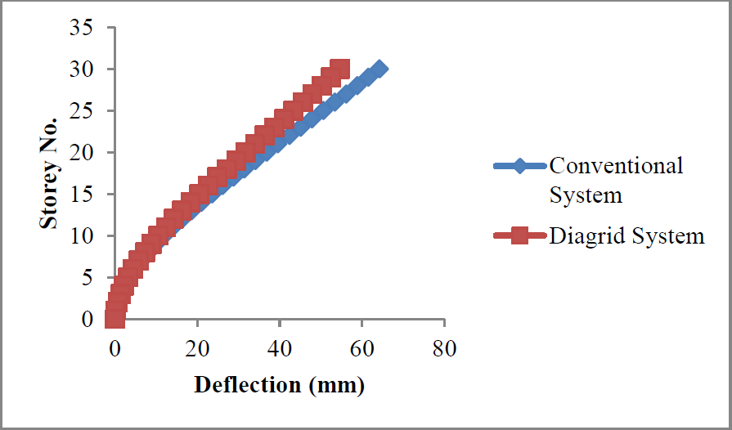

**Figure 3:** Max. Top Storey Displacement for Diagonal-grid and Conventional

1. **CONCLUSION**

The Diagonal-grid structural system has emerged as an innovative solution for tall buildings, offering enhanced structural efficiency and resistance to lateral loads. In this study, the influence of module size variation on the structural properties of Diagonal-grid systems was investigated. The analysis considered parameters such as shear rigidity, bending inflexibility, shear and bending balance, and the cross-stiffening effect with increasing building height.

The results indicate that achieving an optimal balance between shear and bending rigidity is crucial in designing Diagonal-grid systems. A module angle of 35 degrees was found to provide optimal shear rigidity, while a 90-degree module inclination (upright pillar) offers extreme bending inflexibility. By varying the module sizes both horizontally and vertically, it is possible to tailor the structural design to effectively resist shear and bending forces. This flexibility in design allows for the construction of tall buildings with improved stability and reduced lateral displacements.

Furthermore, the analysis demonstrates that as the Diagonal-grid system increases in height, the cross-stiffening effect improves, leading to enhanced structural stability and reduced lateral displacements. The study suggests the possibility of horizontal variation in the Diagonal-grid system, allowing different ideal angles to be adopted for different sections of the building based on varying shear and bending requirements.

The findings highlight the importance of careful consideration in the design and implementation of Diagonal-grid systems with varying module sizes. Construction techniques, fabrication processes, and connection details should be meticulously managed to ensure successful implementation and to overcome the potential challenges associated with this complex structural system.

Overall, this research contributes to the understanding of the structural behavior of Diagonal-grid systems and provides valuable insights for the design and construction of tall buildings using this innovative structural solution. Further research is warranted to explore optimal module size variations for different building heights and to evaluate the long-term performance and resilience of Diagonal-grid systems under various loading conditions. By advancing the knowledge in this field, engineers can continue to develop sustainable and resilient tall buildings that can withstand the challenges of seismic and wind forces in today's urban landscape.

1. **REFERENCES**
2. Boake T.M, 2013, “Diagonal-grid Structures: Innovation and Detailing”, Conference Proceedings, ICSA.
3. Charnish B, McDonnell T, 2008, “The Bow: Unique Diagonal-grid Structural System for a sustainable Building”, CTBUH 8th world congress, Dubai, Building Case Study, conference proceedings, pp.1-5.
4. Ali M.M, Moon K.S, 2007, “Structural Progresses in Tall Structures: Current Tendencies and Future Prospects, Science Review, Volume 50(3), pp. 205-223.
5. Boake T.M, 2013, “Diagonal-grids, the new stability system, Combining Architecture with Engineering”, J. AEI, pp.574-583.
6. Deshpande R.D, Patil S.M, RatanSubramanya, 2015, “Analysis and Design of Diagonal-grid and conventional Structural system”, Volume 2, IRJET.
7. Gupta I., Sehgal V.K, 2015, “Diagonal-grid Structural System: Analysis using ETABS”, TCIFES-2015, C.S.I.R, CLRI Chennai.
8. Gunel M.H., EmreIlgin H., 2007, “A suggestion for the cataloging of structural systems of tall buildings”, J. Building and Environment, Volume 42, pp. 2667– 2675.
9. IS: 1893 (Part-1)-2002, EQRD aspects.
10. IS: 875 (Part-3) -1987, designing for loading (other than Earthquake) or Buildings and Structures
11. IS: 456-2000, Plain and Reinforced Concrete – Code of PracticeIS: 800-2007,.
12. J. Kim, Y. Jun and Y.-Ho Lee, 2010, “Seismic Performance Evaluation of Diagonal-grid System Buildings” Mitigation.
13. Jani K.D and Patel P.V, 2014, Designing of tall rise buildings as per Indian Standards”, Structure Congress, ASCE, pp.1070-1081.
14. Jani K.D and Patel P.V, 2013, “Analysis-Design of Diagonal-grid-Structural System for high Rise buildings”, Elsevier Procedia Engineering, Volume-51, pp.92-100.
15. Leonard J., 2007, “Investigation Diagonal-grid System”, M.S thesis, MIT.
16. Moon K.S, 2011, “Diagonal-grid structural coplex shape”, Volume 42, pp.1343-1350.
17. Moon K.S, 2015, “Comparative Efficiency between structural systems for tall buildings of various forms”, AEI: Birth and Life of the integrated building, pp.111-119.