ANALYSIS ON RC TEE BEAMS WITH WEB OPENINGS SHEAR STRENGTHENING APPLYING FRP MIXTURES
Vinod Kumar¹, Sunil Kumar²
¹M.Tech. Scholar, Ganga Institute of Technology and Management
²Assistant Professor, Ganga Institute of Technology and Management
ABSTRACT
Retrofitting is a vital practice in civil engineering aimed at enhancing the safety and resilience of existing structures, particularly in response to seismic events. These abstract highlights the significance of retrofitting in addressing the shortcomings of older buildings constructed under outdated design codes. The increasing impact of natural disasters, notably earthquakes, has necessitated the implementation of stricter safety requirements in structures. Retrofitting offers a cost-effective solution to upgrade and strengthen these structures, improving their load-carrying capacity and extending their service life. By making modifications to existing buildings, such as the application of composite jackets to reinforce columns, the structures can be safeguarded against hazards like earthquakes, strong winds, and flooding.
Keywords: fiber-reinforced polymers (FRP) retrofitting, structures, seismic events, safety, resilience
- INTRODUCTION
Concrete structures in civil engineering face the challenge of degradation over time, requiring effective measures to ensure their longevity and safety. While rehabilitation and total replacement are two common approaches, the high costs and extensive labor involved make rehabilitation a preferred choice. A promising solution for reinforcing and restoring these structures is the use of fiber-reinforced polymers (FRP). In this chapter, we present a comprehensive literature review on the application of FRP for reinforcing reinforced concrete (RC) beams.The review focuses on three main areas: strengthening RC rectangular beams, RC Tee beams, and RC rectangular shape beams. Numerous studies have investigated the use of FRP for enhancing the strength and performance of RC beams. For example, researchers have explored the performance of RC beams strengthened with fiber glass plate bonding (FGPB) for shear reinforcement. Others have developed design strategies for RC slabs and flexural beams using externally attached FRP plates.Furthermore, the literature review delves into the application of FRP in improving the flexural and shear strength of RC Tee beams. Studies have examined the effectiveness of various FRP wraps and quantities in enhancing the ductility and load-bearing capacity of these beams.
The literature review is divided into three groups, which include firming up RC-rectangular and Tee beams with web maiden, firming of RC-Tee beams, and firming up RC-rectangular shape beams. Several studies have explored the use of FRP in enhancing the strength and performance of RC beams. Ghazi et al. (1994) investigated the performance of RC beams strengthened with fiber glass plate bonding (FGPB) for shear reinforcement. Chaallal et al. (1998) developed a comprehensive design strategy for one-directional slabs and reinforced concrete flexural beams using externally attached FRP plates. Khalifa et al. (2000) conducted an analytical examination of the shear capacity and failure mechanisms of RC girders enhanced with externally bonded FRP laminates. Alex et al. (2001) experimentally investigated the impact of shear strengthening on stress distribution, early cracking, and ultimate strength of RC beams. Sheikh (2002) examined the use of FRP for retrofitting and repairing damaged buildings, highlighting its potential to improve mechanical performance. Chen and Teng (2003) focused on the shearing capacity of FRP-strengthened girders and proposed a model to predict failure due to FRP debonding.
Furthermore, research has also been conducted on improving the strength of RC Tee beams. Hamid et al. (1992) studied the flexural strength of RC beams reinforced with glass-fiber-reinforced-plastic (GFRP) sheets attached to the tension flange. Sayed et al. (1999) investigated the performance of RC beams enhanced with various types of FRP wraps, evaluating the ductility and load-bearing capacity. Khalifa et al. (2000) examined the shear strength of RC T-section joists strengthened with externally bonded CFRP, exploring different wrapping strategies and CFRP quantities.
- METHODOLOGY
In this examination sample, we provide details about the prestressed concrete Tee beams and the materials used in their construction. The beams are 1400 mm long, with a web width of 40 cm, flange width of 450 mm, and a minimum thickness of 150 mm. Tensile reinforcement is achieved using two sets of 1 cm rods and one set of 12 mm HYSD rods.

The beams are categorized into two groups: Group A and Group B. Group A beams omit the provision for hooking, while Group B beams have double the amount of 20 mm and 10 mm HYSD rods for tensile reinforcement. Additionally, Group B beams have 4-8 mm bars for hanging rods and eight 8 mm bars for shearing reinforcement, spaced 220 mm apart.
Concrete used in the beams follows the guidelines of IS 456-2000. The mixture ratios for cement, fine aggregate, coarse aggregate, and water are provided in Table 1. Compression tests are conducted on control and reinforced cube samples at 7 days and 28 days, with the results presented in Table 3.2.
The materials used in the construction include cement (Portland Slag Cement), fine aggregate (sand), coarse aggregate (crushed stone), water, and steel reinforcement (HYSD rods). The steel reinforcement rods have a diameter of 20 mm and 10 mm, conforming to IS 1786:1985.
Fiber-reinforced polymers (FRPs) are employed for reinforcement, specifically GRP (glass fiber-reinforced polymer) sheets. The GRP sheets are unidirectional, and E-glass from Owens Manufacturing is used. Epoxy resins are utilized as the bonding agent for connecting the GRP sheets to the concrete substrate.
The molding process for GFRP (glass fiber-reinforced polymer) plates is described, highlighting the manual lay-up contact molding method. The materials used for molding include epoxy resin, hardener, polyvinyl malt, and GFRP. Hand lay-up contact molding is performed to assemble the layers of GFRP in the correct order.
Overall, this examination sample provides detailed information about the construction materials, mixture ratios, and reinforcement techniques used in the prestressed concrete Tee beams.
Table 1: Minimal Mixture Amounts of Concrete

Explanation | Cements | Fine | Coarse | Water
 |  | Aggregate | Aggregate
Mixture Ratio | 3 | 2.88 | 2.65 | 0.6
Amounts of ingredients for one | 42.2 | 34.66 | 165.25 | 22.22
sample beam in kg
Table 2: Assessment Outcome of Cubes later 28 days
Sample Designation |  | Size of Cube | Size of | Typical | Typical
 |  | Sample | Cylindrical | Cube | Cylindrical
 |  |  |  | Compressive | Compressive
 |  |  | Sample | Strength (N/mm2) | Strength (N/mm2)
 | Solid | 150 mmx150 mm x150 mm | 150 x 250 | 33.33 | 24.33
 | beam
 | CB | 150 mmx150 mm x150 mm | 150 x 250 | 347.22 | 19.88
 | SB2-1 | 150 mmx150 mm x150 mm | 150 x 250 | 41.66 | 22.63
 | SB2-2 | 150 mmx150 mm x150 mm | 150 x 250 | 38.22 | 21.71
 | SB2-3 | 150 mmx150 mm x150 mm | 150 x 250 | 29.22 | 22.64
 | SBA-1 | 150 mmx150 mm x150 mm | 150 x 250 | 35.69 | 24.33

- RESULTS AND DISCUSSION
With the exception of SB3 and SBB3, all samples are evaluated as straightforward RC Tee beams utilising a 4-plug stationary loadings frames by means of a shearing span to actual profundity ratio (a/d) of 2.66. and SB3 , on the other hand, have an a/d ratio of 2. The testing process is the same aimed at the whole sample. Next 28-day drying time is complete, the beam cleaning is done with sand to make fractures more visible. The particulars of the test arrangement are shown in Figure 1. For evaluation, a test rig with such a 550 kN capability that was connected to a hydraulics jacked were applied to extent the weight. The configuration in Fig 3-10 neatly provides four load. Through a strain gauge and circular seat on a strengthening, the pressure is transferred.
To provide a level, smooth surface, this spreader beam is mounted on rollers that are set in place on steel plates that are cemented to the test member. The test part is supported by spreader plates that operate as comparable roller bearings. The loading structure needs to be strong enough to support the anticipated test loads without experiencing too much deformation. Accessibility to the central portion aimed at fracture explanations, displacement data, and perhaps strain extents is crucial, as is security in the event of collapse. The sample is positioned over through the two steel roller bearings, 150 mm away from the beam's edges. As seen in figure 3-10, the residual 1200 mm is alienated hooked on 3 equally-sized segments of 33 centimetres. A 550 kN power hydraulic jack applies the pressure. The test beam is marked with lines at L/3, L/2, and 2L/3 positions from the lefts supports (L=1200mm), and the refraction of the beams is measured using three dial gauges. To extent the deflections, one dial gauges is positioned by L/2 distance fair under the centre of the beams, while the residual 2 dial gauge are positioned at L/3 and 2L/3 reserves just below the point loads.

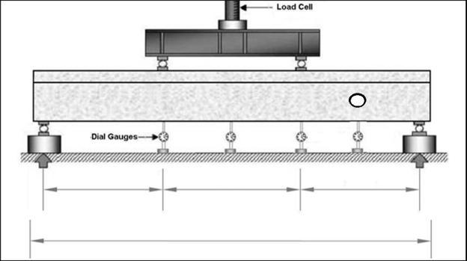

Figure1: Description of the Experimental set - up, including dial indicator placement

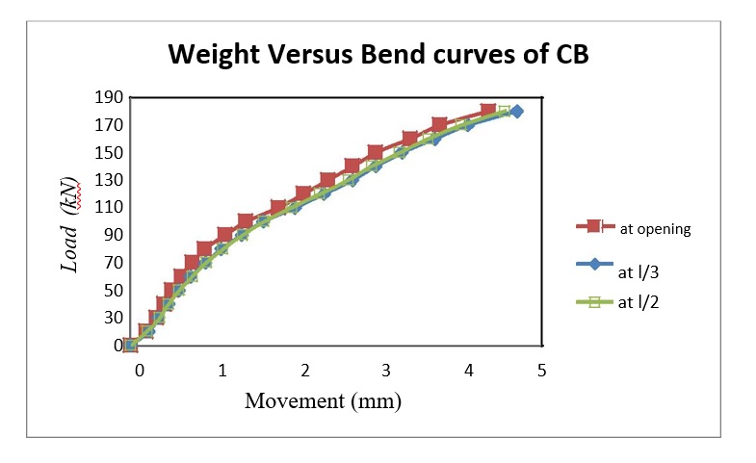
Figure 2: Weight Versus Bend curves for CBA

- CONCLUSION
- The available data unambiguously shows that the anchoring system may increase the appeal and cost-effectiveness of FRP strengthening for concrete repair and reinforcement.
- According to the test results, GFRP contributes more to the shearing capability for beam lacking strengthen shearing reinforcements than it does for beams with sufficient strengthen shearing reinforcements.
- The shearing spans and thickness proportion (a/d) moves how much outwardly attached GFRP reinforcement contributes to the shearing capability, and this contribution rises as the a/d ratio falls.
- The installation of an anchoring system prevents the GFRP sheet from deboning, which improves the exploitation of the GFRPs sheeting full potential.
- REFERENCES
- ACI 440.2R-02, “Guide for the Design and Construction of Externally Bonded FRP
- Systems for Strengthening Concrete Structures”, Reported by ACI Committee 440.
- Al-Amery R., and Al-Mahaidi R. (2006), “Coupled flexural-shear retrofitting of RC
- Beams using CFRP straps”, Construction and Building Materials, 21, 1997-2006.
- Alex L., Assih J., and Delmas Y. (2001), “Shear Strengthening of RC Beams with externally bonded CFRP sheets”, Journal of Structural Engineering, Vol. 127, No. 4, Paper No. 20516.
- Balamuralikrishnan R., and Jeyasehar C. A. (2009), “Flexural behaviour of RC beams strengthened with Carbon Fiber Reinforced Polymer (CFRP) fabrics”, The Open Civil Engineering Journal, 3, 102-109.
- Bousselham A., and Chaallal O. (2006), “Behavior of Reinforced Concrete Tee beams strengthened in shear with carbon fiber-reinforced polymer –An Experimental Study”, ACI Structural Journal, Vol. 103, No. 3, pp. 339-347.
- Ceroni F. (2010), “Experimental performances of RC beams strengthened with FRP materials”, Construction and Building materials, 24, 1547-1559.
- Chaallal O., Nollet M. J., and Perraton D. (1998), “Strengthening of reinforced concrete beams with externally bonded fibre-reinforced-plastic plates: design guidelines for shear and flexure”, Canadian Journal of Civil Engineering, Vol. 25, No. 4, pp. 692-704.
- Chen J. F., and Teng J. G. (2003), “Shear capacity of FRP-strengthened RC beams: FRP debonding”, Construction and Building Materials, 17, 27-41.
- Chen J. F., and Teng J. G. (2003), “Shear capacity of Fiber-Reinforced Polymer-strengthened Reinforced Concrete Beams: Fiber Reinforced Polymer Rupture”, Journal of Structural Engineering, Vol. 129, No. 5, ASCE, ISSN 0733-9445, pp. 615-625.

