**CHALLENGES TO WOMAN ENTREPRENUERS: A Survey On The Current Scenario**

**Dr.Ranjith Somasundaran Chakkambath1, Sethu S L2**

1Asst. Professor, Operations, AMITY Global Business School Kochi, Ernakulam, Kerala, India

2MBA student, AMITY Global Business School Kochi, Ernakulam, Kerala, India

**ABSTRACT**

Over the years, around the world, the number of Woman Entrepreneurs have increased more than any other decades. Woman are getting involved in various business domains in a sector which was dominated by males. This research paper aims to study the demographics of women entrepreneurship in Kerala and investigate the challenges faced by women entrepreneurs in the region. The research will be based on field surveys of women entrepreneurs who are running different business units either as sole proprietorship or as a partnership venture. The study investigated the demographics of the target population and the used Exploratory factor analysis to generate factors from the different variables related to challenges faced by woman entrepreneurs. Factor analysis resulted in three components. This research provides insight to the current scenario in the region related to entrepreneurship.

**Keywords:** Woman Entrepreneur, Exploratory Factor Analysis, Kerala, First Generation, Entrepreneurship.

1. **INTRODUCTION**

Women entrepreneurs face various challenges when starting and running a business. These challenges can range from cultural and societal barriers to financial and operational hurdles. Despite these challenges, women entrepreneurs have been able to make a significant impact on the global economy.

The presence of women entrepreneurs in India's economy is becoming increasingly significant, and it is important to recognize and appreciate their valuable contributions. These women entrepreneurs play a vital role in the Indian economy and have a profound impact on it through the creation of job opportunities, hastening development, and promoting prosperity. Recent statistics reveal that women make up fourteen percent of the total entrepreneurial community in India.

In recent years, the role of women in the business world has gained significant attention, particularly in India, where women entrepreneurs face unique challenges and barriers. This research paper aims to explore the various challenges faced by businesswomen in India, drawing on recent statistical data and scholarly research conducted within the past five years. Despite their competence and potential, women entrepreneurs in India continue to encounter obstacles that hinder their success and growth in the business sector,. Factors such as fear of failure, self-efficacy, and lack of support have been identified as key barriers that prevent women from pursuing and excelling in business ventures. Furthermore, the prevalence of a stereotypically male business model and a male-centered vision has contributed to the underestimation and delay in studying women's participation in the business process as a crucial area of research. By examining these challenges and their implications, this paper seeks to contribute to the ongoing discourse on women's entrepreneurship in India and provide insights for future research and policy development.

According to recent research, the most common challenges faced by women entrepreneurs in India include:

* Lack of financial support: Women entrepreneurs often struggle to access resources for credit and loan borrowing, which hinders their ability to start and grow their businesses
* Fewer sectors being women-friendly: Some industries may not be as welcoming or supportive of women entrepreneurs, limiting their opportunities for success
* Lack of social and institutional support: Women entrepreneurs may face limited support from their families, communities, and institutions, which can negatively impact their business ventures
* Poor funding prospects: Difficulty in securing funding from investors and financial institutions is a significant challenge for women entrepreneurs
* Lack of access to professional networks: Women entrepreneurs may have limited access to professional networks, which can restrict their ability to build connections and gain valuable resources
* Pressure to stick to traditional gender roles: Societal expectations and pressure to conform to traditional gender roles can hinder women's entrepreneurial pursuits
* Balancing family and career: Women in India are often emotionally attached to their homes and families, making it challenging to balance their personal and professional lives

To overcome these challenges, women entrepreneurs can adopt strategies such as crowdfunding, networking, digital marketing, participating in networking events, and joining women entrepreneur support groups.

Cultural and societal norms have a significant impact on women entrepreneurs in Kerala. According to a study on the issues and problems of women entrepreneurs in Kerala, women have traditionally been confined to the four walls of their homes and household chores (Iyer, 2016). This has resulted in women being less motivated to start business units due to fear and lack of motivation. Additionally, cultural norms and patriarchy in India have hindered the growth and livelihood of millions of women(Bharathi & Kaveeswarar, 2017). However, women entrepreneurs in India are challenging social, cultural, and family pressures to challenge the status quo . If the government takes necessary promotional measures, the number of women entrepreneurs in Kerala will rise, and they can contribute much to the entrepreneurial growth of Kerala (Unnikrishnan & Bhuvaneswari, 2016). This research investigates the current challenges among these Woman entrepreneurs in Kerala.

* 1. **PROBLEM STATEMENT**

Despite being equally competent in running businesses, women entrepreneurs in India face a variety of challenges that are unique to their gender. These challenges include a lack of financial support, limited access to resources for credit and loan borrowing, fewer women-friendly sectors, lack of social and institutional support, poor funding prospects, lack of access to professional networks, pressure to stick to traditional gender roles, and difficulty in balancing family and career. These challenges have contributed to the lower number of women entrepreneurs in India compared to men.

The problem statement aims to explore the root causes of these challenges and identify strategies to overcome them, such as providing greater access to financial resources, networking opportunities, and supportive policies.

**1.2 OBJECTIVES**

1. To study the demographics of Woman Entrepreneurship in Kerala
2. To investigate the challenges faces by woman Entrepreneurship in Kerala
3. **LITERATURE REVIEW**

The entrepreneurship scenario in India has witnessed a gradual evolution, with women entrepreneurs (WEs) playing an increasingly significant role in the country's economic growth and development (Baral et al, 2023) . A systematic literature review by organizes the existing empirical research on WEs in India, highlighting four main themes underlying the research: success factors for WEs, challenges faced by WEs, factors that attract and motivate WEs, and performance measures for WEs. The diversified profile of women entrepreneurs in India has been explored in various studies. Women entrepreneurs are a heterogeneous segment, contributing to different sectors and industries in the country. However, the growth of WEs varies from region to region, indicating the need for further research and support in specific areas.

Challenges faced by WEs in India have been a significant focus in the literature. Studies have identified various obstacles, such as limited access to financial resources, lack of social and institutional support, and balancing family and career( Tiwari,2017; Venotha & Mariadoss, 2022 ) . These challenges have been explored in the context of both urban and rural areas, with women from low-income segments often taking up entrepreneurship as a survival strategy (Venotha & Mariadoss, 2022). Success factors for WEs in India have also been examined in the literature. Factors such as access to financial resources, networking opportunities, and supportive policies have been identified as crucial for the growth and success of women entrepreneurs. Additionally, the literature highlights the importance of understanding the factors that attract and motivate WEs, as well as the performance measures used to evaluate their success.

Another study by discusses the challenges faced by women entrepreneurs in India, particularly the difficulty in balancing family and career (Gaur, Kulshreshtha & Chaturvedi, 2018). Women in India are often emotionally attached to their homes and families, making it challenging to manage their personal and professional lives. This issue was further explored in a case study in literature which highlights the challenges faced by women entrepreneurs in India due to limited social support and intense competition(Subburayan,2023). This case study provides insights into the experiences of a real and recent Indian woman entrepreneur, who overcame these challenges through innovative strategies such as crowdfunding, networking, and digital marketing.

Despite the growing body of research on women entrepreneurs in India, there are still areas that require further exploration and attention. The literature review by suggests that while challenges and success factors have been extensively studied, there is a need for more research on the factors that attract and motivate WEs, as well as the performance measures used to evaluate their success. By addressing these gaps in the literature, researchers can contribute to a more comprehensive understanding of women's entrepreneurship in India and inform policies and support mechanisms to foster their growth and success.

1. **METHODOLOGY**

Research Design : This study aims to understand the challenges faced by Woman entrepreneurs in Kerala. We use a descriptive and analytical research design in this study with the help of a structured questionnaire. The study uses convenience sampling for selecting the respondents.

Population Of the Study: The target group were Woman entrepreneurs from different age groups across the State of Kerala. Since Kerala is a state with 100% literacy and the number of females who are on the higher side of the compared to the national level, this research would be able to sight some valuable inputs in this the area of woman entrepreneurship. The data was gathered in accordance with the responses of 40 candidates who received an online questionnaire and provided a sample size.

Data Collection: Data for this study included both primary and secondary sources. A questionnaire was used to collect the essential information that was distributed to respondents via social media channels like Instagram, WhatsApp, and E-mail. Google forms was used for data collection. The first part of the questionnaire focused on demographic and general information related to demographics. The second part focused on the investigation related to factors that contributed as challenges to Woman entrepreneurs . LIKERT scale was used for this part of the questionnaire. Additional inputs for the questionnaire and the research were generated from information gathered from websites, journals, and earlier study papers makes up the secondary data.

Statistical Tools and Techniques Used for Analysis: The statistical techniques and tools employed in this study's analysis consists of Google forms. The software used to analyse and interpret the exploratory factor analysis was with the help of SPSS (Statistical Package for The Social Sciences).

**4. RESULTS AND DISCUSSION**

The first of the research was done to investigate the demographics of Woman Entrepreneurship in Kerala which included their educational background, age and nature of business they were involved in. The survey also identified if they were first generation entrepreneur or following the family business passed on to them.

**4.1 Educational Background:**

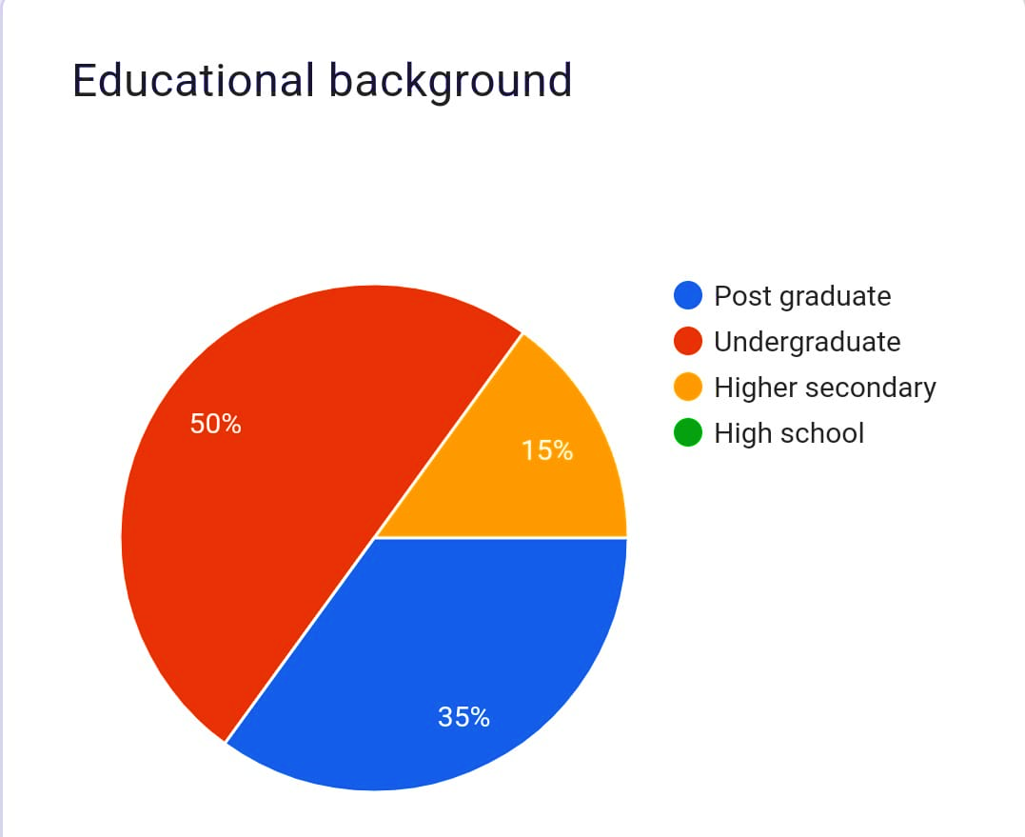

**Fig 1: Educational Background**

From the above, it is evident that majority of the respondents were undergraduates and following this group was Post graduates. A few of the respondents were in the higher secondary educational level who were among the Woman Entrepreneurs.

**4.2 First Generation Entrepreneur Or Not:**

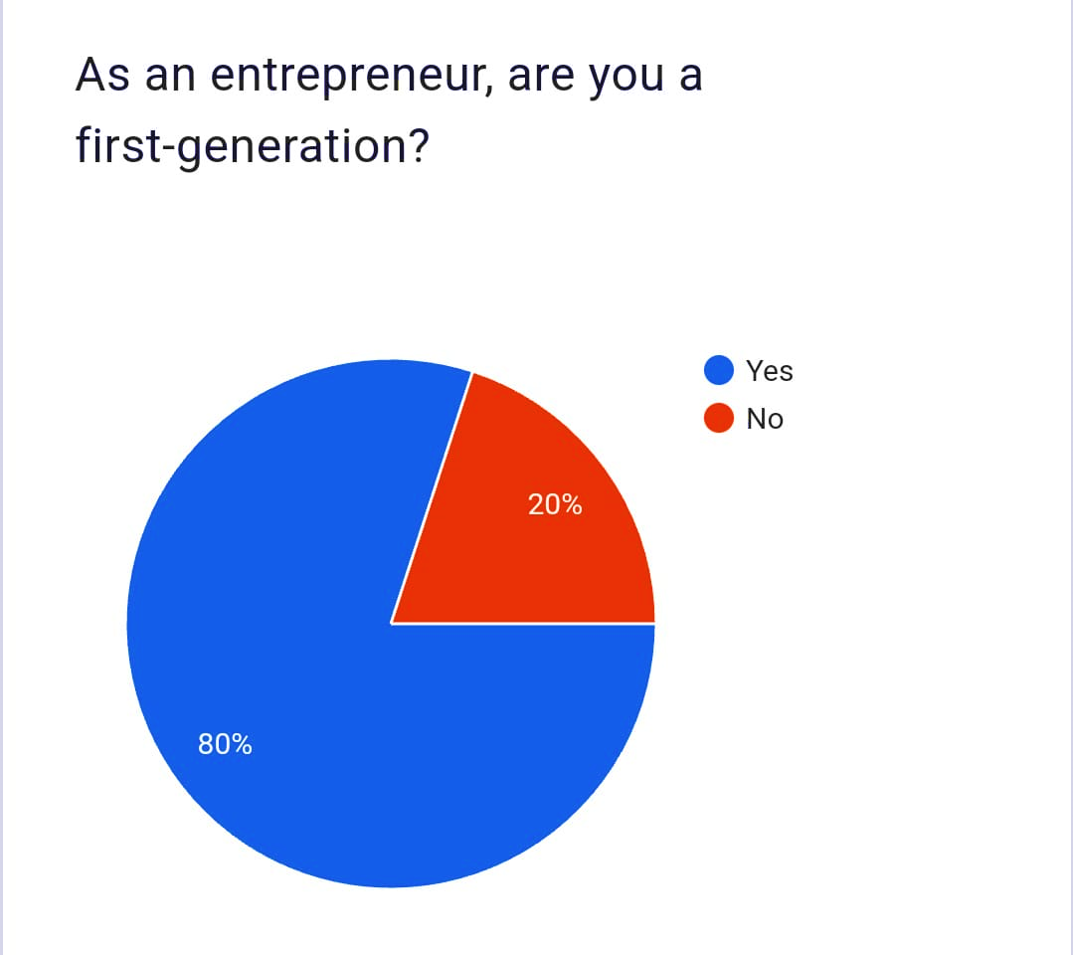

**Fig 2: First Generation Entrepreneur or Not**

From the respondents, it was found that majority were first generation business woman compared to some who had either family involved in Business or other support from previous generation of Entrepreneurs.

**4.3 Age of the Respondent:**

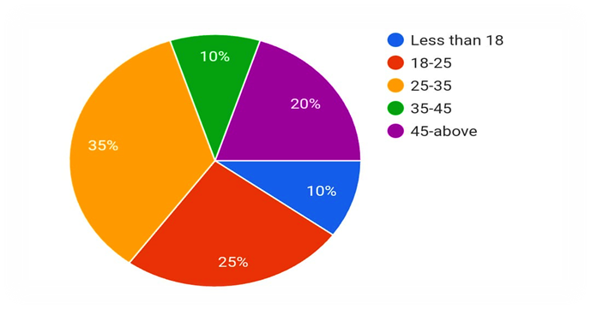

**Fig 3: Age of the Entrepreneurs**

It was found that majority of the respondents are between 18 to 25 years and 25 to 35 years of age. A small portion of the respondents are between 35 to 45 years old. This shows that more and more young woman are showing interest in Business ventures.

**4.4 Nature of Business**

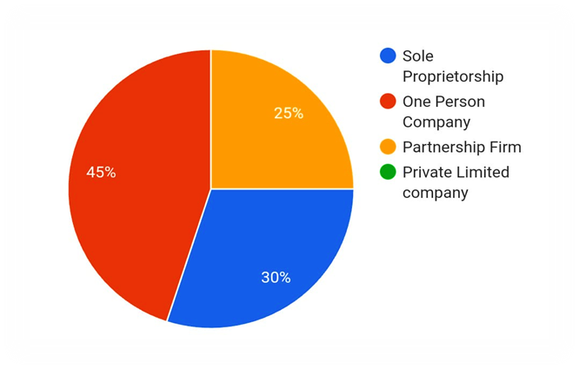

**Fig 4: Nature of Business**

Most of the Woman entrepreneurs were running a One person Company followed by many in Sole ownership ventures as well.

**4.5 Factor Analysis: The Challenges Faced By Women Entrepreneurs**

Exploratory factor analysis was done using IBM SPSS ver. 23 which generated the KMO and Bartlett’s test tables and Rotated Matrix Components for the LIKERT scale variables in the questionnaire.

|  |  |  |
| --- | --- | --- |
|  | | |
| Kaiser-Meyer-Olkin Measure of Sampling Adequacy. | | .543 |
| Bartlett's Test of Sphericity | Approx. Chi-Square | 65.005 |
| df | 36 |
| **Sig.** | .002 |

**Table 1: KMO and Bartlett’s Test**

Bartlett’s test of sphericity, which tests the overall significance of all the correlations within the correlation matrix, was significant (χ2 (36) = 65.005, p<0.05), indicating that it was appropriate to use the factor analytic model on this set of data. The Kaiser-Meyer-Olkin measure of sampling adequacy indicated that the strength of the relationships among variables was adequate (KMO = .543), thus it was acceptable to proceed with the analysis. . A series of factor analyses were conducted which indicated that three factors gave the most interpretable solution.

**Table 2: Rotated Component Matrix , Eigen Values and Total Variance Percentage for Components obtained by Principal Component Analysis with Varimax Rotation Method**

|  |  |  |  |
| --- | --- | --- | --- |
|  | **Component** | | |
| **1** | **2** | **3** |
| *1.Stress and health issues* | 0.749 |  |  |
| *2.Harder for them to succeed in male dominated industries* | 0.611 |  |  |
| *3.Gender based discrimination in business* | 0.581 |  |  |
| *4.Gender bias and discrimination impact funding* | 0.542 | 0.529 |  |
| *5.Government rules and regulations* | 0.507 |  | 0.47 |
| *6.Prioritize their family over their business* |  | 0.845 |  |
| *7.Lack of access to funding opportunities* |  | 0.752 |  |
| *8.Heavy work schedule* |  |  | 0.812 |
| *9.Lack of information about market available* |  |  | 0.786 |
| Eigenvalues | 2.22 | 1.66 | 1.54 |
| Percentage of total variance | 24.68 | 18.46 | 17.12 |

From the table above, The first factor was robust, with a high eigenvalue of 2.22, and it accounted for 24.68% of the variance in the data. Factor two had an eigenvalue of 1.66 and accounted for a further 18.46% of the variance. The eigenvalues for factor three was 1.54 with 17.12 % of the total variance.

The first Factor was identified as “Gender Challenges in Business factors” which includes Stress and Stress and health issues, Harder for them to succeed in male dominated industries, Gender based discrimination in business, gender bias and discrimination impact funding, Government rules and regulations. Similar studies have widely recognized that women face gender-specific opportunities and challenges in their entrepreneurial endeavors (Bullough et al., 2022. The second Factor was identified as “Breaking Barriers factors” which includes Prioritize their family over their business and Lack of access to funding opportunities . Similar studies have sighted challenges include financial constraints, inability to raise funds, inadequate institutional support, family affiliations, lack of social and institutional support, poor funding prospects, lack of access to professional networks, pressure to stick to traditional gender roles, and fewer sectors being women-friendly( Iyer, a2016; b2019; Unnikrishnan & Bhuvaneswari, 2016; 2023). Related studies have sighted that female entrepreneurs lack funding and long-term capital, a base that establishes sustainable businesses (Corrêa et al., 2021; Minniti & Naudé, 2010; Mirchandani, 1999) . The third component was identified as “Overcoming Obstacles factors” which includes Heavy work schedule and Lack of information about market available.

**5. CONCLUSION**

Women entrepreneurs in Kerala are also less in number compared to men, and they face challenges in starting business units due to lack of motivation and fear. This research provides insight into the current demographics of Woman entrepreneurs in Kerala which was found to be dominated by youth between the age of 18 years to 35 years. Majority of the respondents were first generation entrepreneurs with “one person company “ was their nature of business. Exploratory factor analysis generated three factors, namely- Gender Challenges in Business factors. These challenges hinder the progress of women entrepreneurship in Kerala, and the government needs to take necessary promotional measures to address these issues and promote women entrepreneurship in the region. Further research needs to identify the challenges of woman in sustaining their business in this competitive scenario.

**REFERENCES**

[1] Bharathi, S. M., & Kaveeswarar, S. A. (2017). Cultural Impact on Women Entrepreneurship in India and It's Effect on GDP Contribution and Growth. *Asian Journal of Research in Business Economics and Management*, *7*(6), 92-103.

[2] Tiwari, N. (2017). Women entrepreneurship in India: A literature review. *Amity Journal of Entrepreneurship*, *2*(1), 47-60.

[3] Venotha, A. S., & Mariadoss, S. WOMEN ENTREPRENEURSHIP IN INDIA: A LITERATURE REVIEW.

[4] Baral, R., Dey, C., Manavazhagan, S. and Kamalini, S. (2023), "Women entrepreneurs in India: a systematic literature review", International Journal of Gender and Entrepreneurship, Vol. 15 No. 1, pp. 94-121. https://doi.org/10.1108/IJGE-05-2021-0079

[5] Gaur, S., Kulshreshtha, V., & Chaturvedi, R. (2018). Challenges and opportunities for women entrepreneurs in India. *International Journal of Research and Analytical Reviews*, *5*(3), 396-403.

[6] Subburayan, B. (2023). A Case Study On Exploring the Challenges of Women Entrepreneurs in India: Insights on Limited Social Support and Intense Competition. *CASE Research Paper Forthcoming*.

[7] P, U., & Bhuvaneswari, S. (2016). A study on the issues and problems of women entrepreneurs in Kerala with special reference to malappuram district. *International Journal of Research-GRANTHAALAYAH*, *4*(9), 105-112.

[8] Iyer, M. R. (2016). A Study On Problems Faced By Women Entrepreneurs In Ernakulam District, Kerala. *International Journal of Development Research*, *6*(7), 8616-8620.

[9] Iyer, M. R. (2019). Problems faced by women entrepreneurs in Ernakulam district, Kerala. *Commerce Spectr*, *5*(2), 19-22.

[10] R. (2023, April 23). *15 Major Problems Faced by Women Entrepreneurs in India While Starting A Business in 2023*. The Office Pass. <https://www.theofficepass.com/toppings/top-problems-faced-by-women-entrepreneurs-in-india.html>

[11] Bullough, A., Guelich, U., Manolova, T. S., & Schjoedt, L. (2022). Women’s entrepreneurship and culture: gender role expectations and identities, societal culture, and the entrepreneurial environment. Small Business Economics, 58(2), 985–996. https://doi.org/10.1007/s11187-020-00429-6

[12] Corrêa, Victor Silva, Fernanda Regina da Silva Brito, Rosileine Mendonça de Lima, and Maciel M. Queiroz. 2021. Female entrepreneurship in emerging and developing countries: A systematic literature review. International Journal of Gender and Entrepreneurship 14: 300–22.

[

13] Minniti, Maria, and Wim Naudé. 2010. What do we know about the patterns and determinants of female entrepreneurship across countries? The European Journal of Development Research 22: 277–93.

[14] Mirchandani, Kiran. 1999. Women, entrepreneurship and the opportunity to lead. Gender in Management: An International Journal 14 (5): 212–22.