**AUTOMATIC LOAD SHARING OF TRANSFORMER USING MICRO CONTROLLER**

**G.V Swathi 1, Samba Rajula Sandeep2, Gurrala Sampath3,Alasyam Rakesh4**

1Assistant Professor, Department of Electrical & Electronics Engineering**,** ACE Engineering College Ghatkesar, Telangana, India

2Student, Department of Electrical & Electronics Engineering**,** ACE Engineering College Ghatkesar, Telangana, India

3Student, Department of Electrical & Electronics Engineering**,** ACE Engineering College Ghatkesar, Telangana, India

4Student, Department of Electrical & Electronics Engineering**,** ACE Engineering College Ghatkesar, Telangana,

India

**ABSTRACT**

The purpose of the challenge is to defend the transformer underneath overload situation through load sharing. due to overload on transformer, the efficiency drops and windings get overheated and might get burnt. for that reason, via sharing load on transformer, the transformer is included. this will be done via connecting any other transformer in parallel through a micro-controller. The micro controller compares the load on the primary transformer with a reference price. whilst the weight exceeds the reference cost, the second one transformer will share the more load. consequently, the two transformers’ paintings correctly and harm is averted. on this project 3 modules are used to govern the load currents. the primary module is a sensing unit, which is used to sense the modern-day of the load and the second one module is a manipulate unit. The remaining module is micro-controller unit and it will study the analogue sign and perform a few calculations and ultimately gives manipulate signal to a relay. A GSM modem is likewise used to inform the manage station approximately switching. The advantages of the assignment are transformer safety, uninterrupted strength deliver, and quick circuit safety.

**Keywords:** Transformers, Load, Micro Controller, GSM modem, Regulated Power Supply.

1. **INTRODUCTION**

The transformer is a static device, which converts strength from one stage to some other degree. due to overload on transformer, the efficiency drops and windings get overheated and might get burnt.

As a consequence, through sharing load on transformer, the transformer is blanketed. this may be finished by means of connecting every other transformer in parallel thru a micro-controller. The micro controller compares the weight on the first transformer with a reference fee. when the burden exceeds the reference price, the second one transformer will percentage the greater load. therefore,

the second transformer work correctly and harm is inverted.

**METHODOLOGY**

In our project we're using identical step-down transformers of rating (220-12v) that are related in parallel via electromagnetic relay.to start with while the transformer T1 is switched on 2 resistive bulbs of 12v AC gets became on. But while the Overload is occurred the present-day cost is improved across the cutting-edge Transformer and this makes the electromagnetic relay to replace on the back up transformer T2 accordingly the Overload is shared similarly through the 2 Transformers. And we will study that almost in our undertaking with five bulbs of 12v AC glowing with high lamination at some stage in the Overload situation. And once more when the Overload comes down to normal condition most effective transformer T1 will act within the undertaking.

**2.1 Embedded systems**

wireless communique has become a vital characteristic for business products and a popular research subject matter inside the final ten years. There are now more cellular cellphone subscriptions than wired-line subscriptions. currently, one region of industrial interest has been low-cost, low-power, and short-distance wi-fi verbal exchange used for non-public wireless networks." era advancements are supplying smaller and extra fee effective gadgets for integrating computational processing, wireless communique, and a host of different functionalities. those embedded communications devices can be included into programs starting from homeland safety to industry automation and monitoring. they may also enable custom tailored engineering solutions, growing a revolutionary way of disseminating and processing facts.

**2.2 Real Time Issues**

Embedded systems frequently manipulate hardware, and must be capable of respond to them in actual time. Failure to achieve this ought to reason inaccuracy in measurements, or even damage hardware consisting of automobiles. that is made even extra hard by the dearth of resources to be had. almost all embedded systems need a good way to prioritize a few responsibilities over others, and so that you can get rid of/pass low precedence duties which includes UI in want of high precedence tasks like hardware control.

**MODELING AND ANALYSIS**

There are numerous special sorts of software architecture in not unusual use.  
simple manage Loop:  
on this layout, the software program truly has a loop. The loop calls subroutines, each of which manages a part of the hardware or software program.  
Interrupt controlled machine:  
some embedded structures are predominantly interrupt controlled. because of these obligations achieved with the aid of the machine are prompted through distinct sorts of occasions. An interrupt will be generated as an example by means of a timer in a predefined frequency, or with the aid of a serial port controller receiving a byte. these forms of systems are used if occasion handlers need low latency and the occasion handlers are brief and simple.  
typically these sorts of structures run a easy assignment in a major loop also, but this venture isn't always very touchy to unexpected delays. every now and then the interrupt handler will add longer responsibilities to a queue structure. Later, after the interrupt handler has completed, those tasks are executed by way of the main loop. This technique brings the device close to a multitasking kernel with discrete tactics.  
Cooperative Multitasking:  
A non-preemptive multitasking system may be very much like the easy manage loop scheme, except that the loop is hidden in an API. The programmer defines a sequence of responsibilities, and every assignment receives its personal environment to “run” in. whilst a assignment is idle, it calls an idle recurring, typically called “pause”, “wait”, “yield”, “nop” (stands for no operation), and so forth. The benefits and downsides are very much like the control loop, besides that including new software program is less complicated, by without a doubt writing a new mission, or adding to the queue-interpreter.

RPS

PIC

16F877A

CURRENT SENSOR

TEMP

SENSOR

GSM

RELAY

BUZZER

LCD

TRANSFORMER 1

TRANSFORMER 2

**Figure 1:** Block diagram of automatic load sharing of transformer using micro controller

1. **RESULTS AND DISCUSSION**

**Figure 2:** Output result

The system robotically connects and disconnects transfer to percentage the transformer loads. The controller changed into controlled the burden in keeping with regulations. He transformer with any other transformer it increases the performance of the device. the use of this approach, we supply the uninterrupted power supply to the client and to offer the answer for the fault on the road and non-stop power offer to run the hundreds. this will be done mechanically to boom the life span of the transformer and to make the machine green.

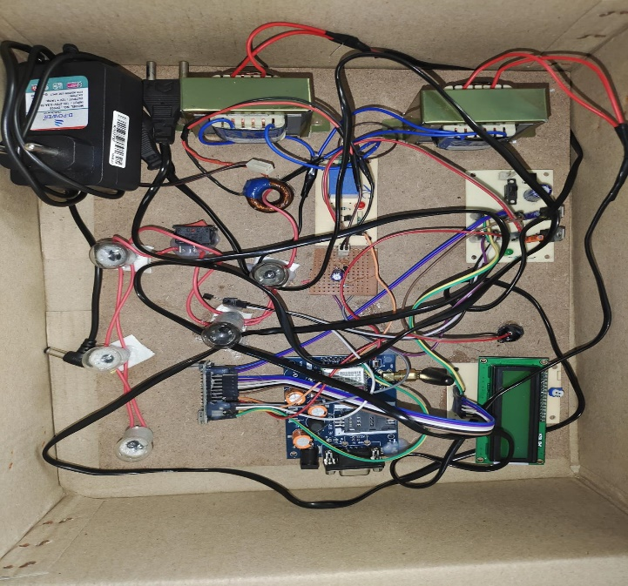**CONCLUSION**

On this assignment we observed that if load on one transformer is expanded then the relay will experience the alternate in cutting-edge & microcontroller operates & auxiliary transformer comes robotically in operation to proportion the weight. The paintings on “computerized load sharing of transformers” is efficaciously designed, examined and a demo unit is fabricated for operating two transformers in parallel to percentage the load automatically with the help of electromagnetic relay. This venture reduces the manual paintings for sharing the burden of transformer. additionally, provide the dependable electricity to the client with the aid of the usage of the weight sharing of the transformer with some other transformer, it increases the performance of the machine. the usage of this technique, we deliver the uninterrupted electricity deliver to the client and to offer the answer for the fault on the road and continuous energy provide to run the loads. this may be carried out robotically to increase the existence span of the transformer and to make the system green.

1. **REFERENCES**

[1]. V. K. Mehta and Rohit Mehta “Principals of power system”, 2003 pp. 104-107.

[2]. Bhel (Bharat Heavy Electricals Limited) “Transformers”, second edition 2003.

[3]. Ashish R. Ambalkar, Nitesh M. Bhoyar, Vivek V. Badarkhe and Vivek B. Bathe, “Automatic Load Sharing of Transformers”, International Journal for Scientific Research & Development, Volume 2, Issue 12, pp. 739-741,2015.

[4]. Rekha.T, Bindu Prakash, Asna. S, Dinesh.S and Nandana.S. Prasad, “An Intelligent Method for Load Sharing of Transformers With Temperature Monitoring and Automatic Correction of Power Factor”, International Journal Of Engineering Sciences & Research Technology, Volume 4, Issue3, pp. 416- 421, 2015.