**EXPERIMENTAL INVESTIGATION ON SS316L MADE THROUGH ADDITIVE MANUFACTURING**

S.Vignesh, Faculty of Mechanical Engineering, Sir Issac Newton College of Engineering & Technology, Nagapattinam

K.M. Alex Raja, Faculty of Mechanical Engineering, VV College of Engineering, Tirunelveli, India

**ABSTRACT**

Laser-Powder Bed Fusion of metallic parts is a highly multivariate process. An understanding of powder feedstock properties is critical to ensure part quality. In this paper, a detailed examination of two commercial stainless steel 316L powders produced using the gas atomization process is presented. In particular, the effects of the powder properties (particle size and shape) on the powder rheology were examined. The results presented suggest that the powder properties strongly inﬂuence the powder rheology and are important factors in the selection of suitable powder for use in an additive manufacturing (AM) process. Both of the powders exhibited a strong correlation between the particle size and shape parameters and the powder rheology. Optical microscope images of melt pools of parts printed using the powders in an L-PBF machine are presented, which demonstrated further the signiﬁcance of the powder morphology parameters on resulting part microstructures.

Keywords: SS316L, Additive Manufacturing, Hardness Test and Compression Test

**INTRODUCTION**

Additive manufacturing describes layer wise production processes that incrementally build structures from a feedstock material. Laser powder bed fusion (LPBF) is an example of additive manufacturing whereby structures are built in a repeated layer wise fashion via laser induced localized melting and solidification of a metal powder bed feedstock.

These processes offer significantly greater freedom of design compared to conventional subtractive manufacturing processes, with the potential for improved efficiency and functionality. However, despite the technological improvements made in recent years, metal additive manufacturing, also known as metal 3D printing, still faces many different challenges such as microstructures defects, residual stresses (RSs), mechanical anisotropy and in general lack of understanding of process- property-performance relationship. These issues are reported to prevent additive manufacturing from mass adoption in safety-critical environments.

Stainless steel 316L specimens produced via laser powder bed fusion (LPBF316L) usually have a layered morphology, which consists of many different features on a broad range of length scales. Additively manufactured (AM) alloys and, in particular, LPBF316L have been reported to exhibit anisotropic mechanical properties.

The cause of the anisotropic behavior of LPBF316L has been attributed to many different factors.The consequence of layer-by-layer manufacturing, particularly the interface between layers, is one of the more frequently mentioned causes, since oxidation, inclusions, and defects are more frequent in these regions .The grain size, grain shape, and grain aspect ratio, in combination with the Hall–Patch effect, have also been cited as the source of anisotropy in LPBF316L .The explanation which is usually given for this effect is that the high angle grain boundaries are a major barrier for dislocation glide, and since the dislocations have to cross a different number of grain boundaries in various directions, this results in an anisotropic behavior. However, several authors consider that the mechanical performance of LPBF316L is mainly determined by its subgrain structures, predominantly the fine-scaled dendrite microstructure, and not by the high angle grain boundaries.

### ADDITIVE MANUFACTURING

In additive manufacturing, material is applied layer by layer in precise geometric shapes based on a CAD model. In contrast, conventional manufacturing processes typically involve milling, carving or otherwise removing material to create an object. The terms 3D printing and additive manufacturing are often used synonymously. Strictly speaking, however, a distinction must be made: 3D printing is the more colloquial term. Additive manufacturing refers to the general manufacturing process - the production of objects by adding material - under which various production processes such as rapid prototyping, rapid tooling or mass customization can be subsumed.

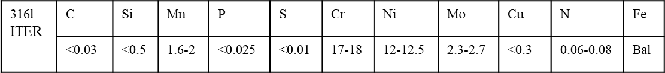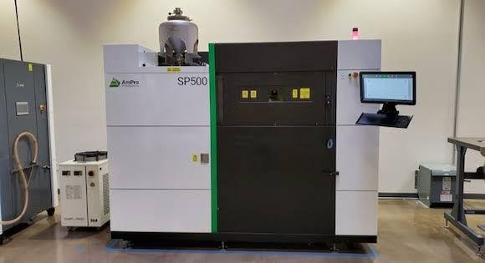

Additive manufacturing offers significant benefits to a wide range of industries, whether it's the ability for agile product customization, functional integration, or rapid and cost-effective spare parts procurement. EOS offers a variety of metals and polymers to suit each application.

### POWDER-BED FUSION

Powder bed fusion (PBF) is an additive manufacturing, or 3d printing, technology that uses a heat source—typically a laser—to sinter or fuse atomized powder particles together.

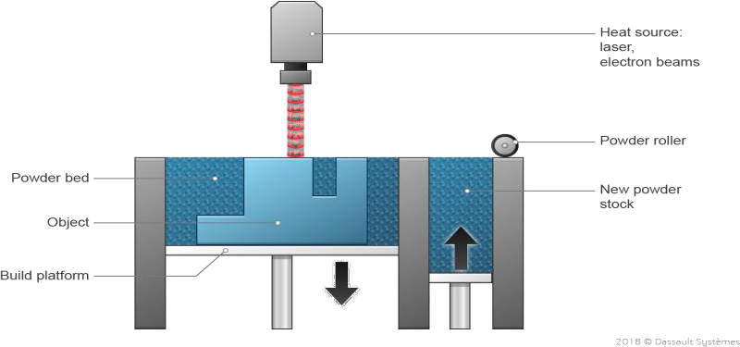

### STAINLESS STEEL 316L

SS316L is a molybdenum-bearing austenitic stainless steel that is widely used in architecture, locomotion industry, medicine; etc.It has also been selected as one structural material in nuclear fission and fusion industry due to its combination of good mechanical properties at elevated temperatures, excellent corrosion resistance and good machinability. The materials used in a fusion reactor have stricter control on composition and mechanical properties due to the critical working environment. The composition range and mechanical property requirement are listed in Table

### BRINELL HARDNESS TEST

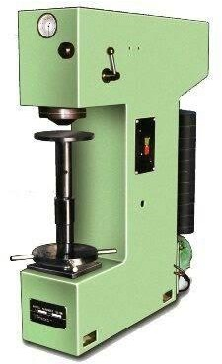

**Brinell Hardness Testing Machine**

The Brinell scale characterizes the indentation hardness of materials through the scale of penetration of an indenter, loaded on a material test-piece. It is one of several definitions of hardness in materials science

### COMPRESSION TEST

Compression testing allows manufacturers to assess the integrity and safety of materials, components, and products during several phases of the manufacturing process. The potential applications can vary from strength testing of a car windshield to endurance testing of concrete beams used in construction. Materials that exhibit high tensile strength tend to (but do not always!) exhibit low compressive strength. Likewise, materials high in compressive strength tend to exhibit low tensile strength. Therefore, compression testing is often used on brittle materials such as concrete, metals, plastics, ceramics, composites, and corrugated materials like cardboard. These materials are often used in a load-bearing capacity where their integrity under compressive forces is critical. Unlike tensile tests, which are usually conducted to determine the tensile properties of a specific material, compression tests are often performed on finished products. Common items such as tennis balls, golf balls, water bottles, protective cases, plastic pipes, and furniture are all examples of products that need to be evaluated for their compressive strength.

Effective method of compression test is simplification that is used to find best result of solid material.

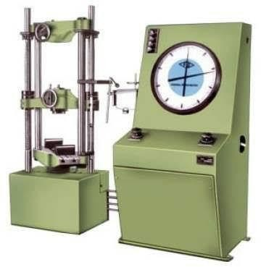

**Universal Testing machine**

**SAMPLE PREPARATION**

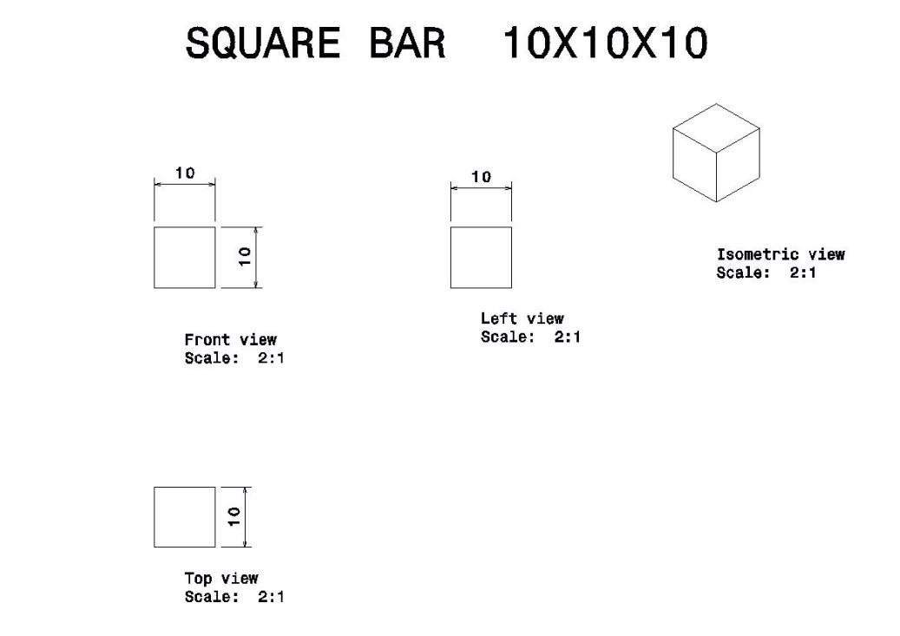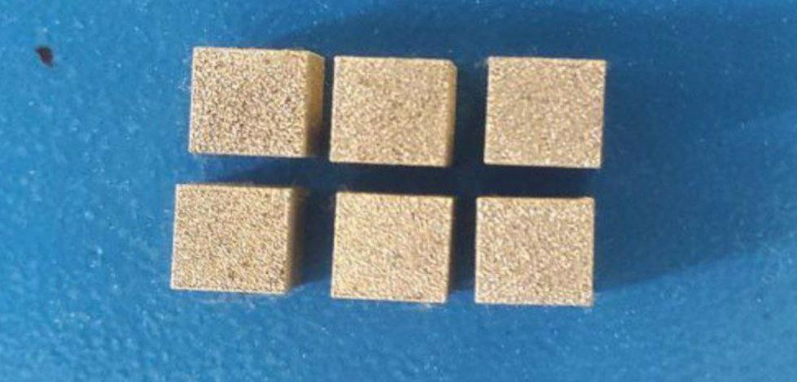

**Sample square job preparation (10x10x10)**

**RESULT**

1. **Hardness Test**

**Compression Test**

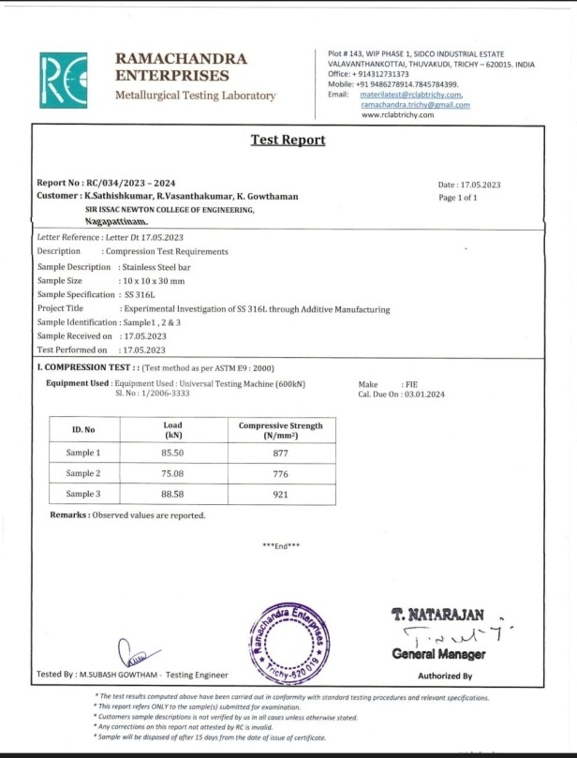

**CONCLUSION**

A general method for the application of a predetermined failure location using a surface notch is described and successfully validated using a simple pressure loaded vessel. Tensile testing is performed to evaluate overall material behavior due to the applied safety function in an early design state. Computational analysis and formula-based design rules from literature enable a short development time for the component geometry. Burst tests were performed and evaluated using AM imaging and 3-D scanning. The manufactured components made from austenitic steel 316L using fulfill the expectations. Implementation of directly manufactured predetermined failure locations works especially well. This goal of this project was to obtain baseline data and mechanical property for Cal Poly’s 316L stainless steel. This would allow students to design functional parts with proven strength values and make improvements to the printing process. Additionally, the compressive stiffness of 3D printed microlattices, a technology enabled by the SLM printing process, was investigated.

**REFERENCES**

1. Costa, L., Vilar, R.(2009). Laser powder deposition.Rapid Prototyping Journal, 15(4), 264-279.
2. Jinoop, A. N., Paul, C. P., &Bindra, K. S. (2019). Laser-assisted directed energy deposition of nickel super alloys: a review. Proceedings of the Institution of Mechanical Engineers, Part L: Journal of Materials: Design and Applications, 233(11). 2376-2400.
3. Sames, W. J., List, F. A., Pannala, S., Dehoff, R. R., &Babu, S. S. (2016). The metallurgy and processing science of metal additive manufacturing.International Materials Reviews, 61(5), 315-360.
4. Sasikumar, R., Kannan, A. R., Kumar, S. M., Pramod, R., Kumar, N. P., Shanmugam,N. S., &Sivankalai, S. (2022). Wire arc additive manufacturing of functionally graded material with SS 316L and IN625: Microstructural and mechanical perspectives. CIRP Journal of Manufacturing Science and Technology, 38, 230-242.
5. Steen, W. M. (2003). Rapid Prototyping and Low-volume Manufacture. In: Laser Material Processing, (279-299). Springer- London.

Svetlizky, D., Das, M., Zheng, B., Vyatskikh, A. L., Bose, S., Bandyopadhyay, A., Schoenung, J. M., Lavernia, E. J., Eliaz, N. (2021). Directed energy deposition (DED) additive manufacturing: Physical characteristics, defects, challenges and applications.Materials Today, 49, 271-295.