Power optimization scheme on Induction Motor Using Artificial Neural Network for Electrical vehicle

CH Prasanna 1, Punumalli Naga Ganesh 2, N.Bharath Kumar 3,Botte Sathish 4,Vempalla Naveen 5*

***Assistant Professor, Department of Electrical & Electronics Engineering, Teegala Krishna Reddy Engineering College, Hyderabad.***

UG Students, Department of Electrical & Electronics Engineering, Teegala Krishna Reddy Engineering College, Hyderabad .

|  |  |
| --- | --- |
|  | **A B S T R A C T**  In electric vehicles (EVs) and hybrid EVs, energy efficiency is essential where the energy storage is limited. Adding to its high stability and low cost, the induction motor efficiency improves with loss minimization. Also, it can consume more power than the actual need to perform its working when it is operating in less than full load condition. This study proposes a control strategy based on the Artificial Neural Network (ANN) for EV applications. ANN controller can improve the starting current amplitude and saves more power. Through the MATLAB/SIMULINK software package, the performance of this control was verified through simulation. As compared with the conventional proportional integral derivative controller, the simulation schemes show good, high-performance results in time-domain response and rapid rejection of system-affected disturbance. Therefore, the core losses of the induction motor are greatly reduced, and in this way improves the efficiency of the driving system. Finally, the suggested control system is validated by the experimental results obtained in the authors’ laboratory, which are in good agreement with the simulation results. |

**Keywords**: Induction motor, electric vehicle, Proportional–integral derivative controller, fuzzy logic, artificial neural networks.

1. **Introduction**

With increasing global awareness of air quality and reduce greenhouse gas emissions, electric vehicles (EVs) have increasingly attracted the attention of manufacturers, governments, international organizations, and consumers. Accord ing to the European Renewable Energy Council (EREC) [1], many governments promote EV as an important part of their proposals for technologies required to reduce greenhouse gas emissions in the long term and to improve energy efficiency in the transport sector. In addition to reducing pollution in the environment, the electric vehicle gives good performance in terms of efficiency and torque [2]. The only drawback of electric vehicles is their cost [3]. It is, therefore, necessary to choose the appropriate drive motor and its control technology. In the previous literature review, a DC motor is preferred used in EV applications due to the simplicity of the control unit design and its characteristics well matched with an elec trick vehicle motor. With the increasing research progress of control technology, induction motors are among the best candidates for driving electric vehicles and are widely used in modern electric vehicles [4]. The structure of the induction motor is simple, it has strong durability, it is inexpensive, it is very reliable, and it requires no maintenance [5]. Although it has more advantages than DC motors, it has some disadvantages such as non-linear properties; as a result, analysis becomes very complex [6, 7] and flux in induction motor is not measurable [8]. To overcome these drawbacks, several modern control techniques have been invented to control the two main parameters, torque and flux of induction motor for electric vehicle applications.

There are various control technologies for induction motors in electric vehicle applications. They are: (1) proportional–integral (PI) controller, (2) PID controller, (3) sliding mode controller (SMC), (4) fuzzy logic controller (FLC),(5) neural network controller (NNC), (6) model predictive control (MPC), (7) hybrid controllers, and more. Few important algorithms are reviewed here. One can choose the best algorithm for controlling the IM drives. In [9], this paper presents a compound sliding mode control (CSMC) method for controlling the speed of surface-mounted permanent mag- net synchronous motors (SPMSMs). The proposed CSMC consists of a new sliding mode controller (SMC) based on a new hybrid reaching law and an extended sliding mode disturbance observer (ESMDO), and due to the complexity of There are various control technologies for induction motors in electric vehicle applications. They are: (1) proportional–integral (PI) controller, (2) PID controller, (3) sliding mode controller (SMC), (4) fuzzy logic controller (FLC),(5) neural network controller (NNC), (6) model predictive control (MPC), (7) hybrid controllers, and more. Few important algorithms are reviewed here. One can choose the best algorithm for controlling the IM drives. In [9], this paper presents a compound sliding mode control (CSMC) method for controlling the speed of surface-mounted permanent mag- net synchronous motors (SPMSMs). The proposed CSMC consists of a new sliding mode controller (SMC) based on a new hybrid reaching law and an extended sliding mode disturbance observer (ESMDO), and due to the complexity of organization of the brain, are interconnected to form a network, this is called a neural network (NN). An artificial network composed of structural units of perceptron that mimic these neurons is called ANN. A single-layer perceptron is a linear classifier that divides an input vector into two classes. MLP is a multi-layered perceptron and learns by using a hidden layer addition and a back-propagation algorithm between the input layer and the output layer to enable nonlinear classification that the single-layer perceptron cannot solve [29]. [30] pro- poses an artificial neural network (ANN) controller to reduce both torque and flux ripples by considering appropriate input and feedback values through online mode. By using both simulation and process, it shows that the proposed controller is more efficient than the traditional controller. [31] Improves the transient analysis using the ANN controller but without changes in the torque and flux ripples.

Finally, all of these algorithms have their advantages and disadvantages. So the choice of these algorithms for induc tion motor depends on cost, accuracy, and application. A fuzzy logic controller is used where the system behavior is more complicated and semantic rules are necessary to explain the system. Compared to the artificial neural network, it is good for modeling in these conditions as ANN is more suit- able for controlling nonlinear devices. As induction motor has a nonlinear model, ANN is highly suitable for controlling induction motor drive in electrical vehicles. In this paper, a neural network controller-based method using simulation in the MATLAB/Simulink Power system cluster environment is then linked to the prototype reflector through the use of a micro ds PACE laboratory box control panel. The proposed neural network control is then compared with conventional PID control based on its effect on IM performance.

The main problem is to reduce the life cycle cost of the drive, i.e., manufacturing, maintenance, and energy costs.

* Efficiency is an indicator of energy cost, particularly important at rated speeds and above.

•

* Also, the efficiency of the inverter is very important as it affects the overall driving efficiency.

•

* The power factor is an indicator of the apparent power that the inverter must deliver.

•

* The inverter kVA rating is determined by the peak current of the maximum torque at low speeds and the maximum output voltage at high speeds

•



**Vdcin Co**

**A**

**C**

**B**

C

B A

IM

m

*w\**

Inverter/motor controls

*ia*

*wm*

**Fig.1 Electrical vehicle drive with an induction motor**

This paper presents a comparative study between the PID controller and the ANN-based controller which is organized as follows: after introduction in the first section. In Sect. 2, the circuit description and control principle are given in Sect. 3. In Sect. 4, simulation results are provided. In Sect. 5, the experimental results are performed. In Sect. 6, conclusion is discussed, and future work is discussed in Sect. 7. is connected by the acceleration pedal and/or the brake pedal. In Fig. 1, the traction process is done by controlling the 3-phase induction motor. The right and left wheels are controlled separately by a differential system with a gear ratio to adapt to the high speed of the low-speed electric wheel shaft. The IM torque and speed are controlled by the DC/AC inverter which converts the DC voltage to the 3-phase AC voltage. To run the EV system efficiently, a robust controller is designed and implemented with adaptive capabilities in the process of network learning.

**2. INDUCTION MOTOR DRIVE SYSTEM MODEL**

Figure 1 shows the power circuit of the electric vehicle which consists of three main parts as follows: The first is the 3-phase induction motor. The second is a battery unit that is used as an energy storage element. The battery DC voltage is converted to 3-phase AC voltage by a DC/AC power converter. Third, the AC/DC controller controls the converter output voltage magnitude and frequency that is applied to the induction motor. The voltage magnitude is adjusted depending on the driver’s current request, which is connected by the acceleration pedal and/or the brake pedal. In Fig. 1, the traction process is done by controlling the 3-phase induction motor. The right and left wheels are controlled separately by a differential system with a gear ratio to adapt to the high speed of the low-speed electric wheel shaft. The IM torque and speed are controlled by the DC/AC inverter which converts the DC voltage to the 3-phase AC voltage. To run the EV system efficiently, a robust controller is designed and implemented with adaptive capabilities in the process of network learning.

**3. CONTROL PRINCIPLE**

**3.1 PID Conventional control**

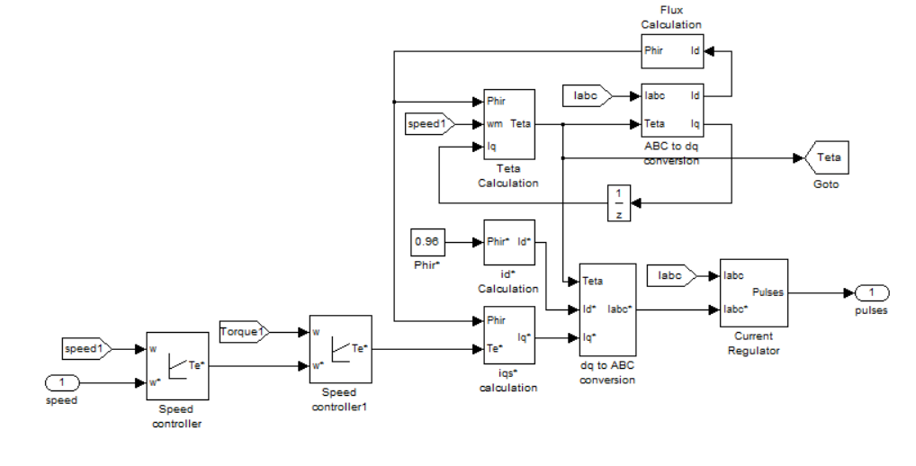

**Fig 2 PID controller block diagram**



**Equation (1)**

The grid side active and reactive power consists of the average and ripple components which are controlled by using the grid side d and q-axis currents. In this case, two outer PID control loops are used to regulate the average active and reactive components to the reference values. Figure 3 shows the block diagram of the classical PID control. The reference active and reactive current components (*id*\* and *iq*\*) are obtained as the output of the active and reactive

power controllers and can be expressed as follows:



**Equation (2)**



**Equation (3)**

where *kp* and *ki* are the proportional constant and the integral constant of the PID controllers, respectively. *P*ref is the active power reference, and *q*ref is the reference reactive power required by the AC source.

The inner control loop of the PID controller is to compare the reference current which is the output of the outer loop to the real measured value to regulate the real value to the reference one.

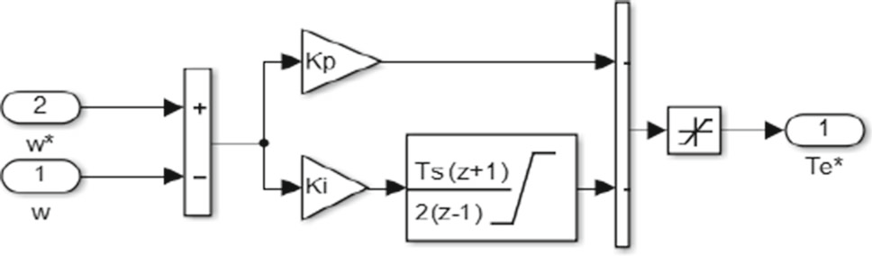

**Fig 3. Block diagram of the conventional PID controller**

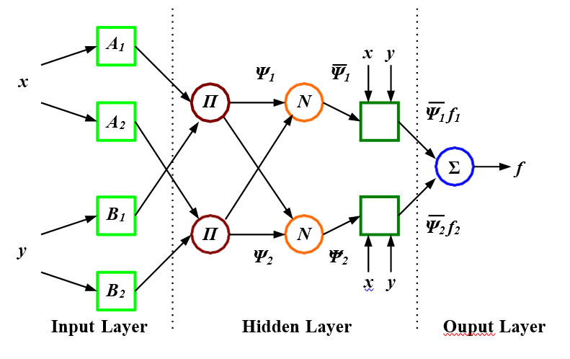

**Fig 4. Neural Network Internal structure**

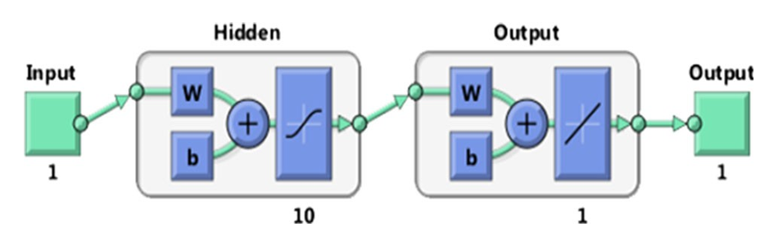

**Fig 5. Training Network Model in Matlab**

The operating ratios (*dd* and *dq*) are obtained by normalizing by using the results (*ed* and *eq*) by the disengagement condition which is normalized by the DC voltage as follows.



**Equation (4)**

**3.2 A proposed artificial neural network controller**

ANN is an algorithm that models a human brain and processes various data like that of two brains. When neurons, the basic structural organization of the brain, are interconnected which imitates these neurons, is called an ANN, an artificial network composed of structural units. Single-Layer Perceptron (SLP) is a linear classifier that divides input vectors into two classes. MLP is a multilayer perceptron that learns by adding a hidden layer and back-propagation algorithm between the input layer and output layer so that nonlinear classification cannot be solved by a single-layer perceptron. It is possible to express all functions as a single hidden layer, but it is generally more accurate to use multiple hidden layers. Multilayer perceptron (MLP) and radial basis function (RBF) are two of the most widely used neural network architecture. In this study, a controller based on RBF for network adaptation is considered [XYZ1]. The common RBF is a Gauss function in the RBF neural network that can be expressed as [34].which imitates these neurons, is called an ANN, an artificial network composed of structural units. Single-Layer Perceptron (SLP) is a linear classifier that divides input vectors into two classes. MLP is a multilayer perceptron that learns by adding a hidden layer and back-propagation algorithm between the input layer and output layer so that nonlinear classification cannot be solved by a single-layer perceptron. It is possible to express all functions as a single hidden layer, but it is generally more accurate to use multiple hidden layers. Multilayer perceptron (MLP) and radial basis function (RBF) are two of the most widely used neural network architecture. In this study, a controller based on RBF for network adaptation is considered [XYZ1]. The common RBF is a Gauss function in the RBF neural network that can be expressed as [34].



**Equation (5)**

Where Xp Ci.. the Euclidean norm; *c* the center deviation of the Gauss function *σ* the mean square deviation of the Gauss function. The output of the RBF is as follows [35].



**Equation (6)**

Where  the pth input sample; p=1,2,….P, with P total number of samples; ci the center of the celebration of the output layer; i= 1,2,..h the number of hidden layer points; yj the true output form the output node jth corresponding to the input sample. The proposed ANN in this research consists of an input layer, output layer, and several hidden layers as shown in Fig. 4. The input layer depends on the control in the current, which is composed of two axes (*d*-axis and *q*- axis). The output layer is represented by the control signal axis.

Neurons number in each layer and structure of multilayer feed-forward propagation NN are mostly variable and thus determined by experience and trial and error. So many of the trials are implemented until reaching the best design. And the final design consists of a hidden layer constructed of 10 neurons whose activation function is a tangent sigmoid and the output layer has 1 neuron in which activation function is a linear transfer function. The building of the ANN is illus trated in Fig 5. Figure 6 shows block diagram of ANN with two layers. We have used only ten neurons in the hidden layer because using more neurons may result in a relatively large error due to the overrun problem [36]. The results of the training are given in Fig . The correlation coefficient of 0.8 or higher shows good training of the ANN controller. The histogram is shown in Fig it shows an indicator of errors during the training process, where the blue bars represent training data, the green bars represent the verification data, and the red bars represent the test data [38–40].

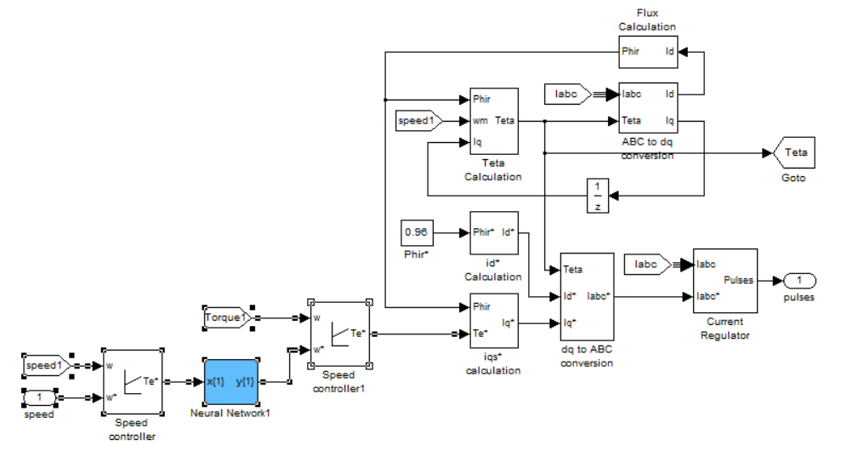

**Fig 6. Block diagram of three phase IM drive and speed control using ANN.**

**4. Simulation results and discussion**

In this paper, two cases were studied. In both, MAT- LAB/Simulink toolboxes are used as shown in Fig. 9. In the first case study, a 50 *hp* IM is run and controlled by a PID controller. The 3-phase voltages and currents are measured and planned in the first 5 s of operation. Also, the acceleration curve and output torque are checked. In the second case, the engine itself is operated and controlled by the ANN controller. The PID controller response is compared with the ANN controller response, and the simulation results are presented in Fig. 10 through Fig. 13. As shown in Figs. 10 and 11, the outputs were improved concerning the size of the starting currents as well as the acceleration time response in the proposed ANN method. The phase current using the proposed ANN method has lower loss components or lower capacity in the same arrangement components.

From Figs. 12 and 13, from interval 0.7 s to 2 s, it is seen that for the desired speed there are spikes in the torque wave- form due to the conventional torque controller that draws more power and these ripples are suppressed using an ANN torque controller. For the actual torque in the steady state, the average loss capacity in the proposed ANN is reduced compared to the PID controller. This shows that the system generates actual torque smoother and reduces speed fluctua tion.

The fluctuation in the mechanical speed *ω*m and load torque TL is reduced with the ANN method. Furthermore, the ANN method shows a faster response in speed tracking. The ANN control achieves better robustness and less over- shoot than PID control by the same velocity reference. By equal initial conditions, the ANN control achieves a shorter duration of the transients. Another advantage of the ANN control is less deviation from the reference signal as shown in Fig. 13. As the figures showed, the proposed ANN method presents better dynamic performance than the PID scheme. Figures illustrate the harmonic velocity wave- form of PID and ANN, respectively. The simulation results show a net superiority of the proposed control as compared to the conventional PID. It can be observed from the simulation results that the torque and flux ripples have substantially reduced. Consequently, the stator current becomes

Vab (V)

-1000

-500

0

500

1000

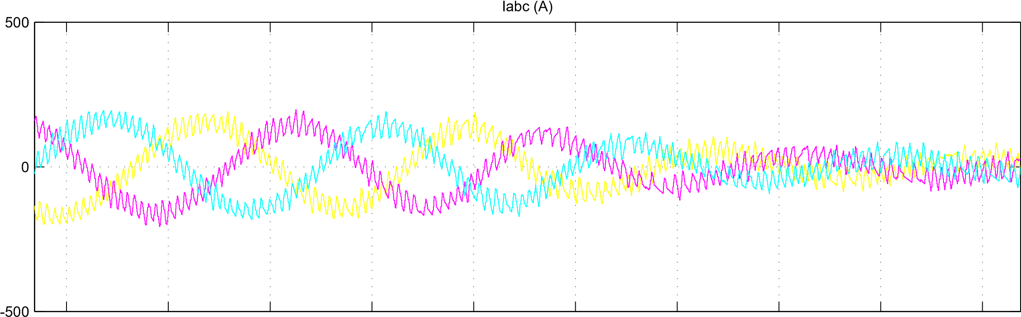

-50

0

50

100

150

)>

<

Rotor speed (wm

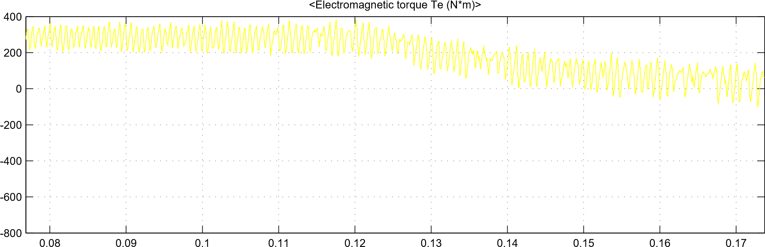

Time offset: 0 **Fig14. Electromagnetic torque response of PID and ANN simulation results)**

more smother and its harmonic contents become smaller as shown in Fig. 11. The THD is reduced by 49.57% compared to conventional PID. Figure shows the efficiency of the IM drive vs. percent load. From the figure, the energy efficiency increases when the IM runs at optimal performance. By comparison between the results obtained by the controller tuned using some known tuning rules and the results obtained by the suggested rules in a worthier performance is achieved by the proposed controller. A comparison between PID and ANN control of this sys- tem is presented. Fine-tuning of the PID controller for the actual parameters of the model could lead to better results, but it could hardly outperform the ANN-based con trol. Furthermore, the PID controller is sensitive to changes in the system model (i.e., simulations of a vehicle with different mass or aerodynamics) and requires repetitive fine-tuning of the controller. Therefore, another advantage of ANN control is that training and tuning are performed automatically. ANN showed a faster response in both the settling time and the overshoot compared to the PID response for multi-step speed input. As a result, ANN showed better performance compared to the PID controller. ANN has also demonstrated the ability to control the speed of the 3-ph. IM and provide an accurate and fast response with no relatively large overshoot and stable state error. This shows the dynamic response for a 20-s simulation result. At time *t* 0, the vehicle is completely stopped and the accelerator is suddenly pushed to 70%. The car starts in electrical mode until the power required by the vehicle reaches 10 kW (at *t* = 0.8 s). At the time *t* 12 s, the brakes are pushed to 70%. This turns on the electric motor to transfer the brake energy to the battery and charge it for 4S. At the time *t* 16 s, the accelerator is suddenly pushed to 70% again [41, 42].

=

=

=



Fig Efficiency of the IM drive using PID vs. ANN

## **5. Experimental results**

Some experimental results are presented for the 1.5 kW induction motor employing the indirect rotor field-oriented control system as shown in Fig. In this case, a multilayer feedforward ANN is used to estimate the rotor speed. The developed circuit controller is designed and implemented using the ds PACE Micro Lab Box controller. Fig shows the experimental setup circuit that consists of IM, 3-ph. inverter, Lithium-ion batteries, and voltage and current sensors. The experimental results of the proposed control system show good stability and better performance of the suggested ANN on the traditional PID controller in full harmonic distortion. The experimental results were in good agreement with the simulated results. Figure shows the experimental waveforms of the gate control signal (*Q*1, *Q*2, *Q*3). Figure shows currents through switches *i*ds1 & *i*ds2 & *i*ds3. Figure shows stator current of the PID model. Figure shows an experimental validation of the stator current of the ANN model. Figure shows harmonic speed waveform of the PID model. Figure shows harmonic speed waveform of the ANN model. As shown in Figs. and, the experimental results reveal that ANN yields a 30% increase in core output with improved quality (i.e., less THD compared to PID). The experimental results exhibit the minimum ripples as previously obtained from the simulation results. The proposed control offers significantly torque and flux ripples reduction than the conventional PID and keeps the current harmonics content at low levels. Experimental results show that when IM operates at optimal flux, energy efficiency increases. These experimental results are more close to those obtained by simulation results. As the figures show, there is the superiority of the proposed controller in reducing the losses during drive cycles in an electric vehicle.

## **6. Conclusions**

In this paper, a simulation study was conducted on an electric motor driven by 50 horsepower; the results showed that the phase current contains fewer loss components or less capacity in the same arrangement components. For the actual torque in the steady state, the amplitude of the loss is reduced on average. This shows that the system generates the actual torque more smoothly and reduces the speed fluctuation of the higher system performance and satisfactory system response is obtained. Various performance indicators were measured such as override peak or lower condition, steady- state error, climb time, stability time, etc. The results of the proposed control scheme simulation show very good stability. The simulation results showed better performance of the ANN proposed on the conventional PID controller in ascension time, time stability, and peak step, and the experimental results were in good agreement with the simulation results obtained using the micro ds PACE laboratory box controller. The main contributions resulting from this work can be summarized as follows:

* ANN is more suitable for controlling nonlinear devices. Since the induction motor has a nonlinear model, the ANN is very suitable for the control of the induction motor in electric vehicles.
* Using the ANN controller, you can control the startup capacity as well as save more power during this time.
* Also, the cost and complexity of the console are reduced when designed by the ANN method, because it does not need data about the system used in detail.
* These controllers are capable of handling nonlinear signals with high efficiency, handling digital and analog data, and are powerful controllers.
* The proposed controller can produce smooth torque and improve system performance.

## **7.References**

* 1. Lin F-J et al (2012) Digital signal processor-based probabilistic fuzzy neural network control of in-wheel motor drive for light elec- tric vehicle. IET Electr Power Appl 6(2):47–61
  2. Aktas M, Awaili K, Ehsani M, Arisoy A (2020) Direct torque con- trol versus indirect field-oriented control of induction motors for electric vehicle applications. Int J Eng Sci Technol 23:1134–1143
  3. Chau KT (2015) Electric vehicle machines and drives: design, anal- ysis and application. Wiley, Hoboken
  4. Tabbache B, Kheloui A, Benbouzid MEH (2010) Design and con- trol of the induction motor propulsion of an electric vehicle. In: IEEE vehicle power and propulsion conference, pp 1–6. IEEE
  5. Butler KL, Ehsani M, Kamath P (1999) A Matlab-based model- ing and simulation package for electric and hybrid electric vehicle design. IEEE Trans Veh Technol 48(6):1770–1778
  6. Karagiannis D, Astolfi A, Ortega R, Hilairet M (2009) A nonlinear tracking controller for voltage-fed induction motors with uncertain load torque. IEEE Trans Control Syst Technol 17(3):608–619
  7. Sen PC (1990) Electric motor drives and control past, present, and future. IEEE Trans Industr Electron 37(6):562–575
  8. Trabelsi R, Khedher A, Mimouni MF, M’sahli F (2012) Back- stepping control for an induction motor using an adaptive sliding rotor-flux observer. Electric Power Syst Res 93:1–15Sun X, Cao J, Lei G, Guo Y, Zhu J (2021) A composite sliding mode control for SPMSM drives based on a new hybrid reaching law with disturbance compensation. IEEE Trans Transp Electrif 7(3):1427–1436. <https://doi.org/10.1109/tte.2021.3052986>
  9. Abdelfatah N, Abdeldjebar H, Bousserhane IK, Hadjeri S, Sicard P (2008) Two-wheel speed robust sliding mode control for electric vehicle drive. Serbian J Electr Eng 5(2):199–216
  10. Alagna S, Cipriani G, Corpora M, Di Dio V, Miceli R (2016) Sliding mode torque control of an induction motor for automotive application with sliding model flux observer. In: IEEE international conference on renewable energy research and applications (ICR- ERA), pp 1207–1212. IEEE
  11. Ltifi A, Ghariani M, Neji R (2014) Performance comparison of PI, SMC and PI-sliding mode controller for EV. In: 2014 15th international conference on sciences and techniques of automatic control and computer engineering (STA), pp 291–297. IEEE
  12. Nasri A, Gasbaoui B, Fayssal BM (2016) Sliding mode control for four wheels electric vehicle drive. Procedia Technol 22:518–526
  13. Boumediène A, Abdellah L (2012) A novel sliding mode fuzzy con- trol based on SVM for electric vehicles propulsion system. ECTI Trans Electr Eng Electron Commun 10(2):153–163
  14. Nasri A, Hazzab A, Bousserhane IK, Hadjeri S, Sicard P (2009) Fuzzy-sliding mode speed control for two wheels electric vehicle drive. J Electr Eng Technol 4(4):499–509
  15. Viswanathan P, Thathan M (2016) Minimization of torque ripple in direct torque controlled switched reluctance drive using neural network. Asian J Res Soc Sci Humanit 6(8):65–80
  16. Kousalya V, Rai R, Singh B (2020) Predictive torque control of induction motor for electric vehicles. In: IEEE transportation elec- trification conference & Expo (ITEC), pp 890–895. IEEE
  17. Pushparajesh V, Balamurugan M, Ramaiah NS (2019) Artificial neural network based direct torque control of four-phase switched reluctance motor. Available at SSRN 3371369
  18. Singh B, Jain P, Mittal AP, Gupta JRP (2006) Direct torque con- trol: a practical approach to electric vehicle. In: IEEE power India conference, pp 4-pp. IEEE
  19. Haddoun A et al (2008) Modeling, analysis, and neural network control of an EV electrical differential. IEEE Trans Industr Electron 55(6):2286–2294
  20. Das S, Pal A, Manohar M (2017) Adaptive quadratic interpolation for loss minimization of direct torque controlled induction motor driven electric vehicle. In: 2017 IEEE 15th international conference on in industrial informatics (INDIN). IEEE
  21. Morsalin S, Mahmud K, Town G (2016) Electric vehicle charge scheduling using an artificial neural network. In: IEEE innovative smart grid technologies-Asia (ISGT-Asia). IEEE
  22. Saleeb H, Sayed K, Kassem A et al (2019) Control and analysis of bidirectional interleaved hybrid converter with coupled inductors for electric vehicle applications. Electr Eng 102(1):195–222
  23. Sayed K, El-Zohri E, Mahfouz H (2017) Analysis and design for interleaved ZCS buck DC-DC converter with low switching losses. Int J Power Electron 8(3):210–231
  24. Singh B et al (2006) Neural network based DTC IM drive for elec- tric vehicle propulsion system. In: IEEE conference on electric and hybrid vehicles. IEEE
  25. Chan C (1993) An overview of electric vehicle technology. Proc IEEE 81(9):1202–1213
  26. Asaii B, Gosden D, Sathiakumar S (1996) A new technique for highly efficient sensor-less control of electric vehicles by using neural networks. In: Power electronics in transportation. IEEE
  27. Kalogirou SA (2003) Artificial intelligence for the modeling and control of combustion processes: a review. Prog Energy Combust Sci 29(6):515–566
  28. Mediouni H et al (2017) Artificial neural networks applied on double squirrel cage induction motor for an electric vehicle motor-zation. In: International conference on electrical and information technologies (ICEIT). IEEE
  29. Bouhoune K, Yazid K, Boucherit MS, Nahid-Mobarakeh B (2018) Simple and efficient direct torque control of induction motor based on artificial neural networks. In: IEEE international conference on electrical systems for aircraft, railway, ship propulsion and road vehicles & international transportation electrification conference (ESARS-ITEC), pp 1–7
  30. Zegai ML, Bendjebbar M, Belhadri K, Doumbia ML, Hamane B, Koumba PM (2015) Direct torque control of Induction Motor based on artificial neural networks speed control using MRAS and neural PID controller. In: IEEE electrical power and energy conference (EPEC), pp 320–325
  31. Kassem R, Sayed K, Kassem A et al (2020) Power optimization scheme of induction motor using FLC for electric vehicle. IET Electr Syst Transp 10(3):301–309
  32. Sayed K, Kassem A, Saleeb H, Alghamdi AS, Abo-Khalil AG (2020) Energy-saving of battery electric vehicle powertrain and efficiency improvement during different standard driving cycles. Sustainability 12(24):10466. <https://doi.org/10.3390/su122410466>
  33. Shi Y, Lorenz RD (2017) Induction machine design for dynamic loss minimization along driving cycles for traction applications. In: IEEE energy conversion congress and exposition (ECCE)
  34. Ericsson E (2001) Independent driving pattern factors and their influence on fuel-use and exhaust emission factors. Transp Res Part D: Transp Environ 6(5):325–345
  35. Lee J-S et al (2000) A neural network model of electric differen- tial system for electric vehicle. In: IEEE international conference on industrial electronics, control and instrumentation. 21st century technologies. IEEE
  36. Topic J, Skugor B, Deur J (2019) Neural network-based modeling of electric vehicle energy demand and all electric range. Energies 12(7):1396
  37. Ericsson E (2000) Driving pattern in urban areas: descriptive anal- ysis and initial prediction model. Univ
  38. Zhao J et al (2019) Optimization and matching for range-extenders of electric vehicles with artificial neural network and genetic algo- rithm. Energy Convers Manage 184:709–725
  39. Demuth H, Beale M, Hagan M (1992) Neural network toolbox. For use with MATLAB. The MathWorks Inc, Natick
  40. Saleeb H, Sayed K, Kassem A et al (2019) Power management strat- egy for battery electric vehicles. IET Electr Syst Transp 9(2):65–74
  41. Almutairi A, Sayed K, Albagami N, Abo-Khalil AG, Saleeb H (2021) Multi-port PWM DC–DC power converter for renewable [energy applications. Energies 14:3490. https://doi.org/10.3390/ en14123490](https://doi.org/10.3390/en14123490)