Harmonic Reduction In VSG Using Fuzzy Logic Considering Nonlinear loads and Distorted Grid.

A Naga Sridhar 1, G Raj Rohan Reddy 2, P Alekhya3, N Pawan Kalyan 4, S Madhusudhan5  *

Assistant Professor, Department of Electrical & Electronics Engineering, Teegala Krishna Reddy Engineering college,Hyderabad

UG Students, Department of Electrical & Electronics Engineering, Teegala Krishna Reddy Engineering College, Hyderabad

|  |  |
| --- | --- |
|  | A B S T R A C T  Harmonics are always present in the electrical networks in both no-load and load conditions. Harmonics reduces the power quality of the VSG in the presence of nonlinear loads and distorted grid. Completely removing the Harmonics from the network is impossible but we need to reduce them to a minimum value so that the system efficiency improves. A hybrid harmonic suppression scheme is proposed to enable the further improvement of the adaptability of VSG, which mainly consists of a voltage harmonic control loop and a grid current-controlled loop. The voltage harmonic control loop aims to scale down the inverter output impedance via a negative feedback loop, while the grid current-controlled compensator is intended to counteract the adverse effects from a weak grid via an additional voltage, which leads to substantially lower total harmonic distortion for both the load voltage and the grid current at the same time .By using a proper controller we can reduce the THD value of the grid to the minimum. |

Keywords: Distorted Grid, Active Power, Reactive Power, Inverter, THD,VSG.

**1 INTODUCTION**

MPC uses a discrete-time model of the system to predict the optimal solution in the next instant according to the current system state acting as the initial value. The method proposed in belongs to a continuous control set model predictive control, with a fixed switching frequency. In this paper, an MPC method is proposed for grid connected DC/DC converters of a HESS with a double layer control strategy to realize the voltage regulation and power allocation between battery and UC [1]. In the recent years, there has been a considerable increment of diffused generators connected to distribution grids by means of power converters. These converters operate frequently below their rated power due to the fluctuation of the power generated by the renewable sources. In this scenario, power electronics interfaces could be also used as active harmonic compensators for other converters or distorting loads.[2] Typically, these converters do not have information on other loads or on the level of grid current distortion. For this reason, this paper presents a new control algorithm for the grid harmonics compensation that relies only on the measurement of the voltage at the point of connection of the power converter. The reference of the compensating current is calculated from the harmonic content of the voltage in a reference frame synchronous with the grid voltage. [3] . In this work, an adaptive observer supported fundamental extractor is developed to estimate the fundamental components of the load current for a three phase distribution static compensator (DSTATCOM) under nonlinear load. Main variations in the proposed work are the fundamental drawing out from the distorted load current and estimation of PI controller gains. With this observer, salp swarm optimization algorithm (SSOA) is used for estimation of DC PI controller and AC PI controller gains. The estimated gains are used for DC bus voltage and AC terminal voltage error minimization respectively. This optimization algorithm commendably progresses the initial random solutions and converge to optimum. Pareto optimal solutions are approximated in SSOA with prodigious convergence and coverage. The SSOA can search unknown spaces and can deal with real world problems for solutions. This paper presents a method for improving the reliability of DC nanogrids by decreasing the input capacitance requirement.[4] The nanogrid DC bus capacitance requirement is reduced by utilizing the zero-sequence operation mode of the solid state converter (SSC). This SSC is often considered as the main DC nanogrid energy control unit that is linking the nanogrid with the main utility AC grid and managing the nanogrid elements. The proposed method injects a zero-sequence voltage in the SSC AC filter capacitors to compensate the low frequency power ripples that are imposed on the DC bus. The proposed method compensates power ripple due to non-linear loads, linear loads, distorted grids, and load variations. Moreover, the compensation method does not require additional components that are commonly used with the existing power ripple compensators. Furthermore, practical considerations of the proposed control are discussed in the paper regarding stabilization of the nanogrid in case of lack of critical damping[5]. In fuel-cell-connected utility networks, electrical loads attached to the power network often generate reactive power, which hinders the utility from normal functioning and reduces the system power factor. This condition results in wasted energy, increase demand for electricity, system overload, and higher utility costs for customers. Besides, a power system’s poor power factor is often caused by a large distorted reactive power element because of the widespread use of non-linear loads. Moreover, power outages were brought on by voltage dips resulting from reactive power. In a fuel cell-based network, traditional utilities often use classical filters that are unable to remove harmonic properties, and incapable of compensating for the reactive power. Moreover, power outage compensation is overlooked in most fuel cell-based energy systems. To address this problem, the proposed article provides a novel unified linear self-regulating (LSR) active/reactive sustainable energy management system (SEM) that can adjust the power factor by compensating for power outages and reactive power, and precisely removing harmonics from the electricity network. As a result, the suggested mechanism may avoid power losses and allow users to save money on their power costs. Furthermore, notwithstanding grid availability, the critical loads receive an uninterrupted power supply due to the automatic transition circuit implemented in the SEM.[6]. DC-link voltage directly affects the compensation range and performance of shunt active power filters (SAPFs). DC-link voltage in SAPF is generally high, fixed, and dependent on rated power. DC-link voltage could become excessive in low-load conditions, which increases switching loss and switching noise. Optimized DC-link voltage was obtained in this study to enhance compensation adaptability for variable nonlinear loads and fluctuation in grid voltage. We proposed a novel adaptive DC-link voltage control for SAPFs, which reduced switching noise and switching loss during operation. The proposed DC-link voltage control method employed model predictive current control, proportional voltage control and calculation of optimal DC-link voltage. A real-time observer, which was insensitive to distorted grid condition, was used to capture peak grid voltage. [7]. The increasing use of power electronic devices can deteriorate the power quality by introducing voltage and current harmonics. In islanded microgrids, the presence of nonlinear loads can distort the point of common coupling (PCC) voltage, while the dead-time effect can also bring additional circulating current harmonics among parallel inverters. To simultaneously attenuate the PCC voltage harmonics and suppress the dead-time induced circulating current harmonics, this paper proposes a coordinated control strategy for harmonic mitigation of parallel inverters. The proposed control strategy allows inverter impedances to be properly reshaped at selective harmonic frequencies. As a consequence, the PCC voltage harmonics are filtered by the inverter operating in the harmonic compensation mode (HCM),[8] whereas the dead-time induced circulating current harmonics are suppressed by the inverter operating in the harmonic rejection mode (HRM).[9]. With the rapid development of industrialization, the proportion of electric arc furnaces (EAF) in distribution networks is getting higher and higher. Aiming at the problem that grid voltage is distorted by a large number of arc furnace nonlinear loads accessing to distribution networks, it is crucial to make dynamic analysis of distribution network voltage and adopt a control strategy of grid-connected converter based on the new phase-locked loop (PLL) technology. As a result, the harmonic distortion rate is reduced and the quality of grid-connected current and voltage is improved. In this paper, photovoltaic (PV) system model and the typical dynamic model of the EAF are established. By analyzing the influence of the EAF model on the PV grid-connected converter with the traditional phase-locked loop while connected to distribution network, a control strategy of the PV grid-connected converter with the self-adjusting double SOGI (MAF-SASOGI) phase-locked loop with the ideal low-pass filter is proposed.[10]. an alternative control technique for producing reference current signal to manage operation of three-phase three-wire parallel-connected active power filter (PAPF) is presented. In the context of generating reference current, time-domain synchronous reference frame (SRF) technique has commonly been recognized to provide the benefit of control simplicity. However, its control structure is rather rigid which restricted its flexibility to be applied in different power system configurations. For instance,[11]SRF technique which is initially designated to work with three-phase system cannot be applied directly to single-phase network without intensive modification to its overall control structure. Hence, in this work, a control technique named as modular fundamental element detection (modular-FED) which exhibits modular structure is proposed, to manage mitigation of harmonic current under unbalanced and/or distorted grid. The design concept of the proposed technique was modeled using MATLAB-Simulink software. Two types of highly nonlinear loads are applied to assess the effectiveness of the proposed modular-FED technique under various unbalanced and/or distorted grids. In-depth comparative analysis with the standard SRF technique is performed to evaluate the benefits of using the proposed technique.[12]

**2 PROPOSED TOPOLOGY**

Harmonics are always present in the network even in ideal and non ideal conditions. We cannot remove harmonics totally from the network but we can reduce them to the minimum, so that the losses in the network will be reduced and electrical energy transmission will be done efficiently. Most common causes of harmonics in the circuit are from non-linear loads and distortions in the grid due to various reasons. In this simulation above hybrid harmonic sources are used to produce harmonics in the circuit. Our goal is to reduce these harmonics present in the circuit to a minimum value. Harmonics in the circuit are reduced by using a negative feedback loop consisting of PWM which injects Controlled outputs to the VSG. Control outputs are derived by comparing the derived quantities and desired quantities using fuzzy logic controller. The outputs from the fuzzy logic controller is given to the PWM .

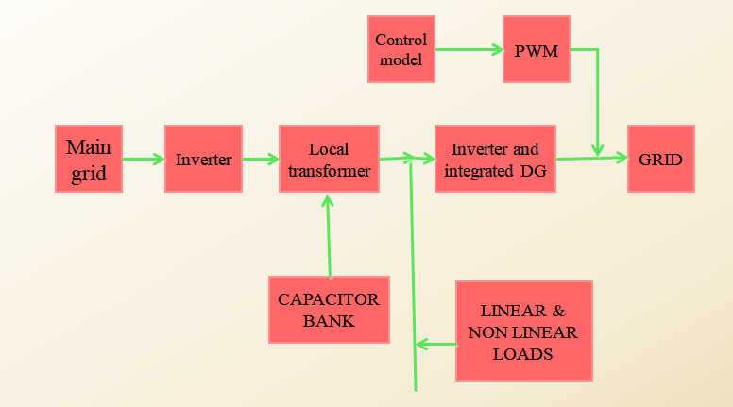

**Fig 1. Block Diagram**

**3 CONTROL SCHEME**

In order to control the bus voltage of the DC microgrid and the voltage of UC, the control structure includes two parts: the battery provides the UC with energy and the UC provides the DC bus with energy. Each part includes two layers of control: outer voltage control and inner current control. The purpose of outer voltage control is to calculate the predictive value of the inductor current needed to stabilize the voltage. The function of the inner current control is to make the actual current follow the predictive value calculated from the outer control, so as to realize the function of the outer layer steady-state predictive value calculation and inner layer dynamic rolling optimization.

The battery provides the UC with energy to regulate UC voltage and UC regulates the bus voltage by the three-level DC/DC converter. There are two types of input voltage values on the bus side, i.e., the full bus voltage *V*dc or half of the bus voltage *V*dc/2. The input voltage can be selected according to the actual situation. This topology can effectively reduce the inductor current ripples and the voltage stress of each switch, thereby suppressing the DC bus power fluctuations of the higher voltage levels.

Changing the parameter δi only affects the change rate of the current in the transition process, and has no effect on the steady-state value. By changing the value of parameter δi , the charging/discharging rate of the battery can be controlled, and then the power fluctuations under different frequency ranges can be allocated between the battery and UC.The rated reference bus voltage is Vdcref, and the actual voltage Vdc is regulated by the UC charging/discharging through the three-level DC/DC converter. duc is the duty cycle of the switches on the UC side. The UC terminal voltage Vuc may be larger or smaller than Vdc/2 in the dynamic process of the system, which is according to the principle of NPV balance. The input voltage on the bus side may be Vdc or Vdc/2, which will be discussed in the following two cases.

In case 1, when Vuc > Vdc/2, the UC is charged or discharged. The input voltage on the bus side is Vdc, and the equivalent capacitance C is the series value of C1 and C2.

In case 2, when Vuc < Vdc/2, the UC is charged or discharged . Due to the NPV balance control strategy, Vc1 almost equals Vc2. The input voltage on the bus side can be considered as Vdc/2, and the equivalent capacitance is C1 = C2 = 440 µF

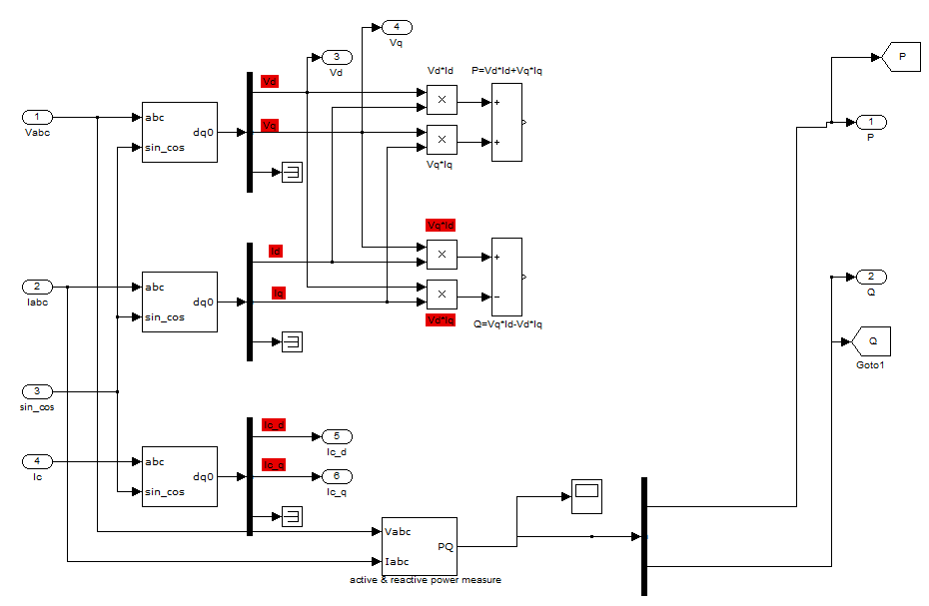

**Fig 2: Active and Reactive power measurements**

Above figure shows the simulation diagram for calculating active and reactive power. Load voltages and currents are given as input to this circuit. From these current and voltage values both active power and reactive power values are calculated using instantaneous active and reactive power measure tool. Vd and Vq values are also calculated in this circuit , which are used to compare with desired values. For finding Vd and Vq values load voltage and current values are converted into DQ quantities.

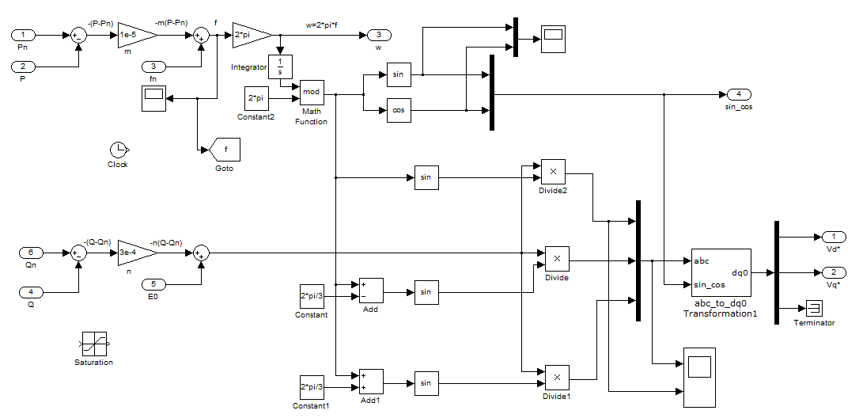

**Fig 3: Power loop controller**

In power loop controller Vd and Vq values are derived from the active and reactive power values. Reference active and reactive power ,voltage, frequency values are given as inputs for this circuit based on the requirement. Vd and Vq and W values are calculated in this circuit using reference values.

These values are used to compare with the values from active and reactive power measurement circuit.

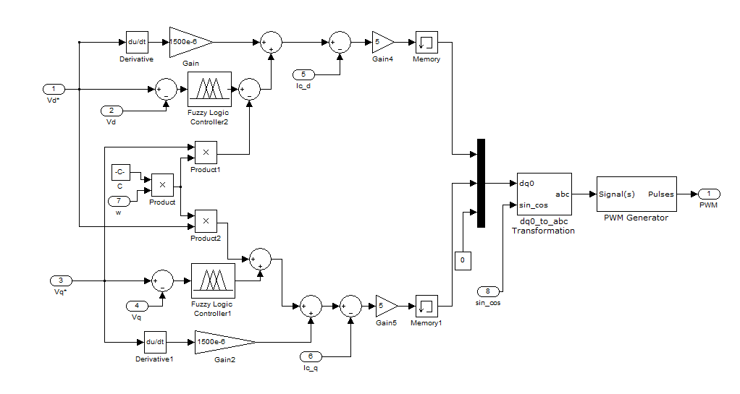

**Fig 4: UI control diagram :**

Above control loop only controles the values of PWM in the main simulation diagram. In this UI control loop inputs are derived and desired conditions of the transmission line. Fuzzy logic performs the control function in this loop. Inputs of this loop are derived active power and reactive power from active and reactive power measurement. Desired conditions are obtained from the power loop controller. Fuzzy logic compares these values and give output to the PWM accordingly.

**4. SIMULATION RESULTS**

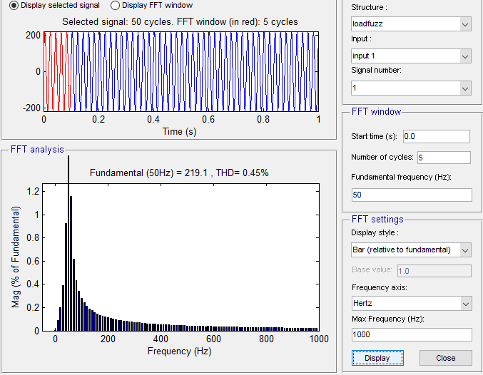

**Fig 5. Total harmonic distortion value**

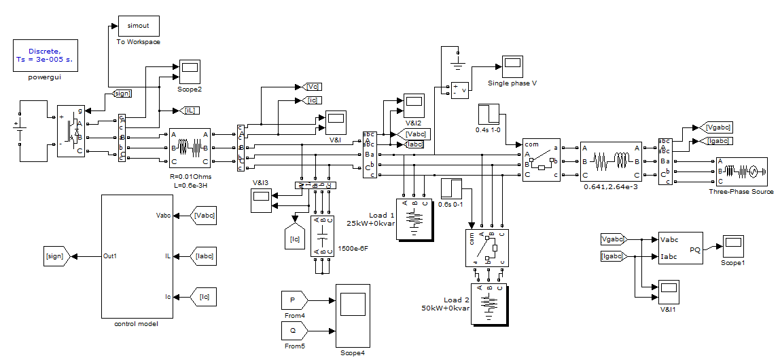

**Fig 6 :Simulation diagram**

There are two loops. First loop is DG (distributed energy generator) is connected to the inverter. The loops are are connected across the inverter and the inverter is connected to the grid.We take the voltage feedback value and current loop, powerloop through that values hormonics eliminates from the loop. The output of the voltage,current and power values we take as the reference value and the reference value is given input to the pwm modulator.The pwm modulator is connected to the inverter and the DG is sapress the values and this value is connected to the grid.The DG is connected to the inverter .for the inverter we assign some pulses and the local transmission line we connected to the inverter.In local transmission line we using capacitor and linear and non linear loads arranged to the transmission line .The capacitor is used to reduce the powerrfactor correction and the linear and non linear loads are arranged to the transmission .In control loop we takeing the input values of the active and reactive power values .the output values of active and reactive values taking as reference values and these reference values given input to the power loop and the output of the power loop is connected to the the UI control loop.Using the reference values are given to the converter and using these values reduces the harmonics .

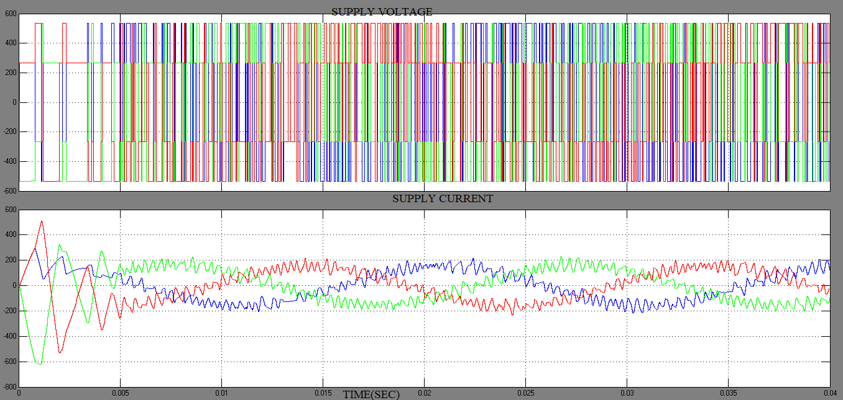

**Fig 7. Supply Voltage and Current**

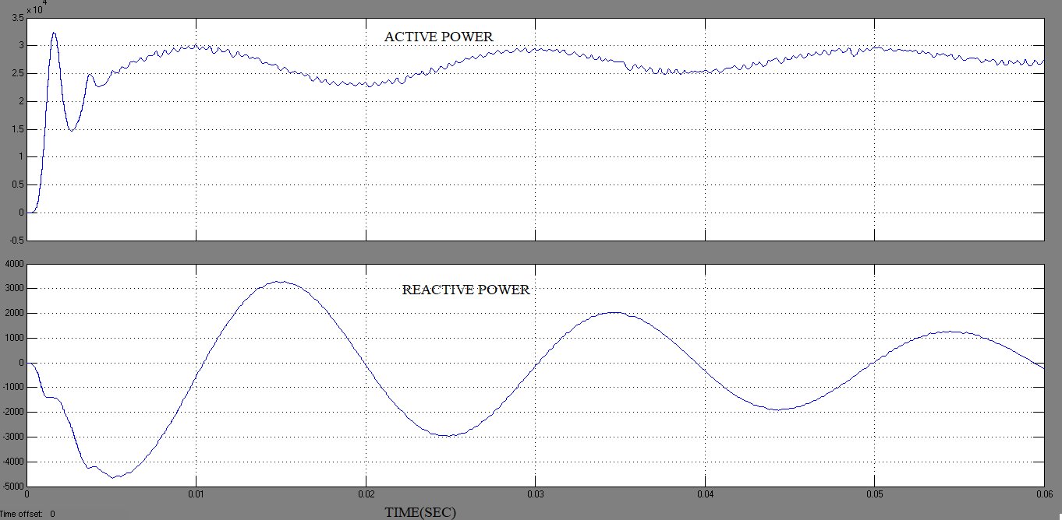

**Fig 8. Active power and Reactive power**

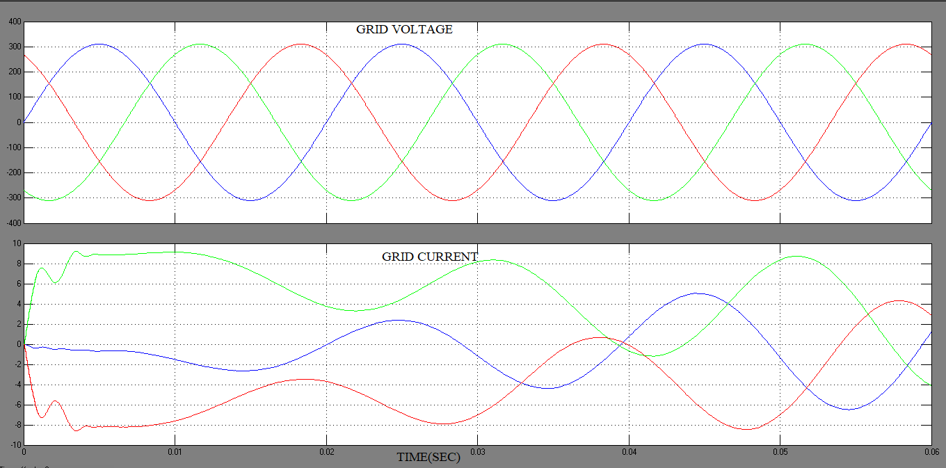

**Fig 9. Grid Voltage and Grid Current**

**5. CONCLUSION**

In this paper, the advantages of a three-level bidirectional DC/DC converter for battery/UC HESS and the effectiveness of the proposed MPC method are discussed . At the same grid voltage level, the battery can suppress higher voltage level fluctuations after a two-stage boosting structure. Compared with the fuzzy logic controller, the MPC controller doesn’t need a tedious step of adjusting parameters and various state variables are considered in each sampling instant. Moreover, the MPC algorithm based on the constant switching frequency achieves fast and accurate regulation of voltage and current with diminished ripples. Finally, the system does not need filters to allocate power fluctuations, and the control structure is optimized while the battery life is prolonged.

**6. References**

1. Chen, Siyuan, et al. "A model predictive control method for hybrid energy storage systems." *CSEE Journal of Power and Energy Systems* 7.2 (2020): 329-338.
2. S. D'Arco, L. Piegari and P. Tricoli, "Harmonic compensation with active front-end converters based only on grid voltage measurements," 3rd Renewable Power Generation Conference (RPG 2014), Naples, 2014, pp. 1-6, doi: 10.1049/cp.2014.0935.
3. J. Srikakolapu, S. R. Arya and R. Maurya, "Distribution static compensator using an adaptive observer based control algorithm with salp swarm optimization algorithm," in CPSS Transactions on Power Electronics and Applications, vol. 6, no. 1, pp. 52-62, March 2021, doi: 10.24295/CPSSTPEA.2021.00005.
4. A. Khan, M. B. Shadmand, S. Bayhan and H. Abu-Rub, "A Power Ripple Compensator for DC Nanogrids via a Solid-State Converter," in IEEE Open Journal of the Industrial Electronics Society, vol. 1, pp. 311-325, 2020, doi: 10.1109/OJIES.2020.3035073.
5. K. Hasan, M. M. Othman, S. T. Meraj, M. Ahmadipour, M. S. H. Lipu and M. Gitizadeh, "A Unified Linear Self-Regulating Method for Active/Reactive Sustainable Energy Management System in Fuel-Cell Connected Utility Network," in IEEE Access, vol. 11, pp. 21612-21630, 2023, doi: 10.1109/ACCESS.2023.3249483.
6. J. Zhou, Y. Yuan and H. Dong, "Adaptive DC-Link Voltage Control for Shunt Active Power Filters Based on Model Predictive Control," in IEEE Access, vol. 8, pp. 208348-208357, 2020, doi: 10.1109/ACCESS.2020.3038459.
7. Y. Qi, J. Fang, J. Liu and Y. Tang, "Coordinated control for harmonic mitigation of parallel voltage-source inverters," in CES Transactions on Electrical Machines and Systems, vol. 2, no. 3, pp. 276-283, September 2018, doi: 10.30941/CESTEMS.2018.00034.
8. L. Kong, Z. Shi, G. Cai, C. Liu and C. Xiong, "Phase-Locked Strategy of Photovoltaic Connected to Distribution Network With High Proportion Electric Arc Furnace," in IEEE Access, vol. 8, pp. 86012-86023, 2020, doi: 10.1109/ACCESS.2020.2989896.
9. H. K. M. Paredes, D. T. Rodrigues, J. C. Cebrian and J. P. Bonaldo, "CPT-Based Multi-Objective Strategy for Power Quality Enhancement in Three-Phase Three-Wire Systems Under Distorted and Unbalanced Voltage Conditions," in IEEE Access, vol. 9, pp. 53078-53095, 2021, doi: 10.1109/ACCESS.2021.3069832.
10. Q. -N. Trinh and H. -H. Lee, "Improvement of grid current performance for grid-connected DG under distorted grid voltage and nonlinear local loads," 2014 IEEE 23rd International Symposium on Industrial Electronics (ISIE), Istanbul, Turkey, 2014, pp. 2607-2612, doi: 10.1109/ISIE.2014.6865031.
11. G. Lou, Q. Yang, W. Gu, X. Quan, J. M. Guerrero and S. Li, "Analysis and Design of Hybrid Harmonic Suppression Scheme for VSG Considering Nonlinear Loads and Distorted Grid," in IEEE Transactions on Energy Conversion, vol. 36, no. 4, pp. 3096-3107, Dec. 2021, doi: 10.1109/TEC.2021.3063607.
12. H. Ahmed, S. Biricik and M. Benbouzid, "Extended Self-Tuning Filter-Based Synchronization Technique for Unbalanced and Distorted Grid," 2020 2nd International Conference on Smart Power & Internet Energy Systems (SPIES), Bangkok, Thailand, 2020, pp. 350-355, doi: 10.1109/SPIES48661.2020.9242953.