**ANDROID CONTROLLED SOLAR BASED GRASS CUTTER**

**Mr. Goutam Barma1, N. Shankar2, N. Srujan Kumar3,T. Hemakanth4**

1Assistant Professor, Department of Electrical & Electronics Engineering**,** ACE EngineeringCollege Ghatkesar,Telangana, India

2Student, Department of Electrical & Electronics Engineering**,** ACE EngineeringCollege Ghatkesar,Telangana, India

3Student, Department of Electrical & Electronics Engineering**,** ACE EngineeringCollege Ghatkesar,Telangana, India

4Student, Department of Electrical & Electronics Engineering**,** ACE EngineeringCollege Ghatkesar,Telangana,

India

**ABSTRACT**

The prevailing technology normally used for reducing the grass by means of using the manually cope with device. The venture pursuits to manufacture a grass slicing system machine managed via android utility using Bluetooth module function which runs with the assist of motor via using solar power.These systems can be installed at a lower cost than other existing systems. This is permanent and irreversible. The system does not pollute the environment as it uses solar energy to charge the batteries. In previous days, grass cutter machines are operated via gasoline and electrical power which can be pricey and requires high renovation. The sun panel is used to fee the battery in order that there may be no need of charging it externally. on this device we use Adriano IDE software to do all the programming of this tool even the slightest movement of wheel. For the up and down motion of grass cutter device named Servo Motor is being introduced. by way of using Bluetooth utility we can manipulate grass cutter robot like left, proper, back and front movements by the usage of distinctive command. in the end, we are right here to talk approximately the electricity used on this tool. We’ve got used a battery of capability 12V, additionally solar Panels with a purpose to come available in sunny days and are surroundings friendly.

**Key Words:** Adriano IDE, Solar panel, Battery, DC motor, Bluetooth module.

1. **INTRODUCTION**

Grass cutter machines have emerged as very popular today. Most of the instances grass cutter machines are used for smooth grass furnishing. In a time where era is merging with environmental focus, consumers are seeking out approaches to contribute to the relaxation of their personal carbon footprints. Pollution is man-made and may be visible in our personal daily lives, more specifically in our personal houses. Here with thereby, we're heading off the carbon foot print and the entire operation may be automated via interfacing the right instructions with our manage circuit. Automatic grass slicing machine is a device which goes to carry out the grass reducing operation on its personal. This model reduces each environment and noise pollutants. Our new design will help each consumer and the environment and also lessen the environmental impact in addition to noise pollutants. This challenge of a sun powered automatic grass cutter will relieve the patron from mowing their personal lawns and will lessen each environmental and noise pollution. This layout is meant to be an exchange green option to the popular and environmentally hazardous fuel powered garden strength.

1. **METHODOLOGY**

Automated solar grass cutter is a fully automated grass cutting robotic vehicle powered by solar energy that also avoids obstacles and is capable of fully automated grass cutting, without the need of any human interaction. The system uses 12V batteries to power the vehicle movement motors as well as the grass cutter motor. We also use a solar panel to charge the battery so that there is no need of charging it externally. The grass cutter and vehicle motors are interfaced to an L293D motor driver that controls the working of all the motors. It is also interfaced to an proximity sensor for object detection. The driver circuit moves the vehicle motors in forward direction in case no obstacle is detected. On obstacle detection, proximity sensor monitors it and the driver circuit thus stops the grass cuter motor so as to avoid any damage to the object/human/animal. Driver circuit then turns the robotic vehicle off until it gets clear of the object and then moves the grass cutter in forward direction again.

**2.1 Reduction in energy consumption**

The energy supplied to the lawnmower in this project is solar energy, which is abundant in nature. We also use a DC motor that uses very little energy so that we can save electricity from non- -renewable equipment. This solar powered lawnmower uses less energy than diesel, petrol electric lawnmowers

**2.2 Reduction in cost**

Our main goal in this project is to reduce energy costs and eliminate labor costs. Thus, we can use lawnmowers without additional costs such as labor costs. Electricity, maintenance and gas. Since the number of parts we use is low, the production cost is also low. This way we can save a lot of money without having to buy an electric or gas mower.

1. **MODELING AND ANALYSIS**

This project is a centrally controlled solar lawnmower model prepared using non-renewable energy sources such as solar energy. Solar energy is a renewable energy that is abundant in nature and can be obtained free of charge. The energy of the solar panel is stored in the battery. Therefore, we can always use electrical power when using the lawnmower.  
Here we use Arduino NANO to connect the bluetooth module to activate the system and work on the mobile phone. The  
motor driver circuit is the main part of the solar generator, it controls the two motors to start and stop according to the bluetooth commands given to it. For the normal operation of the LM293D, 12v is input to the 8" pin supplied to the motor, and 5v to the driver circuit. With this driver, we can change the direction show on the lawnmower.  
The HC-05 Bluetooth module we used in this project, so we can run the lawnmower with Android.  
From this, we can operate the Android-controlled solar lawnmower without labor costs and reduce human intervention.

Voltage

Regulator

A

R

D

U

I

N

O

NANO

Solar Panel

Bluetooth

Module

L293D

Relay

Android Device

Battery

**Figure1:**Block diagram.

**SOLAR PANEL**

* Voltage 12V
* Power =5W

**BATTERY**

* Voltage =12V
* Current =1.2Ah

**7805 VOLTAGE REGULATOR**

* Minimum input voltage = 10 V
* Maximum input voltage = 35 V
* Minimum output voltage = 5V
* Operation Ambient Temp = 0-125℃
* Maximum output current = 1 A

**7812 VOLTAGE REGULATOR**

* Minimum input voltage = 10 V
* Maximum input voltage = 35 V
* Minimum output voltage = 12V
* Operation Ambient Temp = 0-125℃
* Maximum output current = 1.5 A

**HC-05 BLUTOOTH MODULE**

* Supply voltage (Vcc) = 3.3 V to 5V DC
* Operating current = 50mA
* Frequency = 2.4 GHz ISM band
* Operating temperature = -20℃ to 75℃
* Range = 10 meters (or 33 feet) in open air

**ARDUINO NANO**

* Analog I/O Pins = 8
* Architecture AVR
* Clock Speed = 16 MHz
* DC Current per I/O Pins = 40mA
* Digital I/O Pins = 22
* EEPROM = 1 KB
* Flash Memory = 32 KB of which 2 KB used by Bootloader
* Input Voltage =(7-12) Volts
* Microcontroller = ATmega328P
* Operating Voltage = 5 V
* Power Consumption = 19mA
* PWM Output = 6
* SRAM = 2KB
* Weight =7gms

**RELAY**

* Rated voltage = 5 V DC
* Type = SPDT
* Rated current = 30mA
* Coil resistance = 160 ohm
* Power consumption = 150mW

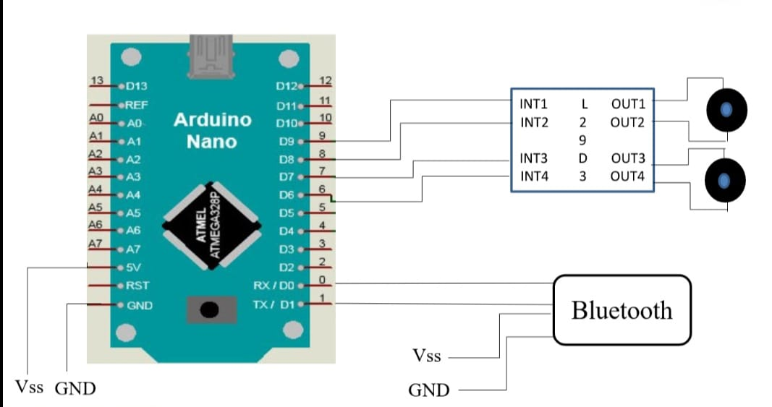

**Figure2:**Circuit diagram.

1. **RESULTS AND DISCUSSION**

The grass cutter is light weight. Eco friendly & pollution free. It requires very less human supervision. Less cost.it is easy to carry from one place to another. Less maintenance. There is no need to use any fuel.

The use of gas mowers creates a lot of environmental pollution that often affects living things. So there will be no pollutants that harm the environment in this solar lawnmower. There will be no noise and therefore will not disturb the people

around you.

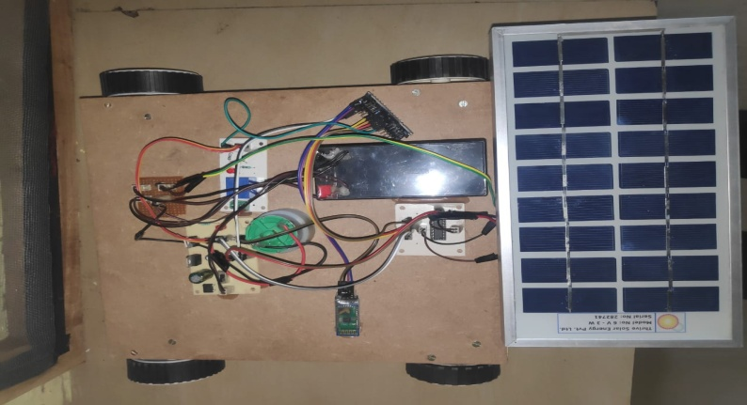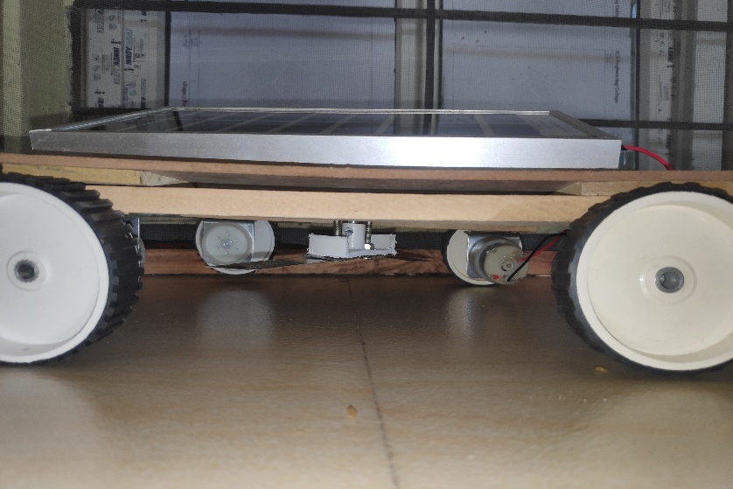

**Figure3:**Solar gross cutter

1. **CONCLUSION**

This project shows how to use a smartphone as a lawnmower. The system uses a 12 V, 1.3 Ah lead-acid rechargeable battery. The battery can be charged by solar energy. The solar panel is connected to the system to charge

 the battery.The system is cheaper and more powerful. After using this system, manual mowing work will be greatly reduced. Also, manual mowing can create uneven lawns. However, with this system, the cutting process is equal and the grass in all playgrounds can be cut with this system..

1. **REFERENCES**
2. Aditya S. Rajmani, Appaji N. Gaonkar, AjayDarak, Akshay Joshi, Prof. Vinay M. Murgod, “Design and Fabrication of Hybrid Operating Grass Cutter”, pp 795-799, Vol. 8 Issue 05, May-2019
3. Anuradha Kadam, VrushaliKhadake, SnehalNalawade, Karishma Mujawar, Nilofar Mulla, “Automated Solar Operated Grass Cutting Machine”, International Journal of Advance Research in Science and Engineering, pp 11-18, Volume: 07, Special Issue: 03, Feb 2018
4. M/s. SnehalPopatJagdale,Prof. Priti Rajput,“Android Controlled Solar based Grass Cutter Robot”,International Journal of Engineering Research & Technology(IJERT), Vol.9 Issue 07,July-2000