**AGRIBOT FOR SMART FARMING**

**Mrs Sunantha .A *1 , G. Beekoji *2 , P. Swathi *3 , G. Sumanth *4 , A.Narendhar*5**

*1Assistent Professor, Department of Electrical & Electronics Engineering, ACE Engineering College, Hyderabad, Telangana , India

*2Student, Department of Electrical & Electronics Engineering, ACE Engineering College, Hyderabad, Telangana , India

*3Student, Department of Electrical & Electrical Engineering, ACE Engineering College, Hyderabad, Telangana , India

*4Student, Department of Electrical & Electronics Engineering, ACE Engineering College, Hyderabad, Telangana , India

*5Student, Department of Electrical & Electronics Engineering, ACE Engineering College, Hyderabad, Telangana , India

**ABSTRACT**

Increasing population requires the food production to be increased which requires better cultivation in the form of proper utilization of seeds and fertilizers with minimum labour work. The main objective of autonomous AGRIBOT is efficient utilization of resources and to reduce labour work. It can perform various tasks like soil testing ,ploughing, sowing of seeds ,spraying of water. All above operations are performed by using ARDUINO controlled. This smart farming robot all operations can be controlling through Smartphone via Bluetooth communication, so this project can be very useful for the farmers.

The qualitative approach of this project is to develop a system which minimizes the working cost of seed sowing operation. Automated seed sowing robot contains Arduino , sensors, motor driving circuit, sowing mechanism and motors. There are battery powered wheels and dc motor inbuilt in these wheels. In each complete rotation of rotating wheel there are seeds falling from the seed container and the seed plantation process can take place smoothly as well as without wastage of seeds. This system provides all the facility which can work efficiently and brings down Labour dependency. Seed sowing robot will move on various ground contours. Keywords: Agribot , ARDUINO controllers oil sensor, sowing of seeds.

**I.INTRODUCTION**

Agriculture robot is a device which helps in the sowing of seeds in the desired position, hence assisting the farmers in saving time and money. Works reliably under different working conditions. Decreases the cost of the machine. Decreases labor cost by advancing the spraying method.The bot can be operated in the small farming land (1acre).

**II. METHODOLOGY**

**The major steps**

**Step1:** start the robot

**Step2:** pairing Bluetooth with smart phone

**Step3:** Is Bluetooth paired

**Step4:** select an activity from list of commands

**Step5:** If gives the commands F, B, R, L

If it is YES, The robot is F-Forward, B-Backward, R-Right, L-Left If it is NO,

The robot is S-Stop.

**Step6:** If Gives the commands C, A

If it is YES, C-Ploughing ON, A-Ploughing OFF

If it is NO, Stop The above command.

**Step7:** If gives the command E, H

If it is YES, E-Seeding ON, H-Seeding OFF

If it is NO, stop the above commands

# III.MODELING AND ANALYSIS

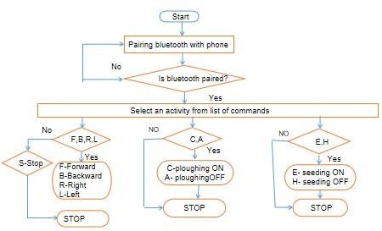

Fig 1:Flow Diagram

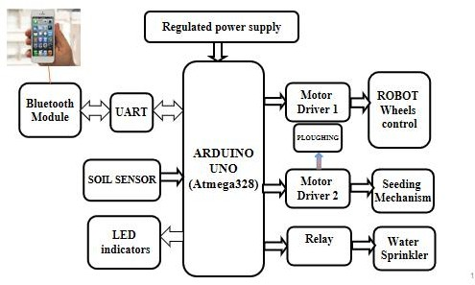**IV.BLOCK DIAGRAM**

FIG 2: Block diagram of AGRIBOT

# V.RESULTS AND DISSCUSION

Fig 3 : Agribot for smart farming

By using this robot reduce the labour work. It can perform the various tasks like ploughing, soil testing ,spraying of water and sowing of seeds .When the power supply is turned on the robot will be in idle mode it performs nothing till any one manual switch is pressed. As soon as the switch is press the robot will perform the dedicated task provided in the program. After the robot start performing the all tasks .This smart farming robot .All operations can be controlling through Bluetooth module HC-05.

# OUTPUT:

It can perform the various tasks like ploughing ,soil testing, spraying of water and sowing of seeds. This smart farming robot. All operations can be controlling through Bluetooth module HC-05.

# VI . CONCLUSION

In this work a robot, named, AGRIBOT, has been designed, built and demonstrated to carry out ploughing in an agriculture field. It is expected the robot will assist the farmers in improving the efficiency of operations in their farms. This work has been carried out as an undergraduate research project.

# VII. REFERENCES

1. S. Umarkar and A. Karwankar , “Automated Seed Sowing Agribot using Arduino," in IEEE Conference on Communication and Signal Processing, April 2016, pp. 1379-1383.
2. M.D.I. Sujon, R. Nasir, M.M.I. Habib, M.I. Nomaan J. Baidya and M.R. Islam “Agribot: Arduino Controlled Autonomous Multipurpose Farm Machinery Robot for Small to medium scale cultivation," in IEEE conference on intelligent autonomous systems, March 2018, pp. 155- 159
3. Amritanshu Srivastava, Shubham Vijay, Alka Negi, Akash Singh, “DTMF Based Intelligent Farming Robotic Vehicle,” International Conference on Embedded Systems (ICES 2014), 978-1-4799- 5026-3, IEEE 2014.
4. Gulam Amer, S.M.M. Mudassir, M.A. Malik, “Design and operation of Wi-Fi Agribot Integrated system”, International Conference on Industrial Instrmentation And control (ICIC), 978-1-4799-7165- 7/15, IEEE 2015.
5. M. priyadarshini, Mrs. L. Sheela, “Command based self guided digging and seed sowing rover”,International Conference on Engineering Trends and Science & Humanities, ISSN: 2348 – 8379, ICETSH-2015.
6. Akhila Gollakota, M. B. shriniva, “Agribot - a multipurpose agricultural robot,” India conference (INDICON) 2011 Annual IEEE 978-1-4577-1110- 7, 1-4, IEEE 2011.