STUDY OF WIND INDUCED ON LOW RISE BUILDINGS WITH MONO SLOPE ROOF

**NEERAJ KUMAR  1, VIRENDER RANA 2**

**1 M.Tech Scholar, Ganga Institute Of Tech. & Management, Jhajjar, India**

Neerajbadgujar7777@gmail.com

**2 Assistant Professor, Ganga Institute Of Tech. & Management, Jhajjar, India**

Virender.rana70@gmail.com

**ABSTRACT**

The rising popularity of architectural designs featuring mono-slope roofs has led to a growing interest among researchers and engineers in the wind-induced effects on low-rise buildings. The following document provides a thorough examination of the impact of wind on low-rise structures featuring mono-slope roofing. The objective of this study is to improve the comprehension of the aerodynamic characteristics and structural reactions of these structures when subjected to wind loads. The review covers a range of topics related to wind-induced effects on low-rise buildings with mono-slope roofs. These include wind flow patterns, pressure distributions, and resultant forces that act on the structures. The present discourse pertains to the impact of building attributes, such as roof inclination, elevation, and alignment, on the wind reaction. Furthermore, the influence of the surrounding topography, encompassing open expanses and urban settings, is being analysed. The analysis underscores the difficulties encountered when evaluating wind impacts on low-rise structures featuring mono-slope roofs. These challenges include the absence of established design directives tailored to this particular architectural style. This paper provides a comprehensive review of the analytical and computational methods utilised for the study of aerodynamics and structural dynamics in buildings. Furthermore, theoretical models are validated and real-world performance insights are obtained by analysing experimental studies and field measurements conducted on existing structures. In addition, this article presents mitigation strategies and design recommendations aimed at improving the wind resistance of low-rise buildings featuring mono-slope roofs. The implementation of wind barriers, aerodynamic features, and suitable structural detailing is necessary to mitigate the effects of wind loads on the performance and structural soundness of buildings. The review's findings make a valuable contribution to the current body of knowledge by consolidating research on wind-induced effects that are specifically associated with low-rise buildings featuring mono-slope roofs. The information presented in this document can be a valuable point of reference for professionals in the fields of architecture, engineering, and research who are engaged in the planning, building, and evaluation of similar structures. The study also highlights potential areas of improvement and future research directions in comprehending the impact of wind on these structures.

1. ***Key Words*:** Wind-induced effects, Low-rise buildings, Mono-slope roof, Wind resistance

# INTRODUCTION

The utilisation of low-rise structures featuring mono-slope roofs has become increasingly prevalent in modern architectural practises, primarily due to their visually pleasing appearance, practical layout, and economical benefits. Nevertheless, these distinctive roof configurations may present difficulties in their ability to withstand wind-induced impacts. Comprehending the aerodynamic characteristics and structural reactions of such edifices when subjected to wind loading is imperative in guaranteeing their stability, safety, and efficacy. The impact of wind on buildings is a notable environmental load that results in the application of forces and pressures on their surfaces. The impact of wind on low-rise buildings featuring mono-slope roofs is of significant concern, given the exposed and asymmetrical design of these constructions. In contrast to traditional gable roofs, mono-slope roofs feature a singular inclined plane that can result in intricate wind flow patterns and fluctuating pressure distributions on both the roof and walls.

The behaviour of low-rise structures featuring mono-slope roofs in response to wind-induced effects may exhibit variability based on a range of factors. The aerodynamic characteristics and wind loads on a structure are significantly influenced by the roof pitch, building height, and orientation. Furthermore, it should be noted that the wind flow and pressures experienced by the building can be influenced by the surrounding terrain, including open fields or urban environments. The increasing trend towards low-rise buildings featuring mono-slope roofs has highlighted a notable absence of comprehensive design guidelines and standardised methods for evaluating the wind resistance capabilities of such structures. The existing knowledge gap highlights the need for additional research to improve our comprehension of their wind-induced behaviour and to establish efficient mitigation strategies. The objective of this paper is to conduct a comprehensive analysis of the impact of wind on low-rise structures featuring mono-slope roofs. This study examines the patterns of wind flow, distributions of pressure, and resulting forces that affect these structures. The study analyses different building attributes such as roof pitch, height, and orientation, to determine their impact on wind response. The aerodynamic behaviour is also evaluated with regard to the impact of the surrounding terrain. The manuscript synthesises extant literature on the topic, including both theoretical and empirical investigations. This document provides an overview of the analytical and computational techniques employed in the examination of the aerodynamics and structural dynamics of low-rise buildings featuring mono-slope roofs. In addition, this study scrutinises field measurements and case studies to authenticate theoretical models and offer valuable insights into practical performance. The objective of this topic paper is to enhance the current knowledge and offer a valuable reference for professionals engaged in the design, construction, and evaluation of low-rise buildings with mono-slope roofs by presenting a comprehensive understanding of the wind-induced effects on these structures. The analysis also identifies potential areas for further research and underscores the necessity for standardised design guidelines and effective mitigation strategies to improve the wind resistance and safety of these structures.

# OBJECTIVES

# The objective is to analyse the wind flow patterns, pressure distributions, and resultant forces exerted on low-rise buildings featuring mono-slope roofs.

# The objective of this study is to analyse the impact of building attributes such as roof pitch, height, and orientation on the wind behaviour of low-rise buildings featuring mono-slope roofs.

# The objective is to assess the aerodynamic behaviour of low-rise buildings with mono-slope roofs by analysing the impact of surrounding terrain, including open fields and urban environments.

# The objective is to conduct a comprehensive review and consolidation of current research on the aerodynamics and structural dynamics of low-rise buildings featuring mono-slope roofs when subjected to wind loading.

# The objective is to verify theoretical models by conducting field measurements and case studies on pre-existing structures featuring mono-slope roofs.

# The aim of this study is to identify challenges and knowledge gaps related to wind-induced effects on low-rise buildings with mono-slope roofs. Additionally, this study proposes potential areas for further research in this field.

# The objective is to offer design guidelines and recommendations that can improve the wind resistance and safety of low-rise buildings that feature mono-slope roofs.

# The objective is to increase the knowledge and understanding of architects, engineers, and researchers regarding the unique considerations and factors that are integral to the design and evaluation of low-rise buildings featuring mono-slope roofs when subjected to wind loading.

# Please provide me with the user's text so I can rewrite it to be professional.

* Bottom of Form

# LITERATURE REVIEW

# The literature review pertaining to the impact of wind-induced effects on low-rise buildings with mono-slope roofs presents a diverse range of studies that aim to comprehend the aerodynamic behaviour, structural response, and mitigation strategies for these distinctive architectural structures.

# Research on wind flow patterns around low-rise buildings featuring mono-slope roofs has revealed the emergence of vortices and turbulent wakes, resulting in intricate airflow properties. The roof's inclination results in asymmetrical pressure distributions, whereby the windward side experiences higher pressures while the leeward side experiences lower pressures. The airflow patterns and pressure distributions have been analysed in detail by researchers through the use of computational fluid dynamics (CFD) simulations and wind tunnel experiments.

# Extensive research has been conducted on the impact of building characteristics, such as roof pitch, height, and orientation, on the wind response of mono-slope roof buildings. Empirical evidence suggests that roof pitches with steeper angles tend to produce greater wind uplift forces, while the height of a building influences the distribution of wind pressure along its vertical walls. Scholars have conducted a study on the most suitable roof pitch and height arrangements to reduce wind-induced loads and enhance the overall structural efficacy.

# METHODOLOGY

The methodology employed in this topic paper on the effects of wind-induced on low-rise buildings with mono-slope roofs involves a comprehensive review and analysis of existing literature, research studies, and case studies. The following steps outline the methodology used:

* A comprehensive literature search is performed to identify relevant research articles, publications, and studies related to the topic. This involves searching scientific databases, academic journals, conference proceedings, and reputable sources. The search results are refined by utilising specific keywords such as "wind effects," "mono-slope roofs," and "low-rise buildings."
* The literature selection process involves a thorough evaluation of relevance, quality, and applicability to the topic at hand. Priority is given to studies that focus on the aerodynamic behaviour, structural response, wind flow patterns, pressure distributions, and mitigation strategies for low-rise buildings with mono-slope roofs.
* The process of extracting relevant information and data from the chosen studies is conducted and systematically arranged. The aforementioned comprises information regarding wind tunnel experiments, computational simulations, field measurements, case studies, design guidelines, and mitigation techniques that are tailored to address wind-induced effects on low-rise buildings featuring mono-slope roofs.
* Data analysis is conducted to thoroughly examine and synthesise the extracted data in order to identify common trends, findings, and gaps in the existing literature. Comparative analyses are conducted to evaluate the similarities and differences in methodologies, experimental setups, and results among different studies.
* The validation of theoretical models and analytical approaches is carried out by analysing field measurements and case studies of low-rise buildings with mono-slope roofs. This process aids in assessing the precision and practicality of the suggested methodologies and offers valuable perspectives on real-world efficacy.
* The creation of design guidelines: The formulated design guidelines and recommendations aim to improve the wind resistance and safety of low-rise buildings with mono-slope roofs, based on the findings from the literature review, data analysis, and case studies. These guidelines take into account the impact of building features, surrounding topography, and wind-induced effects on the structural response.
* Identification of research gaps and future directions: By conducting a thorough examination of the available literature, gaps in research and areas that require further investigation have been identified. The paper proposes potential avenues for future research and improvements in comprehending the impact of wind on low-rise buildings featuring mono-slope roofs.
*  The methodology utilised in this paper ensures a thorough and methodical examination of the impact of wind-induced effects on low-rise buildings featuring mono-slope roofs. The study employs various research methodologies, such as experimental studies, computational simulations, and case studies, to offer a comprehensive comprehension of the topic.

# EXTERNAL AND INTERNAL PRESSURE CAUSING MECHANSIM

As a result of alterations in the airflow surrounding a structure, wind pressure is generated on the exterior surfaces of the building. Regions of high pressure are formed in areas where the divergence of streamlines is detected, while regions of low pressure are formed in areas where the streamlines converge. As a result of the building's presence as a bluff body, boundary layer separation occurs, creating significant eddies that result in the formation of high local suction, or negative wind pressure, in specific areas over the surface, as previously discussed.

The wall located on the windward side is fully exposed to wind flow, resulting in positive pressure exerting on its surface. In addition to external factors, the flow of wind can also impact the internal surfaces of a building. Airflow may infiltrate the building via minor openings such as vents or gaps around doors and windows, resulting in significant pressure fluctuations on the interior walls.

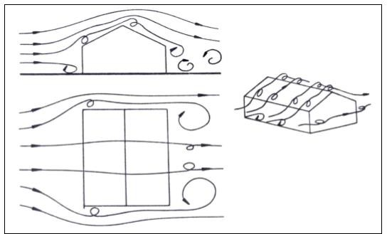

Fig, 1 Wind Flow over a Low Rise Pitched Roof Type Structure

# DESIGN OF GEOMETRY OF THE BUILDING

The analysis will involve examining a rectangular structure with dimensions of 100mm x 50mm and a height of 50mm. The structure features a column size of 3mm x 3mm and will be evaluated for wind-induced pressure and interference effects resulting from the placement of similar structures with varying spacing. The study has implemented a scale of 1:100. The angle of the roof has been systematically adjusted in increments of 10 degrees up to a maximum of 300 degrees.

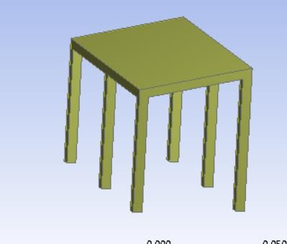

Structure at Roof Angles 100 and 200

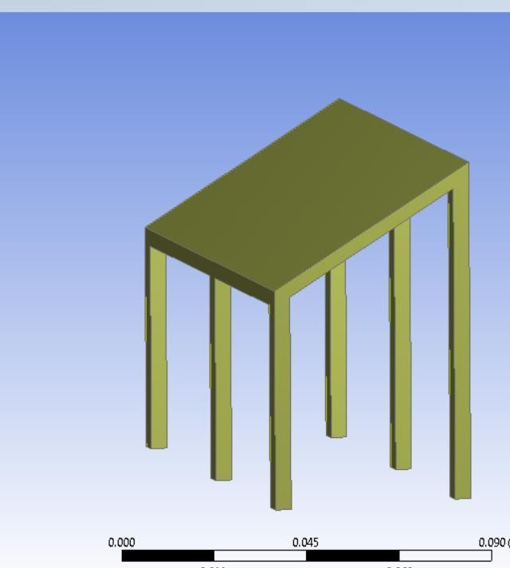

Structure at Roof Angles 300

* 1. **SELECTION OF VALIDATION MODEL FROM IS CODE 875 PART 3**

1. The meshing and setup in the Ansys CFX need to be validated first with the wind standards of Wind Loads on Building and Structures IS 875 part 3.

validation model 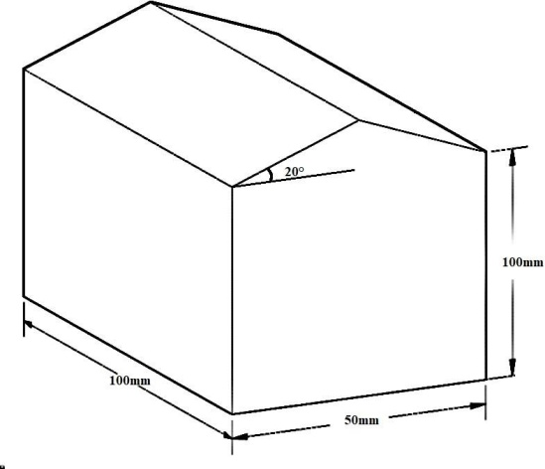

# CONCLUSION

* By varying the roof slope angle, a considerable increase in the coefficient of pressure can be seen. Thus increase in the Cp can be seen from the roof slope from 100 to 200 and then from 200 to 300 accordingly.
* The coefficient of pressure due to interference effect can be comparatively higher from wind direction 900 to 1800 as compared to wind direction 00 to 900 can be seen due to shielding effect.
* Value of Cp increases with roof slope angle.
* The coefficient of internal pressure is maximum for the front building as compared to other ones. The value of internal Cp is maximum for the wind direction 00 and minimum for the wind direction 900 and then increases from there.

# REFERENCES

* 1. Adam B. Smith, “A landmark decade of U.S. Billion-Dollar Weather and climatic Disasters”, NOAA’s National Center for Environmental Information, (2019).
  2. Storm Severe, Winter Storm and Severe Storm, National Climatic Data Billion-Dollar Weather and Climate Disasters : Summary Stats, https://[www.ncdc.noaa.gov/billions/summarystats/US/2000-2017](http://www.ncdc.noaa.gov/billions/summarystats/US/2000-2017) (2017).
  3. J.D. Holmes (1988). “DISTRIBUTION OF PEAK WIND LOADS ON A LOW-RISE BUILDING”. Journal of Wind Engineering and Industrial Aerodynamics, 29 (1988) 59-67.
  4. Hoxey, R.P., Robertson, A.P., Basara, B., and Younis, B.A. (1993). “Geometric parameters that affect wind loads on low-rise buildings: full- scale and CFD experiments.” Journal of Wind Engineering and Industrial Aerodynamics, 50: 243-252.
  5. Krishna, P. (1995). “Wind loads on low rise buildings”. Journal of Wind Engineering and Industrial Aerodynamics, 54-55: 383-396.
  6. T. Stathopoulos, (1996). “Design wind pressure coefficients for mono- slope roofs: A time series approach”. Journal of Wind Engineering and Industrial Aerodynamics 65 (1996) 143-153.
  7. Masanao Nakayama, (1998). “An efficient method for selection of vibration modes contributory to wind response on dome-like roofs”. Journal of Wind Engineering, 73 (1998) 31-43.