EXPERIMENTAL STUDY ON USING A TUNED LIQUID COLUMN DAMPER, DO SEISMIC ANALYSIS ON A HIGH RISE BUILDING

**VIKAS SAROHA1, HARISH PANGHAL2**

**1 M.Tech Scholar, Ganga Institute Of Tech. & Management, Jhajjar, India**

Vikas43saroha@gmail.com

**2 Assistant Professor, Ganga Institute Of Tech. & Management, Jhajjar, India**

Harishpanghal2012@gmail.com

**Abstract** –

The objective of this investigation is to analyse the Tuned Liquid Damper (TLD) and Column Tuned Liquid Damper (CTLD) systems. These systems utilise the motion of liquid in a rigid container to modify the dynamic characteristics of a structure and mitigate vibration energy during seismic activity. A three-story edifice was constructed for this specific purpose and subjected to rigorous vibration testing. The top floor has separate installations for TLD and CTLD to accommodate different frequencies. A TLD (Tuned Liquid Damper) and CTLD (Coupled Tuned Liquid Damper) are devices that utilise water contained within a container, typically situated atop a building, to mitigate the displacement of the system when exposed to external forces. Experimental observations were conducted on a scaled model of the structure equipped with Tuned Liquid Dampers (TLD) and Connected Tuned Liquid Dampers (CTLD) to evaluate their performance under seismic excitation. The rectangular-shaped Tuned Liquid Damper (TLD) and Coupled Tuned Liquid Damper (CTLD) are subjected to controlled uniaxial shake table testing to assess their performance across different frequencies, while considering varying mass ratios. The assessment of TLD and CTLD effectiveness is based on the reduction in the response of the structure. The accelerometer utilised in the experiment is employed to quantify the acceleration of the structure under investigation in the presence and absence of a Tuned Liquid Damper (TLD) and a Controllable Tuned Liquid Damper (CTLD) while being exposed to vibrations.

**Key words:** Seismic excitation, tuned liquid damper, Tuned liquid column damper, Energy dissipation, Mass Ratio.

# INTRODUCTION

In recent years, there has been an increase in demand for constructions that are taller, lighter, more flexible, and have relatively low damping values. Tall and slender structures such as chimneys, skyscrapers, high-rise buildings, cable structures, and telecommunication towers exhibit a relatively low natural frequency and structural damping. This may elevate the probability of failure and, furthermore, result in complications with serviceability. Dynamic stresses, such as wind loads and seismic loads, are observed as a consequence. The dynamic response of a framed structure is determined by the structural damping, as well as the magnitude and frequency of the applied load. Therefore, in order to decrease the dynamic response of the framed structure, it is necessary to either modify the loading or enhance the damping.Currently, there exist multiple techniques for reducing structural vibrations, including the relatively new approach of implementing Tuned Liquid Dampers (TLDs). The present study was undertaken to examine the efficacy of utilising Tuned Liquid Dampers (TLDs) and Coulomb Type Liquid Dampers (CTLDs) in mitigating structural vibration. Tuned Mass Dampers (TMD) are widely recognised as an effective method for enhancing damping in high-rise buildings, chimneys, cables, telecom towers, skyscrapers, and similar structures. In recent decades, Tuned Liquid Dampers (TLDs) have gained significant traction and are presently widely accessible. The rationale behind its widespread adoption can be attributed to the uncomplicated nature of a top-level domain, which can be likened to a water tank that is only partially filled.It is evident that the aforementioned device necessitates minimal maintenance in comparison to TMD. The complexity of TLDs' description, in comparison to a simple spring-mass system such as TMD, appears to constrain their popularity. This is due to the difficulty in designing them and their unpredictability from a design perspective, which is equally significant.A Tuned Liquid Damper (TLD) is a passive control mechanism that is typically installed on a structure to mitigate applied excitation energy through the use of liquid boundary layer friction, waves, and free surface contamination.Assuming optimal tuning, satisfactory TLCD performance can be achieved through precise control of the opening ratio.[2] In order to develop a proficient top-level domain (TLD), it is imperative to utilise a suitable model to depict the fluid dynamics and to possess knowledge of the optimal TLD parameters.

# LITERATURE REVIEW

**Fahim Sadek and et al. (1997)** The aim of this study was to determine the design parameters for tuned liquid column dampers (TLCDs) intended for use in seismic applications. [3]

**S.D.Xue. and et al. (1999)** An experimental study was conducted to analyse the effectiveness and performance of Tuned Liquid Column Dampers in suppressing pitching vibrations of structures. The study was conducted with precision.[4]

**Y. K. Ju and et al. (2004)** This study evaluates the characteristics of a Tuned Liquid Damper (TLD) that features wire screens and small blocks connected to the wall. Additionally, an equation is proposed to determine the equivalent damping ratio of the TLD.[5]

**Emili and et al. (2013)** The objective of this study was to implement a tuned mass damper for the purpose of reducing structural response.[6]

**Jitaditya Mondal and et al. (2014)** The experimental setup involved modelling a building using polymer beams and trusses. A moveable base, powered by a motor, was utilised to simulate an earthquake.[7]

**Namrata Yannawar and G.R.Patil (2014)** A water tank was fabricated and utilised as a tuned liquid damper in the present investigation.[8]

# PROBLEM STATEMENT

The present study involves the analysis of a G + 3 storey frame structure incorporating TLD and CTLD models. The objective is to identify the optimal parameters of TLD and CTLD that can effectively minimise the maximum displacements of the structure when subjected to harmonic sinusoidal ground motion. The optimal parameters for TLD and CTLD were determined by evaluating various parameter combinations through shake table analysis of a physical model equipped with TLD and CTLD.

# METHODOLOGY

Calculate the natural frequency of the framed model with Tuned Liquid Damper (TLD) and Compact Tuned Liquid Damper (CTLD) attached to the top floor centre. Perform a Fast Fourier Transform (FFT) to obtain the Natural Frequencies of the framed structural model. The resulting natural frequencies are 1.2 Hz, 4 Hz, and 6 Hz. The damper is affixed to the central area of the top floor and subsequently adjusts the water level based on the mass ratio percentage. The mass ratios (%) considered for TLD are 5%, 10%, 15%, 20%, 25%, 30%, 40%, 50%, 60%, 70%, 75%, and 80%. The mass ratios (%) considered for CTLD are 5%, 10%, 15%, 20%, 25%, 30%, 35%, 40%, 45%, 50%, and 55%. The base of the structure, specifically the shake table, has been established with the following parameters: amplitude of 5 mm, frequency of 1.2 Hz, and a total of 15 cycles. Harmonic sinusoidal motion is being utilised. The maximum displacement of the structure is recorded for each mass ratio. The aforementioned process is subsequently replicated for the damper, with an amplitude of 5 mm, frequency of 4 Hz, and 40 cycles.

# FRAMED MODAL AND DAMPERS DESCRIPTION

**Table-1:** Framed Model and Damper Description

|  |  |
| --- | --- |
| FRAMED G+3 MODEL DESCRIPTION | |
| Type of the Structure | Multi-storey rigid jointed plane frame |
| Number of Storeys | Three, (G + 3) |
| Material | Plywood and Aluminium |
| Slab Descriptions | Plywood (Dimensions: Length= 360 mm, Width = 260mm, Thickness = 12mm, Density = 8.458 KN/m3) |
| Column Descriptions | Aluminum (Dimensions: Width = 19 mm, Thickness = 2 mm, Floor to Floor Height = 400 mm) |
| Weight | 3500 gm |
| TUNED LIQUID DAMPER(TLD) DESCRIPTION | |
| Material | Acrylic |
| Damper Descriptions | (Interior Dimensions: Length = 200 mm, Width = 140 mm, Height = 180 mm, Thickness of acrylic sheet = 3mm) |
| Weight | 846 gm |
| COLUMN TUNED LIQUID DAMPER(CTLD) DESCRIPTION | |
| Material | Acrylic |
| Damper Descriptions | (Interior Dimensions: Length = 200 mm, Width = 14 mm, Height of Bottom Channel = 40 mm, total Height = 18 mm, Width of Vertical Column = 40 mm Each, Thickness of acrylic sheet = 3 mm) |
| Weight | 775 gm |

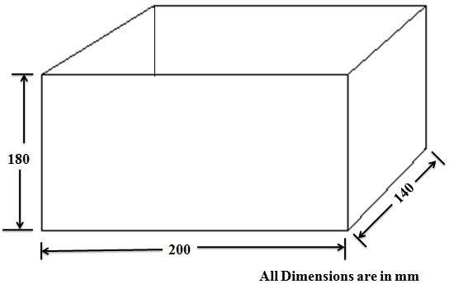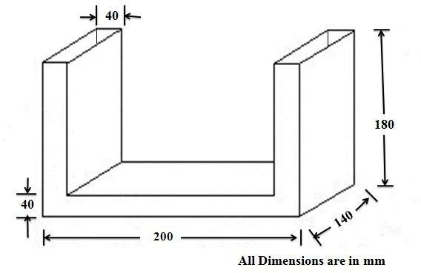

**Fig -1**: Dimensions of TLD **Fig -2**: Dimensions of CTLD

# EXPERIMENTAL ANALYSIS USING SHAKE TABLE

* 1. **Free Vibration Analysis of the Framed Model with TLD and CTLD**

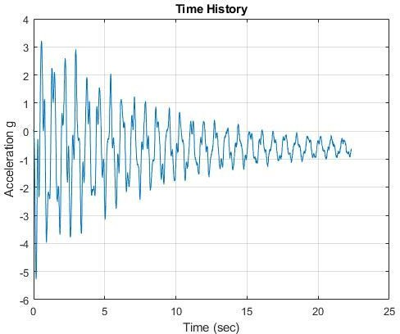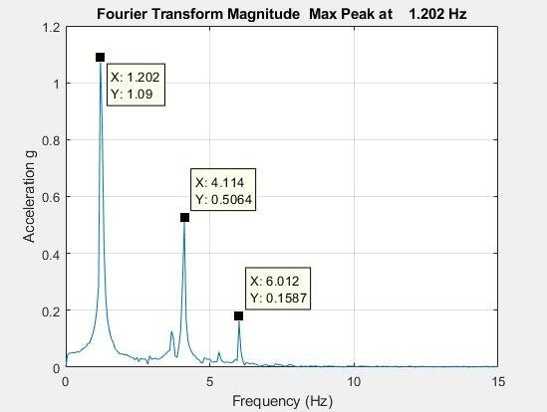

**Fig -3**: Time Response and Natural Frequency of TLD for Free Vibration

# RESULTS AND DISCUSSION

When considering a frequency of 1.2 Hz, an accelerometer is affixed to the top in order to measure top displacement.

When analysing a 4 Hz frequency, an accelerometer is affixed to the second floor while a TLD/CTLD is affixed to the top floor.

**η = Efficiency, Mr = Mass Ratio, η =** Displacement for No Damping −Displacement for nth Mass Ratio

Displacement for No Damping

# Maximum Displacement when TLD at 1.2 Hz Frequency

# x100, Mr = Mass of Water

Mass of Structure

### x100

**Table-2:** Maximum Displacement for Varying Mass Ratio when TLD at 1.2 Hz Frequency

|  |  |  |  |  |
| --- | --- | --- | --- | --- |
| Sr.  No. | Mr (%) | Hs (mm) | When TLD is at TOP Floor | |
| Ymax (mm) | η (%) |
| 1 | 0 | 0 | 43.32 | 0 |
| 2 | 5 | 8 | 28.69 | 33.77 |
| 3 | 10 | 16 | 16.38 | 62.19 |
| 4 | 15 | 24 | 14.34 | 66.9 |
| 5 | 20 | 32 | 14.33 | 66.92 |
| 6 | 25 | 40 | 14.24 | 67.13 |
| 7 | 30 | 48 | 13.49 | 68.86 |

|  |  |  |  |  |
| --- | --- | --- | --- | --- |
| 8 | 40 | 64 | 11.97 | 72.37 |
| 9 | 50 | 80 | 12.17 | 71.91 |
| 10 | 60 | 96 | 11.18 | 74.19 |
| 11 | 70 | 112 | 9.704 | 77.6 |
| 12 | 75 | 120 | 8.637 | 80.06 |
| 13 | 80 | 128 | 9.867 | 77.22 |

**Chart -1**: Maximum Displacement for Varying Mass Ratio when TLD at 1.2 Hz Frequency



**Top displacement when TLD is placed at Top (3rd)**

**Floor for 1.2 Hz Frequency**

50

40

30

20

10

0

0

10

20

30

40

50

60

70

80

90

**Mr(%)**

**Ymax (mm)**

# Maximum Displacement when TLD at 4 Hz Frequency

**Table-3:** Maximum Displacement for Varying Mass Ratio when TLD at 4 Hz Frequency

|  |  |  |  |  |
| --- | --- | --- | --- | --- |
| Sr.  No. | Mr (%) | Hs (mm) | When TLD is at TOP Floor | |
| Ymax (mm) | η (%) |
| 1 | 0 | 0 | 15.15 | 0 |
| 2 | 5 | 8 | 14.19 | 6.34 |
| 3 | 10 | 16 | 14.5 | 4.29 |
| 4 | 15 | 24 | 12.98 | 14.32 |
| 5 | 20 | 32 | 12.51 | 17.43 |
| 6 | 25 | 40 | 11.93 | 21.25 |
| 7 | 30 | 48 | 11.65 | 23.1 |
| 8 | 40 | 64 | 11.43 | 24.55 |
| 9 | 50 | 80 | 11.92 | 21.32 |
| 10 | 60 | 96 | 12.47 | 17.69 |
| 11 | 70 | 112 | 12.59 | 16.9 |
| 12 | 75 | 120 | 12.73 | 15.97 |
| 13 | 80 | 128 | 12.31 | 18.74 |

**Chart -2**: Maximum Displacement for Varying Mass Ratio when TLD at 4 Hz Frequency



**2nd Floor Displacement when TLD is placed at Top**

**(3rd) Floor for 4 Hz frequency**

20

15

10

5

0

0

10

20

30

40

50

60

70

80

90

**Mr(%)**

**Ymax (mm)**

# Maximum Displacement when CTLD at 1.2 Hz Frequency

**Table-4:**Maximum Displacement for Varying Mass Ratio when CTLD at 1.2 Hz Frequency

|  |  |  |  |  |
| --- | --- | --- | --- | --- |
| Sr.  No. | Mr (%) | Hs (mm) | When CTLD is at TOP Floor | |
| Ymax (mm) | η (%) |
| 1 | 0 | 0 | 35.14 | 0 |
| 2 | 5 | 7.5 | 27.51 | 21.71 |
| 3 | 10 | 15 | 18.32 | 47.87 |
| 4 | 15 | 22.5 | 15.11 | 57.0 |
| 5 | 20 | 30 | 12.82 | 63.52 |
| 6 | 25 | 37.5 | 13.63 | 61.21 |
| 7 | 30 | 52.5 | 13.25 | 62.29 |
| 8 | 35 | 71.25 | 12.26 | 65.11 |
| 9 | 40 | 90 | 12.35 | 64.85 |
| 10 | 45 | 108.75 | 10.52 | 70.06 |
| 11 | 50 | 127.5 | 10.62 | 69.78 |
| 12 | 55 | 146.25 | 11.09 | 68.44 |

**Chart -3**: Maximum Displacement for Varying Mass Ratio when CTLD at 1.2 Hz Frequency



**Top displacement when CTLD is placed at Top**

**(3rd) Floor for 1.2 Hz frequency**

40

30

20

10

0

0

10

20

30

**Mr(%)**

40

50

60

**Ymax (mm)**

# Maximum Displacement when CTLD at 4 Hz Frequency

**Table-5:**Maximum Displacement for Varying Mass Ratio when CTLD at 4 Hz Frequency

|  |  |  |  |  |
| --- | --- | --- | --- | --- |
| Sr.  No. | Mr (%) | Hs (mm) | When CTLD is at TOP Floor | |
| Ymax (mm) | η (%) |
| 1 | 0 | 0 | 15.18 | 0 |
| 2 | 5 | 7.5 | 14.47 | 4.68 |
| 3 | 10 | 15 | 13.84 | 8.83 |
| 4 | 15 | 22.5 | 12.9 | 15.02 |
| 5 | 20 | 30 | 12.48 | 17.79 |
| 6 | 25 | 37.5 | 12.39 | 18.38 |
| 7 | 30 | 52.5 | 11.54 | 23.98 |
| 8 | 35 | 71.25 | 12.38 | 18.45 |
| 9 | 40 | 90 | 12.83 | 15.48 |
| 10 | 45 | 108.75 | 12.93 | 14.82 |
| 11 | 50 | 127.5 | 13.55 | 10.74 |
| 12 | 55 | 146.25 | 13.53 | 10.87 |

**Chart -4**: Maximum Displacement for Varying Mass Ratio when CTLD at 4 Hz Frequency



**2nd Floor Displacement when CTLD is placed at Top**

**(3rd) Floor for 4 Hz frequency**

20

15

10

5

0

0

10

20

30

**Mr(%)**

40

50

60

**Ymax (mm)**

# Comparison Between TLD and CTLD on Top Floor for 1.2 Hz Frequency

**Table-6:** Comparison Between TLD and CTLD on Top Floor for 1.2 Hz Frequency

|  |  |  |  |
| --- | --- | --- | --- |
| **Sr.**  **No.** | **Mr**  **(%)** | **Displacement when TLD is at Top Floor (mm)** | **Displacement when CTLD is at Top Floor (mm)** |
| 1 | 0 | 43.32 | 35.14 |
| 2 | 5 | 28.69 | 27.51 |
| 3 | 10 | 16.38 | 18.32 |
| 4 | 15 | 14.34 | 15.11 |
| 5 | 20 | 14.33 | 12.82 |
| 6 | 25 | 14.24 | 13.63 |

|  |  |  |  |
| --- | --- | --- | --- |
| 7 | 30 | 13.49 | 13.25 |
| 8 | 40 | 11.97 | 12.35 |
| 9 | 50 | 12.17 | 10.62 |

**Chart -5**: Comparison Between TLD and CTLD on Top Floor for 1.2 Hz Frequency



**TLD & CTLD 1.2 Hz**

50

40

30

20

10

0

Top Displacement when TLD is

placed at top(3rd) Floor

Top Displacement when CTLD is placed at top(3rd) Floor

0 20 40 60

**Mr(%)**

**Ymax (mm)**

# Comparison Between TLD and CTLD on Top Floor for 4 Hz Frequency

**Table-7:** Comparison Between TLD and CTLD on Top Floor for 4 Hz Frequency

**Sr.**

**No.**

1

2

3

4

5

6

7

8

9

**Mr (%)** 0

5

10

15

20

25

30

40

50

**Displacement when TLD is at Top Floor (mm)**

15.15

14.19

14.5

12.

12.98

51

11.93

11.65

11.43

11.92

**Displacement when CTLD is at Top Floor (mm)**

15.18

12.48

12.3914.47

13.84

12.9

11.54

12.83

13.55

**Chart -6**: Comparison Between TLD and CTLD on Top Floor for 4 Hz Frequency



**TLD & CTLD 4 Hz**

20

15

10

Top Displacement when TLD is

placed at top(3rd) Floor

5 Top Displacement when CTLD is

placed at top(3rd) Floor

0

0 20 40 60

**Mr(%)**

**Ymax (mm)**

# CONCLUSION

* Based on experimental analysis, it has been demonstrated that both TLDs and CTLDs are capable of significantly reducing a structure's response to seismic activity.
* It has been determined that at a frequency of 1.2 Hz, the impact of TLD is amplified by an increase in mass ratio. It has been determined that the optimal mass ratio for the TLD design is approximately 15%, beyond which the reduction in displacement is negligible. The efficiency of the Top-Level Domain (TLD) has been determined to be approximately 67% for a Mass Ratio of 15%.
* At a frequency of 4 Hz, the displacement is minimal, therefore, increasing the mass ratio does not result in a significant difference in TLD.
* It has been discovered that at a frequency of 1.2 Hz, the impact of CTLD is amplified by an increase in mass ratio. It has been determined that the optimal mass ratio for the CTLD design is approximately 15%, beyond which the reduction in displacement is minimal. The efficiency of the CTLD has been determined to be approximately 57% for a mass ratio of 15%.
* After comparing the displacement values of TLD and CTLD for the optimal position, which is the top centre, it has been observed that CTLD performs slightly better than TLD in reducing vibration excitation.

# REFERENCES

1. Elrahman, Abd & Elbrolosy, Abdo. (2015). Tuned liquid dampers.
2. T. Balendra, C.M. Wang, H.F. Cheong, Effectiveness of tuned liquid column dampers for vibration control of towers,

Engineering Structures, Volume 17, Issue 9, 1995,Pages 668-675, ISSN 0141-0296

1. Fahim Sadek, Bijan Mohraz, and H. S. Lew(1997): SINGLE- AND MULTIPLE-TUNED LIQUID COLUMN DAMPERS FOR SEISMIC APPLICATIONS. https://onlinelibrary.wiley.com/doi/10.1002/(SICI)1096-9845(199805)27:5%3C439::AID- EQE730%3E3.0.CO;2-8.
2. AU - S. D. Xue ,AU - J. M. Ko, AU - Y. L. Xu, TI - Experimental Study on Performance of Tuned Liquid Column Damper in Suppressing Pitching Vibration of Structures. PT - Journal Article,DP - 1999, TA - Journal of Intelligent Material Systems and Structures.
3. Yoon, Sung-Won & Kim, S. & Ju, Young K.. (2004). Experimental evaluation of a tuned liquid damper system. Proceedings of The Institution of Civil Engineers-structures and Buildings - PROC INST CIVIL ENG-STRUCT B. 157. 251- 262. 10.1680/stbu.2004.157.4.251.
4. Bhattacharjee, Emili & Halder, Lipika & Sharma, Richi. (2013). An experimental study on tuned liquid damper for mitigation of structural response. International Journal of Advanced Structural Engineering (IJASE). 5. 10.1186/2008- 6695-5-3.
5. Mondal, Jitaditya & Harsha Nimmala, & Shameel Abdulla,& Tafreshi, Reza. (2014). Active Tuned Mass Damper. 1192- 1197. 10.1109/MED.2015.7158917.
6. Namrata Yannawar, G.R.Patil (2014). Response Behaviour of a Three Storied Framed Structure with Tuned Liquid Damper. Vol. 3, Issue 7, July 2014. ISSN: 2319-8753.

[https://citeseerx.ist.psu.edu/viewdoc/download?doi=10.1.1.1045.6477&rep=rep1&type=pdf.](https://citeseerx.ist.psu.edu/viewdoc/download?doi=10.1.1.1045.6477&rep=rep1&type=pdf)

1. Krabbenhøft, Jørgen. “Shallow Water Tuned Liquid Dampers: Modeling, simulation and experiments.” (2011).