A REVIEW ON ANALYSIS AND STABILITY OF GEOGRID REINFORCED RETAINING WALLS

**VIKAS KUMAR LAKRA 1, VIRENDER RANA2**

**1 M.Tech Scholar, Ganga Institute Of Tech. & Management, Jhajjar, India**

Vikaskumarlakra2@gmail.com

**2 Assistant Professor, Ganga Institute Of Tech. & Management, Jhajjar, India**

Virender.rana70@gmail.com

**ABSTRACT**

This research study examines counterfort retaining wall analysis and design. The counterfort retaining wall was chosen out of all the many forms of retaining walls. Because the counterfort retaining wall is a more dependable and robust form of 2H/3 resp., we selected it. For counterforts, the height-corresponding 2H/3 distance is often employed. Retaining wall with a counterfort. When compared to a traditional cantilever retaining wall, this form of retaining wall is more stronger since it has counterforts or a pressure relief shelf placed at appropriate intervals (H/2, H/3).

***Key Words*:** Pressure Relief Shelves ,Counterfort retaining wall, Counterforts, Counterfort and cantilever retaining etc.

# INTRODUCTION

A retaining wall is a building that prevents soil or other materials from moving forward while keeping the ground surface at different elevations that are higher than the angle of repose of the soil. The soil is supported laterally by these walls as well, allowing it to retain a range of levels on both sides. A range of materials, such as concrete blocks, treated timber, treated concrete, and pebbles or boulders, may be used to construct retaining walls. A counterfort retaining wall is a cantilever wall that has counter forts. The counterfort and foundation slab are joined. It is a cantilever retaining wall that has monolithic counter forts created out of base and back wall slabs to strengthen it. Counter forts are spaced apart by an amount that is generally equal to or slightly more than half of their height. Retaining walls are typically built from treated wood, poured concrete, stone, brick, concrete block systems, and other materials. The counter-fort wall rises between 8 and 12 metres. Retaining walls are constructed to hold back soil or engineered fill at a steeper angle than the material's angle of repose, or the steepest angle the material can sustain naturally without giving way. To do this, they must be able to withstand the horizontal, or lateral, ground pressure exerted on them by the material being kept. The lateral earth pressure is determined by the vertical tension placed on the ground behind a wall, which is dependent on the density and height of the backfill. Because the vertical tension is greater the deeper the backfill, the base of the wall receives the most lateral earth pressure.

# OBJECTIVES

* A comparison of counter fort retaining walls for various soil types.
* The major goal of this research is to analyse and build a counter fort retaining wall effectively.
* Analysis of critical stability.

# PROBLEM STATEMENT

* By using both a manual and a digital technique, we will analyse and design a counter-fort earth retaining wall with a pressure relief shelf.
* The whole research demonstrates the significance of the counter fort points in retaining wall design.
* Using Excel to check for critical stability for various soil types.
* The Counterfort Retaining Wall's suitability for various soil types.

# LITERATURE REVIEW

**Optimization and Prognostication of Counter fort Earth Retaining Wall with Traffic Load Using Artificial Neural Network (2013)Author: Kavan, M.R, Prakash, P, Keerthi Gowda. B.S.**

This research discusses how or when to get the appropriate concrete area (Ac) and tension reinforcement area (Ast). The Counter fort Retaining Wall's behaviour under traffic stress must also be understood, which is a laborious task.In this research, the best Ac and Ast are predicted using an Artificial Neutral Network (ANN), which helps to minimise all of the aforementioned problems. The results show that artificial neural networks may be trained for different design contexts. The limitations established by IS 456 and any relevant Codes are accepted by the optimisation approach. A neural network is a network of interconnected neurons that was developed as a result of studies on the biological nervous system.

**The stability analysis study of the variation in vertical slope of traditional retaining walls. Author. M. Sholeh, I. Hermanto, and U. C. Sari1 (2019)**

In this study, we looked at the best way to construct retaining walls that may be used on steep slopes. According to the results, the size of the retaining wall will increase the safety factor's value. Retaining walls with sloping walls on the front of the retaining wall have a better safety factor as compared to those with narrow forms. Cliffs or steep slopes will enhance the driving force. The creation of the steep slopes is influenced by wind erosion, rivers, springs, sea water, and other factors.

**Critical Study of Counterfort Retaining Wall Author. G. Madhavi and M.M. MahajanM.Tech Student, Department of Applied Mechanics, VNIT, Nagpur, India Department of Applied Mechanics, VNIT, Nagpur, India. ( June 2016 )**

The retaining wall at Counterfort needs to be evaluated from a number of perspectives. One of the first geotechnical engineering problems is understanding the behaviour of earth retaining structures. The aforementioned information indicates that cohesive soil surrounding a wall, as opposed to non cohesive soil, causes the wall's cross section to increase.

**Inder Kumar (5 May 2017)** Found the analysis for the behaviour and optimal design of the counter fort retaining wall and gravity wall in concrete dam. The volume and weight of the concrete and steel are used to compare the cost of each wall design. After a comparison examination, the option with the lowest cost estimate is chosen as the best design option.

**Sustainable Design of Counterfort Retaining Walls Using Black Hole Algorithm Author: José V. Martn, José Garca, and Victor Yepes (1 April 2020)**

This paper examines the parametric optimisation of a buttressed earth-retaining wall using a discrete black hole method. Two target functions—one that optimises the structure's cost and the other that lowers CO2 emissions—were taken into consideration when the study was constructed. After adjusting the wall height in the different experiments, we compared the results of the two optimisations. Results are stabilised while working to reduce emissions while maintaining the economic goal.

# METHODOLOGY

Step 1 is to get samples of various kinds of soil. Finding the fundamental characteristics of the soil is step two.

Step 3: Soil testing should be done, including measurements of moisture levels, specific gravity, maximum dry density, and water absorption.

Step 4: Calculating the passive and active earth pressure (lateral earth pressure).

Step 5: Choosing a retaining wall that is appropriate for the associated soil type.

Step 6: Assessing the cohesiveness and angle of repose of counterfort and cantilever retaining walls.

Step 7: Counter fort retaining wall analysis and design with pressure relief shelves.

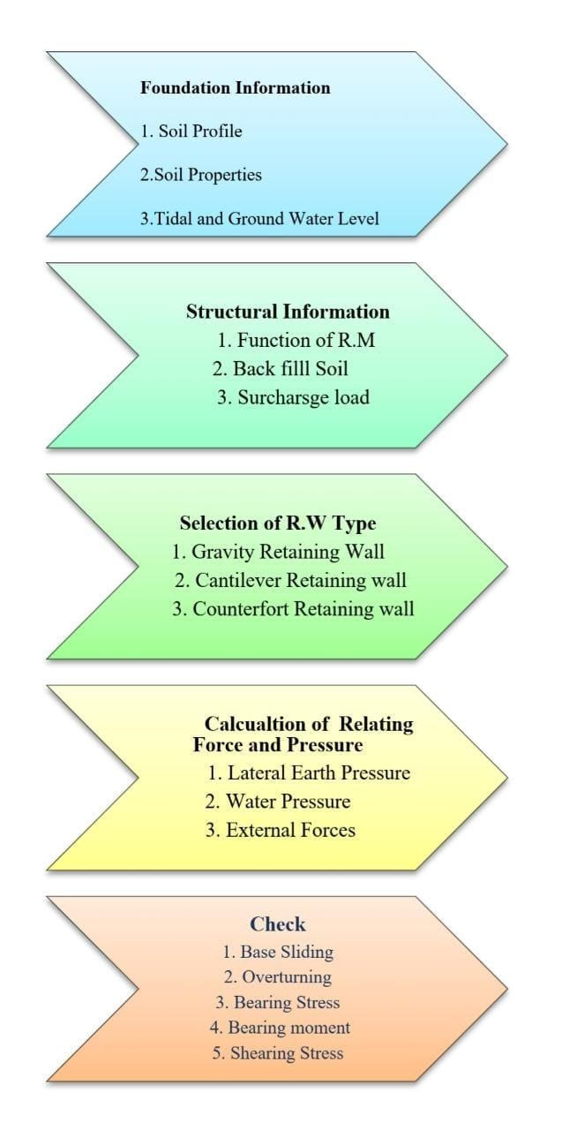

# CONCLUSION

The primary goal of this project is to effectively analyse and design a retaining wall for a counter fort. On the basis of the soil's cohesion and angle of repose, we compared the counterfort retaining wall with pressure relief shelves to the cantilever retaining wall in this research. The available pressure relief shelves are located in the following positions: H/3, 2H/3, and H/2. Comparatively speaking, the counterfort's moment is lower than that of a traditional cantilever retaining wall. Moments are reduced, increasing the counterfort retaining wall's overall stability against tipping over and sliding.

# REFERENCES

* 1. D.R. Dhamdhere, Dr. V. R. Rathi, Dr. P. K. Kolase Department of Civil engineering, PREC, Loni, University of Pune, Maharashtra, India. Feb 2022.
  2. Yash Chaliawala, Gunvant Solanki, Anuj K. Chandiwala, “Comparative study of cantilever and counter fort retaining wall”, International journal of advancedengineering and research development, Vol.
  3. Dec. 2015, pp. 221-224 3.Naveena N, Analysis, Design & Cost Comparison Between Counterfort Retaining Wall & Mechanically Stabilized Earth Wall, International Journal of Civil Engineering and Technology, 9(7), 2018, pp. 1049-1057.
  4. Chethan V.R, Sri RamaRaoT.A, Keerthi Gowda

B.S Department of Civil Engineering M.Tech Student, A.I.T Collage, Chikmagalur, Karnataka, India. (21 July 2015)

* 1. Vicharapu Balaji, S. ShameemBanu Student, Civil Engineering Department, Jawaharlal Nehru Technological University Kakinada Kakinada, Andhra Pradesh, India. Assistant Professor, Civil Engineering Department, Jawaharlal Nehru Technological University Kakinada Kakinada, Andhra Pradesh, India. (March 2022)
  2. Author: Kavan, M.R, Prakash, P, Keerthi Gowda. B.S"Optimization and Prognostication of Counterfort Earth Retaining Wall with Traffic Load Using Artificial Neural Network" (2013)
  3. Author K. Senthil, M. A. Iqbal and Amit Kumar "Behaviour of cantilever and counterfort retaining walls subjected to lateral earth pressure" (2014) Author:Tonne V.R. Mohite P.M. "Optimization and improvement in stability of Counterfort Retaining Wall with pressure relief shelf." (2015)
  4. Author: Karthik Babu C and Keerthi Gowda B. S. "Analysis of Counterfort Retaining Wall with and without Pressure Relief Shelf using Soft Computing Technique" (2016)
  5. Author: Ms.Jhagirdar A.H., Ms.Vibhute D.P., Ms.Sangadi S.S., Ms.Ingale P.M.,N.A.Gram "Analysis and Design of Counterfort Retaining Wall" (2016)
  6. Inder kummar Lilani, Dr. Rakesh Patel, “Analysis of counterfort retaining wall in non over flow section of gravity dam” , IJSRD, Vol., 5 May 2017, pp. 920-924.
  7. Víctor Yepes, José V. Martí, and José García, Institute of Concrete Science and Technology (ICITECH), Universitat Politècnica de València,46022València, Spain; [jvmartia@cst.upv.es](mailto:jvmartia@cst.upv.es) 1 April 2020.
  8. G. Madhavi and M.M. Mahajan M.Tech Student, Department of Applied Mechanics, VNIT, Nagpur, India Department of Applied Mechanics, VNIT, Nagpur, India. June 2016.
  9. Author : U C Sari M N Sholeh and I Hermanto "The stability analysis study of conventional retaining walls variation design in vertical slope"(2019)
  10. Author : Prof. PhD. NedimSuljic, "Importance of soil cohesion on the stability of Retaining reinforced concrete wall"11sept 2013