**OPTIMIZATION OF PROCESS PARAMETERS IN WIRE EDM PROCESS FOR TITANIUM ALLOY**

**Pranav Sawant1 , Rahul Kundiya2**

1Assistant Professor, Department of Mechanical Engineering, Maharshi Parshuram College of Engineering, Velneshwar, Guhagar, Maharashtra, India

2Assistant Professor, Department of Mechanical Engineering, Maharshi Parshuram College of Engineering, Velneshwar, Guhagar, Maharashtra, India

**ABSTRACT**

The recent developments and advancements in technology have lead to the development of newer varieties of materials. But these new materials throw challenges for the present machining techniques for their machining. One of such machining method is Wire Cut Electric Discharge Machining Process. It has become a challenging task for WEDM process to be used for machining of some of the Titanium Alloys. This Research Work focuses on the optimization of the machining input parameters of WEDM process to obtain the better output parameters. The output parameters have been measured and analyzed with the help of the commercial software package MINITAB17. Analysis of Variance (ANOVA) was employed to determine the most significant control parameter affecting the surface roughness, chip thickness and Material Removal Rate(MRR). The work aims to increase productivity and efficiency in WEDM to address the challenges posed by recent developments in materials. The study has utilized the Taguchi method and Minitab Software for experimental design, data analysis, and optimization. The specific material being machined is Alloy of Titanium and Aluminium (Ti6Al4V), a widely used titanium alloy with excellent mechanical properties. The methodology involves the use of Taguchi experiments, orthogonal array matrix, and Minitab software for data analysis.

**Keywords:**OrthogonalArray,ANOVA,PulseON&OFFtime

1. **INTRODUCTION**

Non-traditional machining processes are called advanced manufacturing processes since they are established in modern industries. These machining processes utilize various energies such as mechanical, thermal, electrical or chemical or combinations of these energies to remove extra material. In addition, non-traditional machining processes do not use sharp cutting tools or do not use physical cutting tool at all. Traditional machining processes such as turning, drilling, shaping and milling are not proper techniques to machine extremely hard and brittle materials. Traditional machining processes may have many difficulties in machining such materials. In machining extremely hard and brittle materials, conventional processes may not be feasible, satisfactory or economical due to the following characteristics: The tool is harder than work piece. 2. There is a direct mechanical contact between the tool and the work piece. 3. It is difficult to machine complicated shapes and obtain close tolerances. Thus, non-conventional processes are applied instead of conventional methods for machining extremely hard and brittle materials.

Electrical Discharge Machining (EDM) is a controlled metal-removal process that is used to remove metal by means of electric spark erosion. In this process an electric spark is used as the cutting tool to cut (erode) the work piece to produce the finished part to the desired shape. The metal-removal process is performed by applying a pulsating electrical charge of high-frequency current through the electrode to the work piece[2]. This removes very tiny pieces of metal from the work piece at a controlled rate.

Wire-EDM has become an important non-conventional machining process widely used in the aerospace engineering, manufacturing industries of tools, dies, moulds, metal-workings and automotive industries. This is because wire-EDM provides an effective solution for machining hard materials with intricate shapes. However, selection of cutting parameters for obtaining higher efficiency or accuracy in wire-EDM has been a matter of concern for several years. WEDM is a thermo-electrical process in which material is eroded by series of sparks between work piece and wire electrode. During process wire carries one side of an electrical charge and work piece carries the other side of the charge.[6]

When the wire gets close to the part, the attraction of electrical charges creates a controlled spark, melting and vaporizing microscopic particles of material. After the wire travels through the work piece one time, the machine discards the used wire and automatically new wire is taken up.[3]

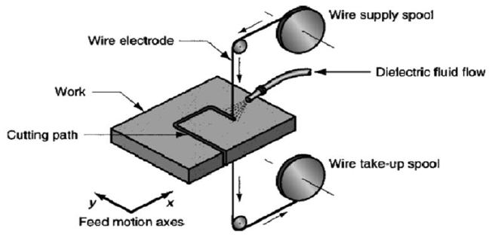

Figure 1: WEDM Process

1. **METHODOLOGY**

In the presented research work, Taguchi’s Experimental design approach has been used. First, some input parameters have been selected with their corresponding three levels for each parameter and then by selecting L9 Orthogonal Array; total 9 experiments have been conducted and then output parameter values in terms of Material Removal Rate and Surface Roughness have been recorded and analyzed.

**2.1 WEDM PARAMETERS**

**2.1.1 Input Parameters**

**Pulse ON time**: Pulse ON time (TON) represents the duration of time in micro seconds (μs) during which arc is ON. During the pulse ON time, the voltage is applied in the gap between work piece and the electrode thereby producing discharge. Higher the pulse ON time, higher will be the energy applied thereby generating more amount of heat energy during this period. Material removal rate depends upon the amount of energy supplied during the pulse ON time. Material removal rate depends on longer or shorter pulse ON time period. Longer pulse duration improves material removal rate.[4]

**Pulse OFF time**: The pulse off time (TOFF) represents the duration of time between the two simultaneous sparks is also expressed in micro seconds. This is the time between discharges. Off time has no effect on discharge energy. Off time is the pause between discharges that allows the debris to solidify and be flushed away by the dielectric prior to the next discharge.

**Peak current**: Peak current is the amount of power used in discharge machining and is measured in unit of amperage. During each pulse ON-time, the current increases until it reaches a preset level, which is expressed as the peak current. In wire-EDM processes, peak current is the maximum amount of amperage governed by the surface area of the cut. Higher amperage is used in roughing operations and in cavities or details with large surface areas. Higher currents will improve MRR, but reduce the surface roughness.[8]

**Feed** : Wire feed is the rate at which the wire-electrode travels along the wire guide path and is fed continuously for sparking. In WEDM, wire electrode contributes 70% of the machining cost. Therefore, it is desirable to set low wire feed rate where stable machining with no wire breakage occurs. As the wire feed rate increases, the consumption of wire as well as cost of machining will increase. Low wire speed will cause wire breakage in high cutting speed[8].

**2.1.2 Output Parameters**

**MRR**: The material removal rate is defined as the amount of material removed from the workpiece per unit time. The material removal rate can be calculated from the volume of material removed or from the weight difference before and after machining. It is an indication of how fast or slow the machining rate is. Higher machining productivity must also be achieved with a desired accuracy and surface finish. The MRR greatly depends on the process parameters.

**Surface finish:** The surface finish can be said as the surface texture or surface topography. There are three characteristics which will define the Surface Finish. The surface finish is an overall measure of these three Characteristics viz., Surface Roughness, Lay and Waviness.

1. **MODELING AND ANALYSIS**
   1. **Material, Machine and Machining process**

**3.1.1** **Material :** Material selected for experimentation is sheet of an alloy of Titanium: Ti6Al4V. Ti6Al4V is the most widely used titanium alloy. It has excellent mechanical properties. The Ti6Al4V alloy offers the best all-round performance for a variety of weight reduction applications in aerospace, automotive and marine equipments. The high strength, low weight ratio and outstanding corrosion resistance inherent to titanium and its alloys has led to a wide and diversified range of successful applications which demand high levels of reliable performance in surgery and medicine as well as in aerospace, automotive, chemical plant, power generation, oil and gas extraction, sports, and other major industries.[5]

**3.1.2 Composition:**

**Table 1: Composition of Ti6Al4V alloy**

| **Elements** | Titanium | Vanadium | Aluminium |
| --- | --- | --- | --- |
| **Percentage** | 90% | 4% | 6% |

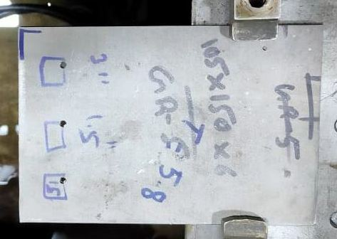

Figure 2: Ti6Al4V material

**3.1.3 Machine Specification:**

Machine Name- **chmer gx+ series gx360l+**

Axis Travel (x,y,z) – 360,250,220 mm

Axis Travel (u,v) – 60,60 mm

X Y feed Rate- Max 1500 mm/min , Max wire feed rate- 300 mm/ sec

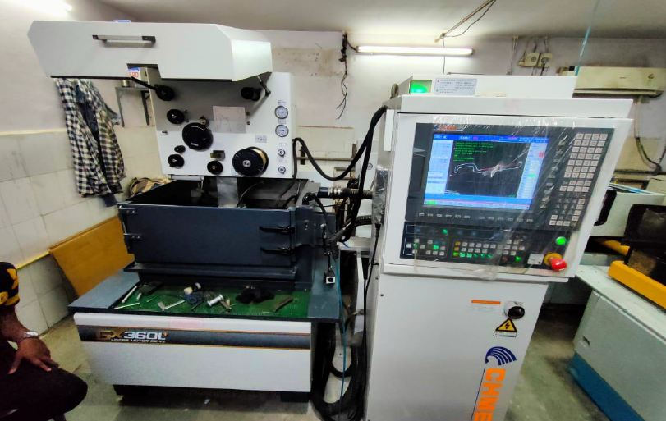

Figure 3:chmer gx+ series gx360l+

* 1. **Surface Finish Measurement:**

Portable Surface Roughness Tester - TIME3100 is a pocket-sized economically priced instrument for measuring surface texture conforming to traceable standards. It can be used on the shop floor in any position, horizontal, vertical or anywhere in between. The large LCD display shows either roughness parameter Ra or Rz at the touch of a button, combined with the selected cut-off length. External calibration of roughness values is possible by means of a special CAL button, which makes adjustment of this instrument very easy. A beep signal informs the user of each individual measurement status when ready.

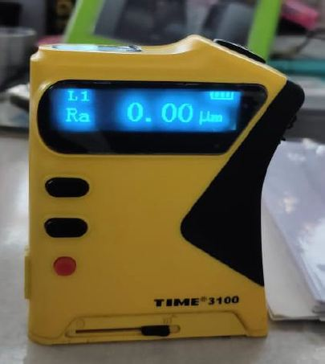

Figure 4: TIME 3100 (Surface Roughness Measurement Instrument)

* 1. **Experimental Setup**

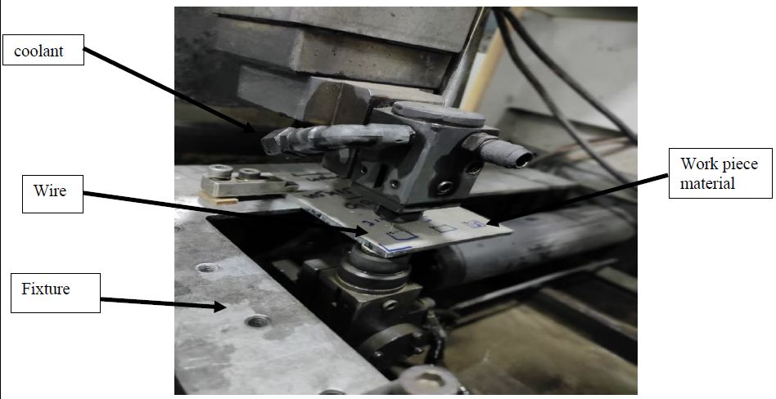

Figure 5: gx 360 1 WEDM Machine

In the above experimental setup, gx 360 1 WEDM Machine has been used for machining of the said titanium alloy. The work piece is held on the fixture mounted on the machine. The wire material is brass. High pressure coolant was used for rapid cooling during drilling of the work piece. The input Parameters were fed to the CNC machine and the output parameters were observed onto the screen.

* 1. **Selection of process parameters:**

Table 2: Input Process Parameters with corresponding levels

|  |  |  |  |  |
| --- | --- | --- | --- | --- |
|  | **Factors** | | | |
| **Levels** | **Pulse ON time** | **Pulse OFF Time** | **Peak Current** | **Feed** |
| 1 | 113 | 58 | 210 | 5 |
| 2 | 116 | 60 | 220 | 5 |
| 3 | 119 | 62 | 230 | 5 |

* 1. **Experimental Data(Based on Orthogonal Array):**

Table 3: Data for experimentation

| **Run Number** | **Pulse ON Time**  **(μs)** | **Pulse Off Time**  **(μs)** | **Peak Current**  **(A)** | **Feed**  **mm / min.** |
| --- | --- | --- | --- | --- |
| 1 | 113 | 58 | 210 | 5 |
| 2 | 113 | 60 | 220 | 5 |
| 3 | 113 | 62 | 230 | 5 |
| 4 | 116 | 58 | 220 | 5 |
| 5 | 116 | 60 | 230 | 5 |
| 6 | 116 | 62 | 210 | 5 |
| 7 | 119 | 58 | 230 | 5 |
| 8 | 119 | 60 | 210 | 5 |
| 9 | 119 | 62 | 220 | 5 |

* 1. **Experimental results(Output parameter values):**

Table 4: Output parameter values

| Run No. | Roughness Value(Ra) | MRR (mm3 / min) |
| --- | --- | --- |
| 1 | 2.37 | 3.37 |
| 2 | 2.04 | 3.40 |
| 3 | 1.96 | 3.43 |
| 4 | 2.62 | 3.60 |
| 5 | 2.43 | 3.75 |
| 6 | 2.78 | 3.40 |
| 7 | 2.47 | 6.3 |
| 8 | 2.83 | 6.05 |
| 9 | 2.65 | 6.15 |

**3.7 Analysis of Variance**

Taguchi method cannot judge and determine effect of individual parameters on entire process while percentage contribution of individual parameters can be well determined using ANOVA. Using Minitab 17 software ANOVA module can be employed to investigate effect of parameters.

To determine whether each main effect and the interaction effect is statistically significant, compare the p-value for each term to your significance level to assess the null hypothesis. Usually a significance level of 0.05 works well. A significance level of 0.05 indicated 5% risk of concluding that an effect exist when there is no actual effect.

Statistical significance of the effect depends on the p value as follows:

If the p-value is greater than significance value the effect is not statistically significant. If the p-value is less than or equal to significance factor, then the effect of term is statistically significant.

Table 5: Response Table for Surface Roughness

|  |  |  |  |  |  |  |  |
| --- | --- | --- | --- | --- | --- | --- | --- |
| Source | DF | Seq SS | Contribution | Adj. SS | Adj. MS | F-Value | P-Value |
| Pulse ON time | 2 | 11.5708 | 68.68% | 11.5708 | 5.7854 | 121.16 | 0.008 |
| Pulse OFF time | 2 | 0.0583 | 0.35% | 0.0583 | 0.02913 | 0.61 | 0.621 |
| Peak Current | 2 | 5.1219 | 30.40% | 5.1219 | 2.56096 | 53.63 | 0.018 |
| Error | 2 | 0.0955 | 0.57% | 0.0955 | 0.0478 |  |  |
| Total | 8 | 16.8465 | 100% |  |  |  |  |

|  |  |
| --- | --- |
| C:\Users\USER\Desktop\1.JPG  Normal probability plot for Surface Roughness | C:\Users\USER\Desktop\2.JPG  Histogram for Surface Roughness |

Figure 6 : Probability and Histogram plot for Suface Roughness

Table 6: Response Table for Material Removal Rate

|  |  |  |  |  |  |  |  |
| --- | --- | --- | --- | --- | --- | --- | --- |
| Source | DF | Seq SS | Contribution | Adj SS | Adj MS | F-Value | P-Value |
| Pulse ON time | 2 | 1.9369 | 45.59% | 2.2037 | 1.1019 | 4.41 | 0.319 |
| Pulse OFF time | 2 | 1.7623 | 41.48% | 1.1717 | 0.5858 | 2.34 | 0.419 |
| Peak Current | 2 | 0.2990 | 7.04% | 0.2990 | 0.1495 | 0.60 | 0.675 |
| Error | 1 | 0.2499 | 5.88% | 0.2499 | 0.2499 |  |  |
| Total | 7 | 4.2481 | 100% |  |  |  |  |

|  |  |
| --- | --- |
| C:\Users\USER\Desktop\3.JPG  Normal Probability plot for MRR | C:\Users\USER\Desktop\4.JPG  Histogram for MRR |

Figure 7 : Probability and Histogram plot for Material Removal Rate

1. **RESULTS AND DISCUSSION**

**Table 7: S/N Ratio for Surface Roughness and MRR**

| **Surface Roughness** | | | **MRR** | | |
| --- | --- | --- | --- | --- | --- |
| **Run No** | **Mean value** | **S/N Ratio** | **Run No** | **Mean value** | **S/N Ratio** |
| 1 | 2.37 | -7.49497 | 1 | 3.37 | 10.5525 |
| 2 | 2.04 | -6.19260 | 2 | 3.40 | 10.6295 |
| 3 | 1.96 | -5.84512 | 3 | 3.43 | 10.7058 |
| 4 | 2.62 | -8.36603 | 4 | 3.60 | 11.2260 |
| 5 | 2.43 | -7.71213 | 5 | 3.75 | 11.4806 |
| 6 | 2.78 | -8.88090 | 6 | 3.40 | 10.6295 |
| 7 | 2.47 | -7.85394 | 7 | 6.30 | 15.9868 |
| 8 | 2.83 | -9.03573 | 8 | 6.05 | 15.6351 |
| 9 | 2.65 | -8.46492 | 9 | 6.15 | 15.7775 |

|  |  |
| --- | --- |
| **C:\Users\USER\Desktop\16.JPG**  Mean effect Plot of S/N Ratio of Surface Roughness | C:\Users\USER\Desktop\new.JPG  Mean effect Plot of S/N Ratio of MRR |

Figure 8: S/N Ratio plots for Surface Roughness and Material Removal Rate

Highest value S/N ratio is for Run No.3 in case of Surface Roughness whereas for Material Removal Rate Parameter; highest value of S/N ratio is for Run No.7.

Hence, Run No. 3 and Run No. 7 give optimum results for Surface Roughness and Material Removal Rate parameters respectively.

1. **CONCLUSION**

From the experiments we have calculated two things:

1)For the signal to noise ratio of MRR; for obtaining the better output we have selected the larger value for the different three levels

The larger value gives the better output which is 3.49

2)For the signal to noise ratio of the surface roughness; for obtaining the better result we have selected the smaller value for the different levels.

The smaller value gives better output i.e. 0.258

Hence, from this we can conclude that if Surface roughness is of primary interest then we have to select all the parameters at their level 1.

If Material Removal Rate is of primary inerest then we have to selct all input parameters at their highest levels. i.e., Level3

In this way, we can optimize all the parameters in Wire cut EDM process to get optimum results.

1. **REFERENCES**

[1] Gokler, Mustafa Ilhan ,Ozanozgu, Alp Mithat, “Experimental investigation of effects of cutting parameters on surface roughness in the WEDM process”, International Journal of Machine Tools and Manufacture, Volume 40, Issue 13,Pages1831-1848,October2000

[2] M.T. Antar, S.L. Soo, D.K. Aspinwall, D. Jones and R. “Productivity and Workpiece Surface Integrity of Alloys Using Coated Wires for aerospace applications”, Proceedings Engineering, Volume 19, Pages 3-8, 2011

[3] M.J. Haddad, M. Hadi, “An experiment investigation of cylindrical wire electric discharge turning process” DOI 10.1007/s001

[4] Jaganathan Pa, Naveen kumar Tb, Dr. R.Sivasubramanianc, “Machining Parameters Optimization of WEDM Process Using Taguchi’s Method” International Journal of Scientific and Research Publications, Volume 2, Issue 12, December 2012 1 ISSN 2250-3153

[5] Patil Amit S. ,Ingale Sushil, “Machining challenges in Ti-6Al-4V” International journal of scientific research Publications, Volume 2, Issue 16, December 2012

[6] Puri A.B., Bhattacharyya B., “An analysis and optimisation of the geometrical inaccuracy due to wire lag phenomenon in WEDM”, International Journal of Machine Tools & Manufacture, 43 (2003) pp. 151– 159.

[7] Wang J., Ravani B., “Computer aided contouring operation for traveling wire electric discharge machining (EDM)”, Computer-Aided Design 35 (2003) pp. 925–934.

[8] Puri A.B., Bhattacharyya B., “Modelling and analysis of the wire-tool vibration in wire cut EDM”, Journal of Materials Processing Technology, 141 (2003) pp. 295–301.

[9] Liao Y.S., Yu Y.P., “Study of specific discharge energy in WEDM and its application”, International Journal of Machine Tools & Manufacture, 44 (2004) pp. 1373–1380.

[10] Yan Mu-Tian, Huang Pin-Hsum, “Accuracy improvement of wire-EDM by real-time wire tension control”, International Journal of Machine Tools & Manufacture, 44 (2004), pp. 807–814.