**COGNITIVE CAMPUS MODEL**

**Hrishikesh Sunil Bacchhav1, Sanket Vishnu Thok2, Yash Subhash Tarle3, Sahil Prashant Sadaphal4, prof.Sanjeev Shukla5**

*1,2,3 B.Tech Scholar, School of Computer Science and Engineering, Sandip University, Nashik, Maharashtra, India*

*4 Assistant Professor, School of Computer Science and Engineering, Sandip University, Nashik, Maharashtra, India*

**ABSTRACT**

*The College Social Network Site project aims to create a platform where college students can connect with each other, share information, and collaborate on academic and extracurricular activities. The platform will allow students to create profiles, join groups, post and share content, and communicate with each other through messaging and video conferencing. The site will have a user-friendly interface that will enable students to easily navigate the platform and find the information they need. Users will be able to search for other students based on various criteria such as major, interests, and location. Additionally, the site will provide a newsfeed that displays relevant posts and updates from the groups and individuals that a student follows. The project will also include a feature that allows students to create and manage their own groups, which can be used for academic purposes, student clubs, or social events. Group members will be able to share files, post announcements, and schedule events, making it easy for students to collaborate and stay organized. To ensure the security and privacy of the users, the platform will require users to create accounts and login with their credentials.*

**Keywords:** *Co-ordination, Social Networking, College Competitions*

1. **INTRODUCTION**

The core function of Cognitive Campus Model system is to facilitate and encourage knowledge sharing and knowledge creation on campus. To facilitate online communication, sharing, and collaboration in learning, teaching, and research activities of campus users is specifically one of the primary functions of campus social network system. Knowledge generation and sharing are inextricably linked and constantly influenced by one another. Because Cognitive Campus Model system provides direct support to knowledge sharing and indirect support to knowledge creation. The most frequent consumers of Internet services, particularly newer ones like social networking services, are campus members like students and professors. The chance of faculty members using this social networking site will increase because it is limited to activities on college campuses. This is the project's main benefit because it will encourage both students and staff to improve their interactions and partnerships in the classroom. We are aware of the rising popularity of social networking sites. Depending on their needs and interests, people use different social media platforms. Social media is a flexible platform that may be utilized in a wide variety of ways to exchange information, entertainment, and more. In this project, a social media platform for college campuses has been developed, enabling everyone connected to the campus, including students and staff, to interact and exchange knowledge about academics, projects, placements, and all other activities taking place there. It will promote teaching and learning through a more dynamic and cognitive platform without causing any threat to privacy. They will only be permitted to read information that is pertinent to their academic or professional careers. They can view the research that has been done by their professors, their department, their disciplines, etc. Students can register and login into the system once their registration is approved by the admin. Once logged in, the student can write and upload articles on a variety of topics of their choosing. He or she also converses with the other students. Along with their article, students can also upload photographs. All students have access to the news feeds that each student posts. The administrator will approve or reject each and every student registration, and all posts will be kept pending until the administrator approves or rejects each and every post.

1. **PROPOSED METHODOLOGY**

The solution we suggested is a website for the college that uses Node.js as a server-side scripting language, HTML, CSS, and JS to style web pages, and MongoDB as a database. This is a social and business networking website which allows users i.e. Students, College Staff etc. to create and update profile. There are many features available, including post, message, search, connect, etc. to communicate with each other and to increase network which will increase sharing knowledge, real life experience as well as news, events etc.

**Features of proposed system** :

• **User-friendly Design**: Any user may use it with ease thanks to the design's excellent usability.

•**Secure Login**: A secure login is provided by validating the user.

**•Post**: Users may upload pictures or videos of any events, pursuits, or other data.can also comment on, like, and share other postings.

•**Pages**: Constructing pages with uploadable posts for each page.

•**Groups**: Establishing groups allows people to communicate about their academic endeavors.

•**Friends**: The user can send invitations to connect with others or receive friend requests from others.

•**Messaging**: Using this feature, users can chat with one another.

• **Search**: To look up friends, groups, or other pages on the website.

.

1. **ARCHITECTURE**

It is a conceptual model that describes the behavior and structure of the system.This graphic demonstrates how the system functions, including how the user interacts with it and how data is handled. An illustration. The user will submit a request to the web server using a laptop or a mobile device.The interface module facilitates user communication with the application's web server. All information gathered from users, with the exception of photographs and videos, will be kept on a database server. Videos and images will be kept on a file server. The system operates in this manner

1. **METHODOLOGY**

A software development methodology is a framework that is employed to structure, plan, and regulate the process of creating an information system. This includes the pre-definition of particular deliverables and artefacts that are created and finished by a project team to develop or maintain an application. Such frameworks have taken many different forms throughout the years, each with its own set of well-known advantages and disadvantages. Depending on a variety of technical, organizational, project, and team concerns, each of the methodology frameworks that are now accessible is best suited to particular types of projects. Frequently, the approach framework is outlined in formal documentation.. To implement the project goals, the following Methodologies need to be followed:

**a)** Specifying the application and various components of architecture.

**b)** Specifying binding between tasks and resources.

**c)** Specifying port interconnection between the resources.

**d)** Analysis, extracting data required for analysis and doing analysis.

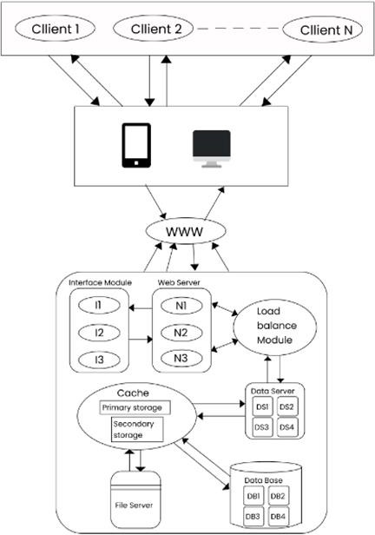

**Fig.1 :DataFlowDiagram**

1. **CONCLUSION**

In conclusion, the College Social Network Site project aims to create a platform that enables college students to connect, collaborate, and succeed academically and socially. With its user-friendly interface, robust features, and strong security measures, the platform has the potential to become a valuable tool for students to enhance their college experience. The site will allow students to create profiles, join groups, post and share content, and communicate with each other through messaging and video conferencing. Additionally, the site will provide a newsfeed that displays relevant posts and updates from the groups and individuals that a student follows. The project is an exciting opportunity to provide college students with a platform that enables them to connect and collaborate with each other, access learning resources, and stay organized. By leveraging technology and data analytics, the platform can provide personalized feedback and recommendations to help students improve their academic performance and achieve their goals. Overall, the College Social Network Site project has the potential to transform the traditional college experience and create a more connected, collaborative, and engaging learning environment for students. It is a promising initiative that can benefit students, faculty, and the entire campus community.

1. **REFERENCES**
2. [1] Wilson, Phillip Ian, and John Fernandez, "Facial feature detection using classifiers." Journal of Computers in Higher Education, Volume 21, Number 4, 2006, p. 127–134
3. [2] Robert P. Dellavalle, Sarah Garner, and Hywel C. Williams. "Acnevulgaris." 2012. 361-372 9813 The Lancet, vol. 379
4. [3] Estimated incidence of keratinocytecarcinomas, a type of non-melanoma skin cancer, in the U.S. population, 2012 In JAMA Dermatol, vol. 151, no. 10, p. 1081, October 2015, H. W. Rogers, M. A. Weinstock, S. R. Feldman, and B. M. Coldiron published their study.
5. [4] J. K. L. Tan and K. Bhate, "International view of the epidemiology of acne," British Journal of Dermatology 172(2015):3–12.