**FOOD ORDERING WEB APPLICATION LIKE ZOMATO, SWIGGY**

# Mayuri Balu Waghmare1, Diksha Kishor Nandre2, Nikita Mahajan3, Ram Kumar solanki4

# *1,2,3 B.Tech Scholar, School of Computer Science and Engineering, Sandip University, Nashik, Maharashtra, India*

# *4 Assistant Professor, School of Computer Science and Engineering, Sandip University, Nashik, Maharashtra, India*

# *1*[*waghmaremayuri22@gmail.com*](mailto:waghmaremayuri22@gmail.com)*, 2*[*dikshanandre2403@gmail.com*](mailto:dikshanandre2403@gmail.com)*, 3*[*nikitamahajan472@gmail.com*](mailto:nikitamahajan472@gmail.com)*, 4*[*ramkumar.solanki@sandipuniversity.edu.in*](mailto:ramkumar.solanki@sandipuniversity.edu.in)

# Abstract

# *In recent years, food ordering web applications have revolutionized the way people dine, providing convenient access to a wide range of restaurants and cuisines. This research paper aims to analyze and compare two popular* FOOD ORDERING WEB APPLICATIONS, ZOMATO AND SWIGGY*, to gain insights into their features, functionality, and impact on the food industry. The study employs a mixed-methods approach, combining qualitative and quantitative research methods. Firstly, a comprehensive review of the literature is conducted to explore the evolution of food ordering platforms and their significance in the market. This literature review provides a theoretical framework for understanding the key factors contributing to the success of these applications.*

# *Keywords:* Online Food Delivery App, Zomato, Swiggy, Menu, e-commerce*.*

1. **INTRODUCTION**

Swiggy and Zomato are food delivery apps. Local hotels, restaurants, chefs, and canteens supply takeout and meal parcels to customers through online food ordering applications. This concept is growing due to metro city's working youth and frantic work culture. This system has changed the working kitchen. Online ordering applications are becoming more popular than restaurant delivery. Online meal ordering applications are more private since no humans are involved. Apps feature restaurants and chef kitchens with their menus. Customers don't need booklets or menus for future orders. Click-to-order food is convenient. These applications may be downloaded to smartphones for easier access. Your address and profile establish a payment information account. Customers must download and register the app on their phones. App profiles contain address and payment details. Apps accept credit, debit, cashless, and home delivery payments. Apps provide diverse services, features, and eateries. The previously downloaded app used to provide some coupons for savings, past purchase information, some ideas for flavor palettes, and current customer reviews of restaurants and meals. According to BCG's projections, the total value of the Indian food industry's market business would have reached $420 billion by the year 2020. The current market for Indian cuisine is estimated to be worth over 350 billion dollars in 2019. This industry is coming up with novel concepts in order to better serve its customers. The convenience, the contentment, and the retention of the employee. There is a lot of rivalry between different restaurants that provide free home delivery and the many applications that can be used to purchase meals online. Customers now have an overwhelming number of choices and alternatives available to them as a direct result of the proliferation of new technologies and innovations. Initially, due to adherences there was skepticism, diceyness, and hesitation about the notion investor; nevertheless, with the success of the concept, there is a rising number of participants in the market. There are a few major participants in this market, including Zomato, Swiggy, Food Panda, Ubereat, and Just Eat. Domino's Pizza, Pizza Hut, Fasso's, and KFC are among the few large restaurant brands that also run their own network of delivery outlets.

1. **LITERATURE SURVEY**

It has been hypothesized that global e-commerce is experiencing rapid expansion, and there are signs that the food business is also experiencing expansion. They have proposed using something called the Technology Acceptance Model (TAM) as a foundation for doing research on how people feel about using applications to place orders for meals online. According to their examination of the data, people's attitudes regarding purchasing meals online differ depending on their openness to new forms of information technology, the degree to which they place their faith in online shopping websites, and the number of outside factors that have an impact.

1. According to Ashoutosh Bhargve (2013), an online meal ordering app called Foodpanda has been available in the Indian market from the month of May in 2012. Foodpanda's first significant move was the purchase of TastyKhana, which had been operating in Pune since the year 2007.As a result of its purchase of TastyKhana and JUST EAT, it is currently accessible in more than 200 locations and works as a delivery partner with more than 12,000 eateries. JUST EAT, which began operations in Denmark in 2001 and later went public on the London Stock Exchange, is another company that is discussed here. Their business in India began in 2006 under the name Hungry Bangalore. As a result of JUST EAT's acquisition of the company's controlling stake in 2011, the service was restarted. At the present time, the firm has partnerships with approximately 2,000 eateries.

2. In H.S. Sethu and Bhavya Saini's (2016) study, the researchers' objective was to investigate the ways in which students think about, use, and feel about apps for online food ordering and delivery. The results of their research reveal that using mobile applications to place online food orders saves them time since these apps are readily available. It has also been discovered that the primary reasons people use apps are to have constant access to the internet and free data, as well as the availability of their preferred foods at any given moment.

3. According to Sheryl E. Kimes (2011), his research showed that perceived control and convenience connected with online meal ordering services were relevant for both users and non-users of the services. Nonusers need more individualized care and also had a significant level of confusion around the usage of early technology.

4. According to Leong Wai Hong (2016), the development of technology in many different fields has caused a shift in the business model that is used to expand. A restaurant's production and profitability may be significantly improved by using methods that are more efficient. It is considered that the use of an online meal delivery system may cause restaurants' businesses to expand from time to time and will assist restaurants in facilitating big online business transactions.

5. The usage of smart phone mobile interfaces allowing customers to monitor their orders and track them, as stated by Varsha Chavan et al. (2015), has reportedly assisted restaurants in promptly delivering customer orders. The rise in popularity of computer and smartphone usage is providing a new opportunity for businesses in the service sector. According to the findings of their analysis, this method is practical, efficient, and simple to implement; moreover, it is anticipated that these qualities will continue to improve over the course of the foreseeable future.

1. **DATA FLOW DIAGRAM**

The usage of smart phone mobile interfaces allowing customers to monitor their orders and track them, as stated by Varsha Chavan et al. (2015), has reportedly assisted restaurants in promptly delivering customer orders. The rise in popularity of computer and smartphone usage is providing a new opportunity for businesses in the service sector. According to the findings of their analysis, this method is practical, efficient, and simple to implement; moreover, it is anticipated that these qualities will continue to improve over the course of the foreseeable future.

**Zero Level Data flow Diagram (0 Level DFD) of Online Food Ordering System :**

The zero-level DFD of the online food ordering system is shown here. Within this document, the online food ordering system's high-level procedure has been elaborated upon. It gives a basic overview of the complete system or process of placing an order for food online, which is currently being examined or modeled. In this quick glance view of delivery, category, and item, the system is shown as a single high-level process along with its link to several external entities. Some examples of these relationships are food, order, and customer. It should be understandable to a wide range of people, including food, customers, and delivery. The zero-level DFD of the system defines the high-level flow of the online meal ordering system. This flow is defined at a high level.

Entities at the Highest Level of the Online Food Ordering System and the Flow of Processes:

• Controlling every Single Order

• Taking Care of Every Single Bit of Food

• Looking after each and every Customer

• Controlling each and every Transaction

• Managing each and every Delivery

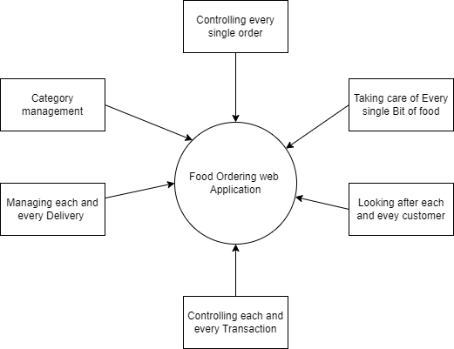

**Fig.1 DFD Level 0**

**First-Level Data Flow Diagram of Online Food Ordering System :**

The First Level DFD (1st Level) of the Online Food Ordering System demonstrates how the system is broken down into smaller units (processes). Each of these processes deals with data flows to or from an external agent, and when combined, these processes provide all of the functionality that is required by the Online Food Ordering System system as a whole. Additionally, it outlines the internal data repositories for Item, Category, Delivery, Payment, and Customer that are required for the Online Food Ordering system to work as it was meant to, and it depicts the data flow across the system's many Food, Customer, Category, Item, and Delivery components. Lastly, it provides an overview of the system's overall architecture. DFD Level 1 provides a more in-depth analysis of the first level DFD's constituent parts than does the DFD itself. You will focus on the most important aspects of Online.

Main entities and output of First Level DFD (1st Level DFD):

* Scanning and reporting all Food records
* Order processing and report generation
* Managing Customer records and generating report of all Customer
* Handling payments and generating a report
* Handling Delivery records and generating report of all Delivery
* Handling Category data and generating Category report
* Handling Product entries and generating report of all Item

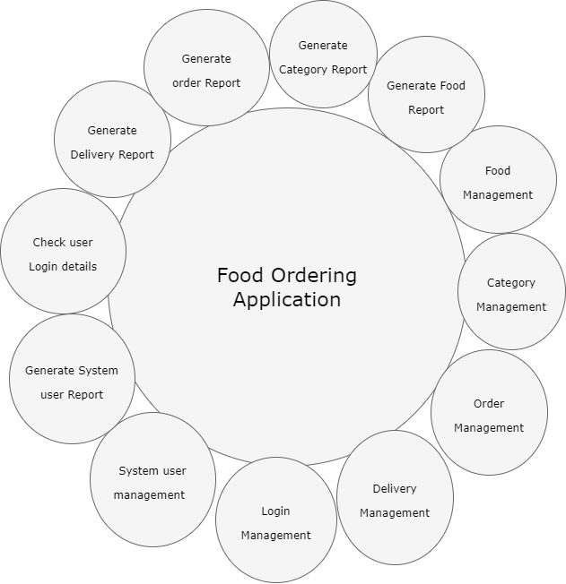

**Fig .2 DFD Level 1**

**Online Food Ordering System's 2nd Level Data Flow Diagram:**

Then, DFD Level 2 takes a more in-depth look at several of the Online Food Ordering components from Level 1. Additional Online Food Ordering capabilities could be essential if a sufficient level of specificity is to be provided on the operation of the Online Food Ordering system. The First Level DFD of the Online Food Ordering System (1st Level) illustrates how the system is partitioned into sub-systems (processes). The second level DFD includes a greater quantity of data pertaining to Item, Category, Delivery, Payment, Customer, Order, and Food than the first level DFD does.

Online Food Ordering System basics :

* Admin controls all Online Food Ordering System functions.
* Admin may add, edit, remove, and view Food, Customer, Delivery, and Item records.
* Admin manages Order, Payment, Category data.
* Admin may also produce Food, Order, Customer, Payment, Delivery, and Category reports.
* Admin may search Order, Delivery, Category data.
* Admin may filter Food, Payment, Delivery reports.
* Admin monitors Order, Customer, Payment, Delivery details.

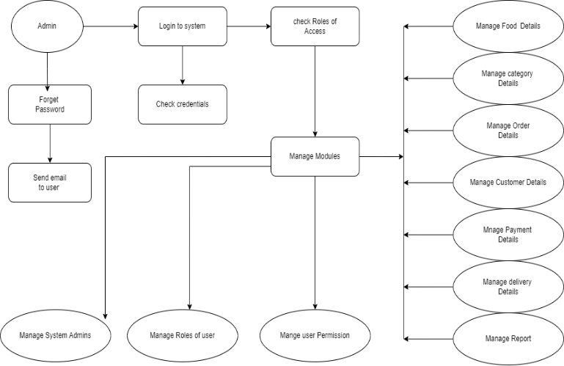

**Fig. 3 DFD Level 2**

1. **Facilities required for proposed work**

* **Software requirements**

|  |  |
| --- | --- |
| Name of Component | Specification |
| Operating System | Windows OS, Linux, MacOS |
| Language | Angular CLI 15.2.6, Node 14.20.0 |
| Database | MongoDb |
| Browser | Mozilla, Chrome , etc. |
| Framework | Express JS |
| Web Technologies | Html, CSS, JavaScript |

* **Hardware requirements**

|  |  |
| --- | --- |
| Name of Component | Specification |
| Processsor | Pentinum III 630MHZ and above |
| RAM | 256MB and above |
| Hard Disk | 20GB and Above |
| Monitor | 15’’color monitor |
| keyboard | 122 keys |

1. **CONCLUSION**

In conclusion, we developed a safe and user-friendly food ordering administration system in order to facilitate online meal ordering. This system is capable of looking after all of its users, whether they are Administrators or Customers. Because of this system, they will be able to manage the meals for their customers, keep track of the delivery boys' information, and grow without causing any problems. Due to the fact that every user is provided with a one-of-a-kind user ID and password, this system offers unrivaled levels of protection against unwanted access. The ability to make payments, register, and cancel orders online makes it far simpler to use. As a consequence of this, using this method will assist to reduce the costs associated with labor while simultaneously providing customers with more opportunities to take use of the services.

The ability to provide Doorstep Delivery at any location and at any time is the element that most appeals to customers.The receipt of rewards and cashbacks, followed by the accumulation of loyalty points or the receipt of perks, is the single most effective way to inspire customers. A negative previous experience, negative reviews, and negative word of mouth are the three things that prevent people from trying out online meal delivery applications. This idea, together with its potential for innovation, may flourish via the provision of services that are reliable and efficient. In the future, businesses may choose to focus their growth efforts on Tier 2 cities since such locations also have sizable populations of young adults who are employed.

**REFERENCES**

1. H.S. Sethu & Bhavya Saini (2016), “Customer Perception and Satisfaction on Ordering Food via Internet, a Case on Foodzoned.Com, in Manipal,” Proceedings of the Seventh AsiaPacific Conference on Global Business, Economics, Finance, and Social Sciences (AP16Malaysia Conference) ISBN: 978-1-943579-81-5. Kuala Lumpur, July 15-17, 2016. Paper KL631
2. heryl E. Kimes Ph.D. (2011), “Customer Perceptions of Electronic Food Ordering,” Cornell Hospitality Report, 11(10), 6-15.
3. Leong Wai Hong (2016), “Food Ordering System Using Mobile Phone,” BIS (Hons) Information Systems Engineering report, Faculty of Information and Communication Technology (Perak Campus), UTAR.
4. Varsha Chavan, Priya Jadhav, Snehal Korade, and Priyanka Teli (2015), “Implementing Customizable Online Food Ordering System Using Web Based Application,” International Journal of Innovative Science, Engineering & Technology, Vol 2 Issue 4, April