**Cascaded Multilevel Inverter Based Power and Signal Multiplex Transmission for Electric Vehicles**

S.Rajkumar1, G.Stalin2, R.Vinay3, MD.Irshad Ali4, R.Pavan Kalyan5, P.Lokesh6

1Assistant Professor, EEE, Nigama Engineering College, Karimnagar, Telangana, India.

2,3,4,5.6UG Students, EEE, Nigama Engineering College, Karimnagar, Telangana, India.

**ABSTRACT**

Power & signal multiplex transmission (P&SMT) is a technique that uses power electronic circuits for communication signal transmission. In this paper, a three-phase cascaded multilevel inverter-based P&S MT system is proposed. The proposed method can transmit communication signals without using a Controller Area Network bus, thereby reducing the wiring cost of the conventional electric vehicle (EV) communication system. The designed system can achieve motor speed regulation and battery balance discharging for EVs. With the combined pulse width modulation scheme and frequency shift keying method, both power and communication signals are transmitted successfully in a simulation model implemented in Matlab/Simulink. By evaluating the bit error rate of the transmitted signal, the maximum signal rate of the proposed system is determined as 600 bit/s.

**Keywords:** Cascaded Multilevel Inverter, Electric Vehicles.

1. **INTRODUCTION**

The challenges posed by climate change are spurring experts and researchers to investigate the alternatives for fossil fuels to achieve carbon dioxide emissions reduction. Nowadays, the application of electric vehicles provides a feasible solution for energy saving and emission reduction in the automotive industry. Compared to traditional internal combustion engine cars, electric vehicles (EVs) not only produce fewer air pollutants such as CO and NOx but also generate less noise [1], [2]. Furthermore, if the battery of the EV is charged at night, it can avoid the peak of power consumption, which is beneficial to the grid to balance the load and reduce the cost [3]. Since various subsystems such as the motor control unit (MCU) and the battery management system (BMS) in an EV require communication with the transmission control unit (TCU), it is necessary to employ an effective method to realize

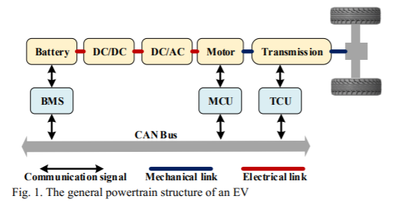

signals transmission [4], [5]. One of the approaches that is widely accepted by manufacturers and researchers for data transmission in EVs is through a Controller Area Network (CAN) bus because of its high reliability and high communication baud rate [6], [7]. The general powertrain structure of an EV is exhibited in Fig.1. Some conventional power systems for EVs employ a DC/DC converter to boost the battery voltage for a 2-level inverter [8], [9]. This approach can have high voltage change rates (dV/dt), which leads to high switching losses [8]. Moreover, such a system is expensive and has low power density because of the utilized bulky inductors for the DC/DC boost converters [9]. Although the traditional EVs realize their internal communication through the CAN bus, the communication channel and the power transmission line are still two independent sections, and the whole system can still be optimized.

This paper proposes a power & signal multiplex transmission (P&SMT) method to transmit both power and communication signals through a three-phase multilevel inverter circuit for EVs. The individual devices of the multilevel inverter have a much lower switching loss than that of a 2-level inverter, and a DC/DC converter is not required since the cascaded multilevel inverter itself can boost the battery voltage. In the proposed system, the power conversion is realized by the pulse width modulation (PWM) method, and the transmitted signals are modulated by the frequency shift keying (FSK) approach. Instead of using a CAN bus as a communication channel in the up-to-date EVs, the proposed approach can greatly reduce the expenditure on the communication system because the power and signals are transmitted simultaneously through the same power line. The remainder of this paper is arranged as below. Section II reviews some relevant literature about the P&SMT technique. Section III describes the structure and the P&SMT mechanisms of the proposed system. The simulation results are provided in Section IV. Section V draws a brief conclusion at the end of this paper.

1. **LITERATURE SURVEY**

There are several power and signal transmission methods that have been applied in various areas. For example, the general method for transmitting data through a power line is to modulate the data onto a high-frequency carrier, and then couple the data to the power line through a coupling circuit after power amplification [10]. Since the power line itself is not designed to transmit communication data, adding signals to it can increase the complexity of the power line channel. Additionally, electromagnetic interference should be considered while designing a broadband power line communication (PLC) model as its 2 MHz to 32 MHz carrier frequency may coincide with the frequency of short-wave radios [11]. Power over Ethernet (PoE) is the technology that uses twisted-pair Ethernet cabling to pass data along with electric power to some IP-based terminals such as voice-over-Internet telephones and IP cameras [12]. However, because the maximum output power of power sourcing equipment of PoE is larger than 15.4W in the standard IEEE802.3af, such a technique is not suitable for pan–tilt–zoom cameras and other high-power-required applications [13]. In order to expand the application range of power and signal transmission technology, literature [14] proposes the concept of power electronic signaling, which aims to use power electronic devices for communication signals generation. The generated signals can then be used for power line communication, online condition monitoring, fault detection, and active protection in smart grids, distributed power generation, and other areas where simultaneous transmission of power and signals is required. The approaches of using power electronic circuits for signal transmission are investigated in recent years. The literature [15]-[17] utilizes the Buck circuit with a multipath load structure to realize the signal transmission function while converting power. By adjusting the switching frequency with the PWM technique, the switching ripple generated on the input bus can be modulated with the FSK method. In their experiments, a peak detection circuit is employed to capture the switching signal, then followed by band-pass filtering and signal processing to identify the digital '0' and '1'. The literature [18] and [19] employ a time-division multiplexing method for transmitting both communication signals and power through a DC/DC topology. In their design, signals’ bidirectional transmission is realized between a master module and slave modules. Because various switches operate with different duty ratios, power and signal are transmitted alternatively through a single topology and the transmitted signals are extracted by detecting the alteration of the bus voltage. Nevertheless, such a system has a low communication rate as the signals are discontinuously transmitted.

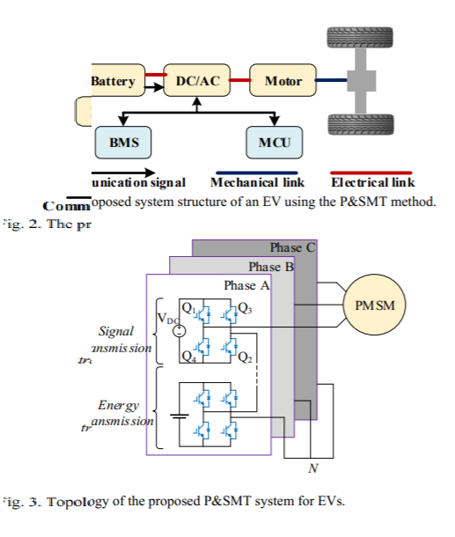

1. **MODELING AND ANALYSIS**

**System Structure**

This paper elaborates the principle of the proposed P&SMT method by using the transmitted battery state of charge (SOC) signal and motor speed control signal as an example. The proposed system structure of an EV using the P&SMT method is shown in Fig. 2. The communication between the battery and BMS, and that between the MCU and motor are realized by transmitting signals through a three-phase multilevel inverter circuit. The proposed topology of a three-phase P&SMT system is indicated in Fig. 3. Specifically, each phase of the inverter topology contains four series connected H-bridge cells, where the cell is powered by a DC voltage source is used for signal transmission, and the rest three cells powered by batteries are applied for energy transmission. The motor speed adjustment signal and the SOC signal are transmitted through the phase A and phase B branches respectively. In this model, a permanent magnet synchronous motor (PMSM) is applied as a load of the inverter topology.

**Signal Transmission**

The signals are modulated by the FSK method in the proposed system and the signal transmission scheme is presented in Fig. 4. If the transmitted 4-bit signal SI is ‘1010’, then two carriers with different frequencies shown in SC can be applied for modulating digital ‘1’ and digital ‘0’ respectively. Since the signal is designed to be transmitted through an H-bridge cell in each phase, the signal can be modulated by controlling the fast-switching process of the four switches in the cell. Specifically, a switch will turn on if a digital ‘1’ is applied as a gate signal and it will turn off when digital ‘0’ is used. In Fig. 3, the switches Q1 and Q2 operate simultaneously Zhang Et Al.: Cascaded Multilevel Inverter Based Power and Signal Multiplex Transmission For Electric Vehicles

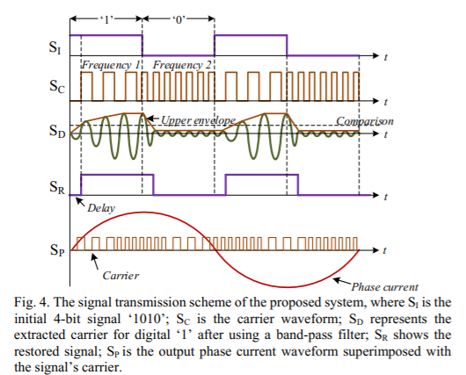

and the switches Q3 and Q4 turn on and turn off at the same time. Besides, the switches Q1 and Q2 operate with the opposite state to that of the switches Q3 and Q4 to avoid short circuit. Because the H-bridge cell used for signal transmission is series connected with the other three cells applied for energy transmission, the transmitted signal can be considered as superimposed on the output current waveform.

Then a band-pass filter is employed to extract the transmitted signal from the output current waveform at receiver. For any signal f(x) with period T and angular frequency ω=2π/T, its Fourier series expansion can be expressed as



where the coefficients defined by

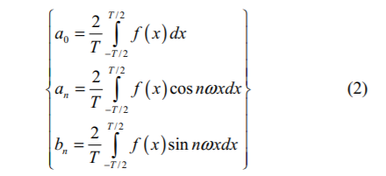

Similarly, if a square wave f(t) with period T is applied as a carrier for digital ‘1’, it can be expressed as

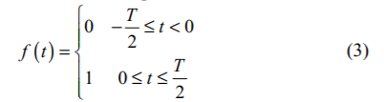

The Fourier series expansion of f (t) is derived as

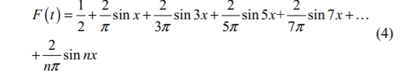

where n is an odd number. Because the Fourier series expansion of f(t) only contains the odd harmonic components, and the first-order harmonic has the largest amplitude, the first-order harmonic can be utilized for restoring the communication signals. For instance, the curve SD in Fig. 4 represents the

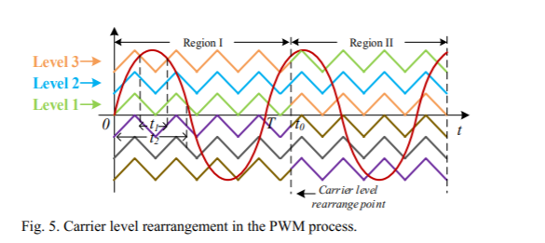

demodulated carrier for digital ‘1’, then its upper envelope can be acquired using an envelope detector. With an appropriate comparison value, the upper envelope can be recovered to digital ‘1’ when its amplitude larger than the comparison value. Otherwise, it will be recovered to digital ‘0’. Finally, the restored SR is obtained after sampling the recovered digital signal using the initial bit rate of SI.

**Motor Speed Regulation and Battery Balance Discharging**

In the proposed system, the motor speed is managed by setting the power frequency to different values with the transmitted signal. Expressly, the relationship among the motor speed n, pole-pair p, and power frequency f for a PMSM is indicated as



where the constant 60 refers to 60 s/min. Theoretically, the speed of a 2-pole pair motor should change between 1200 r/min and 1800 r/min if its power frequency varies between 40 Hz and 60 Hz. With the transmitted signal s, the power frequency f is then calculated by



The power frequency will be 40 Hz and 60 Hz if the digital ‘0’ and digital ‘1’ occur in the transmitted signal s respectively. Next, the three-phase reference sinusoidal waves are obtained from

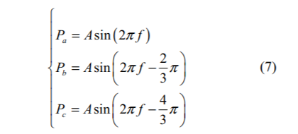

where Pa, Pb, and Pc represent the reference wave in phase A, phase B, and phase C respectively, and A is amplitude. The phase B and phase C reference waves lag the phase A reference wave by 2π/3 and 4π/3 radians respectively. Finally, the modulated variable frequency sine waves are used to drive the motor to achieve motor speed adjustment.

In the conventional sinusoidal PWM method, the gating signal of a switch is generated by comparing the reference wave with a triangular carrier. Because various carriers and the reference wave intersect at different positions, the duty cycle of each switch is different. For instance, in a single period from 0 to T as displayed in Fig. 5, the duty cycle of a switch controlled by ‘Level 3’ carrier is smaller than that of the other switch modulated by ‘Level 1’ carrier (t1<t2) . Since the input power

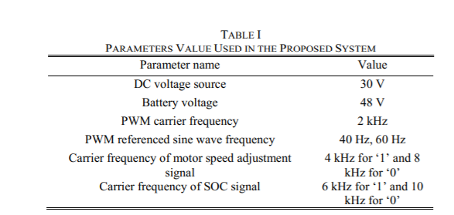

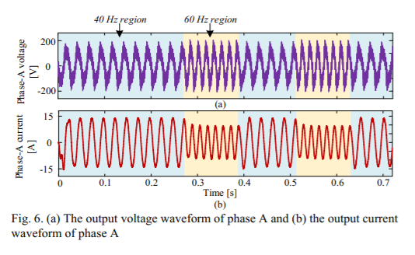

comes from batteries, the switch operating with a smaller duty cycle consumes less power than the switch operating with a larger duty cycle. This will further lead to the case of batteries’ remaining capacity being unbalanced after the system running for a while. Therefore, the battery balance discharging can be realized by periodically rearranging the carrier levels within the PWM process. To achieve this target, firstly, the battery SOC values at the periodical sampling point are combined to form a data stream and transmitted through the DC voltage source powered full-bridge cell using FSK method. After demodulating the signal from the phase current, the SOC values are separated into different decimal numbers. Finally, the carrier levels of PWM are rearranged according to the transmitted SOC values (at t0 in Fig. 5 for example), and the battery balance discharging is realized.

1. **SIMULATION RESULTS AND ANALYSIS**

Based on the mechanisms demonstrated in section III, a simulation model is built in Matlab/Simulink. Table I summarises the values of parameters in the simulation model. Each H-bridge cell for power transmission contains a 48 V battery, and a 30 V DC voltage source is applied in each H-bridge circuit for signal transmission. Therefore, the amplitude of the transmitted signal is neither too small to be restored nor too large to seriously affect the output sinusoidal waveform. Moreover, because the system employs carriers with a frequency distribution from 2 kHz to 10 kHz, it is appropriate for silicon-type IGBT devices to operate in such a frequency range [20].

When connecting a PMSM as a load to the output side of the three-phase inverter circuit, the output voltage and current waveforms measured by a voltage sensor and a current sensor

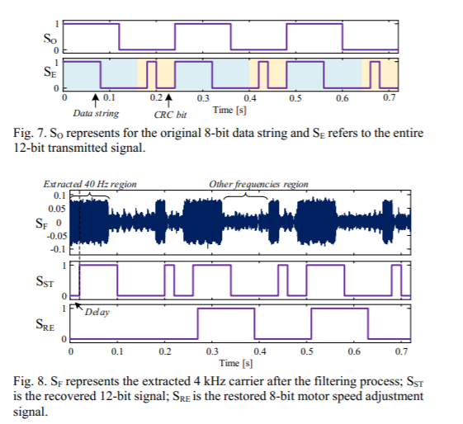

are exhibited in Fig. 6. Since there are three batteries and a DC voltage source in each phase, the maximum phase voltage is 174 V (3×48+30=174). It can be observed that the amplitude of the phase current waveform varies at around 0.27 s and 0.51 s, and this is because the motor power frequency changes from 40 Hz to 60 Hz at these time points.

**5.CONCLUSION**

In this paper, a three-phase multilevel inverter-based P&SMT system is proposed to achieve motor speed adjustment and battery balance discharging for EVs. Four series-connected H-bridge cells are involved in each phase of the inverter topology, where the PWM-controlled three cells are used for energy transmission and the rest of FSK controlled cell is applied for communication signal transmission. Since the proposed approach employs a part of the power electronic circuit as a communication channel, the complexity of the entire system can be reduced by simplifying the system wiring. With a simulation model implemented in Matlab/Simulink, the feasibility of the proposed P&SMT method is verified by transmitting the motor speed adjustment signal and the battery SOC signal through phase-A and phase-B currents respectively. Additionally, the signal transmission capability of the proposed method is determined as 600 bit/s after investigating the relationship between the signal bit rate and error rate.

**REFERENCES**

[1] T. Donateo, F. Licci, A. D’Elia, G. Colangelo, D. Laforgia and F. Ciancarelli, "Evaluation of emissions of CO2 and air pollutants from electric vehicles in italian cities," Applied Energy, vol. 157, pp. 675-687, Nov. 2015.

[2] C. Ma, C. Chen, Q. Liu, H. Gao, Q. Li, H. Gao and Y. Shen, "Sound quality evaluation of the interior noise of pure electric vehicle based on neural network model," IEEE Transactions on Industrial Electronics, vol. 64, no. 12, pp. 9442-9450, 2017.

[3] M. Yilmaz and P. T. Krein, "Review of the impact of vehicle-to-grid technologies on distribution systems and utility interfaces," IEEE Transactions on Power Electronics, vol. 28, no. 12, pp. 5673-5689, 2013.

[4] K.Ç. Bayindir, M.A. Gözüküçük and A. Teke, "A comprehensive overview of hybrid electric vehicle: Powertrain configurations, powertrain control techniques and electronic control units," Energy conversion and Management, vol. 52, no. 2, pp. 1305-1313, 2011.

[5] X. Zhu, H. Zhang, J. Xi, J. Wang and Z. Fang, "Optimal speed synchronization control for clutchless AMT systems in electric vehicles with preview actions," 2014 American Control Conference, pp. 4611-4616, 2014.

[6] F. Zhou, S. Li and X. Hou, "Development method of simulation and test system for vehicle body CAN bus based on CANoe," 2008 7th World Congress on Intelligent Control and Automation, pp. 7515-7519, 2008.

[7] M. Zheng, B. Qi and H. Wu, "A li-ion battery management system based on CAN-bus for electric vehicle," 2008 3rd IEEE Conference on Industrial Electronics and Applications, pp. 1180-1184, 2008. [8] L. M. Tolbert, F. Z. Peng and T. G. Habetler, "Multilevel inverters for electric vehicle applications," Power Electronics in Transportation (Cat. No.98TH8349), pp. 79-84, 1998.

[9] Z. Du, B. Ozpineci, L. M. Tolbert and J. N. Chiasson, "DC–AC cascaded H-bridge multilevel boost inverter with no inductors for Electric/Hybrid electric vehicle applications," IEEE Transactions on Industry Applications, vol. 45, no. 3, pp. 963-970, 2009.

[10] L. Lampe, A.M. Tonello and T.G. Swart, Power Line Communications: Principles, Standards and Applications from multimedia to smart grid, John Wiley & Sons, 2016.

[11] W. Huagang, T. R. Meng and L. S. Wen, "Measurement and analysis of electromagnetic emissions for broadband power line (BPL) communication," 2017 IEEE 5th International Symposium on Electromagnetic Compatibility (EMC-Beijing), pp. 1-4, 2017.

[12] R. V. White, "Electrical isolation requirements in power-over-ethernet (PoE) power sourcing equipment (PSE)," Twenty-First Annual IEEE Applied Power Electronics Conference and Exposition, 2006. APEC '06, pp. 4, 2006.

[13] J. Herbold, "Navigating the IEEE 802.3af standard for PoE," POWER ELECTRONICS TECHNOLOGY, vol.30, no. 6, pp. 45-48, 2004.

[14] W. Xu and W. Wang, "Power electronic signaling Technology—A new class of power electronics applications," IEEE Transactions on Smart Grid, vol. 1, no. 3, pp. 332-339, 2010.

[15] S. Saggini, W. Stefanutti, P. Mattavelli, G. Garcea and M. Ghioni, "Power line communication in dc-dc converters using switching frequency modulation," Twenty-First Annual IEEE Applied Power Electronics Conference and Exposition, 2006. APEC '06, 2006.

[16] W. Stefanutti, P. Mattavelli, S. Saggini and L. Panseri, "Communication on power lines using frequency and duty-cycle modulation in digitally controlled dc-dc converters," IECON 2006 - 32nd Annual Conference on IEEE Industrial Electronics, pp. 2144-2149, 2006.

[17] W. Stefanutti, S. Saggini, P. Mattavelli and M. Ghioni, "Power line communication in digitally controlled DC–DC converters using switching frequency modulation,"IEEE Transactions on Industrial Electronics, vol. 55, no. 4, pp. 1509-1518, 2008.

[18] J. Wu, C. Li and X. He, "A novel power line communication technique based on power electronics circuit topology," 2010 Twenty-Fifth Annual IEEE Applied Power Electronics Conference and Exposition (APEC), pp. 681-685, 2010.

[19] J. Wu, S. Zong and X. He, "Power/signal time division multiplexing technique based on power electronic circuits," 2011 Twenty-Sixth Annual IEEE Applied Power Electronics Conference and Exposition (APEC), pp. 1710-1714, 2011.

[20] C. Blake and C. Bull, "IGBT or MOSFET: Choose wisely," International Rectifier, 2001.