**ABSTRACT**

Numerous studies have identified connections between economic growth and corruption, prompting governments to employ diverse strategies to combat it. Technology, particularly blockchain technology, has emerged as a significant tool in addressing corruption. This paper provides a concise overview of blockchain technology, which functions as a distributed database and a public ledger for all executed transactions shared among participants. Each transaction recorded in the ledger undergoes verification by a majority of system participants. The current risks associated with corruption are examined, and potential solutions utilizing blockchain technology are presented. Non-Governmental Organizations (NGOs) dedicated to addressing societal issues encounter challenges in maintaining and securing support from donors and funds. Recent instances of corruption and misconduct have tarnished the public perception of NGOs. These events have sparked concerns about the destination of donations, organizational leadership, and the appropriate use of contributed funds. Consequently, a pressing need arises to address such issues for the betterment of society. To tackle the aforementioned fund management problem in NGOs, we propose the adoption of blockchain technology, among other available technological alternatives. By offering data security, immutability, and transparency, blockchain technology can help restore public trust in the NGO sector.

**Keywords:** Blockchain, Distributed system, smart contract, Non-Governmental Organizations (NGOs), Ledger, Security, Transparency.

**I. INTRODUCTION**

The term "block" refers to transaction data that is organized in a "chain" and connected to other blocks of data. This synchronized approach enables easy detection of any alterations in the chain, thereby safeguarding the system against illegal and unauthorized transactions. A blockchain serves as a digital ledger of records that is shared among all participants. This technology ensures the authenticity of each transaction by verifying the involved parties, transaction time and date, and transaction contents. If a transaction is found to contain fraudulent details resulting from corruption, it is not validated according to the protocol, rendering it invalid. Consequently, blockchain technology proves to be an effective tool in promoting transparency and eliminating corruption by providing a clear view of every transaction.

**II. RESEARCH**

**A. Relationship Between Corruption and Economic Growth**

This section explores the connection between corruption and economic growth in different countries. Corruption typically hampers economic growth in a nation. To achieve high economic growth, countries devise strategies to reduce corruption, which is one of the primary factors impeding progress. The detrimental effects of high corruption on economic growth include:

Impact on Foreign Investment: Corruption directly affects foreign investment, discouraging potential investors from committing resources to the country.

Diversion of Public Resources: Corruption leads to the diversion of public resources for private gain, depriving the public of essential services and infrastructure.

Erosion of Trust in the Government: Corruption undermines public trust in the government, creating scepticisms about the government's ability to serve the people's interests.

Hindrance to Development: Corruption directly hinders the country's development by impeding the government's ability to collect sufficient taxes and allocate resources effectively.

The figure below illustrates the corruption levels in different countries worldwide.

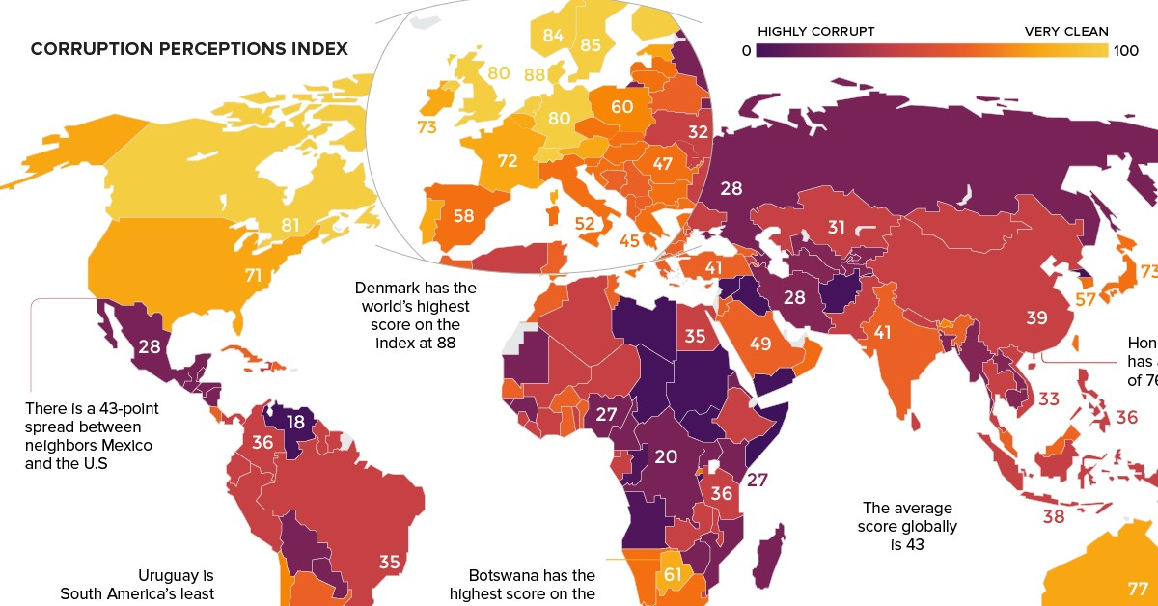

**Fig-: Corruption level in countries.**

**B. Technological Solutions to Combat Corruption**

Recognizing the detrimental effects of corruption on society, many countries are actively striving to eradicate it. These nations are exploring the implementation of anti-corruption strategies and technologies to detect and prevent corrupt practices. Among various measures and research initiatives, technology has emerged as a powerful tool in the fight against corruption. Different types of technologies offer diverse methods to mitigate specific risks associated with corruption. This paper focuses on the utility of blockchain technology in detecting and preventing corruption, while also introducing several applications that leverage blockchain technology for this purpose.

**III. THE BLOCKCHAIN TECHNOLOGY**

**A. Understanding Blockchain Technology**

Blockchain technology refers to a decentralized database where information is distributed across a vast network of computers, rather than being stored on a single server. This decentralization is a key characteristic of blockchain. The concept of blockchain was initially introduced by Nakamoto in 2008, and its first practical application came in the form of the widely known digital currency called Bitcoin.

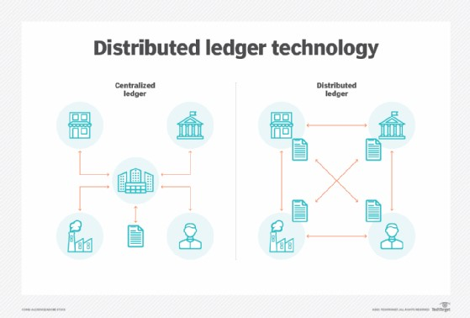

**Fig-: Blockchain Technology.**

Blockchain technology encompasses several key components: Ethereum, smart contracts, distributed ledgers, chains of blocks, and wallets.

1. **Ethereum:** Ethereum is a platform that facilitates the implementation of blockchain technology. It allows for the execution of code through the Ethereum Virtual Machine (EVM) and supports the creation and deployment of smart contracts.
2. **Smart contracts:** Smart contracts are agreements written in the Solidity programming language that can be executed on the Ethereum platform. They serve as self-executing contracts with predefined conditions and actions, enabling automated and transparent transactions.
3. **Distributed ledger:** A ledger is a type of database where confirmed transactions are recorded. In the context of blockchain technology, the ledger is distributed across multiple computers or nodes, rather than being stored centrally. This distribution ensures transparency, immutability, and security of the recorded transactions.
4. **Chain of blocks:** A blockchain consists of a series of blocks, where each block contains specific information. The blocks are linked together in a chain-like structure, similar to a linked-list data structure. Each block typically includes an index, previous hash, current hash, and transaction data.
5. **Index:** The index uniquely identifies a particular block within the blockchain.
6. Previous hash: The previous hash contains the hash value of the preceding block in the chain, creating a chronological order.
7. **Current hash:** The current hash represents the hash value of the current block, ensuring data integrity and tamper resistance.
8. **Transaction data:** The transaction data section stores information about the transactions that have been successfully executed by the node.
9. Wallet: A wallet is a digital tool that allows individuals to securely store, manage, and interact with their blockchain-based assets, such as cryptocurrencies. Wallets enable users to access and control their digital assets using private keys.
10. In summary, blockchain technology comprises Ethereum as a platform, smart contracts for automated agreements, distributed ledgers for recording transactions, chains of blocks to maintain data integrity, and wallets for managing digital assets.

**B. Characteristics of Blockchain**

1. **Decentralized:** The decentralized nature of the blockchain network transforms transaction record databases from closed and centralized systems. The failure or fraudulent activity of a single node does not impact the entire network. This eliminates a single point of failure, ensuring high reliability for applications built on blockchain technology.
2. **Immutability:** The blockchain network employs one-way hash functions, which are mathematical functions that convert input strings into fixed-length binary sequences. The output has no apparent relationship with the input, and the process is difficult to reverse. This ensures the immutability of data stored in the blockchain.
3. **Reliability:** Blockchain networks establish trust through decentralized ledgers. Unlike centralized trust systems, such as government-issued currencies or commercial banks, blockchain networks introduce a new decentralized trust mechanism.
4. **Transparency:** Since all nodes within the network can view the data, the potential for falsification is minimized. Each node can observe transactions and the number of transactions performed by any node, promoting transparency throughout the network.

**C. How Blockchain Works**

In blockchain technology, numerous nodes are connected to form a vast network. When a user initiates a transaction, it is represented by a block. This block is then broadcasted to all nodes in the network for verification. Once a node verifies the details of the transaction, the block is appended to the blockchain, indicating a successful transaction.

**D. Key Benefits of Blockchain Technology**

Blockchain technology offers three significant advantages - distributed architecture, immutability, and transparency - which can help combat corruption and fraud in the public sector. It can be utilized to perform many functions traditionally handled by regulators, ensuring that taxpayer money is not being misused by politicians. Governments and financial institutions can leverage this technology to fight financial crimes like money laundering and track funds involved in criminal activities such as drug trade or terrorism. With blockchain, every transaction can be recorded without manipulation, providing transparency regarding the ultimate destination of funds. Blockchain technology enhances transaction transparency and resists unauthorized modifications or hacks. Hash values play a crucial role in this technology as they detect interception attempts and prevent unauthenticated users. Generating a hash value requires complex algorithms, making it challenging to manipulate. Even a single character change in the input data alters the hash value significantly. Additionally, each node in the blockchain stores the hash value of the previous node, making it difficult for a hacker to join the blockchain without having the required hash values. Unauthorized access is prevented through these mechanisms.

**E. Ensuring Security in Blockchain**

Blockchain technology ensures security by utilizing hash values to uniquely identify each block in the chain. This is achieved through a method called proof-of-work. In this method, certain criteria are set for the hash value of each block. For example, the hash value may need to begin with four consecutive zeros, resulting in a hash value like "0000kjdvvb...". If someone attempts to modify the block data, such as increasing the value or number of coins, the data is altered, which directly affects the hash value. The modified data no longer satisfies the set criteria, and the blockchain rejects it. Similarly, any changes made to the attributes of a block will result in modifications to the hash value, and the block will not be accepted by the blockchain unless it full fills the conditions specified by the proof-of-work method.

**IV. BLOCKCHAIN TECHNOLOGY FOR NGOs**

**A. Challenges Faced by NGOs**

Currently, trust in NGOs has been diminished due to corruption. NGOs also face challenges such as limited technical capabilities, lack of credibility, absence of a centralized user point, and poor strategic planning. Several questions arise in people's minds regarding NGOs, such as how they use donated money, where the money is actually utilized, whether it is being corrupted, and who is responsible for secure transactions. The diagram depicts the current flow system of NGOs. In the current scenario, donors contribute funds to NGOs through various means based on the organization's requirements. The entire system is managed manually, checking the adequacy of funds. If the funds meet the requirements, they are accepted. Manual processes handle payment scheduling, fund distribution, and balance statements in a centralized manner. However, there is a possibility of funds becoming insufficient, leading to loops in the process and causing problems that harm the system's efficiency.

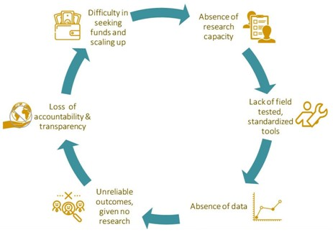

**Fig-: Problems in NGOs**

We can observe that insufficient records may lead to non-acceptance, resulting in delays and creating an unfavourable environment. Furthermore, there is a risk of fraud since manually generated records can be falsified, especially in a centralized system.

**B. Implementation of Block-Chain for NGO**

To address the problems faced by NGOs, this paper proposes the implementation of block-chain technology as the backend solution. The aim is to enhance security and transparency within the NGO sector. Block-chain technology, being decentralized, eliminates the need for a central authority. Node.js is used to implement nodes, while smart contracts are written in languages like Solidity. A crypto currency, known as NGO coin, is created using programming languages such as Python or JavaScript.

The system architecture involves collaboration between the front-end and back-end, with interactions between nodes of different users. A chain of blocks is generated, representing transactions, and smart contracts serve as agreements. The system supports two types of users: NGOs and Vendors/Suppliers. NGOs can sign up with their official email and undergo a verification and approval process. Vendors and Suppliers associated with NGOs can sign up using their email addresses. Each user is assigned a unique address on the Ethereum block-chain for sending and receiving NGO coins.

NGO coins serve as a crypto currency and can be managed through the portal's wallet. Users can send and receive NGO coins instantly, anytime and anywhere in the world. Each wallet has a unique address and a private key for protection. NGO coins can be purchased using bank transfers or credit/debit cards in US dollars. The value of one NGO coin is equivalent to 1 US dollar. Deposited money is converted into NGO coins and reflected in the wallet's balance. Users can perform transactions using NGO coins, and if they need more coins, they can follow the same process. Withdrawal requests can be made to convert NGO coins back into the corresponding currency.

This implementation ensures a secure and transparent system for NGOs, providing ease of transactions and reducing the risk of fraud.

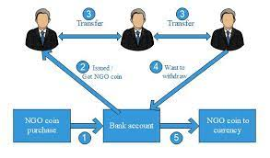

**Fig-: Coin Flow In NGO.**

**V. CONCLUSION**

In conclusion, block-chain technology, particularly when implemented using platforms like Ethereum, offers significant potential for the NGO sector. The use of block-chain can help address the problems of limited technical capabilities, lack of credibility, and poor strategic planning that plague many NGOs. By implementing a system that ensures security, transparency, and accountability, block-chain can help rebuild trust between NGOs and donors.

The proposed system, as outlined in this paper, leverages the decentralized nature of block-chain, the use of smart contracts, and the creation of a crypto currency (NGO coin) to facilitate secure and transparent transactions. Donors can have confidence in knowing where their money is being utilized and can track the flow of funds within the system. This transparency helps donors regain trust in the NGO sector and encourages them to contribute towards meaningful causes.

It is important to note that block-chain technology is continually evolving, and new innovations and upgrades are being introduced regularly. As the technology advances, it is crucial for NGOs to stay up to date with the latest developments and explore ways to leverage block-chain to further improve their operations, transparency, and accountability.

Overall, the implementation of block-chain technology in the NGO sector holds immense promise in combating corruption, enhancing transparency, and rebuilding public trust. With continued advancements and adoption of block-chain, NGOs can create a more efficient, accountable, and impactful ecosystem for the benefit of society and the causes they serve.

**REFERENCES**

[1] Yli-Huumo, Jesse, et al. "Where is current research on blockchain technology?—a systematic review." PloS one 11.10 (2016): e0163477.

[2] Yaga, Dylan, et al. "Blockchain technology overview." arXiv preprint arXiv:1906.11078 (2019).

[3] Yli-Huumo, J., Ko, D., Choi, S., Park, S. and Smolander, K., 2016. Where is current research on blockchain technology?—a systematic review. PloS

one, 11(10), p.e0163477.

[4] Zheng, Z., Xie, S., Dai, H., Chen, X. and Wang, H., 2017, June. An overview of blockchain technology: Architecture, consensus, and future trends. In 2017 IEEE International Congress on Big Data (BigData Congress) (pp. 557-564). IEEE.INFOTEH-JAHORINA (INFOTEH). IEEE, 2018.

[5] Vujičić, D., Jagodić, D. and Ranđić, S., 2018, March. Blockchain technology, bitcoin, and Ethereum: A brief overview. In 2018 17th International Symposium INFOTEH-JAHORINA (INFOTEH) (pp. 1-6). IEEE.

[6] Pilkington, Marc. "11 Blockchain technology: principles and applications." Research handbook on digital transformations 225 (2016).

[7] M. Young, The Technical Writer’s Handbook. Mill Valley, CA: University Science, 1989