**Comparison of performance parameters for coated and uncoated solar panels**

**Somesh Singh1, Ritik Bhatt2, Pankaj Kumar3, Snehal Marathe4**

1Student, Electronics and Telecommunication, Army Institute of Technology, Pune, Maharashtra, India

2Student, Electronics and Telecommunication, Army Institute of Technology, Pune, Maharashtra, India

3Student, Electronics and Telecommunication, Army Institute of Technology, Pune, Maharashtra, India

4Assitant Professor, Electronics and Telecommunication, Army Institute of Technology, Pune, Maharashtra, India

**ABSTRACT**

In order to apply an antireflection coating to a PV panel and increase the solar cell efficiency by producing more voltage, current, and power at the peak power point, a thorough investigation of several chemicals and nano composite materials was carried out (MPP). An improved method of capturing solar energy and converting it into electrical energy, which would lower costs and boost power production, would be indicated by an improvement in solar cell efficiency. Antireflection, surface inactivity and the desired vitality materials band hole alter in an incredibly encouraging way when the nano composite materials are mixed with certain composition of effective chemicals to boost efficiency by coating technique. The gallium chloride nano particle solution will be made thick and applied over the solar panel using brush so that it will be applied uniformly. Monometallic nano particle coating is prepared to apply over the existing polycrystalline solar panel. Synthesis of different natural extract for monometallic nanoparticle is done. The natural extracts used are flower powder, Kailashpati fruit juice, triphala powder, neem powder and jackfruit juice. By the synthesis of these natural extracts, the monometallic nanoparticle such as gallium flower, gallium kailashpati, gallium triphala, gallium neem and gallium jackfruit are used to check its effect over the material efficiency of the existing solar panel. It is a 90% natural process using natural products such as roots, flowers, petals, fruits peels or leaves are utilized. Effect of this thin coating, applied over the existing solar panel is observed. The gallium chloride monometallic nano particle will be applied over the solar panel using spraying technique to check the effect on the solar panel efficiency. Automation in measurement of the power output of the uncoated and coated panel will be implemented. The uncoated and coated panel will be tested under the sunlight throughout the day.

**Keywords:***solar panel,* *monometallic nano particle coating, maximum power point, MMNPC, nano composites, polycrystalline and power conversion efficiency.*

1. **INTRODUCTION**

On the one hand, energy prices have risen globally in recent years, while solar panels have become less expensive and environmental concerns have received more attention [1]. Solar energy has helped to partially meet the world's energy needs, and attempts have been made to construct solar power plants and farms [2]. The sun's light should travel through a cover glass before being turned to heat or electricity, regardless of whether a solar collector or photovoltaic panel is being used. Therefore, for the system to operate efficiently, the transmission coefficient of the cover glass is just as crucial as other elements such as panel pitch and orientation, cell temperature, maximum power point tracking and energy conversion efficiency [3]. A glass cover's gearbox coefficient steadily decreases as dust builds up on it, which reduces the output energy overall [4].

Arid areas are more suited for the installation of big solar arrays because they have stronger radiation qualities, such as great radiation power and lengthy daylight hours. The deposition of dust on surfaces, which therefore reduces the transmission coefficient and overall efficiency of the solar system [5], is one of the difficulties in employing solar systems in such places, whether they are photovoltaic panels or flat collectors. The density of dust deposition on the surface and the loss in transmittance can be influenced by a variety of factors, including installation tilt, azimuth angle, the predominant wind direction and strength, rain, and the amount of time panels and collectors are exposed to outdoor conditions without cleaning [6]. It is clear from reading the text that meteorological conditions have a considerable impact on dust accumulation. For instance, a single dust storm might result in a 20% reduction in power output from PV modules. The more sunlight that is absorbed by active photovoltaic materials will result in a higher production of electrical energy since solar cells are made to convert available light into electrical energy [7].

To maximize sunlight absorption and enhance solar cell efficiency, silicon surfaces are frequently coated with anti-reflection coatings (ARC) [8]. Texturing the silicon surface to reduce light reflection has drawn a lot of interest as a method of boosting solar cell efficiency [9]. Chemically etched porous silicon has recently been used as an ARC for high-efficiency solar cells [10]. In order to reduce the layer's macroscopic refractive index and, consequently, the reflection caused by the index mismatch at the interface, air and silicon are combined to create a porous structure [11]. This method uses a nanostructure to decrease the graded refractive index (GRIN) in order to lessen reflection.

A fixed solar panel must be positioned with it’s tilted up at a precise angle in order to produce the greatest power, depending on the location's latitude [12]. The position of the sun also affects how much power a stationary solar panel produces [13]. At dawn and dusk, the majority of fixed solar panels generate 84% less power than they do at noon [14]. Therefore, if an ARC system can increase the reflection of low sunlight onto the surface of the solar cell, it will also increase the efficiency of the external solar cells [15]. This article discusses a technique for creating an efficient ARC that can keep a solar cell's efficiency. Glass samples with and without coatings had their dust surface densities and transmission coefficient losses evaluated and compared. First, a few different coatings will be briefly discussed in the following sections. After a description of the climate in the test location, the fundamentals of the experiment and the findings will be discussed.

1. **METHODOLOGY**

**2.1 Monometallic nano particle coating**

* **Gallium Kailashpati**

Gallium chloride (2 Mm) metal salt was dissolved in 1000 ml deionized water. Take 10 flasks and add 100 ml mixture of gallium chloride and deionized water to each flask. Add 4 ml Kailashpati fruit extract into each flask and then sonicate the solution for 60 minutes to maintain its PH. After 24 hours these nanoparticles are settled down and the color is changed. This nanoparticle is further centrifuged at 3000 RPM and then separated. This separated nanoparticle is dried at room temperature at 40 to 50°C and the powder is used for the characterization.

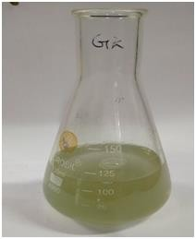

**Figure 1:** Gallium Kailashpati

.

* **Gallium Triphala**

Gallium chloride (2 Mm) metal salt was dissolved in 1000 ml deionized water. Take 10 flasks and add 100 ml mixture of gallium chloride and deionized water to each flask. Add 3 ml Triphala fruit extract into each flask and then sonicate the solution for 60 minutes to maintain its PH. After 24 hours these nanoparticles are settled down and the color is changed. This nanoparticle is further centrifuged at 3000 RPM and then separated. This separated nanoparticle is dried at room temperature at 40 to 50°C and the powder is used for the characterization.

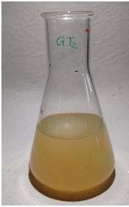

**Figure 2:** Gallium Triphala.

**2.2 Coating Methodology**

The steps for doing MMNPC on a PV cell are listed below:

Process1: Buy a polycrystalline PV panel made of commercially available materials, then thoroughly clean it with ethanol to ensure that all accumulated dirt is eliminated and the panel is clean [25].

Process 2: To make a solid adhesive basis for additional coating, take a tiny composition of gallium chloride, carry out the experiment described above, and apply the main coating to solar cells.

Process 3: Spraying should be used to coat the panel in order to preserve consistency, which boosts productivity.

Process 4: In order to more effectively accomplish the optical qualities that the MMNPC gains on the panel surface, the coated panel should be maintained at a consistent temperature of around 3,000 K before being evenly returned to normal temperature conditions after drying.

**2.3 Hardware Setup**

The pin diagram for the module utilized in this instance, the INA226 Voltage and Current Monitoring Sensor Module, is shown in figure 3. A current shunt and power monitor with an interface compatible with I2C or SMBUS is the INA226. Both the bus power supply voltage and the parallel voltage drop are concurrently monitored by the gadget. The internal multiplier is utilized

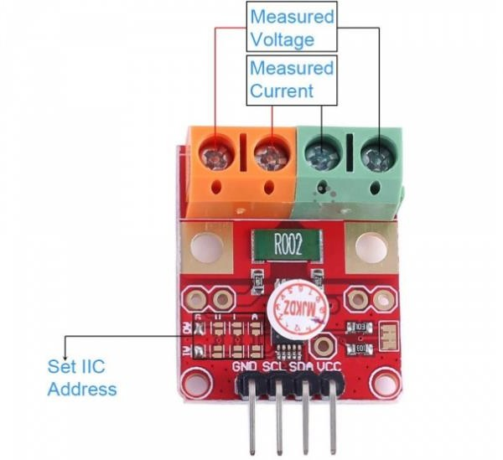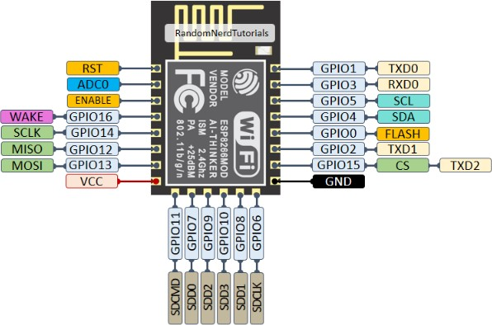

**Figure 3:** INA226 Module and pin diagram

in conjunction with the programmable calibration value, conversion time, and average value to directly read the current in amperes and the power in watts. The I2C compliant interfaces of the device provide up to 16 programmable addresses. The ESP8266 is regarded as the most extensively used WiFi module. If you are utilizing a 5V supply, you need to use an external logic level converter since it operates at a maximum voltage of around 3.6 V and runs at 3V.

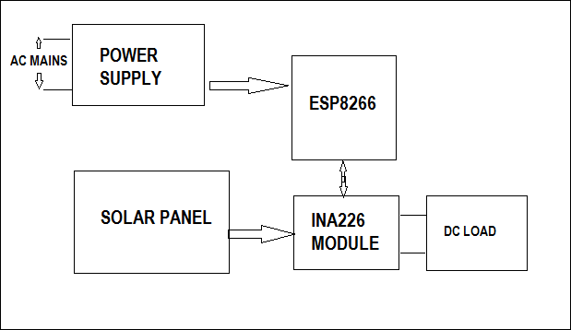

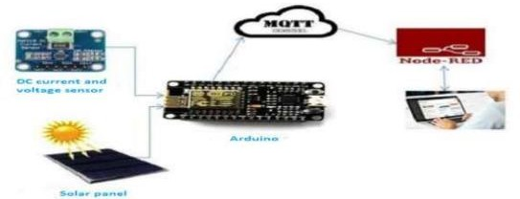

**Figure 4:** System block diagram and design diagram.

Five devices were designed to measure the voltage and current across the load connected with the solar panels, the system block diagram and design diagram is illustrated in figure 4. In one device the lux meter is mounted to measure the sun intensity. One panel is kept uncoated and others are coated with the anti-reflecting coating. The parameters measured for uncoated and coated panels are Voltage, current, power output, temperature of the panel.

1. **EXPERIMENTATION AND ANALYSIS**

Both coated and bare surfaces exhibit molecular structural organization. The original surface finishing of Si will still be present on the untreated surface, however on the coated surface, a thin coating layer that can reduce reflection will be seen. As compared to the current literature, there will be a significant increase in efficiency if the MMNPC is used. Mono metallic nano particle coating that is gallium chloride solution is sprayed over the existing polycrystalline solar panel. The testing of the uncoated and coated panel is done directly under the sunlight. The figure of the setup is shown in figure 5.

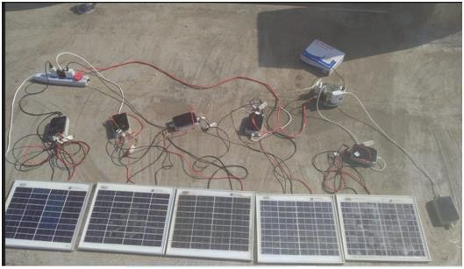

**Figure 5:** System block diagram and design diagram.

**Performance of Gallium Kailashpati(GK) Coating:**

The graphical representation of the uncoated and Gallium Kailashpati coated panel output power in different days is shown in Figure 6.

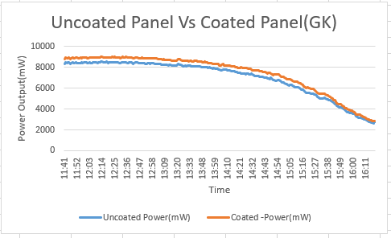

**Figure 6:** Power vs time Graph for GK coated solar Panel and uncoated solar panel.

**Performance of Gallium Triphala(GT) Coating:**

The graphical representation of the uncoated and Gallium Triphala coated panel output power in different days is shown in Figure 7.

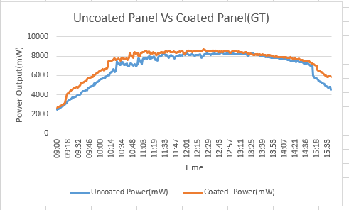

**Figure 7:** Power vs time Graph for GT coated solar Panel and uncoated solar panel.

**Additional power generated:**

Solar panel technology and efficiency play a crucial role in determining the energy output of a solar panel system. Several factors, such as Pmax (maximum power) and cross-section area, contribute to the overall performance. Below are the results and calculations of the energy output of our coated and uncoated solar panels.

* Pmax (GT)=9.11W
* Pmax (GK)=8.8W
* Pmax (Uncoated)=7.2W
* Cross section area of solar panel =21cm*30cm
* taking solar irradiance= 1000 W/m^2
* Next, we can calculate the power produced in an hour by multiplying the solar irradiance by the panel's area and the panel's maximum power (Pmax):
* Power produced = Solar irradiance x Panel area x Pmax
* Energy generated in hour for GT=57.5Wh
* Energy generated in hour for GK=55Wh
* Energy generated in hour for Uncoated=45Wh
* Total annual amount of sun in Pune = 2870 hours
* Annual Energy generated by GT coated solar panel =164.86KWh
* Annual Energy generated by GK coated solar panel =158.35KWh
* Annual Energy generated by Uncoated solar panel =129.15KWh
* Percentage increase in annual Energy after using GT coating = 24.92%
* Percentage increase in annual Energy after using GK coating = 22.59%
* Suppose if we consider annual Energy generated by our college solar panel setup = 360MWh
* after using GT coating Energy generated = 459.439 MWh
* after using GK coating Energy generated = 441.684 MWh

Solar irradiance, which refers to the amount of solar energy received per unit area, also affects energy generation. This indicates a significant percentage increase in annual energy production, with GT-coated panels exhibiting a 24.92% increase and GK-coated panels showing a 22.59% increase compared to uncoated panels.

Considering a solar panel setup in a college that generates 360MWh annually, the use of coatings results in even higher energy outputs. With GT coating, the energy generation increases to 459.439 MWh, while GK coating leads to 441.684 MWh of energy generation. These improvements highlight the positive impact of coating technologies on enhancing the energy production of solar panel systems.

In conclusion, the choice of coating, along with other factors like Pmax and solar irradiance, significantly influences the energy output of solar panel systems. Coated panels demonstrate higher energy generation compared to uncoated panels, with GT and GK coatings leading to substantial annual energy increases. Implementing these coatings in solar panel setups, such as in college installations, can result in significantly improved energy production.

**Efficiency of coated Solar panels:**

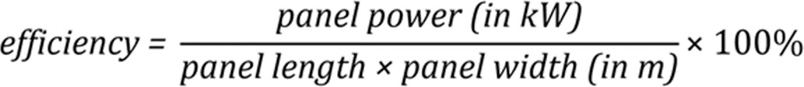

**Figure 8:** Efficiency formula.

* Efficiency of Uncoated Solar Panel=7.2(0.205*0.3*1000)*100%=11.7%
* Efficiency of GK(AE5) coating=8.8/(0.205*0.3*1000)*100%=14.3%
* Efficiency of GT(AE5) coating=9.11/(0.205*0.3*1000)*100%=14.8%

1. **RESULTS AND DISCUSSION**

So, by applying GK and GT coatings respectively the output energy efficiency Increases because the output power increases about 16% to 19% with respect to uncoated solar panels.

1. **CONCLUSION**

•To evaluate the performance of the panels, both the uncoated and coated panels were subjected to

continuous testing under sunlight throughout the day for multiple days. Measurements were taken every second to capture the variations in the power output under different solar conditions. There was a increase of 3-4% in the overall efficiency of solar panel (Considering Ideal as 16%).

•The results consistently showed that the panels with GK and GT coatings outperformed the uncoated panel, generating higher power output. The average output power improved by GK fruit coating was 16% and by gallium GT coating was 19%.

•Also, we calculated annual total energy for both uncoated and coated solar panels and significant percentage increase in annual energy production, with GT-coated panels exhibiting a 24.92% increase and GK-coated panels showing a 22.59% increase compared to uncoated panels.

1. **REFERENCES**

[1] A.K.Ibrahim, R.I.Saeed and R.A.Ali, "Partially Shading a PV Module: Analysis and Design with Simulation", International Journal on Technical and Physical Problems of Engineering, Vol.14, No.51, pp.124-129, 2022

[2] Ali Hussein Numan, Zahraa Salman Dawood and Hashim A. Hussein, "Theoretical and experimental analysis of photovoltaic module characteristics under different partial shading conditions", International Journal of Power Electronics and Drive System (IJPEDS), Vol.11, No.3, pp.1508-1518, 2020

[3] Abdul Qayoom Jakhrani, Saleem Raza Samo, Shakeel Ahmed Kamboh, Jane Labadin and Andrew Ragai Henry Rigit, "An Improved Mathematical Model for Computing Power Output of Solar Photovoltaic Modules", International Journal of Photoenergy, Vol.2014, No.346704, pp.1-9, 2014

[4] Tao Ma, Wenbo Gu, Lu Shen and Meng Li, "An improved and comprehensive mathematical model for solar photovoltaic modules under real operating conditions", Solar Energy, Vol.184, pp.292–304, 2019

[5] Asnil, Krismadinata, Irma Husnaini and Erita Astrid, "Characteristics of Photovoltaic Modules in Various Configurations for Partial Shading Conditions", Journal of Theoretical and Applied Information Technology, Vol.99, No.22, 2021

[6] Malgorzata Rudnicka and Ewa Klugmann-Radziemska, "The Issue of Shading Photovoltaic Installation Caused by Dust Accumulation on the Glass Surface", Ecol Chem Engs, Vol.28, No.2, pp.173-182, 2021

[7] Yotham Andrea, Tatiana Pogrebnaya and Baraka Kichonge, "Effect of Industrial Dust Deposition on Photovoltaic Module Performance: Experimental Measurements in the Tropical Region", International Journal of Photoenergy, Vol.2019, No.1892148, pp.1-10, 2019

[8] Shaima K. Abdulridha, Saad A. Tuma and Omar A. Abdulrazzaq, "Study of the Partial Shading Effect on the Performance of Silicon PV Panels String", Journal of Applied Sciences and Nanotechnology, Vol.1, No.1, pp.32-42, 2021

[9] Mohammad Sayem Mozumder, Abdel-Hamid I. Mourad, Hifsa Pervez, Riham Surkatti, “Recent developments in multifunctional coatings for solar panel applications : A review,” Science Direct Journal in Solar Energy Materials and Solar Cells, vol. 189, pp. 75- 102, 2019

[10] Zhang.G, Kim.G and Choi.W, “Visible light driven photocatalysis mediated via ligand-to-metal charge transfer (LMCT): An alternative approach to solar activation of titania”, Energy Environ. Sci, 7, 954–966, 2014

[11] Homam Al Bakri, Wejdan Abu Elhaija and Ali Al Zyoud, "Solar photovoltaic panels performance improvement using active self cleaning nanotechnology of SurfaShield G",

Energy, Vol.223, 119908, 2021

[12] Marcus King, Dacheng Li, Mark Dooner, Saikat Ghosh, Jatindra Nath Roy, Chandan Chakraborty and Jihong Wang, "Mathematical Modelling of a System for Solar PV Efficiency Improvement Using Compressed Air for Panel Cleaning and Cooling",

Energies, Vol.14, No.4072, 2021

[13] Murat Altintas and Serdal Arslan, "Reduction of Dust on Solar Panels through Unipolar Electrostatic Traveling Wave", applied sciences, Vol.11, No.9121, pp.1-18, 2021

[14] Hatem R. Alamri, Hegazy Rezk, Heba Abd-Elbary, Hamdy A. Ziedan and Ahmed Elnozahy, "Experimental Investigation to Improve the Energy Efficiency of Solar PV Panels Using Hydrophobic SiO2 Nanomaterial", Coatings, Vol.10, No.503, 2020

[15] Valerie Depauw, Christos Trompoukis, Ines Massiot, Wanghua Chen, Alexandre Dmitriev, Pere Roca i Cabarrocas, Ivan Gordon and Jef Poortmans, "Sunlight-thin nanophotonic monocrystalline silicon solar cells", Nano Futures, Vol.1, 2017

[16] Aisha Koprulu, Adem Atmaca and Abdulelah Yaseen, "Experimental and Numerical Study of the Effect of Dust Accumulation on Photovoltaic Panels", The International Journal of Energy & Engineering Sciences, Vol.7, No.2, pp.88-98, 2022

[17] Reham Kamal, Mazen Abdel‑Salam and Mohamed Nayel, "Performance characteristic of a PV module as infuenced by dust accumulation: theory versus experiment", Journal of Engineering and Applied Science, Vol.70, No.13, 2023

[18] Fatima lach-heb, Mohamed Cherif Aidara, Mamadou Lamine Ndiyae and Anna Kerstin Usbeck, "Evaluation of the impact of partial shading on the performance of photovoltaic panels", Journal of Engineering and Technology Research, Vol.14, No.1, pp. 1-8, 2022

[19] Tarek I. Alanazi, "Current spray-coating approaches to manufacture perovskite solar cells", Results in Physics, Vol.44, 106144, 2023

[20] Yunfei Xu, Jing Zhang, Ling Ai, Xueqin Lou, Shenghua Lin, Yuehui Lu, Bin Fan, Jing Jin and Weijie Song, "Fabrication of mesoporous double-layer antireflection coatings

with nearneutral color and application in crystalline silicon solar modules", Solar Energy,

Vol.201, 149–156, 2020

[21] Aslan Gholama, Ali Akbar Alemrajabi, Ahmad Saboonchi, ” Experimental study of self-cleaning property of titanium dioxide and nanospray coatings in solar applications”,

Science Direct Journal in Solar Energy, vol. 157, pp. 559–565, 2017

[22] M. Rama Krishna, K. Rakesh Tej Kumar and G. Durga Sukumar, “Antireflection nanocomposite coating on PV panel to improve power at maximum power point”, Energy Sources, Part A: Recovery, Utilization, and Environmental Effects, Vol.40, No.20, pp.2407-2414, 2018

[23] Ioannis Arabatzis, Nadia Todorova, Ioanna Fasaki, Chrysovalanti Tsesmeli, Antonis Peppas, Wen Xin Li and Zhiwei Zhao, “Photocatalytic, self-cleaning, antireflective coating for photovoltaic panels: Characterization and monitoring in real conditions”, Journal in Solar Energy, vol. 159, pp. 251–259, 2018

[24] S.Sutha, Sisira Suresh, Baldev Raj and K.R.Ravi, “Transparent alumina based superhydrophobic sel- cleaning coatings for solar cell cover glass applications”, Journal in Solar Energy Materials and Solar Cells, vol.165, pp. 128-137, 2017