**CAR LANE DETECTION**

**Mayank Srivastava *1, Dr. Santosh Kr. Dwivedi *2,**

**Mr. Shadab Ali *3**

*1UG Student of Department of Bachelor of Computer Application, Shri Ramswaroop Memorial College of Management Lucknow, Uttar Pradesh, India.

*2Professor, Head of Department of Bachelor of Computer Application, Shri Ramswaroop Memorial College Of Management Lucknow, Uttar Pradesh, India.

*3Assistant professor, Department of Bachelor of Computer Application, Shri Ramswaroop Memorial College Of Management Lucknow, Uttar Pradesh, India.

# ABSTRACT

Modern intelligent transport systems and advanced driver support systems both depend on accurate car lane detection. The short summary of automobile lane detection in this abstract emphasises its significance for improving vehicle safety and autonomous driving capabilities. The abstract highlights the contributions of both standard and deep learning-based techniques to reliable lane recognition. It also refers to difficulties like occlusions and various lighting situations. To allow safer and more effective transportation systems, the abstract acknowledges the need for more research and development to enhance automobile lane detecting approaches.

# INTRODUCTION

A key job in computer vision is car lane recognition, which tries to locate and follow lane lines on the road. It is essential to autonomous driving, enhanced driver support systems, and intelligent transportation systems. Applications for self-driving cars that need accurate lane recognition include lane keeping, lane departure warning, and path planning.

Car lane detection's main objective is to extract lane markers from photos or video streams taken by the vehicle's onboard cameras. The location of the car within the lane may be determined with the help of lane markers, which also promote safe navigation. However, due to variables including changing road conditions, lighting conditions, obstructions, and the presence of other cars, lane recognition is a difficult process.

Researchers have created several methods and algorithms to solve these problems over time. Traditional methods for extracting lane markers include edge detection, colour thresholding, and geometric modifications. Convolutional neural networks (CNNs), in particular, have lately shown considerable improvements in lane detecting accuracy and resilience.

The creation of precise automobile lane detecting technology is essential for raising traffic efficiency, promoting road safety, and facilitating the use of autonomous cars on a large scale. With continuing research and improvements in sensor, computer vision, and machine learning technologies, this sector is still developing.

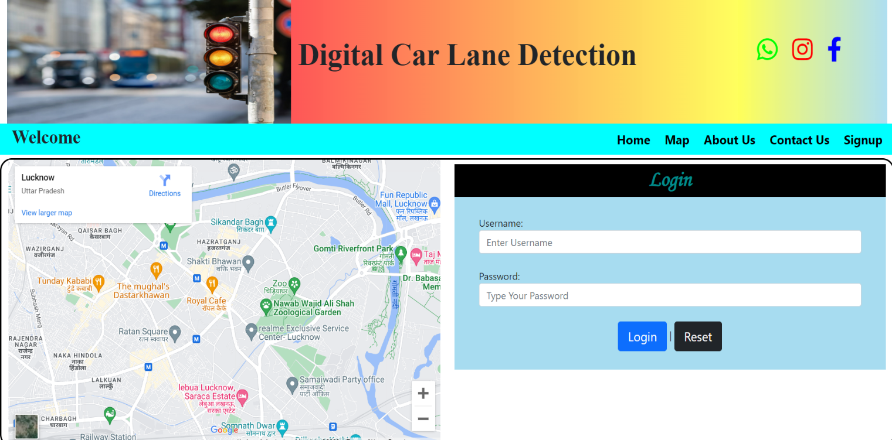

# WORKFLOW

# The following list of essential phases is a typical process for car lane detection:

* Acquisition of Input
* Preprocessing
* Extraction of Lane Marking
* Selection of the region of interest (ROI)
* Fitting the Lane Model
* Lane Monitoring
* Classification of lanes
* Visualisation of output

It is significant to note that depending on the lane detection strategy being utilised, such as conventional computer vision methods or deep learning-based approaches, the particular algorithms, methodologies, and parameters used in each phase might change. The workflow and algorithm selection may also be impacted by real-time implementation issues and hardware limitations.

# PROPOSED SYSTEM

Computer vision techniques are used in automobile lane recognition to precisely find and follow lane markers on the road.

* Data input acquisition
* Preprocessing
* Lane Delineation Extraction
* Estimation of the Lane Model
* Tracking lanes and stability
* Lane Leaving Alert or command
* Output visualisation

In order to increase vehicle safety, driver assistance, and autonomous driving capabilities, the system intends to deliver reliable and robust lane detecting capabilities. It uses mathematical models, image processing algorithms, and computer vision techniques to recognise and follow lane lines in real-time situations.

# IV. ANALYSIS

# Advanced driver assistance systems and intelligent transportation systems both depend on accurate car lane detection. It has a number of benefits and affects many elements of driving and vehicle safety. Here are some crucial analytical considerations for detecting automobile lanes:

* Improved Auto Safety
* Assisted Driving
* Optimisation of Traffic Flow
* Driver Support Technologies
* Environmental Awareness
* Limitations and Challenges

Car lane identification greatly improves automobile safety, helps with autonomous driving, improves traffic flow, and supports driver assistance systems. It makes it possible for cars to stay in their lanes, provide lane departure alerts, and improves general road safety. Despite obstacles, continued research and improvements in sensor and computer vision technologies are enhancing the precision, durability, and usability of automobile lane detecting systems.

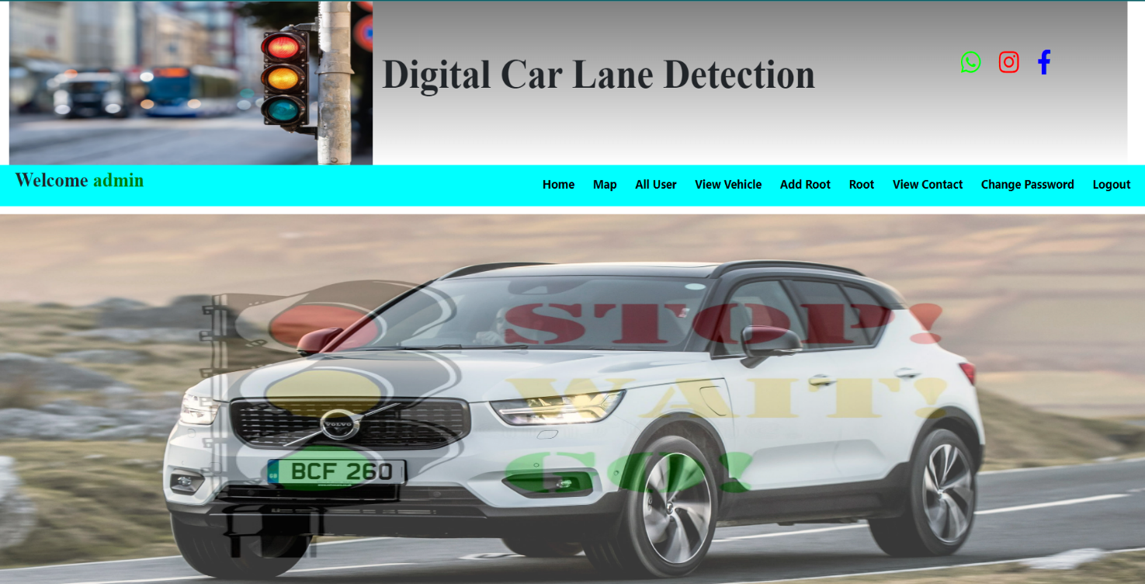

# V. CONCLUSION

In order to improve vehicle safety, enable autonomous driving, improve traffic flow, and support driver assistance systems, it is essential to have automobile lane detecting technology. It offers precise lane marker recognition and tracking, assisting drivers in staying in their allotted lanes and reducing accidents brought on by lane exits. Car lane recognition systems have the power to transform the way we travel by enhancing road safety, easing traffic, and promoting more economical and environmentally friendly driving habits. Car lane detection systems are becoming more precise and reliable because to ongoing developments in computer vision, deep learning, and sensor technology.

# VI. FUTURE WORK

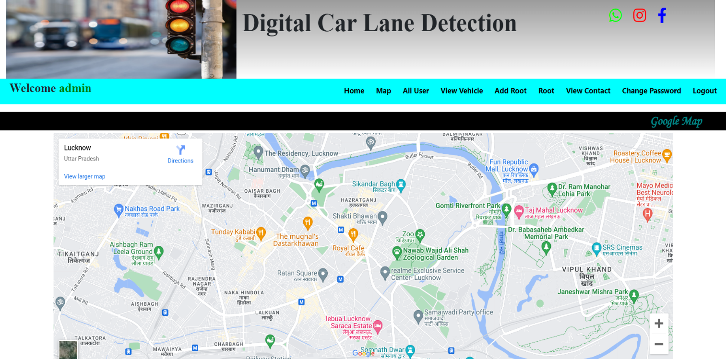There are a lot of intriguing possibilities in the far future for automobile lane detection. Significant advancements in the subject will be made possible by breakthroughs in technology and research. First off, powerful deep learning methods designed exclusively for automobile lane recognition have a bright future. To increase accuracy and resilience, more complex structures like recurrent neural networks (RNNs) or attention processes might be investigated. Additionally, lane detecting systems will be improved significantly by multi-modal sensor fusion. Accuracy and dependability will be improved, especially in difficult conditions, by integrating data from cameras, LiDAR, radar, and IMUs. Another area of attention is real-time implementation, where hardware acceleration and algorithm optimisation will enable higher processing rates and guarantee real-time performance on embedded devices. Another crucial factor is robustness in challenging circumstances. The goal of future research is to create algorithms that are more resistant to bad weather and obstructions brought on by other cars or road infrastructure. Additionally, there is a chance for semantic lane comprehension, which goes beyond lane recognition to identify various lane kinds and road markers, improving situational awareness. Integration with Vehicle-to-Everything (V2X) technology shows potential for exchanging lane information across cars for enhanced accuracy and dependability in cooperative lane recognition. Lane detection systems will be able to adapt to changing road conditions and new lane marking patterns thanks to continuous learning and adaptation procedures. The development of intelligent transportation systems, safer and more effective driving experiences, and improved autonomous driving capabilities all lie in the exciting future of automobile lane detection.

# ACKNOWLEDGEMENT

We would want to express our gratitude to our friends, family, teachers, and other staff at Shri Ramswaroop Memorial College of Engineering and Management for supporting and mentoring me. A particular thank you to my instructor for proposing the best and most appropriate course of action.

We would like to first and foremost convey our sincere thanks to my mentor, Dr. Santosh Kr. Dwivedi, for his essential leadership, mentorship, and support during this research effort. Our research's direction and technique have been greatly influenced by their knowledge and ideas.

Last but not least, we want to express our gratitude to our family, friends, and other loved ones for their unfailing help, compassion, and inspiration during this research trip. Their unwavering faith in us has been the source of our inspiration and tenacity.

Although it is hard to thank everyone who has helped in any manner, we sincerely appreciate all of the assistance.

# VII. REFERENCES

1. Real-time lane identification for autonomous driving using a deep learning technique was published in 2017 in Sensors, vol. 17, no. 7, p. 1496 by C. Kim, J. Kim, and S. Lee.
2. Y. Hou, Z. Ma, and C. Liu, "Real-time lane detection algorithm based on edge detection and RANSAC method," in 36th Chinese Control Conference (CCC), 2017, pp. 1697–1701.
3. The article "Lane detection using deep learning and geometrical constraints," published in Proceedings of the IEEE Conference on Computer Vision and Pattern Recognition (CVPR), 2017, pp. 197–205. T. Zhang, T. Xia, and B. Li.
4. Real-time lane recognition using deep learning and SIFT, 2018 International Conference on Networking and Network Applications (NaNA), M. Li, H. Qi, J. Chen, and X. Shen.
5. IEEE Transactions on Intelligent Transportation Systems, volume 20, issue 10, pages 3837–3853, Huang.IEEE Transactions on Intelligent Transportation Systems, vol. 20, no. 10, 2019, pp. 3837–3853, "A review on lane detection and tracking algorithms for intelligent transportation systems," by D. Lin and J. Huang.
6. Y. Zhang, S. Li, Q. Cheng, and H. Yang, "A review of vision-based lane detection methods," Sensors, vol. 20, no. 7, p. 2081, 2020.