**Mouse Cursor Movement Control Using Facial gesture Movements using ML Technique**

**Kadu Rohan1, Chavan Ritesh 2, Saindanshiv Pravin3, Sasane Rupali4,Mrs. Lingampalli P.V.**

Student, Department of Computer Engineering, RGCOE, Ahmednagar, India1-4

Assistant Prof, Department of Computer Engineering, RGCOE, Ahmednagar, India5

ABSTRACT

Our dependence on computers for the majority of our work has made them an indispensable component of our life. However, optimizing computer functionality and making them easier to use is a field that is constantly under development. Dealing Human-Machine interaction is necessary for effective computer control. The PC mouse was a ground-breaking invention in the area of communication, which is a crucial step. The closest thing we have to a touch-free control right now is a Bluetooth mouse, which is still technically not free of devices since it links to the PC via USB. The suggested system provides a cursor control method for computers that use an external or built-in camera, which helps to overcome this limitation.

**Keywords:** Head Gesture, OpenCV, Mouse Control, GUI Control, Face Movement.

I. INTRODUCTION

One of the key pieces of equipment for people with physical disabilities is the face detection-based mouse movement. The computer can be informed of a specific task by head movement. Understanding allows impaired persons to communicate with others via computers, allowing them to alert others to their critical needs. In this project, a tool has been created to assist those who can only move their head but have no control over their hands. This work employs Haar-like feature extraction on the OpenCV platform to identify faces. Face detection algorithm classifies both faces and non-faces as faces. Therefore, the face detection algorithm has been improved in order to decrease the false positive results. After identifying faces, a mouse movement has been controlled with the coordinate of face movement.

In the field of gesture recognition, computers use mathematical algorithms to decipher and comprehend human motions. It relates to computer vision. With a focus on facial expressions and hand gestures, gesture recognition uses mathematical algorithms to analyse and comprehend human body motions and expressions. These expressions of emotion can be recognised by this technology, which also enables users to interact with or control objects with simple movements without actually touching them. Gesture recognition include not just deciphering sign language but also recognizing body posture, walking patterns, personal space, and human behavior. This technology can make the interface between people and machines more natural and intuitive than

current methods by reading body language. The field of human-machine interaction is constantly developing and being worked on in an effort to lessen the users' cognitive and physical exertion while also giving machines intelligence. One such tool that gives the user a lot of power to complete all the activities they want their computers to carry out is the PC mouse. It has significantly changed over time as a result of the advancement of Bluetooth and wireless technologies. However, they continue to require batteries and other connecting tools. This study suggests a computer vision-based virtual mouse system that is genuinely touch-free and operates on the idea of hand motion detection for carrying out PC mouse duties.

II. LITERATURE REVIEW

Karan Kharbanda el. et. author system's goal is to replace the computer mouse by allowing users to use it with hand gestures. With the use of an external or built-in webcam that processes a live video feed and recognises hand gestures to carry out specified mouse actions, this model can be realised. Our suggested solution has a wide range of applications and an accuracy of >90%, which is significantly higher than that of existing systems. According to testing findings, the suggested AI virtual mouse system outperforms existing models in terms of performance and accuracy while also addressing most of their drawbacks. The proposed model can be used in real life because it is more accurate[1].

Reajul Haque Reayz el.et. in this system author has been created for the system to control the mouse using the real-time camera, which detects the face and performs several actions such cursor movement, left, right, and double click. The system was created using algorithms for computer vision. The system will operate effectively if the computer vision algorithms perform well in all environments. However, variable lighting conditions and skin tones of different human races provide challenges for face detection systems. In the future, scientists will be able to identify eyeballs on faces and utilise those eyes to control mice[2].

PAVITHRA el.et. By putting this approach into practise, we can draw the conclusion that the cursor can be moved without the need of hands by changing face expressions and eye movements. For those who are incapacitated or have lost limbs, being able to control the cursor with their eyes alone instead of needing a partner is helpful. This technology can be improved in the future by creating, changing, or developing other approaches such clicking events and human computer interfaces that employ eye movement and blinking to control the cursor. Technology advanced to include this eye tracking method to obtain the precise and effective movement [3].

Madan Venkat Sai P el.et authors project's main goal was to improve how machines interact with and react to human behavior. The essay concentrated on developing technology that is lightweight, affordable, and functional with any typical operating system. By taking a picture of a person's face and figuring out where their eyes and nose are located, the suggested system tries to control the mouse cursor. The pointer will follow the head's movement in the same direction. The system will manage standard mouse operations including scrolling, left- and right-clicking, and all-around movement. Opening the mouth causes the system to activate the cursor, and looking at the head causes it to move. The clicking actions are carried out by giving the eyes winks. The left eye is used to wink when clicking left, while the right eye is used to wink when clicking right. Squinting the eyes can be used to either activate or disable scrolling [4].

Venuu madhav R el.et. Author mainly focus to analysis of how mouse cursor movements were developed using the human face, eyes, and application in all aspects. The purpose of our system is to control mouse movements and events hands-free using facial expressions, eye blinks, and speech. Additionally, our technology is able to produce the desired results. The problem domain was first determined, and then similar commercial items were compared and contrasted by analysing their strengths and weaknesses. The system is incredibly user-friendly, especially when used with desktop programmes. It has accuracy and speed that are enough for many real-time applications and that enable disabled persons to participate in a variety of computing tasks[5].

III PROBLEM IDENTIFICATION

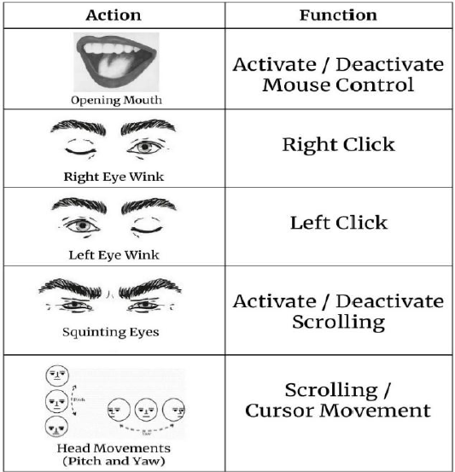Our daily lives now revolve around computers, which are utilized for everything from business to amusement. Unfortunately, using a computer can be quite difficult for those who have physical limitations. Researchers have created assistive devices that allow users to operate a cursor using facial expressions to improve greater accessibility. The ability to use this technology could be of tremendous assistance to those who are disabled or handicapped and are unable to use conventional input devices. . Although systems for controlling the cursor using hand gestures and using the pupil of the eye already exist [12, 13], they have limitations and are unable to carry out common mouse functions including minimizing, dragging, scrolling up and down, left-clicking and right-clicking. The primary goal of our suggested methodology in this system is to provide a way for controlling the computer mouse cursor through face motions rather than physical manipulation.

This method eliminates the need for wearable devices Fig.1.1 tasks and their respective purposes or sensors because the system may be used with a laptop's built-in camera or a conventional webcam to work. The user's options include opening their mouth to activate programmers, squinting their eyes to activate and deactivate scroll mode, and winking one eye to click events. Additionally, the user has the ability to steer the pointer in the desired direction by just changing the angle and motion of their face.

IV-SYSTEM METHODOLOGY.

According to the diagram, the method entails employing a Face Detection Model to capture a face image from a video stream coming from a camera or webcam. The Landmark Detection Model is then used to extract numerous elements from the collected face image, such as the mouth, left and right eyes, and other facial qualities. The motions of the head, which correlate to the movement of the computer mouse cursor, are then determined using the Head Pose Estimation Model

V CONCLUSION

With an emphasis on tracking head movement as the main event for cursor movement, our research's goal is to improve the operation of our programme. Faster pointer movements are intended to completely replace conventional mouse activities. Furthermore, we want to include advanced functionality like dragging, zooming in and out, voice recognition, text extraction for typing, and more. According to this concept, an interface will be created that may be used in practical applications, notably to help physically disabled persons operate a PC or laptop using their facial expressions and movement without the aid of others. This study intends to enable people with impairments to pursue their technological ambitions and lessen their reliance on for computer operation.

V-REFERENCES:

[1].Karan Kharbanda, Utsav Sachdeva” GESTURE CONTROLLED VIRTUAL MOUSE USING ARTIFICIAL INTELLIGENC” Volume: 05/Issue: 01/January-2023

e-ISSN: 2582-5208.

[2]. Reajul Haque Reayz, Prashanta Kumar Dey, Md Kamal Hossain Chowdhury, Mahmudul Hasan”GUI Control with Head Gesture” IJRTE ISSN: 2277-3878, Volume-8 Issue-3, September 2019.

[3] PAVITHRA ,RAKSHITHA , RAMYA , VIKAS REDDY Cursor Movement Control Using Eyes and Facial Movements for Physically Challenged People. Volume: 08 Issue: 07 | July 2021

[4] Madan Venkat Sai P, Harish Reddy N, Akshay S, 4.Tarun Sai K,Rajamani P Facial-Expression Based Mouse Cursor Control for Physically Challenged Individuals: A Human Computer Interaction (HCI) Approach. e-ISSN: 2395-0056, Volume: 10 Issue: 04 | Apr 2023.

[5]. Venuu madhav R, Anirudh parlapalli”Cursor tracking by sensory organs for handicapped people” ISSN: 2454-132X (Volume 5, Issue 6) © 2019, www.IJARIIT.com