**SMART HEALTH DISEASE PREDICTION**

**Achal Telmasre , Gayatri Sathawane , Aakansha Dahekar , Aarati Jagtap**

Dept. of Computer Science & Engg., Tulsiramji Gaikwad-Patil College of Engineering & Technology, Nagpur

**Abstract-** It might have happened so many times that you or someone yours need doctors help immediately, but they are not available due to some reason. The Health Prediction system is an end user support and online consultation project. Here we propose a system that allows users to get instant guidance on their health issues through an intelligent health care system online. The system is fed with various symptoms and the disease/illness associated with those systems. The system allows user to share their symptoms and issues. It then processes user’s symptoms to check for various illnesses that could be associated with it. Here we use some intelligent data mining techniques to guess the most accurate illness that could be associated with patient’s symptoms.

# INTRODUCTION

The Health Prediction system is an end user support and online consultation project. Here we propose a system that allows users to get instant guidance on their health issues through an intelligent health care system online. The system is fed with various symptoms and the disease/illness associated with those systems. The system allows user to share their symptoms and issues. It then processes user’s symptoms to check for various illnesses that could be associated with it.

In doctor module when doctor login to the system doctor can view his patient details and the report of that patient. Doctor can view details about the patient search what patient searched for according to their prediction. Doctor can view his personal details. Admin can add new disease details by specifying the type and symptoms of the disease into the database.

Based on the name of the disease and symptom the data mining algorithm works.

# EXISTING SYSTEM

Throughout this day and age, new technologies have been created and developed to improve people’s daily life and routine especially for health care. Doctors and nurses were now guided by smart health prediction system on the Throughout this day and age, new technologies have been created and developed to improve people’s daily life and routine especially for health care. Doctors and nurses were now guided by smart health prediction system on the purpose of storing medical information that may be used for research and diagnosis. Few years ago, doctors were expected to use their own intuition and experience to

handle every medical situation that different patients are facing every day.

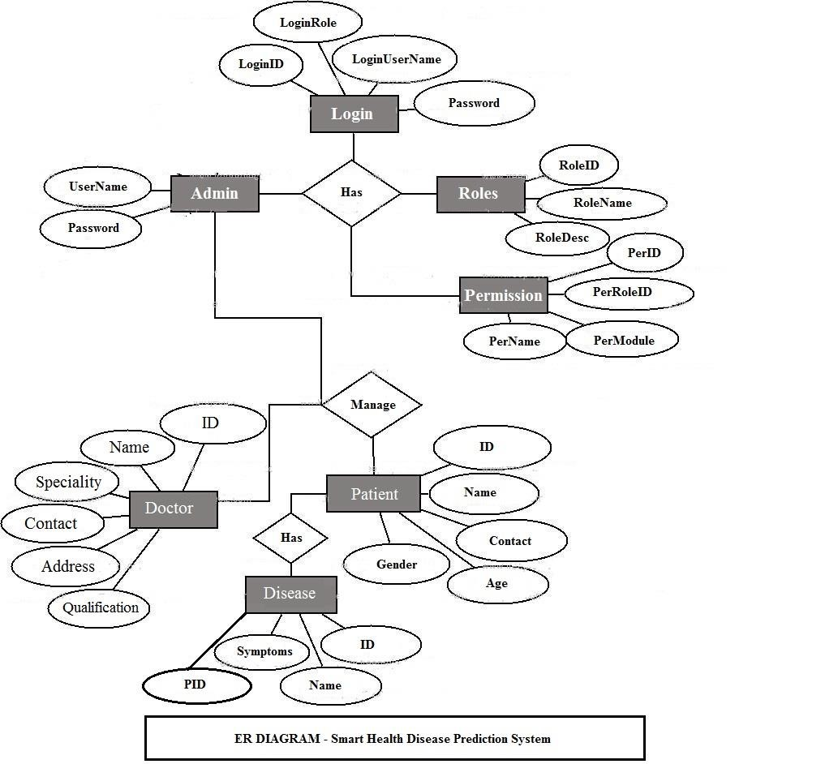

# PROPOSED SYSTEM

To beat the downside of existing framework we have created smart health disease prediction System. We have built up a specialist framework called Smart Health Prediction framework, which is utilized for improving the task of specialists. A framework checks a patient at initial level and proposes the possible diseases. It begins with getting some information about manifestations to the patient, in the event that the framework can distinguish the fitting sickness, at that point it proposes a specialist accessible to the patient in the closest conceivable territory.

On the off chance that the framework isn't sufficiently sure, it asks few questions to the patients, still on the off chance that the framework isn't sure; at that point it will show a few tests to the patient. In light of accessible total data, the framework will demonstrate the result. Here we utilize some intelligent methods to figure the most precise disorder that could be associated with patient's appearances and dependent on the database of a couple of patients restorative record, calculation (Naïve Bayes) is connected for mapping the side effects with conceivable diseases.This framework improves undertaking of the specialists as well as helps the patients by giving vital help at a soonest organize conceivable.

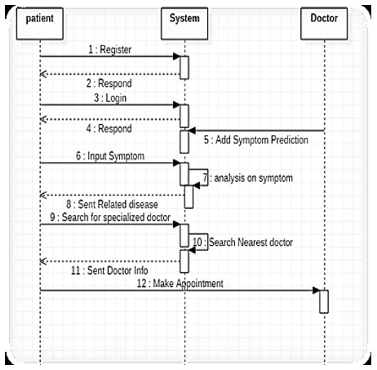

# REQUIREMENT

**Python & IDEs**: Python is a widely used general-purpose, high level programming language. It was initially designed by Guido van Rossum in 1991 and developed by Python Software Foundation. It was mainly developed for emphasis on code readability, and its syntax allows programmers to express concepts in fewer lines of code.

**HTML**: HTML (Hypertext Markup Language) is the set of markup symbols or codes inserted in a file intended for display on a World Wide Web browser page. The markup tells the Web browser how to display a Web page's words and images for the user. Each individual markup code is referred to as an element (but many people also refer to it as a tag).

**Design Framework (CSS)**: Cascading Style Sheets (CSS) are a collection of rules we use to define and modify web pages. CSS are similar to styles in Word. CSS allow Web designers to have much more control over their pages look and layout.

**Javascript:** JavaScript is a programming languagecommonly used in web development. It was originally developed by Netscape as a means to add

, the syntax is more similar to C and is based on ECMAScript, a scripting language developed by Sun

Microsystems.

**Django:** Django is a web application framework written in Python programming language. It is based on MVT (Model View Template) design pattern. The Django is very demanding due to its rapid development feature. It takes less time to build application after collecting client requirement.

**Machine Learning:** Machine learning is a growing technology which enables computers to learn automatically from past data. Machine learning uses various algorithms for building mathematical models and making predictions using historical data or information.

# CONCLUSION

It has been a great pleasure for me to work on this exciting and challenging project. This project proved good for me as it provided practical knowledge of not only programming in Python and Sqlite web based application. It also provides knowledge about the latest technology used in developing web enabled application and client server technology that will be great demand in future. This will provide better opportunities and guidance in future in developing projects independently. Currently, it is being used for various tasks such as image recognition, speech recognition, email filtering, Facebook autotagging, recommender system, and many more.

# REFERENCES

1. S. M. Metev and V. P. Veiko, *Laser Assisted Microtechnology*, 2nd ed., R. M. Osgood, Jr., Ed. Berlin, Germany: Springer-Verlag, 1998.
2. J. Breckling, Ed., *The Analysis of Directional Time Series: Applications to Wind Speed and Direction*, ser. Lecture Notes inStatistics. Berlin, Germany: Springer, 1989, vol. 61.
3. S. Zhang, C. Zhu, J. K. O. Sin, and P. K. T. Mok, “A novel ultrathin elevated channel low-temperature poly-Si TFT,” *IEEE Electron Device Lett.*, vol. 20, pp. 569–571, Nov. 1999.
4. M. Wegmuller, J. P. von der Weid, P. Oberson, and N. Gisin, “High resolution fiber distributed measurements with coherent OFDR,” in *Proc. ECOC’00*, 2000, paper 11.3.4, p. 109.
5. R. E. Sorace, V. S. Reinhardt, and S. A. Vaughn, “High-speed digital-to-RF converter,” U.S. Patent 5 668 842, Sept. 16, 1997.
6. (2002) The IEEE website. [Online]. Available: http://www.ieee.org/
7. M. Shell. (2002) IEEEtran homepage on CTAN. [Online]. Available: http://www.ctan.org/tex-archive/macros/latex/contrib/supported/IEEEtran/
8. *FLEXChip Signal Processor (MC68175/D)*, Motorola, 1996.
9. “PDCA12-70 data sheet,” Opto Speed SA, Mezzovico, Switzerland.
10. A. Karnik, “Performance of TCP congestion control with rate feedback: TCP/ABR and rate adaptive TCP/IP,” M. Eng. thesis, Indian

⬇⬇⬇