STOCK;MARKET,ANALYSIS .

AND,PREDICTION

**Vaibhav Rastogi*1, Dr. Santosh Kr. Dwivedi *2,**

**Mr. Raghvendra Singh *3 Mr. Shadab Ali *4**

*1UG Student of BCA, Shri.Ramswaroop.Memorial.College/Of Engineering .And/Management

Lucknow, Uttar Pradesh, India.

*2Professor, Head of Department of BCA , Shri,Ramswaroop,Memorial ;College Of Management’Lucknow, Uttar Pradesh, India.

*3Assistant professor, Department of BCA, Shri’Ramswaroop[Memorial,College.Of

Management;Lucknow, Uttar Pradesh, India.

*4Assistant professor, Department of BCA, Shri Ramswaroop Memorial College of Management

Lucknow, Uttar Pradesh, India.

# ABSTRACT

Understanding and predicting the behaviour of stock prices and market trends are the main goals of the subject of study known as "stock market analysis and prediction." By analysing historical data, market indicators, and a variety of quantitative and qualitative criteria, it is possible to spot patterns and anticipate future price movements with accuracy.

To help investors, traders, and financial professionals make educated decisions about buying,;selling,.and,holding stocks is the main objective of stock.market.analysis and forecasting. Individuals and organisations try to obtain a competitive edge and increase.their,profits,by studying market data and using different analytical approaches.

# INTRODUCTION

Welcome to the thrilling world of stock’market;forecasting and research! The stock,market.is a volatile and complicated environment in which investors attempt to capitalise on opportunities and make lucrative trading decisions. The goal of this project is to dig into the domain of stock,market,analysis;and/prediction, studying various tools and procedures that can assist us in gaining insights into stock behaviour. We can try to find patterns and trends in historical data, statistical models, and machine learning algorithms in order to make more accurate forecasts about future market movements.

A variety of variables impact the stock market, including economic statistics, corporate performance, industry trends, investor attitude, and worldwide events. Analysing and comprehending these characteristics may offer investors and traders with useful information, helping them to make better educated decisions and manage their portfolios more successfully.

While it is important to emphasise that 100% precision in predicting the. Stock,market. is unachievable, the purpose of this research is to establish a framework that improves our understanding of market dynamics and our capacity to make educated investing decisions. We want to find possible patterns, correlations, and indications that can help us anticipate market behaviour by using rigorous research and experimenting with various methodologies.

Throughout this project, we will explore different approaches to stock.market,analysis;and.prediction, including fundamental analysis, technical analysis, and quantitative analysis. We will examine key indicators, study historical data, and employ statistical models to uncover potential signals and trends that may impact stock prices.

# WORKFLOW

Performing stock.market,analysis;and’prediction is a complex task that requires a systematic workflow. Here's a general outline of a workflow for a stock.market .analysis, and,,prediction project:

* Define the Problem
* Gather Data
* Data Preprocessing
* Feature Engineering
* Exploratory,Data,Analysis,(.EDA,)
* Model Selection
* Integration with Accounting System
* Prediction and Interpretation
* Portfolio Management

It's important to note that stock,market.analysis and prediction can be highly challenging and uncertain, as the stock/market is influenced by numerous factors, including economic conditions, geopolitical events, and investor sentiment. Therefore, it's essential to maintain a realistic understanding of the limitations and potential risks associated with any stock market predictions.

# PROPOSED SYSTEM

The proposed stock.market,analysis and prediction system aims to increase your knowledge of the dynamics, underlying principles, and influencing aspects of the stock market. We want to improve our expertise and understanding of how the market functions by investigating various analysis approaches and procedures.

A further objective is to investigate and assess various methods of stock market analysis and forecasting. We will examine the advantages, disadvantages, and suitability of fundamental, technical, and quantitative analysis in various market contexts. By doing this, we hope to diversify our tool-set and get a comprehensive grasp of the numerous analytical techniques that are accessible

# ANALYSIS

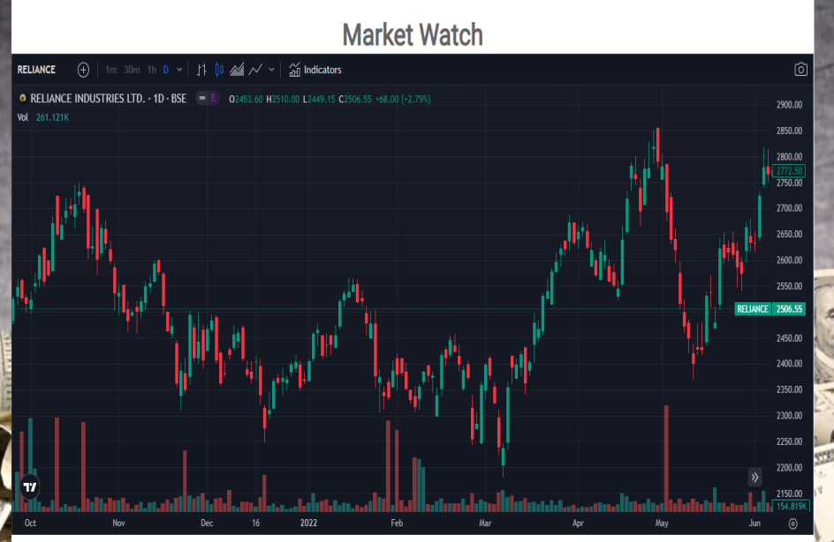Remember that stock.market,analysis and prediction is a complex and highly volatile field, and accurate predictions are challenging. It's essential to stay updated with the latest market news, regulatory changes, and economic developments that can impact stock prices. Additionally, be aware of the limitations of your models and understand that past performance is not indicative of future results:

Figure 1:Analysis

Continuously monitoring of the performance of your models and update them as new data becomes available. Adapt your strategies based on changing,market.conditions and refine your models to improve their accuracy. The following are the issues with the real system that the majority of people utilise:

1. Since there is a lot of rewriting to be done, it is difficult to keep much detail.
2. Searching and referencing is difficult and time-consuming.
3. Analysis and comparison of data become difficult.
4. Report generation is a tedious process.
5. The work being done is not accurate.

Investors may use stock market research and forecasting to make well-informed choices about buying,[selling,-and holding;stocks. Investors may spot potentially lucrative investment possibilities or stay away from high-risk ventures by examining the financial health, industry trends, and market circumstances.The main purpose of this tool is to:

* + Collect relevant historical data for the stocks or markets you want to analyze. This data can include stock prices, trading volumes, financial statements, economic indicators, and news sentiment data;
  + Cleanse and prepare the collected data for analysis. This involves handling missing values, removing outliers, normalizing data, and formatting it into a suitable structure for analysis.

# SYSTEM OVERVIEW

Building a system that uses data and analytical methods to give insights and forecasts for investment choices is the goal of a stock.market,analysis;and,prediction project. The system starts with data collecting, where pertinent information is obtained from numerous sources, including past stock prices, financial statements, economic indicators, and news sentiment data. Preprocessing is then applied to the obtained data to guarantee its accuracy and appropriateness for analysis. Fundamental,analysis;is.used.to assess the inherent value of equities by looking at financial statements, market circumstances, and industry trends. In order to spot patterns and trends in historical price and volume data, technical analysis methods are used. From the data, features such as sentiment ratings, financial ratios, and technical indications are retrieved. Predictive models are created using machine learning algorithms and based on extracted characteristics and historical data. With the help of the proper procedures, these models are trained and verified so that their resilience and accuracy can be evaluated. Investment choices are further honed by combining trading strategies, risk management procedures, and portfolio optimisation approaches based on the forecasts and trade signals produced by the models. The system is continually monitored, enabling performance assessment, model improvement, and market situation adaptability. Reports, dashboards, and visualisations are used to show the results of the research and forecasts, giving users useful performance measures to direct their investment plans

# CONCLUSION

To summarize, a project that integrates data collecting, preprocessing, fundamental analysis, technical analysis, feature extraction, model construction, and performance monitoring is called a stock;market,analysis;and prediction;project. The project intends to provide insights and forecasts for investment decision-making by using historical data, financial records, market indicators, and sentiment research. The system aids in locating prospective trading opportunities, controlling risks, and optimising portfolio allocation via the use of machine learning algorithms and predictive models. But it's vital to keep in mind that stock market research and forecasting entail inherent uncertainties, and precise forecasting is difficult since financial markets are dynamic. However, the project may provide useful insights and improve decision-making for investors and traders by regularly monitoring and improving the models, including risk management measures, and remaining up to current with market circumstances.

# FUTURE WORK

In prospective work for a stock;market;analysis.and;prediction endeavour, there are several areas that can be investigated to enhance the system's capabilities and performance. Firstly, incorporating alternative data sources and utilizing natural language processing techniques to analyze news articles, social media sentiment, and corporate announcements can provide a deeper understanding of market sentiment and enhance predictive models. Additionally, investigating sophisticated machine learning algorithms, such as recurrent;neural;networks (;RNNs;) or convolutional neural networks (CNNs), can capture more complex patterns and dependencies in the data, potentially leading to enhanced predictions.

Furthermore, integrating real-time data inputs and implementing a dynamic and adaptive system that can rapidly respond to altering market conditions would be beneficial. Exploring sophisticated techniques like reinforcement learning can help develop trading strategies that adapt to evolving market dynamics. Furthermore, collaborating with domain experts and incorporating their insights can provide valuable domain-specific knowledge and increase the accuracy of predictions. Finally, contemplating the,ethical;implications’.of utilizing predictive models in financial markets and addressing issues like bias and impartiality in the analysis and decision-making process should be given due attention. Future work in these areas can contribute to advancing the field of.stock.market. Analysis,.and;prediction and lead to more robust and reliable systems.

# ACKNOWLEDGEMENT

I owe a great deal of gratitude to my mentor Mr. Raghuvendra Singh for his advice and for making the project clear to me in a manner that allowed me to accomplish it quickly and successfully.

I would want to/extend;my,appreciation.to all of the academic members of the SRMCM who have been very supportive of the creation of this project. I'd want.to.,express,my/gratitude,to everyone of my friends for their suggestions and inspiration while I worked on this project.

I am most appreciative to my parents and to God, without whom nothing is possible..

# REFERENCES

**Books**

* "Stock Learning: A common sense Guide" by Linda Susie.
* "The Power of Stocks: The Essential Guide for Buying and Selling stocks" by Shirley Caruso
* "Stocks analysis with Technology: Beyond Constructivism" by Carl F. Berger and Michelle D. Johnston

**Website**

* •https://www.stockprediction.edu/
* https://nces.ed.gov/
* •https://www.aalhe.org/
* https://onlinestocklearningconsortium.org/7