**BANK LOCKER**

**Srishti Nigam *1, Dr. Santosh Kr. Dwivedi *2, Mr .Raghvendra Singh**

**\*3 Mr . Shadab Ali**

*1UG Student of Department of Bachelor of Computer Application, Shri Ramswaroop Memorial College of Management Lucknow, Uttar Pradesh, India.

*2Professor, Head of Department of Bachelor of Computer Application, Shri Ramswaroop Memorial College Of Management Lucknow, Uttar Pradesh, India.

*3Assistant professor, Department of Bachelor of Computer Application, Shri Ramswaroop Memorial College Of Management Lucknow, Uttar Pradesh, India.

# ABSTRACT

This study looks at the problems with security and access control in bank locker systems and offers innovative solutions to increase their effectiveness. For financial institutions and their clients, the security of bank vaults is of the utmost importance because they are necessary for safeguarding valuable assets. Case studies, experiments, and simulations are included in the research report to validate the offered solutions and evaluate their effectiveness. Real-world data and user feedback are considered to assess whether the proposed enhancements are practicable and have any implications. The investigation begins by carefully analysing the advantages, disadvantages, and vulnerabilities of the existing bank locker systems. The study examines a number of security issues, including physical break-ins, unauthorised access, technology breaches, and insider threats in order to understand the shifting risks faced by banks and their clients.

# INTRODUCTION

With the completion of this project, the antiquated method of managing lockers will be replaced with a modern, efficient, and secure web-based platform. By harnessing the power of the web and applying new technologies, the project seeks to improve operations, raise customer satisfaction, and increase the overall security and dependability of bank locker management. The idea of a bank locker was developed to give account holders ways to deposit money in the bank. Using this technology, the service request procedure for the various bank facilities may be automated. In the past, managing the services in banks was a laborious and inefficient process. The earlier systems were created using outdated methods, the majority of which have been abandoned in favour of the new ones. The increase in their workload has led to the development of numerous software programmes. The Bank Locker's requirements were also taken into consideration when developing this project, which included automating record-keeping procedures and storing data in the form of a sizable, user-friendly database to make accessing it even simpler for personnel.

# WORKFLOW

In order to effectively record and manage user or customer details, a bank locker usually comprises multiple processes. Here is a recommended workflow for a bank safe:

# Admin

# Access to locker

# Manager

# Locker

# Account Holder

# Contact to customer

It's vital to keep in mind that the specific workflow and steps may change depending on the policies of the organisation, the software utilised, and the reporting needs. The process must be altered to meet your requirements and satisfy each customer's particular needs for bank locker to operate well.

# PROPOSED SYSTEM

The goal of the suggested research study is to develop and put into use a secure bank locker system to increase the convenience and protection of customers' priceless belongings. The solution has strong security safeguards, effective locker allocation management, and smooth user experience. The system's architecture, essential features, security measures, and a thorough assessment of the system's usability and performance are all included in this study report. Describe the importance of bank locker systems in maintaining the safety of clients' belongings. Describe the purpose of the study and emphasize the demand for a better bank locker system. Investigate pertinent academic articles, trade guidelines, and industry best practices in the area of secure storage systems. Describe the main features of the system, such as transaction logging, locker distribution, and customer registration. For both bank employees and consumers, describe the user interface design and its usability considerations .Determine the system's resistance to common security risks and weaknesses and suggest mitigating measures.

# IV. SYSTEM OVERVIEW

The goal of the research study is to improve the security and convenience of customers' important assets through the design and implementation of a secure bank locker system. The system includes effective locker administration, strong security features, and user-friendly interfaces for bank employees and consumers.Frontend, backend, and database components make up the proposed system design. The main features are transaction tracking, access controls, locker distribution, and client registration. To safeguard customer assets and data, the system uses strong security mechanisms like authentication, access limits, and encryption.Usability was taken into consideration when designing the user interfaces, guaranteeing a simple and straightforward experience for both bank employees and clients. Real-time notifications, self-service locker reservations, and remote access capabilities are just a few of the features offered by the system

Overall, the research paper presents a comprehensive overview of the proposed bank locker system, its functionalities, security measures, and potential impact on customer satisfaction and asset security.

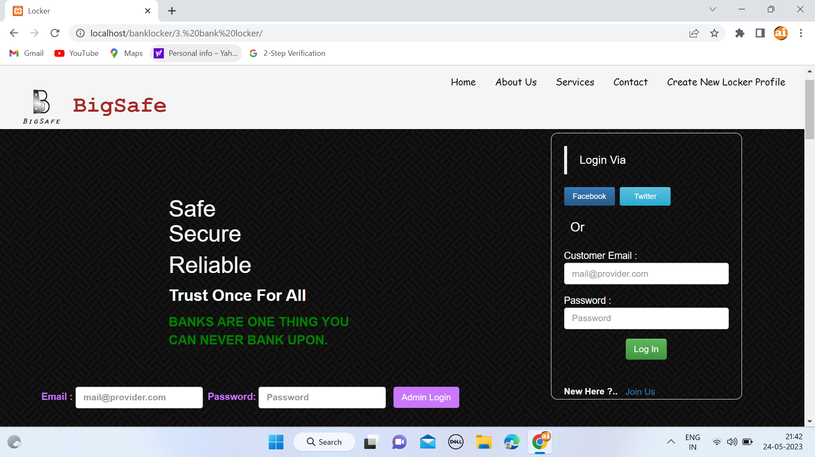

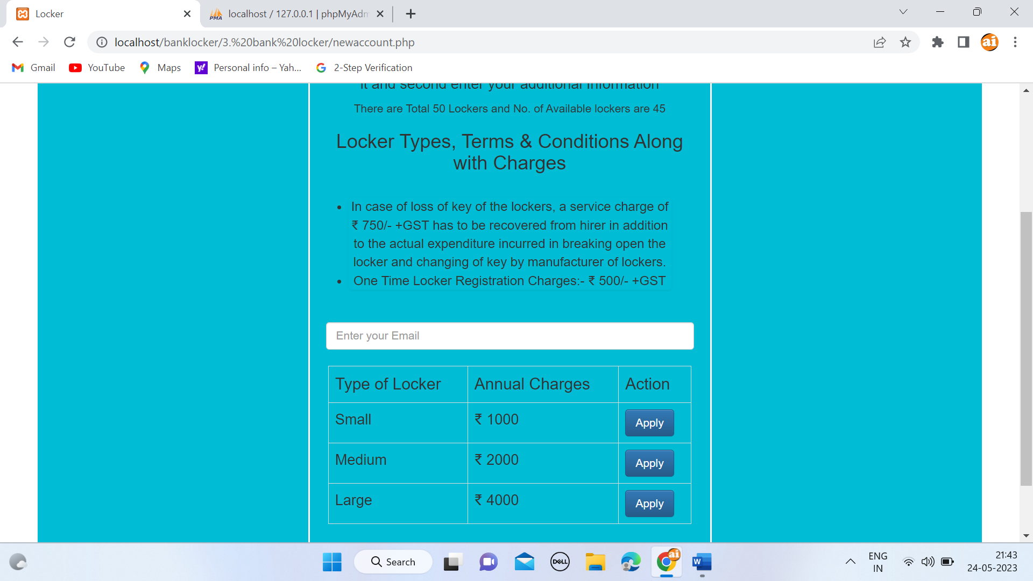

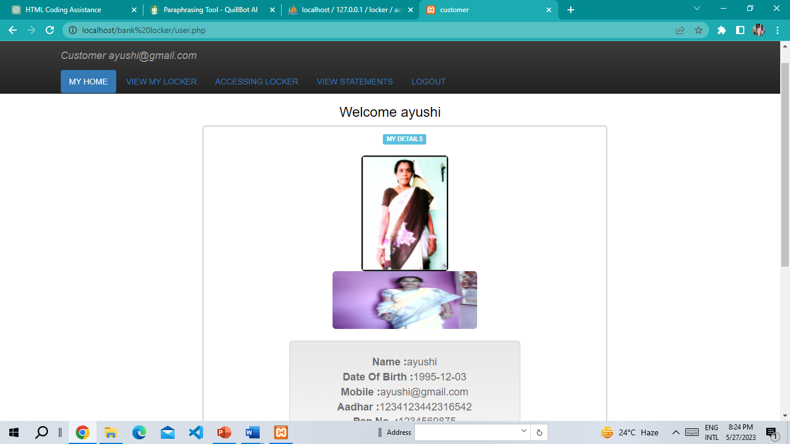

# V. ANALYSIS

The usefulness, significance, and prospective effects of the suggested bank locker system can be better understood by completing a thorough study of the paper's many components. To analysis the Bank Locker Project; Let Consider Several key Aspects:

Analyse the problem's significance and effects on clients' asset security and overall banking experiences. the importance of the research in addressing the found gap in a concise manner.

System Architecture Analysis: Assess the scalability, flexibility, and modularity of the proposed system architecture.Examine whether the architecture you've chosen can handle the demands of a bank locker system.

Key Features: A thorough explanation of each feature's primary functions as they relate to the bank locker system. the process for allocating lockers to clients, maintaining efficiency and fairness.Talk about the authentication and access control procedures involved in gaining access to the designated lockers.

Present both bank employees and consumers with the user interfaces for the bank locker system.Give examples of the user interfaces and their features using screenshots or wireframes.

The security procedures used in the bank locker system to safeguard customer assets and data.username/password, biometric verification, or token-based authentication are examples of authentication methods.

Emphasise any additional security measures that have been built into the system, such as alarm or surveillance systems

# VI. CONCLUSION

Finally, the bank locker project is an extensive system designed to make it simpler for bank customers to manage and safely store their belongings. The project aims to provide a seamless and reliable solution in order to ensure the security and accessibility of customers' goods.Overall, the bank locker project provides a dependable and efficient method of managing bank lockers, boosting consumer satisfaction and confidence. The project's goal is to maximise client items' storage and accessibility while upholding the highest standards of security and dependability by implementing robust security measures, useful booking systems, and efficient monitoring.

# VII. FUTURE WORK

The future scope of the bank locker project may be expanded in a variety of ways to further enhance its capabilities and cater for new needs in the banking industry. By looking into these prospective paths in the future, the bank locker project may keep growing and adapting to the changing needs and expectations of customers, providing a secure and useful choice for holding assets in the banking industry.The suggested technique offers them significant advantages. It simplifies billing for them considerably. Additionally, account maintenance is simplified. The bank locker project can develop to suit changing customer expectations, incorporate technical improvements, and further improve security, convenience, and efficiency in the management of bank lockers by looking into these potential future research paths. IoT and Smart Lockers: Look at the development of smart lockers using Internet of Things (IoT) technology. This can entail adding functions like real-time monitoring, remote access control, and automatic notifications for clients and bank employees.

Research the viability of enabling customers to remotely access and control their lockers through the use of safe protocols and automation tools. This might incorporate functions like self-service locker reservations, alerts of available lockers, and remote keyless access.Conduct research on the compliance and regulatory requirements relating to bank lockers to make sure the system complies with industry standards, data privacy laws, and security protocols.

# ACKNOWLEDGEMENT

We would like to thank our friends, relatives, our faculty, and other staff members of Shri Ramswaroop Memorial College of Engineering and Management for helping and guiding me, and special thanks to my instructor for suggesting me the right and suitable path.

First and foremost, we would like to express our deepest gratitude to my guide, Mr Raghvendra Singh , for their invaluable guidance, mentorship, and support throughout this research project. Their expertise and insights have been instrumental in shaping our research direction and refining our methodology.

Last but not least, we would like to thank our family members, friends, and loved ones for their unwavering support, understanding, and encouragement throughout this research journey. Their constant belief in us has been a driving force behind our motivation and perseverance.

While it is impossible to mention everyone who has contributed in one way or another, we genuinely appreciate all the support we have received.

# VIII. REFERENCES

1. By David LEE Kuo Chuen, "Handbook of Blockchain, Digital Finance, and Inclusion: Cryptocurrency, FinTech, InsurTech, and Regulation"
2. By Andreas Röthig and Andreas Hackethal, "Bank Management and Control: Strategy, Capital, and Risk Management"
3. David D. Zhang, Anil K. Jain, and Zhenhua Guo's "Biometric Security: Intelligent Applications"
4. Tim Koch, S. Scott MacDonald, and Stephen M. Wachowicz Jr.'s
5. "Bank Management & Financial Services" is based on the work of Peter S. Rose and Sylvia C. Hudgins.
6. Devie Mohan's "The New Age Banking and Bankability"
7. By Brett King, "Bank 4.0: Banking Everywhere, Never at a Bank"