Design and Manufacturing of Vertical Spiral Wind Turbine

# Deep Milind Patel1, Dev Sachin Patil2, Pratik Kantilal Patil3, Vansh Jaiprakash Pawar4

1,2,3,4Student, Department of Mechanical engineering, NDMVP’s KBTCOE, Nashik, Maharashtra, India

# ABSTRACT

The use of wind energy for energy generation is one of the oldest methods for harnessing renewable energy. Use of renewable energy is an essential ingredient of socio-economic development and economic growth. Renewable energy sources such as wind energy, tidal energy etc. is abundant and can help in reducing the dependency on fossil fuels. With increased concern for environment now days led to the research for more environment friendly sources of energy and with this considerations wind energy can be considered as a viable option in this regard. Different configurations of wind turbines such as horizontal axis wind turbine and vertical axis wind turbines are mainly used for energy extraction.Horizontal axis mainly used in large scale applications and thus its implementation is generally a concern due to huge installment setup and initial cost; whereas vertical axis wind turbines offer promising solution for smaller ruler areas or medium sized residential spaces. Energy generation from wind turbines will surely be affected by geometry of bade it is using and its orientation in turbine. For effective use of turbine both parameters should be optimally set and determined***.***

**Keywords**: Vertical spiral wind turbine , Renewable energy ,Wind Energy ,Energy generation.

# INTRODUCTION

Wind power turbines come in handy in the market today. Vertical spiral wind turbine happens to be one of the most popular and widely used wind turbines.It is also more practical, reliable and cost effective has the best longevity and durability features. Therefore, you will be able to use it efficiently over a long haul.The turbine is also designed in a unique way that enables it to work efficiently in an rural and suburban area.

# PROBLEM STATEMENT

Most of HAWTs having larger investments & big structural requirements for power generations. HAWTs having large

stricture due to the additional drag as their blades rotate into the wind horizontally. While VSWTs' parts are situated on the ground, they are also placed under the less weight of the structure above it that can nearly possible make small scale structure designed for low cost highway power generation appropriately. In VSWTs having rotors located close to the ground where wind speeds are manage by road vehicle because of wind shear effectively for power generation use. HAWTs may not harvest as much energy at a given site as a VSWT with the same track or height. That‘s why VSWTs are normally deployed due

mostly to at power generation oh highway. To overcome the problem associated with conventional wind turbine system

applications, we are making electricity generation system VSWTs along with road side power generation arrangements. The project deals with the study and design of power generation for highway roads area’s applications. In some cases wind energy turbines are not efficient to produce continues & sufficient power so that, to overcome the problem associated with

conventional wind power system, we are making wind power electricity generation system. The project deals with the study, design, fabrication and testing of VSWT system of wind energy system.

# METHODOLOGY

The below flow chart shows the sequential operation/steps that will be performed during the project process. We have proposed a methodology to solve the problems. Our methodology is divided in different parts, under different titles. The sequential operation/steps that will be performed during the project process.

Sequence of proposed methodology is as follows –

* + Proposed Methodology 1 – Problem Definitions.
  + Proposed Methodology 2 – Basic Information & literature survey.
  + Proposed Methodology 3 – Design of Components.
  + Proposed Methodology 4 –Selection of material & standard parts.
  + Proposed Methodology 5 – Manufacturing process & testing.
  + Proposed Methodology 6 –Cost Estimation & Report writing.

Data Collection

Final Design

Machining

Process

Complete Manufacturing

Testing

Documentation & Costing

Material Procurement

Design Analysis

Data Analysis

Concept Design

Concept Development

Project Selection

# RESULTS

Below given are the pictures taken of the trials done after successful assembly of the prototype. This is a scale down model made by our group following the given design procedure. The gear are made up using nylon having 25 Teeth. The one gear is attach to the DC motor(12V) and another gear is attach to shaft. The shaft consist of spiral Two blades consisting of PVC material. Two identical pair of spur gear is use to transmit power from shaft to motor.The entire project has been made in a cost efficient way and with a motive of increasing efficiency in the given resources. Fig 4.1 shows complete assembly of the model.

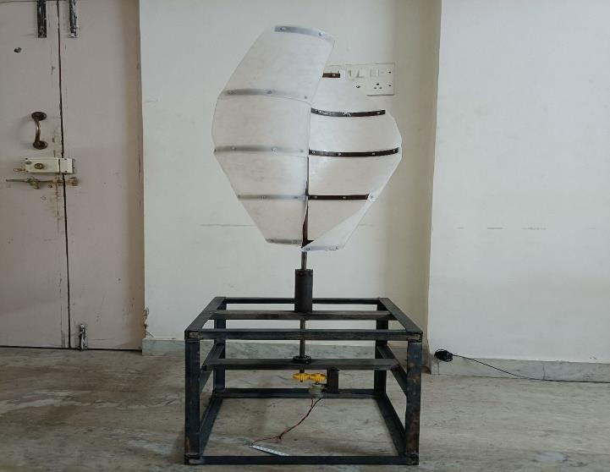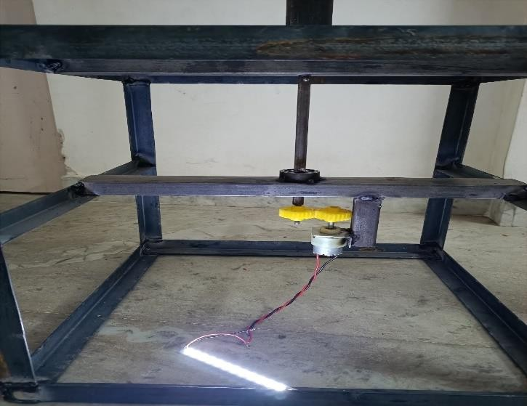

**Fig.-** Completed model

**Applications:**

1. The system is used for domestic purpose.
2. Street lighting, Traffic signals.
3. Various traffic monitoring systems.
4. Powering up for communication system.
5. Pump irrigation Systems.
6. As per requirement of electrical energy the system can be either designed or updated for higher energy requirement.
7. So, it can be used for almost every electronic, mechanic, viz. system needing/ require electric energy to work on.

# CONCLUSION

While concluding this report, we feel quite fulfill in having completed the project assignment well on time, we had enormous practical experience on fulfillment of the manufacturing schedules of the working project model. We are therefore, happy to state that the in calculation of mechanical aptitude proved to be a very useful purpose. Although the design criterions imposed challenging problems which, however were overcome by us due to availability of good reference books. The selection of choice raw materials helped us in machining of the various components to very close tolerance and thereby minimizing the level of balancing problem. Needless to emphasis here that we had lift no stone unturned in our potential efforts during machining, fabrication and assembly work of the project model to our entire satisfaction. The model develops by us fulfill the required objectives & hence we are satisfied with our project work.

# REFERENCES

1. Design of Vertical Axis Wind Turbine - Mukesh Kumar Lalji
2. S.V.Saravanan, M. Varatharaj, L. Ayyadurai, S. Palani & D. Prem, “Design and fabrication of vertical axis highway windmill”, International Journal of Advanced Electrical and Electronics Engineering (IJAEEE), Volume-2(2), 2013, page no. 2278-8948
3. Raciti Castelli, M., Englaro, A., Benini, E., “The Darrieus wind turbine: Proposal for a new performance prediction model based on CFD”, Volume 36, 2011, pp. 4919 4934.
4. Nilesh N Sorte, S. M. Sheikh, “Design and development of micro vertical axis wind turbine for rural application”, International Journal of Engineering and Computer Science, Volume 03 (07), 2014, pp. 7035-7040.
5. G.M. Joselin Herberta, S. Iniyanb,_, E. Sreevalsanc, S. Rajapandiand ―A review of wind energy technologies‖; Department of Mechanical Engineering, St. Joseph’s College of Engineering, Chennai-119, India