**ONLINE LOAN MANAGEMENT SYSTEM**

**Aditi Rai *1, Dr. Santosh Kr. Dwivedi *2,**

**Mr. Aakash Srivastava *3**

*1UG Student of Department of Bachelor of Computer Application, Shri Ramswaroop Memorial College of Management Lucknow, Uttar Pradesh, India.

*2Professor, Head of Department of Bachelor of Computer Application, Shri Ramswaroop Memorial College Of Management Lucknow, Uttar Pradesh, India.

*3Assistant professor, Department of Bachelor of Computer Application, Shri Ramswaroop Memorial College Of Management Lucknow, Uttar Pradesh, India.

# ABSTRACT

# 

# The Block chain-Based Online Loan Management System (BOLMS) is an inn

The Block chain-Based Online Loan Management System (BOLMS) is an innovative web application that leverages block chain technology to revolutionize the process of loan management for financial institutions. By utilizing the decentralized and transparent nature of block chain, BOLMS aims to enhance security, trust, and efficiency in the loan management process.

BOLMS provides a secure and immutable platform for borrowers to apply for loans online. Through the system, borrowers can create digital identities, store and manage their financial data securely on the block chain, and submit loan applications without the need for intermediaries. The use of block chain ensures that borrower information remains tamper-proof and resistant to unauthorized modifications, reducing the risks associated with data breaches and identity theft.

# INTRODUCTION

An online loan management system using block chain technology is a platform that leverages the decentralized nature of block chain to provide a secure, transparent, and efficient system for managing loans online.

Traditional loan management systems often involve intermediaries such as banks, financial institutions, or loan brokers, which can lead to high costs, delays, and potential security risks. However, with a block chain-based loan management system, lenders and borrowers can interact directly, eliminating the need for intermediaries and reducing costs.

In this system, loan agreements are recorded on a block chain, which is a decentralized and tamper-proof digital ledger. Smart contracts, which are self-executing programs stored on the block chain, can be used to automate the loan process, including disbursement, repayment, and enforcement of loan terms.

# WORKFLOW

# An online loan management system typically involves several stages and processes. Here's a suggested work flow for an online loan management system are :

* Borrower Registration
* Loan Application Submission
* Loan Evaluation
* Loan Approval
* Loan Repayment
* Account Management
* Loan Disbursement

Throughout the entire work flow, the online loan management system may incorporate additional features such as document management, notifications, reporting and analytic , customer support, and integration with external systems like credit bureaus or banking platforms to facilitate a comprehensive loan management process.

# PROPOSED SYSTEM

The proposed system aims to develop an efficient and user-friendly Online Loan Management System that streamlines and automates the loan management process for both borrowers and lenders. The system leverages modern technologies and features to enhance the overall loan management experience.

Online Loan Management System offers a comprehensive solution to streamline and automate loan management processes. It aims to enhance efficiency, transparency, and user experience for both borrowers and lenders while ensuring data security and compliance with regulatory standards.+

# IV. SYSTEM OVERVIEW

The Online Loan Management System (OLMS) is a web-based application designed to streamline and automate the loan management process for financial institutions. It provides a centralized platform for borrowers, lenders, and administrators to interact and manage loan applications efficiently. The Online Loan Management System provides a comprehensive solution for efficient loan management, improving operational efficiency, transparency, and user experience for borrowers, lenders, and administrators. It automates key processes, enhances data security, and enables informed decision-making through advanced reporting and analytics capabilities

.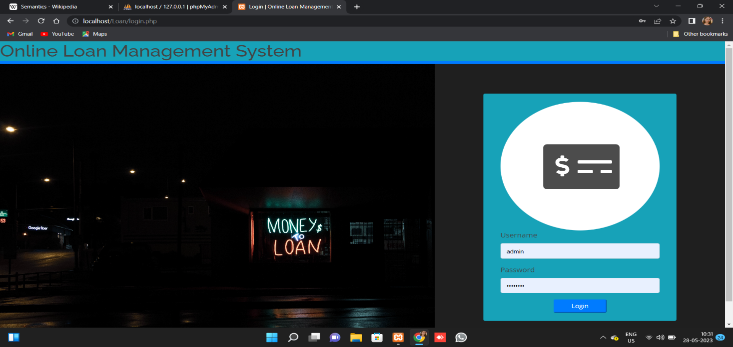

Figure 1: Authentication Page

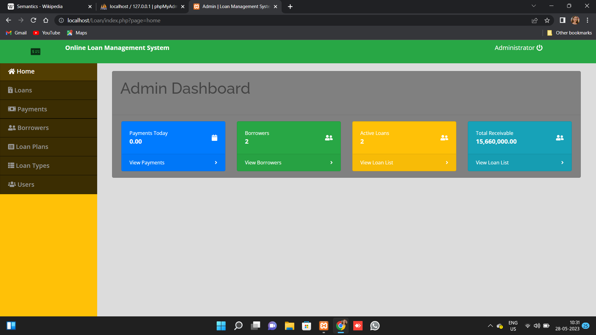

Figure 2: Dashboard

# V. ANALYSIS

An online loan management system is a digital platform that allows financial institutions, such as banks or credit unions, to streamline and automate their loan processes. It provides a centralized platform for managing loan applications, processing, approval, disbursement, and monitoring.an online loan management system offers numerous advantages for financial institutions, including process automation, improved efficiency, enhanced customer experience, risk mitigation, compliance, and data-driven decision making. However, careful consideration of the system's features, benefits, and potential challenges is necessary to select the most suitable solution for an organization's specific needs.

# VI. CONCLUSION

In conclusion, an online loan management system is a vital tool for lenders and financial institutions to efficiently and effectively handle the loan life cycle, from application and approval to disbursement and repayment. It offers numerous benefits such as streamlined processes, improved customer experience, reduced operational costs, and enhanced risk management.Predictive analytics and risk management capabilities will continue to evolve, enabling lenders to make informed decisions and proactively manage risks. Personalization of loan products and customer experiences will be a focus, leveraging data analysis to tailor offerings to individual borrowers. Integration with ecosystem partners and block chain technology are expected to further enhance efficiency, transparency, and collaboration in the lending process.

# VII. FUTURE WORK

The future of online loan management systems is expected to witness several advancements and trends that aim to enhance efficiency, customer experience, and risk management. Online loan management systems will increasingly leverage automation and AI technologies to streamline loan processes. This includes automating loan application processing, credit assessment, document verification, and loan underwriting. AI algorithms can analyse vast amounts of data to make faster and more accurate lending decisions.

This integration enables seamless loan disbursements, real-time payment tracking, and access to non-traditional credit data for risk assessment.

This includes advanced encryption, multi factor authentication, and compliance with data protection regulations like GDPR (General Data Protection Regulation).This includes advanced encryption, multi-factor authentication, and compliance with data protection regulations like GDPR (General Data Protection Regulation).

Block chain technology has the potential to revolutionize loan management systems by offering increased transparency, security, and efficiency. It can facilitate smart contracts, digital identity verification, and decentralized lending platforms.

# ACKNOWLEDGEMENT

We would like to thank our friends, relatives, our faculty, and other staff members of Shri Ramswaroop Memorial College of Engineering and Management for helping and guiding me, and special thanks to my instructor for suggesting me the right and suitable path.

First and foremost, we would like to express our deepest gratitude to my guide, Mr. Shadab Alifor their invaluable guidance, mentorship, and support throughout this research project. Their expertise and insights have been instrumental in shaping our research direction and refining our methodology.

Last but not least, we would like to thank our family members, friends, and loved ones for their unwavering support, understanding, and encouragement throughout this research journey. Their constant belief in us has been a driving force behind our motivation and perseverance.

While it is impossible to mention everyone who has contributed in one way or another, we genuinely appreciate all the support we have received.

# VIII. REFERENCES

1. Mtaki Frank, Dr. B. Ganesh, May 2016 Loan Management and Risk Practices in Banks Vol -4, Issue 5 on, (Pg175-184).
2. [2] Mishra Nandita, Chandra Munesh, Oct 2010 Microfinance in Indian Banking Industry and Its Future on (Pg625-628).
3. [3] Bandyopadhyay Arindam, July 2016, Studying borrower level risk characteristics of education loan in India on (Pg127-135).
4. Heffernan, Sh .: “Modern Banking”, 2005.
5. Arunkumar, R., Kotreshwar, G: “Risk Management in Commercial Banks”, December.2005.
6. Mckinley J., E., & Barrickman, J.R .: "Strategic Credit Risk Management", Robert Morris Association, Philadelphia, 1994.