**Understanding the Benefits & Cons of Online Selling & Purchasing (eCommerce) Over Traditional Selling & Purchasing: A Review**

**Gaurav Avhale1, Harshdeep Hiwrale2, Vaishnavi Borkar3, Aakanksha Vaidya4**

**\*1,2,3,4**Department Of Computer Science & Engineering, Tulsiramji Gaikwad-Patil College of Engineering & Technology, Nagpur, Maharashtra, India.

**ABSTRACT**

Electronic commerce is the practice of conducting business over computer networks. A person can use all of the Internet's features while seated in front of a computer to buy or sell things. Compared to traditional commerce, which requires a person's effort to travel and collect items, ecommerce has made it simpler for people to eliminate physical work and save time. Beginning in the early 1990s, e-commerce has made significant progress in the computer industry, but security concerns have slowed its growth. The trouble that web based business is at present confronting is security, and there have been many advances accomplished around here. The ability to browse stores, compare prices, and place orders from the comfort of one's own home via a computer is the primary advantage of online shopping over traditional retail. B2B e-commerce is used to improve businesses' access to international markets and increase the use of e-commerce in developing nations. E-commerce's growth is crucial for a developing nation. The research method emphasizes how important e-commerce is for business applications in developing nations.

**Keywords:** eCommerce, Online Purchase, Selling, e Store, Online Store, Traditional Trading

1. **INTRODUCTION**

Electronic commerce refers to the process of conducting business over computer networks. Sitting in a chair in front of a computer allows you to access all of the Internet's buying and selling tools. In contrast to traditional commerce, which requires a person's effort to go get products, ecommerce has made it easier for humans to reduce physical work and save time. Since its inception in the early 1990s, e-commerce has made significant advances in the computer field; however, security has stifled its growth. Security is today's issue with e-commerce, and the field of security has made significant progress. The ability to shop online, compare prices, and place orders on a personal computer from the comfort of one's own home is the primary advantage of e-commerce over traditional forms of commerce.

B2B e-commerce is used to help developing country businesses gain access to global markets and increase their use of ecommerce. Ecommerce development is critical for a developing country. The research strategy demonstrates the importance of ecommerce in developing countries for business purposes.

1. **EXISTING SYSTEM**

Keeping all records on paper or in books is analogous to the traditional or current method of selling and/or purchasing. Consistently, businesspeople or proprietors should oversee everyday shutting stock by counting and refreshing the books, as well as opening stock for the following day. When records are needed quickly, it can be hard to find them because they might be burned, wet, or gone. The conventional method of keeping records is depicted in the diagram.

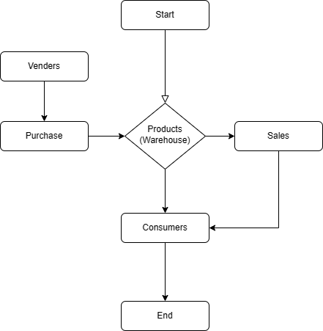

1. **PROPOSED SYSTEM**

However, there are unquestionably a number of advantages that e-commerce has over traditional business, the most notable of which is its ease of use. The user can shop online, compare prices, and place orders from home with a PC. Forrester found that because of its potential for simplicity and quick response times, 37% of online customers use customer support from Web shops more frequently than they do from traditional stores. According to Christopher Kelley of Forrester, businesses must build their identities around the promise of a positive experience once good proactive customer service is in place.

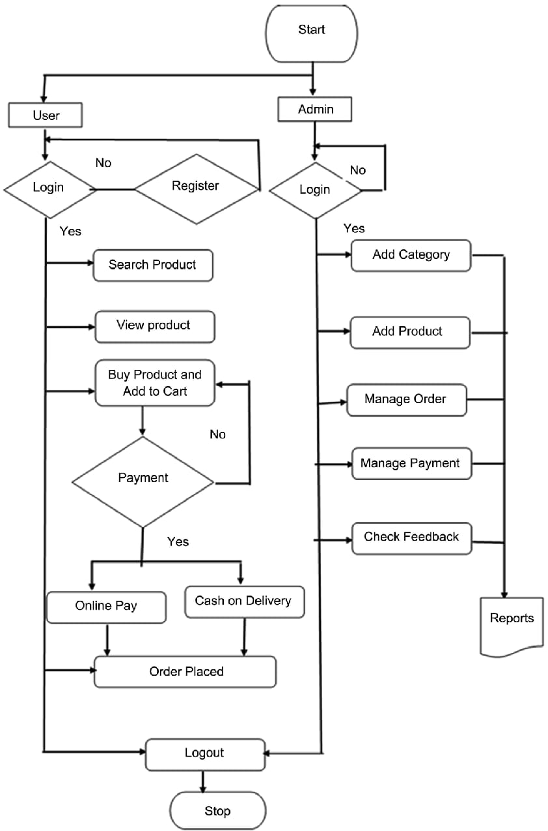

**Figure 1:** Working Model.

1. **REQUIREMENTS**

**Python and IDEs:** Python is a general-purpose, high-level programming language. Its plan reasoning stresses code coherence with a ton of space. Dynamic typing and garbage collection are features of Python. Structured, object-oriented, and functional programming paradigms are among the ones it supports. Python integrated development environments, also known as Python IDEs, are software platforms that provide programmers and developers with a comprehensive set of tools for software development in a single product. These tools are designed specifically for the Python programming language.

**HTML:** HTML, or HyperText Markup Language, is the business standard markup language for records planned to be shown in an internet browser. Innovations like Flowing Templates and prearranging dialects like JavaScript can help.

**Framework for Design (CSS):** A language for describing the presentation of a document written in a markup language like HTML or XML is Cascading Style Sheets (CSS). The World Wide Web's foundational technologies are CSS, HTML, and JavaScript.

**SQL or a database:** Structured Query Language, or SQL for short, is a programming language that can be used to manage data in a relational database management system or to process streams in a relational data stream management system.

1. **CONCLUSION**

Individuals' lives have become unbelievably productive and direct because of internet business. The development of internet business has extraordinarily supported the nation's economy. The majority of everyday activities are now carried out digitally, with the exception of traditional forms of business. The greater part of the country's populace lives in village, which is quickly changing to a computerized economy. E-commerce makes it simple to compare high-quality goods and services' prices, as well as to quickly process returns and deliveries.

1. **REFERENCES**
2. Ms. Satya Kishan , Ms. Prachi Bang, “Comparative study of traditional business and Ecommerce”. 2021 JETIR, Volume 8, Issue 7, July
3. Shettar M.S.,Ajja.H.,Jigalur.S.K.&Shes hgiri.M.S.(2016). “Emerging Trends of Ecommerce in 2. India: An Empirical study”, International journal of Business and Management Invention, Vol. 5(9), 3. 25-31. 4.
4. Wadhawan. N., & Aryan. K. R. (2020). “Understanding E commerce: A study with reference 5. to competitive Economy”, Journal of critical review, Vol. 7(8), 805-809. 6.
5. Panigrahi A., Upadhyaya R., & Raichurkar P. (2016). E commerce Services in India: Prospects 7. and Problem. International Journal on Textile Engineering and Processes, Vol. 2(1), 15-22. 8.
6. Social Media Explained Untangling the World’s Most Misunderstood Business Trend Mark 9. W. Schaefer. 10.
7. The Effects of Social Media on E-commerce: A Perspective of Social Impact Theory 2012 45th Hawaii International Conference on System Sciences