DHOBILITE LAUNDRY

# Tushar Mishra*1, Dr. Santosh Kr. Dwivedi *2, Mr. Aakash Srivastava *3

*1UG Student of Department of Bachelor of Computer Application, Shri Ramswaroop Memorial College of Management Lucknow, Uttar Pradesh, India.

*2Professor, Head of Department of Bachelor of Computer Application, Shri Ramswaroop Memorial College Of Management Lucknow, Uttar Pradesh, India.

*3Assistant professor, Department of Bachelor of Computer Application, Shri Ramswaroop Memorial College Of Management Lucknow, Uttar Pradesh, India.

# ABSTRACT

A laundry management system is a software solution designed to automate and optimize laundry facility operations. It offers a centralized platform for managing customer orders, inventory tracking, scheduling pickups and deliveries, producing invoices, and improving overall workflow efficiency. This abstract gives a brief summary of the laundry management system, emphasizing its essential features and benefits.

By allowing for effective order placement, tracking, and management, the laundry management system accelerates the process of managing customer orders. It allows employees to enter orders, assign specific services or treatments, and track the status of each order from pickup through delivery. Throughout the process, real-time updates and notifications keep both staff and customers informed.

# I. INTRODUCTION

Laundry enterprises presently use a homemade system for the operation and maintenance of critical information. The existing method necessitates a plethora of paper forms, with data stores scattered throughout the washing operation architecture. Frequently, information (on forms) is insufficient or does not adhere to management requirements.

Records are frequently lost in conveyance during calculation taking a comprehensive auditing process to insure that no vital information is lost. Multiple copies of the same information live in the laundry establishment data and may lead to inconsistencies in data in colorful data stores.

A significant part of the operation of any laundry establishment involves the accession, operation and timely reclamation of great volumes of information. This information generally involves; client particular information and clothing records history, stoner information and reclamation period, druggies cataloging as regards customers details and dealings in service rendered, also our products package waiting list. All of this information must be managed in an effective and cost wise fashion so that the association coffers may be effectively utilized .

The thing of laundry operation system is to automate the operation of the laundry establishment making it more effective and error free. It aims at homogenizing data, consolidating data icing data integrity and reducing inconsistencies, through the use of largely motorized process that's stress free, dependable and quick through the use ofasp.net computer programming language and SQL database application to both the druggies and the staff in charge of the enrollment and laundry management processes. HTML would be at the front- end and give the graphical user interface that relates with the stoner, while the SQL database will be at the reverse- end to handle the data storehouse process.

# II. WORKFLOW

The workflow for a laundry system typically involves several steps, from sorting the laundry to folding and storing the clean clothes. Here is a general workflow for a laundry system:

1. Sorting:

2. Pre-treatment:

3. Loading the washing machine

4. Washing

5. Drying.

6. Ironing

7. Folding

8. Storage

9. Maintenance and Cleaning

It's important to note that specific laundry systems may have additional steps or variations based on individual preferences, equipment availability, or special considerations..

# III. PROPOSED SYSTEM

The suggested system aims to make user operations easier. If the registration procedure is to be speedier and more convenient, the processes required must be reduced to the bare minimum. The traditional method of registration, which relies on paper, is time consuming and costly. Customers may be confident in the security and availability of their apparel when it is due since information is protected by a unique Id. An increase in the number of customers will imply additional paperwork and a decrease in the efficiency of the current system. As a result, many laundry companies believe that the suggested approach is a better and more efficient way of compensating for the annoyance and inefficiency of the current registration system.

# IV. SYSTEM OVERVIEW

A simple laundry system is a program that assists users in keeping track of their order. Here's a rundown of the system: User Interface (UI): The user interface (UI) of a system is the component that allows users to interact with it.. User Authentication: The system should have a user authentication mechanism to ensure that only authorized users can access it. This can be accomplished through the use of login and password authentication or other authentication mechanisms such as Auth. Services Categories: Users should be able to create and manage services categories in the system. This allows users to organize their expenses and get a sense of where their money is going users should be able to enter new expense entries into the system. Details such as the date of the expense, the amount spent, the category to which it belongs, and a description of the expense should be included in the expense entry. Reporting: The system should include reporting capabilities to assist users in understanding their expenses. This can include features such as the ability to generate reports based on various criteria such as expense category, date range, and total expenses.:

A laundry management system is a software solution designed to streamline and automate the operations and processes involved in managing a laundry facility. It provides a centralized platform for managing customer orders, tracking inventory, scheduling pickups and deliveries, generating invoices, and facilitating overall workflow efficiency. Here's an overview of the key components and features of a typical laundry management system:

By utilizing a laundry management system, businesses can streamline their operations, improve customer service, optimize resource utilization, and enhance overall efficiency. The system enables effective management of orders, inventory, billing, and reporting, resulting in improved productivity and profitability for laundry facilities.

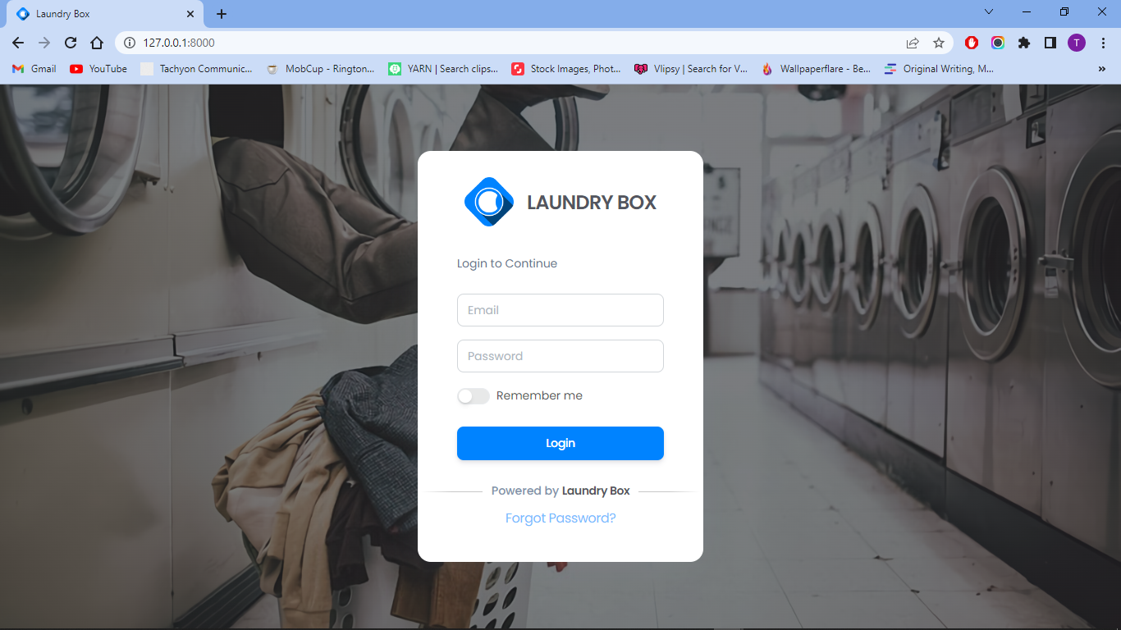

Figure 1: Authentication Page

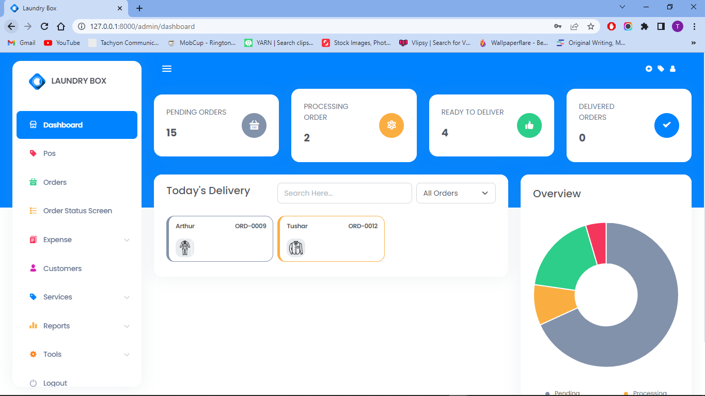

Figure 2: Dashboard

# V. ANALYSIS

Analyzing a laundry system involves assessing its strengths, weaknesses, opportunities, and potential areas for improvement. Here's an analysis of a laundry system:

Strengths:

Cleanliness: The fundamental goal of a laundry system is to properly clean the fabrics, removing dirt, stains, and odours. This promotes personal hygiene, increases clothes longevity, and assures a nice appearance.

Efficiency: Laundry systems strive to maximize efficiency while minimizing time and resource waste. Optimizing machine performance, load capacity, cycle duration, and water and energy usage are all part of this.

Analyzing a laundry system entails evaluating its strengths, flaws, possibilities, and potential improvement areas. Here's an examination of a laundry system:

1. Cleaning Efficiency: A powerful laundry system removes dirt, stains, and odours from garments, ensuring complete cleaning and hygiene.

2. User-Friendliness and Convenience: A well-designed laundry system includes user-friendly washing machine interfaces.

Weaknesses:

1. Environmental Impact: Some washing systems may use an excessive amount of water and electricity, adding to environmental concerns. Addressing this flaw necessitates the implementation of water and energy-saving measures, as well as the promotion of eco-friendly detergents.

2. Lack of Customization: Laundry systems may be limited in their ability to tailor wash cycles to specific demands. More customizable options can improve consumer satisfaction and satisfy a wide range of washing needs.

Overall, analyzing a laundry system aids in the id3entification of areas of strength, weakness, opportunity, and prospective improvements. By resolving these issues, the system can be improved in terms of efficiency, sustainability, and user pleasure.

# VI. CONCLUSION

The laundry management system is a useful tool for streamlining and optimizing laundry facility operations. It provides several advantages, such as improved customer service, increased operational efficiency, and increased profitability. The package was created in such a way that future updates will be simple. The automation of the entire system increases efficiency. It offers a user-friendly graphical user interface that outperforms the current system. It offers a user-friendly graphical user interface that outperforms the current system. It grants appropriate access to authorized users based on their permissions. It successfully compensates for communication delays. Updating information has never been easier. The most notable characteristics are system security, data security, and dependability. If changes are required in the future, the System can be easily modified.

In conclusion, laundry management system is a strong solution that enables laundry businesses to operate more efficiently, provide superior customer service, and increase revenue. The technology revolutionizes the way laundry operations are handled by automating procedures, optimizing resource allocation, and offering important insights, resulting in increased productivity and business performance.

# 

# VII. FUTURE WORK

In the future, the package was constructed in such a way that future changes would be simple. The following conclusion can be drawn from the project's development. Because of technological advancements, the laundry sector has become one of the inevitable industries in everyone's life. A specialised laundry management solution makes it simple to automate everyday important business operations, saving time and streamlining company procedures from order placement to doorstep delivery.

Customers can provide comments and ratings to the organisation based on their degree of satisfaction with the complaint management system, which can then be utilised to enhance the system.

# VIII. ACKNOWLEDGEMENT

We would like to thank our friends, relatives, our faculty, and other staff members of Shri Ramswaroop Memorial College of Engineering and Management for helping and guiding me, and special thanks to my instructor for suggesting me the right and suitable path.

First and foremost, we would like to express our deepest gratitude to my guide, Mr. Shadab Ali for their invaluable guidance, mentorship, and support throughout this research project. Their expertise and insights have been instrumental in shaping our research direction and refining our methodology.

Last but not least, we would like to thank our family members, friends, and loved ones for their unwavering support, understanding, and encouragement throughout this research journey. Their constant belief in us has been a driving force behind our motivation and perseverance.

While it is impossible to mention everyone who has contributed in one way or another, we genuinely appreciate all the support we have received.

# XI. REFERENCES

* - "Design and implementation of a smart laundry management system based on IoT" by M. K. Alam, et al. (2019)
* - "A novel approach to laundry management system using radio frequency identification (RFID)" by M. Z. M. Jenu, et al. (2016)
* - "An intelligent laundry management system using RFID and cloud computing" by Y. Li, et al. (2014)
* - "Global Laundry Facilities and Dry-Cleaning Services Market - Growth, Trends, and Forecast (2021-2026)" by Mordor Intelligence
* - Reports from market research firms like Grand View Research, IBISWorld, and Statista may provide insights into laundry management systems and market trends.
* - LBS - Laundry Business Software (https://www.laundrysoftwaresolutions.com/)