**International Journal of Scientific Research in Engineering and Management (IJSREM)**



**Volume: 07 Issue: 05 | May - 2023 Impact Factor: 8.176** ISSN: 2582-3930

# SMART HEALTH DISEASE PREDICTION

## Achal Telmasre, Gayatri Sathawane , Aakansha Dahekar, Aarati Jagtap

*Information Technology Department, Tusiramji Gaikwad Patil College Of Engineering And Technology Mohgaon, Maharashtra India*

---------------------------------------------------------------------***---------------------------------------------------------------------

**Abstract –**

Health care institutions are essential as it provides to every single people in the world a proper health care. Its main purpose is to improve the current health of the community that we have shared and created. A health care institution such as hospitals or medical centers would essentially consist of numerous of doctors that were qualified and specialize on treating patients of their current illness that they endured and to restore them to proper health. Throughout this day and age, new technologies have been created and developed to improve people’s daily life and routine especially for health care. Doctors and nurses were now guided by smart health prediction system on the purpose of storing medical information that may be used for research and diagnosis.

### 1.INTRODUCTION

It might have happened so many times that you or someone yours need doctors help immediately, but they are not available due to some reason. The Health Prediction system is an end user support and online consultation project. Here we propose a system that allows users to get instant guidance on their health issues through an intelligent health care system online.

The system is fed with various symptoms and the disease/illness associated with those systems. The system allows user to share their symptoms and issues. It then processes user’s symptoms to check for various illnesses that could be associated with it. Here we use some intelligent data mining techniques to guess the most accurate illness that could be associated with patient’s symptoms. In doctor module when doctor login to the system doctor can view his patient details and the report of that patient. Doctor can view details about the patient search what patient searched for according to their prediction. Doctor can view his personal details. Admin can add new disease details by specifying the type and symptoms of the disease into the database.

## 2. Literature Survey

Health care institutions are essential as it provides to every single people in the world a proper health care. Its main purpose is to improve the current health of the community that we have shared and created. A health care institution such as hospitals or medical centers would essentially consist of numerous of doctors that were qualified and specialize on treating patients of their current illness that they endured and to restore them to proper health.

Throughout this day and age, new technologies have been created and developed to improve people’s daily life and routine especially for health care. Doctors and nurses were now guided by smart health prediction system on the Throughout this day and age, new technologies have been created and developed to improve people’s daily life and routine especially for health care. Doctors and nurses were now guided by smart health prediction system on the purpose of storing medical information that may be used for research and diagnosis. Few years ago, doctors were expected to use their own intuition and experience to handle every medical situation that different patients are facing every day. Although their current approach may have saved people’s lives back then, they are still prone to errors and wrongdoings that have endangered the human life [4]. It is without a doubt a heavy burden for everyone especially the medical staffs to understand that a number of decisions could heavily affect other people’s lives and health, it is also why such system itself proves to be vital on guiding medical staff to make a proper clinical decision to cure and restore the human health.

### 3. OBJECTIVE

The objective of this project entitled “Smart health disease prediction using machine learning” is to provide a user friendly and easily understandable GUI to users to easily get instant guidance on their health issues through an intelligent health care system online. The main objective of the System is to predict disease according to symptoms and also suggest list of nearby doctors.

**© 2023, IJSREM** [**|** www.ijsrem.com](http://www.ijsrem.com/)  | Page 1

### International Journal of Scientific Research in Engineering and Management (IJSREM)



**Volume: 07 Issue: 05 | May - 2023 Impact Factor: 8.176** ISSN: 2582-3930

#### 7.PROPOSED WORK

To beat the downside of existing framework we have created smart health disease prediction System. We have built up a specialist framework called Smart Health Prediction framework, which is utilized for improving the task of specialists. A framework checks a patient at initial level and proposes the possible diseases. It begins with getting some information about manifestations to the patient, in the event that the framework can distinguish the fitting sickness, at that point it proposes a specialist accessible to the patient in the closest conceivable territory.

On the off chance that the framework isn't sufficiently sure, it asks few questions to the patients, still on the off chance that the framework isn't sure; at that point it will show a few tests to the patient. In light of accessible total data, the framework will demonstrate the result. Here we utilize some intelligent methods to figure the most precise disorder that could be associated with patient's appearances and dependent on the database of a couple of patients restorative record, calculation (Naïve Bayes) is connected for mapping the side effects with conceivable diseases.This framework improves undertaking of the specialists as well as helps the patients by giving vital help at a soonest organize conceivable.

#### 9. BLOCK DIAGRAM

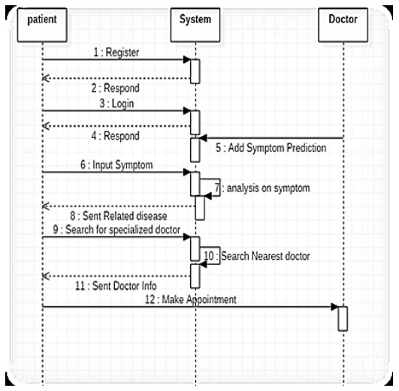

#### 10. CONCLUSIONS

It has been a great pleasure for me to work on this exciting and challenging project. This project proved good for me as it provided practical knowledge of not only programming in Python and Sqlite web based application. It also provides knowledge about the latest technology used in developing web enabled application and client server technology that will be great demand in future. This will provide better opportunities and guidance in future in developing projects independently.

**ACKNOWLEDGEMENT**

We are grateful to our guide Prof.Jayant Rohankar, Associate Professor for this continuous support and guidance. Through their guidance, we were able to successfully complete our project. Sincere thanks to Prof. Abhay Rewatkar, Head of the department of Information Technology at TGPCET, for his support and time.

#### REFERENCES

1. S. M. Metev and V. P. Veiko, *Laser Assisted Microtechnology*, 2nd ed., R. M. Osgood, Jr., Ed. Berlin, Germany: Springer-Verlag, 1998.
2. J. Breckling, Ed., *The Analysis of Directional Time Series: Applications to Wind Speed and Direction*, ser. Lecture Notes inStatistics. Berlin, Germany: Springer, 1989, vol. 61.
3. S. Zhang, C. Zhu, J. K. O. Sin, and P. K. T. Mok, “A novel ultrathin elevated channel low-temperature poly-Si TFT,” *IEEE Electron Device Lett.*, vol. 20, pp. 569–571, Nov. 1999.
4. M. Wegmuller, J. P. von der Weid, P. Oberson, and N. Gisin, “High resolution fiber distributed measurements with coherent OFDR,” in *Proc. ECOC’00*, 2000, paper 11.3.4, p. 109.
5. R. E. Sorace, V. S. Reinhardt, and S. A. Vaughn, “High-speed digital-to-RF converter,” U.S. Patent 5 668 842, Sept. 16, 1997.
6. (2002) The IEEE website. [Online]. Available: http://www.ieee.org/
7. M. Shell. (2002) IEEEtran homepage on CTAN. [Online]. Available: http://www.ctan.org/tex-archive/macros/latex/contrib/supported/IEEEtran/
8. *FLEXChip Signal Processor (MC68175/D)*, Motorola, 1996.
9. “PDCA12-70 data sheet,” Opto Speed SA, Mezzovico, Switzerland.
10. A. Karnik, “Performance of TCP congestion control with rate feedback: TCP/ABR and rate adaptive TCP/IP,” M. Eng. thesis, Indian Institute of Science, Bangalore, India, Jan. 1999.
11. J. Padhye, V. Firoiu, and D. Towsley, “A stochastic model of TCP Reno congestion avoidance and control,” Univ. of Massachusetts, Amherst, MA, CMPSCI Tech. Rep. 99-02, 1999.
12. *Wireless LAN Medium Access Control (MAC) and Physical Layer (PHY) Specification*, IEEE Std. 802.11, 1997.

**© 2023, IJSREM** [**|** www.ijsrem.com](http://www.ijsrem.com/)  | Page 2