# ONLINE AUCTION SYSTEM

# Abhishek Pratap Singh,

# Dr. Santosh Kumar Dwivedi,

# Mr. Shadab Ali,

# 

*1UG Student of Department Of Information Technology, Shri Ramswaroop Memorial College Of Engineering And Management Lucknow, Uttar Pradesh, India.

*2Professor, Head of Department of Information Technology, Shri Ramswaroop Memorial College Of Management Lucknow, Uttar Pradesh, India.

*3Assistant professor, Department of Information Technology, Shri Ramswaroop Memorial College Of Management Lucknow, Uttar Pradesh, India.

# ABSTRACT

Online auctions are currently a hugely popular part of the digital economy. A web-based tool called the online auction management system will assist consumers in buying and selling items. Users of this application will be able to list their goods for auction; interested parties can register and place bids on any goods that are offered nearby. It is being created with the intention of making the system dependable, simple, and quick as well as to enable us to sell or order things from the website from our home.

The foundation of the online auction system is the idea that a thing should be valued at its maximum price. The majority of internet auctions have items that are far from the bidders' places of residence. The bidders or buyers can observe the things being auctioned off via our system.

# INTRODUCTION

Auction is a Latin word meaning increase. An auction is a bidding and selling procedure in which goods and services are offered for sale. There are several sorts of auctions, and each auction has its own set of regulations. An auction can have several variants, such as a minimum price limit, a maximum price limit, and time constraints. Bidders can participate remotely or in person, depending on the auction type. Participation in remote auctions is possible by phone, mail, and the Internet.

The popularity of internet shopping has skyrocketed, as has the popularity of online auctions. Because online auctions are becoming increasingly popular in e-commerce, the system's quality and security should be improved. The online auction system is a paradigm in which we participate in goods and service bidding. This auction is facilitated by the use of online software that can regulate the processes involved. There are several auction techniques or varieties, with the when bidding for products and services. The use of internet software that can control the processes involved in this auction makes it possible. The English auction system is one of the more prevalent auction methods or variants.

This system can manage a huge number of bids in a live auction since it is designed to be scalable. Online auctions are become a popular way to purchase products and services. Users' information can be kept private in order to safeguard the veracity and integrity of contract documents, and bidders can be kept in a single database if necessary [6–10]. By minimising paperwork, postage, and photocopying, clear reporting saves time and money. Multiple bids can be communicated with relatively easily.

# WORKFLOW

It is simple to realise how many distinct topics or industries are pertinent to the design of existing internet online auctions when one takes a look at them. These topics include knowledge of auction mechanisms and information technologies. Corollary. The approach is to deconstruct the architecture of the online auction into distinct elements or layers and explain each one. Online auctions use a variety of hardware and software technologies, much like any other information system:-

* Aucted products
* Aucted users
* Bidders
* Categorys
* Participants
* Products
* Send feedbacks

It's important to note that the specific workflow and steps may vary depending on the organization's policies, software used, and reporting requirements. Customizing the workflow to fit your sales team's and company's unique needs is essential for effective expense tracking.

# Proposed Application Design and Model

The Customers can place bids on and buy the objects listed in this module, which also contains all the necessary information about them. The administrator must supply and oversee all of this because the entire auction process is maintained under surveillance until the merchandise transaction is verified.

Model for Administration Customers can place bids on and buy the objects listed in this module, which also contains all the necessary information about them. The administrator must supply and oversee all of this because the entire auction process is maintained under surveillance until the merchandise transaction is verified.

Customers usually want to purchase a variety of goods, but local markets are the only places where they may do so. However, with this programme, the customer can pay very little money for any item from any part of the world and possess it.

# IV. SYSTEM DESIGN:-

# 

# Design is a fundamental building piece of any software. The design is predicted on an in-depth analysis and comprehension of the existing system, as well as the software developer's conception and strategy for the suggested system. Making a logical model, part a This is most likely the crucial step in the design process. Regardless of how modest the project is, an entity-relationship diagram should be created using a tool like Designer/2000's Entity Relationship Diagram or Erwin from Logic Work. These tools support the development of the logical model of the database and the description of the information stored there. Diagram of an entity-relationship (ER) a diagram showing the logical structure of the database. It shows the different database entities and their connections. c) Selecting a tool for development.

The system will often be used while taking into account the many client devices and platforms. d) Introducing the functionality gradually It is vital to have various "versions" of the product so that customers may test it out and comment on whether it provides the features they were hoping for. When choosing the main goals throughout the design process, take into account this sequential evolution. e) Employing configuration management software With a configuration management solution, you should run various version controls and perform a backup/restore strategy: Recognising and classifying users Selecting a single user interface Create a test plan. Develop a diagnostic strategy for the application's debugging.

System for managing databases (DBMS) Although the terms database and database management system are frequently used interchangeably, the former refers to a piece of software that manages databases. In order to build "Virtual Tour," a relational database management system called Accesses was used. The majority of modern databases have some mechanism for the following features, which a DBMS should have: Data storage and retrieval ought to be straightforward. It must guarantee the security of the saved data. In the event of a database crash, there should be a mechanism to restore the database. It must maintain the consistency and integrity of the data. It should provide a way for controlling concurrency and concurrent access to the database.

**V. Results of Proposed Design:-**



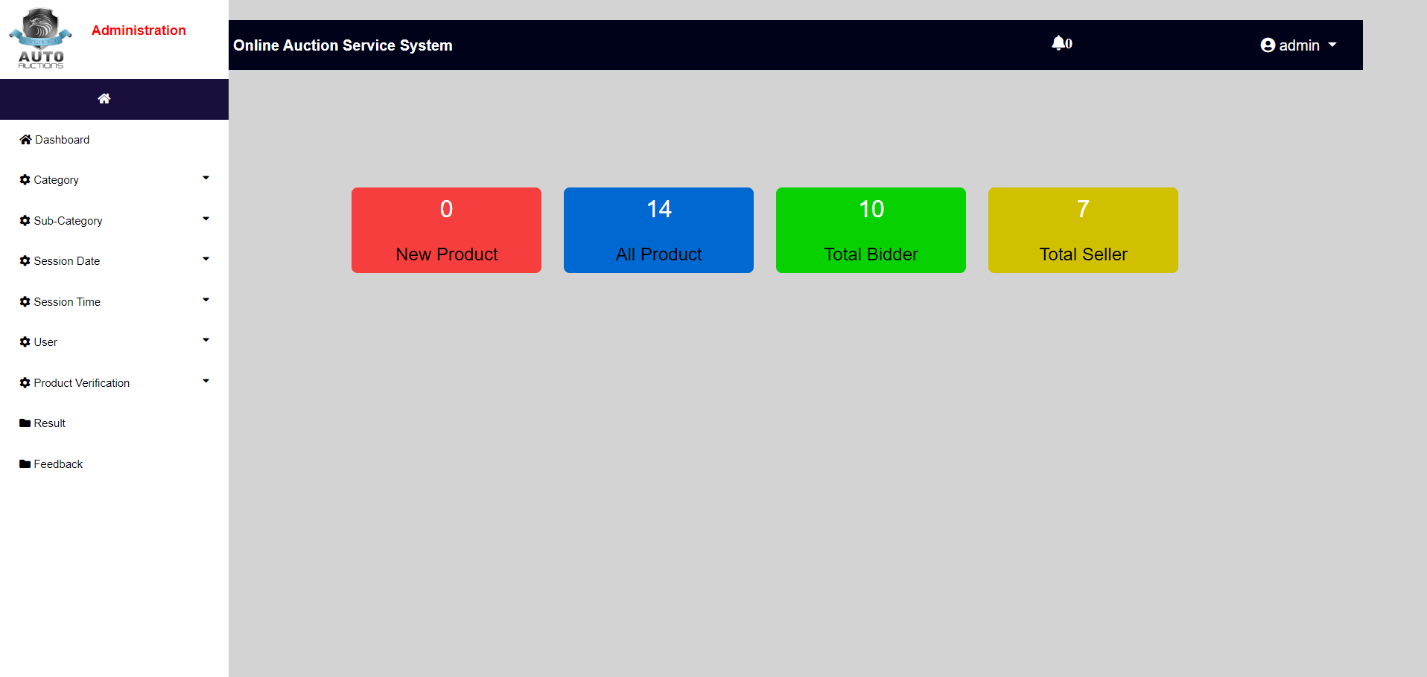

# VI. CONCLUSION

The created programme is a theoretical idea that can, of course, be put into practise. As a result, the programme is flexible and may be adjusted to meet new needs. This software will be utilised as a component of a data management system. As a result, the policy will always be updated whenever it is modified. The programme is reliable since it ensures that no data is lost and generates correct results. The programme is user-friendly because it was made with the variety of users in mind. Usability, performance speed, and error rate are all quantifiable human characteristics that are taken into consideration during the review. Not all of the aforementioned components ensure a distinct user interface, and no programme, no matter how carefully designed and implemented, will always have the same user interface.

offers a unique set of advantages and disadvantages. The software includes a thorough user manual in addition to all the advantageous features that were taken into account during development. The programme also generates pertinent error messages for users' convenience. As a result, using this programme will be simpler for users. It is important to keep a regular schedule for backing up the database to prevent problems brought on by software failure. The system is dependable, safe, and productive.

**VII. FUTURE WORK**

In the future, the expense tracker for sales could benefit from the integration of advanced data visualization techniques, such as interactive charts and real-time dashboards. This would allow sales teams to gain deeper insights into their expenses, identify trends, and make data-driven decisions. Additionally, leveraging technologies like blockchain could enhance the security and transparency of expense records, providing an immutable and auditable ledger for financial transactions.

Furthermore, exploring the potential of integrating the expense tracker with emerging technologies like augmented reality (AR) or virtual reality (VR) could offer innovative ways for sales teams to capture and manage expenses. For instance, AR-powered receipt scanning could enable users to quickly extract information by simply pointing their smartphone camera at a receipt. VR interfaces could provide an immersive expense management experience,

allowing users to visualize and interact with expense data in a more intuitive and engaging manner. These advancements would revolutionize the way sales teams track and analyze their expenses, boosting productivity and efficiency.

# VIII. ACKNOWLEDGEMENT

We would want to express our gratitude to our friends, family, teachers, and other staff at Shri Ramswaroop Memorial College of Engineering and Management for supporting and mentoring me. A special thank you to my instructor for suggesting the best and most appropriate course of action.

We would like to first and foremost convey our sincere gratitude to my mentor, Dr. Santosh Kr. Dwivedi, for his essential leadership, mentorship, and support throughout this research effort. Our research's direction and technique have been greatly influenced by their knowledge and insights.

Last but not least, we want to express our gratitude to our family, friends, and other loved ones for their unfailing help, compassion, and inspiration throughout this research trip. Their unwavering faith in us has been the inspiration for our drive and persistence.

Although it is hard to thank everyone who has helped in any manner, we sincerely appreciate all of the assistance.

# IX. REFERENCES

1. M. R. Albert (undated). Why Online Auction Fraud Should Be Regulated: "E-Buyer Beware. Journal of American Business Law.
2. [2] H. X. Ford and Benjamin J. Ford (2012). "A Real Time Self-Adaptive Classifier for Identifying Suspicious Bidders in Online Auctions" On behalf of The British Computer Society, Oxford University Press published the article.
3. [3] C., R. (2009). Utilising UML, research was conducted to design an online auction system based on a campus network. Web Mining and Web-based Application Conference II in the Pacific-Asia region.
4. [4] H.-H. T. Chuan-Hoo Tan (2010). Online Auction: The Influence of Transaction Probability and Listing Price on a Seller's Decision-Making Behaviour. 20:6779 Electron Markets.
5. [5] Price BadicaS. I. Costin (2014). Online auction system based on distributed agents. 33(3):518-552 Computing and Informatics